JD Security Solutions

Smartphone Security System

**Team Name: JD Security Solutions**

**Project Name: Smartphone Security System**

Scope: To make a smart security system using old smartphones as nodes or cameras. The premise behind it, is people have old devices they do not use. Users will have the ability to customize their solutions based on their needs and unlike other products on the market be able to store data on your own storage devices externally. This project will be completed in 13 weeks with a fully functional application prototype.

**GitHub Strategy:**

Public Repository:

<https://github.com/jakears93/JDSecuritySolutions>

Work on own activities and components. If there are classes and functions that act as a dependency that need an update, then inform developers and get ownership of file confirmed by Project Manager.

**Work Progress:**

1) Created layouts for major pages

2) Stores user information on firebase

3) Retrieves user information from firebase

4) Supports English and French locales

5) Supports portrait and landscape modes

6) Records videos and stores them to local device

7) Plays back previously recorded videos

8) Stores user login to SharedPreferences for easy return login

9) Confirms exit of application via back key press

10) App remembers if device is used as a viewer or recorder

11) Handles run-time permissions

12) Scrubbing of video playback in 3 seconds intervals (The length of each recording)

13) Placeholder logo completion

14) Implemented bottom navigation menu

15) Confirmed working beta release on both emulated Pixel 3 and Physical Samsung Note 9

**Work Distribution:**

Completed Work Distribution:

|  |  |
| --- | --- |
| Task | Completed By: |
| Creation of Layout Pages | Jacob Arsenault |
| Implementation of App Functionality | Jacob Arsenault |
| Language Conversion | Jacob Arsenault |
| Firebase Implementation | Jacob Arsenault |
| Local Preferences Storage | Jacob Arsenault |
| Planning and Consultation | Daniel O’Donnell |
|  |  |

Remaining Work Distribution:

|  |  |
| --- | --- |
| Task | To Be Completed By: |
| Store Recorded Videos on Firebase | Daniel O’Donnell |
| Retrieve Videos from Firebase | Daniel O’Donnell |
| Layout for Activity for Choosing Viewing Room | Daniel O’Donnell |
| Accurate Scrubbing of Video Recordings | Jacob Arsenault |
| Creation and Usage of Settings Page | Jacob Arsenault |
| Creating Test Cases with Junit | Daniel O’Donnell |
| Final App Testing with Junit | Daniel O’Donnell & Jacob Arsenault |

**Updated C4 Model:**

Context Diagram:

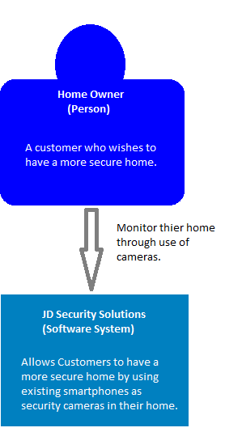

Container Diagram:

