To: Jamie Gomez, PhD

From: Nicholas Baker; Jacob Letcher; Troy Ramos; Jake Silva; Esau Woodhouse

Date: May 11th, 2016

Subject: Final Written Report

The document attached is the Final Written Report for Design Team #6 from the University of New Mexico’s Chemical and Biological Engineering Department. Our design project will provide clean drinking water for the residents of Flint, Michigan. This document will present sections on our project description, economic analysis, process safety, and environmental considerations and concerns.

___________________ ___________________ ____________________

Nicholas Baker Jacob Letcher Troy Ramos

___________________ ___________________

Jake Silva Esau Woodhouse

Clean Drinking Water for Residents of Flint, Michigan

Team No. 6

Nicholas Baker

Jacob Letcher

Troy Ramos

Jake Silva

Esau Woodhouse

|  |  |
| --- | --- |
| **Report Element** | **Specific Section # in the Report** |
| Project Description |  |
| Economics |  |
| Safety |  |
| Environmental |  |

**Capstone Report Type**: Final Written

**Date**: May 11, 2016

**CBE 494L**

Instructor: Jamie Gomez, PhD

# Table of Contents

**List of Figures**

**List of Tables**

**Executive Summary**

**Project Scope:**

Prestige Worldwide Water Solutions will provide clean water for residents in the Flint, Michigan Area.  This project must be implemented because the piping system beneath Flint has been compromised by improperly treated water that caused the leaching of lead from the pipe walls into the water distribution system. The maximum contaminant level (MCL) has exceeded any water that flows through the system at this time. The MCL for lead of 15 parts per billion is set by the Environmental Protection Agency (EPA) and is what has been determined as suitable for human consumption. This level is well below reported contaminant levels that range between 25 and 1,000 parts per billion. Due to these conditions, the best alternative has been determined to be bottled water. The water provided by Prestige Worldwide Water Solutions will be available at a reduced cost from the national average of $1.22 per gallon in order to make it a feasible option for people who are economically disadvantaged. On top of this, the designed plant will output 750 gallons of purified drinking water per minute in order to meet final production of 1 million gallons per day. This volume was selected in order to provide the population of Flint, 100,000 people, with enough water for daily consumption. This will not be enough water for showering and household appliances, but that has been deemed safe to use the unpurified water for. The water that is being purified will come directly from the current Flint water system. This water will be coming in with known lead values, arsenic values, and E. Coli values between 0-1000, 0-50 and 0-200 ppb respectively. Those levels are well over EPA drinking water standards for lead, arsenic and E. Coli of 15, 10, and 0 ppb respectively. The water that is purified will be stored on site for the Coca-Cola Bottling Company to pick up and continue the process of distribution.

**Project description:**

Our key constraints include budget, resources and quality. Prestige Worldwide Water Solutions has a limited budget, but will be receiving $4 million of the $100 million of relief funding in order to aid in plant start up. The limited budget has affected the resources for the project. For example, our team decided to implement a two-stage disinfection process compared to a three-stage disinfection process to fit the budget. This means there is no Ozonation in the process. This saves a large sum of money on start up and based off adjustments to the chlorination process, will not affect the final product.

A constraint in resources comes in the form of water delivery. The current Flint, Michigan water system is where we will receive the water for our plant. This water system feeds off of the Flint River and has a limited flow rate to the plant site. The city is currently building a pipeline directly from Lake Huron that will allow for a greater production rate. Until that pipeline is complete, the plant will continue to be limited to 1 million gallons per day.

Our final constraint of the project is the quality of our product. The Environmental Protection Agency (EPA) enforces the National Primary Drinking Water Regulations (NPDWR). These regulations give specific, acceptable contaminant levels for drinking water. Some examples are E. Coli of 0 mg/L and Arsenic of 0.01 mg/L. If the quality of water does not meet EPA’s standards, the water will be recycled back through the process in order to avoid placing contaminated drinking water into public.

In the early stages of the design process, multiple filtration techniques were considered that would be best for our project and that would fix the crisis in Flint. The techniques that were considered include reverse osmosis, micro, ultra, and nano filtration. Our team decided that reverse osmosis is the best option for our project because this technique removes contaminates as small as monovalent and multivalent ions. Nanofiltration will also remove these ions, but is a relatively recent membrane process that would come with a higher risk. The other processes will not remove small enough ion articles in the water to reach the levels of purification that are desired.

Our design has three key stages, which includes pre-treatment, filtration, and disinfection. Pre-treatment includes a rapid-mix unit, slow-mix unit, and sedimentation tank. We have found a supplier, Veolia Water Technologies, which provides a unit called Actiflo ACP 1750R. This unit is designed to handle 300-1500gpm, and remove any large particulates, such as dirt and pebbles, in the source water. Following pretreatment, the water will flow into the filtration stage. The filtration stage includes the most expensive individual unit, the activated carbon filter. The filter has been designed to handle 750gpm, remove dissolved solids and capture naturally occurring organics. This is done with the use of a single pass design, and 8” membranes that will remove down to 0.1 ppm of free chlorine. We have a two-stage disinfection process that includes chlorine disinfection and UV light disinfection. We considered ozonation disinfection but it did not fit our budget.

**Economic Results:**

For the economic budget it is assumed that we will be getting just the amount necessary for the start up costs. This is 4 million dollars of the 100 million possible from the emergency relief fund.

This plant will run with a on-stream factor of 0.9375 to ensure shut down time to clean and maintain units throughout. This makes our annual cost for employees, maintenance, and running the plant $4,139,611. Having an income that is higher than our expenses will be paramount in ensuring that Prestige Worldwide Water Solutions is a member of the Flint community long into the future. In order to make more than the annual costs we will charge the bottling company $0.02 per gallon, which will lead to an annual income of $7,300,000 per year. In the agreement with the bottling company half of the water must go to Flint for the emergency relief of the area. They other half can be sold however they see fit. This is a low value that can be changed due to demand after the emergency is over.

The biggest annual cost will be the water that we need to purify from the Flint water supply. This will cost us $2,000,000 annually. This price is extremely high compared to national averages and may go down when the crisis is over which would enable us to also lower our prices. The second highest cost will be the employee cost. This will be $1,593,000 annually. This includes 14 operators, 3 security personnel people, 1 accountant, 1 safety consultant and the 5 design engineers. The cost of chemicals to purify the water can also be a significant contributor, as they will cost $160,011 annually.

**Status of the Project:**

Prestige Worldwide Water Solutions is moving forward with the project design and is confident in our ability to finish in a timely manner. In order to maintain organization and keep the team on time, the project is broken down into the 4 basic sections:

* Filtration, Pumps, Treatment and Economics

**Filtration:**

The filtration system for this design process includes 6 different types of filters. The initial filtration comes from the rapid-mix and slow-mix filters. This initial filtration is designed specifically to handle 300 to 1500gpm. The other filters are the rapid sand filter, activated carbon filter, and reverse osmosis filter. Rapid sand filters were chosen over the slow sand filters for their ability to be relatively compact as well as handle much larger flow rates. The rapid sand filter will use micro-sand and have a detention period of 30-60 seconds. The system will also handle up to 800gpm. The activated carbon filter has a carbon matrix that varies in pore size from visible cracks that are diffusion pathways to mesopores (2-50 nm) to catch organics and free chlorine. Finally, the reverse osmosis filter is used in order to desalinate the water and remove monovalent ions. To do this, the filter will have a pore size of 0.1 nm and will give us an efficiency of 97%.

**Pumps**:

The pumps in our process have two main purposes. The first is to move the proper amount of water through our system to produce a minimum of 1 million gallons per day. Ensuring that the flow rate entering the system is 750 gpm, as well as the flow rate exiting the system does this.  The second is to deliver the water to filters and treatment tanks at appropriate flow rates and pressures. In order to do that, pumps are placed in front of filters and tanks that require specific flow rates and pressures. The sizing and selection of pumps has been completed in PUMP-FLO™. This may be seen in our process flow diagram (PFD) above and pump example below.

**Treatment:**

Treatment of drinking water is vital in its flavoring and final safety limits. Our treatment processes have all been selected and contribute to different parts of the final product. First process is the water softening process. This process can be done with different methods such as lime softening, distillation and ion exchange resin devices. The reason we have gone with the addition of a chelating agent is that it is more efficient with higher volumes and is will be more reliable over a long-term project. The other major process in treatment category is the chlorine treatment. Chlorine plays a major role in disinfecting water. With the calculated contact time of 10 min and concentration of 1 mg/L, chlorine will kill off most major bacterium such as *E. coli*, Giardia and most pathogenic microorganisms. The contact time is achieved with a chlorination tank designed with low input, high output and a baffling factor of 0.7. This method is chosen over the alternative of membrane filtration. Using the membrane method has only been shown to work well on small-scale systems. Therefore, since this plant will produce over 1 million gallons per day, a large-scale option was required.

**Economics:**

Table 1: Here are the prices for each piece of equipment. Note: Installation of the equipment has been assumed to be included in the pricing.

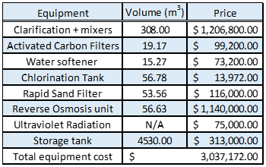

The prices for the equipment have been determined by receiving estimates from several companies, as well as inputting equipment specifications into CAPCOST. Equipment that could not be selected directly on CAPCOST was modeled by using equipment specifications found via company websites and blueprints. This water purification plant is designed to output 1,000,000 gallons per day. It will also have space and capability to allow for the growth in production rate as Prestige World Wide Water Solutions expands in the future.

Table 2: Prices for all chemicals that will be added to the water as part of the final steps of the purification process.

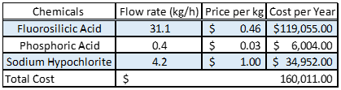

Table 2 demonstrates the chemicals that will be added to the process for chlorination, fluoride, and anti corrosive treatment. The amount of each chemical to be added was based on a program, which allowed us to calculate the flow rate of the chemical that needed to be added to the flowing water. CAPCOST then ran a calculation to find the amount that will be paid for each chemical on an annual basis. With all of this information, an interest rate of 10% and the calculated operation cost of 6.21 million dollars per year, this purification plant will have a profit margin of 1.09 million dollars per year.

**Conclusions**:

One of the main deliverable required for this was to be able to process and clean a minimum of 1,000,000 millions gallons of water per day. Our filters, tanks, and pumps are sized to handle 750 gallons of water per minute and this can be exceeded if necessary. This amount allowed us to exceed the 1,000,000-gallon per day mark required. The second deliverable was to purify the water to the standards set forth by the Environmental Protection Agency (EPA), which can be seen in Table 3. Our process, which includes multiple filtration steps and chemical treatments, has been created in order to meet or exceed all the standards for drinking water. The incoming water contaminant levels and outgoing levels can also be seen in Table 3.

Table 3: Levels of common water pathogens and inorganics that PWWS plans to ensure removal of.

|  |  |  |  |
| --- | --- | --- | --- |
| **Common Contaminants** | **Acceptable Level (ppb)** | **Incoming Level (ppb)** | **Effluent Level (ppb)** |
| **Lead** | 15 | 0-150 | 4.5 |
| **Arsenic** | 10 | 0-50 | 1.5 |
| **E. Coli** | 0 | 200 | 0 |

At Prestige Worldwide Water Solutions we will not only be able to provide clean drinking water for the citizens of Flint, but we also believe that we can do this at a price that is better than the current market price. We are selling our water for $0.04 per gallon, which is much less than it would take for the bottling company to make it themselves. The stipulation for is that an allocated amount of the water must be sold to the people of flint for a reduced price. These agreement not only benefits the client, but also the citizens of Flint and is the reason we at Prestige Worldwide Water Solutions believe we are the most qualified company for the job.

## Innovation Map with Innovation Matrix

**Introduction and Background**

The city of Flint is located in southeast Michigan and is about 69 miles northwest of the capital of Detroit. It is a medium sized city with a population of approximately 100,000. On April 2014 the city of Flint decided that they would switch their water source from the treated water of Lake Huron from Detroit to treating water from the Flint River. This was done to save 5 million dollars over the next coming years. After the switch residents began complaining of brown water coming from their faucets. After further investigation and testing it was concluded that the water in Flint had been contaminated with high levels of lead. Some places tested had a concentration of 150 ppb while the acceptable level is less than 15 ppb. The investigators found that source of the lead were the water pipes themselves. Corrosion inhibitors were not added in the treatment process of the water. This caused significant scaling in the piping system which caused the lead to leech into the city’s water. The city water is now no longer safe to drink and the only way to fix the problem is to replace the pipes which is going to take years and billions of dollars. In the meantime, the residents are left without readily available access to clean drinking water and this is where our company Prestige Worldwide Water Solutions (PWWS) has stepped in. We will be designing and building a water treatment facility in the city of Flint to clean up the contaminated water. The water will be bottled and distributed to the residents of Flint at no cost to them.

The water treatment facility is located at 6460 W Maple Ave Swartz Creek, MI and is pictured below. The plot is approximately 9 acres and will cost $895,000.

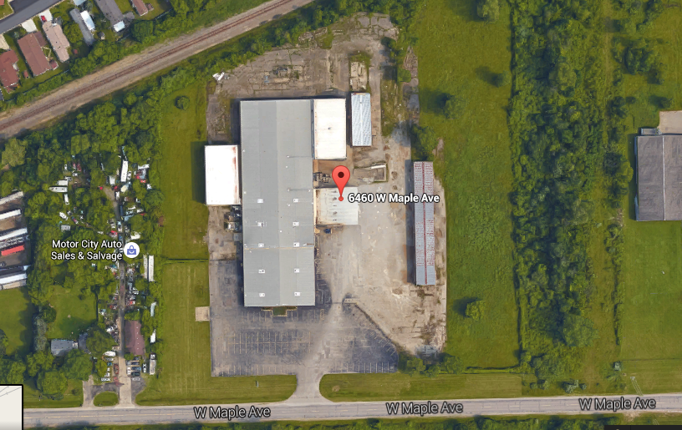

Figure 1: Google maps image of the plant location.

The major assumption that was needed to start the project is PWWS will be loaned 4 million of the 100 million dollar emergency federal relief fund. The conditions of the interest free loan are that the loan must be paid back and that a substantial amount of the water will be donated to the residents of Flint. The constraints associated with the project is funding and resources. First funding will be a constraint because the we are limited to 4 million dollars. This will limit the resources that are available for the plant to utilize. The resources will be a constraint for us because the amount of water that will be received from the city of Flint each day will be limited. The water that will be sent to the plant from the Flint River will be delivered to the plant at a limited flow rate. This will only allow the plant to produce a certain number of gallons of water per day. The main objective of the project will be to produce 1,000,000 gallons of clean water per day to be bottled. Of that 1,000,000 gallons 500,000 will be donated to the Flint residents. The second objective is to clean and filter out all contaminates and pathogens to the standards of the Environmental Protection Agency (EPA) for drinking water. This includes contaminants such lead and arsenic and pathogens such as E. coli and many others. Table 3 in the executive summary section shows the acceptable level of contaminates and the incoming contaminate level of the pathogens and contaminants. The table also shows the effluent stream for these contaminates and pathogens and this was a major factor that influenced the design of the water treatment plant.

The design basis for the plant was based upon the concentration of the effluent streams in table 3 of the executive summary section. Knowing that the water had to meet these requirements helped to narrow types of equipment and also certain types of treatment processes. In the design there are 3 main components, which are pumps, filtration and treatment. All the pumps in the process are specified to ensure a flow rate of 750gpm through the entire system is maintained. The main component of the filtration system will be rapid sand and slow mix filters along with the reverse osmosis filter. The rapid sand and slow mix filter will have a retention time of 30-60 seconds and will be able to handle up to 800gpm. The reverse osmosis filer was designed to use a pore size 0.1 nm and will have an efficiency of 97%. This poor size and efficiency will ensure that our final water will meet the requirements set forth by the EPA. The final stage of the design is treatment and the major equipment in area is the chlorination tank, the UV treatment, and finally the chemical treatment. The chlorination tank will have a contact time of 10 min and will use a concentration of 1mg/ml. It will also use a baffling factor of 0.7. The UV system will use 5 different units with each having a volume of 6 ft3 and each unit will have a contact time of 17.95 seconds. The chemical treatment will also use Fluorosilicic acid, Phosphoric acid, and Sodium Hypochlorite and these will constitute almost all of the raw material needed. The plant will be run for 22.5 hours per day which will give an on stream factor of .9375.

A possible alternative to the design is that instead of using a filter to take out the pathogens and contaminants, a distillation process could be used. This would also be effective, but the downside is cost. The cost of the distillation column is much higher than a filtration system and that is why the filtration option was chosen. A second alternative is using a different type of filter than the reverse osmosis filter. Other possible filters include micro-filtration, ultra-filtration, and nano-filtration. The reverse osmosis was decided on because it does the best job at removing contaminates as small as monovalent and multivalent ions. A final possible alternative is using ozone to disinfect the water instead of using UV radiation. Ozone would work just as well, but it is toxic and you also need to buy a machine to make the ozone, which is costly. The UV just needs lights that are fairly inexpensive to replace and it is also less harmful as long as it is shielded properly.

# Process/Product/Project Description

The following section will present Prestige Worldwide Water Solutions’ process description. This process will meet the National Primary Drinking Water Regulations (NPDWR). These regulations are legally enforceable standards that apply to all public water systems. The complete list of the National Primary Drinking Water Regulations can be found in the Appendices section. Prestige Worldwide Water Solutions would like to highlight a few contaminates that bring a rise of concern. Lead, Arsenic, and E. coli are contaminates that cause serious health effects. The incoming compositions of lead, arsenic, and E. coli in Flint, Michigan range from 0 to 150 parts per billion, 0 to 50 parts per billion, and 0 to 200 colonies per milliliter, respectively. The Environmental Protection Agency has set maximum contaminant level (MCL) that the water technologies must comply to. The MCL for lead, arsenic, and E. coli are 15 parts per billion, 10 parts per billion, and 0 colonies per milliliter, respectively. Prestige Worldwide Water Technologies will produce a product that meets these requirements and comply with the NPDWR. Table #-# summarizes what has been described above.

Table 4: National Primary Drinking Water Standards (EPA)

|  |  |  |  |
| --- | --- | --- | --- |
| Contaminant | Maximum Contaminant Level Goal (mg/L) | Maximum Contaminant Level  (mg/L) | Potential Health Effects |
| Lead | 0 | **15** | Infants and children: Delays in physical or mental development; children could show slight deficits in attention span and learning abilities  Adults: Kidney problems; high blood pressure |
| Arsenic | 0 | **10** | Skin damage or problems with circulatory systems, and may have increased risk of getting cancer |
| E. coli | 0 | **0** | Not a health threat in itself; it is used to indicate whether other potentially harmful bacteria may be present |
|  |  |  | https://www.epa.gov/ground-water-and-drinking-water/table-regulated-drinking-water-contaminants#four |

Prestige Worldwide Water Solutions describes each unit in great detail below and describes how the requirements and regulations will have been met.

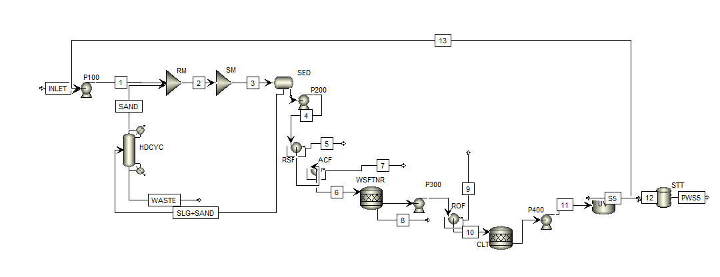**Process Flow Diagram (PFD) and Block Flow Diagram (BFD)**

Figure 2: Process Flow Diagram created using Aspen Plus

Figure 2 above shows our process flow diagram.

Table 5: Explanation of abbreviations in the Process Flow Diagram

|  |  |
| --- | --- |
| **Unit Abbreviation** | **Abbreviation Meaning** |
| **P100** | Initial Pump |
| **P200** | Pre-Filtration Pump |
| **P300** | Pre-Reverse Osmosis Pump |
| **P400** | Pre-UV System Pump |
| **RM** | Rapid Mix Filtration Unit |
| **SM** | Slow Mix Filtration Unit |
| **SED** | Sedimentation Tank |
| **RSF** | Rapid Sand Filter |
| **ACF** | Activated Carbon Filter |
| **WSFTNR** | Water Softener Injection Tanks |
| **ROF** | Reverse Osmosis Filter |
| **CLT** | Chlorination Tank Unit |
| **UV** | UltraViolet Radiation Unit |
| **STT** | Purified Water Storage Tank |

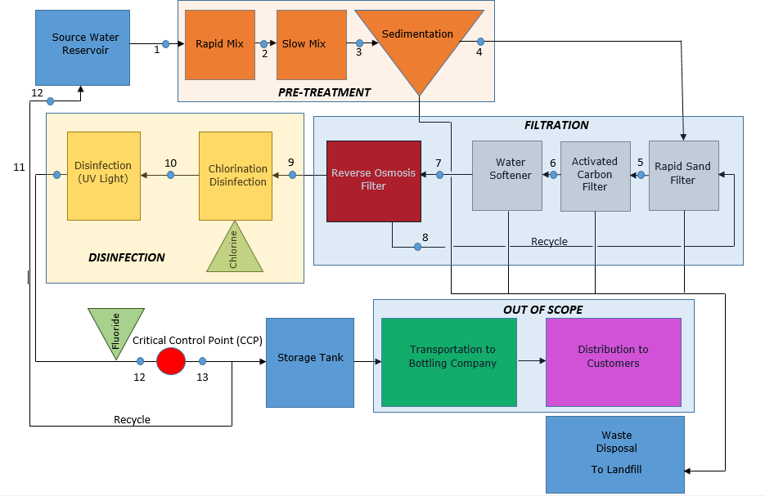

Figure 3: the block flow diagram for our process. It has been divided into three categories: pretreatment, filtration, and disinfection. Below you will find the description of each unit in greater detail.

**Basic Process Controls**

In the water purification process shown above in the process flow diagram, there are five main points of control concern. These five points were chosen in order to ensure that the plant is meeting its deliverables on composition and flow rate. There are two basic types of controls implemented at these points. The first type, which is used four times, is a flow rate control system. The flow rate controllers are set up following each pump. This will allow for the plant engineers to ensure that there is sufficient flow rates entering units that require high or low flow rates. The controls are attached to valves that can be adjusted in order for the control of flow through the system.  For example, the reverse osmosis filter requires a high flow rate and the pump before it will have a control system that ensures its needs are met. The other type of control system that is present in the process is a composition controller. Composition control is vital at the end of the process to ensure the EPA National Primary Drinking Water Regulations. Before the water enters the storage tank, composition will be checked and if the water does not meet requirements, the controller will move the directional valve to send the water through the recycle stream (13) and back to the initial filtration stages.  
Other parameters that were considered during the control system design were temperature, and pressure. Throughout the purification process, there is little variance in these parameters. Due to the lack of heating or cooling, there are no cold water or warm water inlets into the system to be monitored.  This meant that there was no use for temperature controls. Also, without any compressors and a large number of open systems, there is no concern of pressure change during the purification process. The tanks and filters have constantly flowing water and are not working at varying pressures. This meant that there was no need to design any pressure control systems on the water purification process.

**Pretreatment Process**

The pretreatment process includes a rapid mix tank, slow mix tank, and sedimentation tank. In our design, we have purchased a unit that includes all three tanks. For design purpose, below will go into detail of the design of each tank.

**Rapid Mixing**

Coagulation is a process when a coagulant is added to water to destabilize colloidal suspensions in which the particles will settle very slowly because the colloidal particles carry repulsive surface electrical charges. Mixing is the process where the chemicals are quickly and uniformly dispersed in water. It is ideal to have the chemicals instantaneously dispersed throughout the water. The degree of mixing is measure by the velocity gradient, *G*. It is a function of the power input, volume, and dynamic viscosity. The velocity gradient is the amount of shear taking place. The higher the velocity gradient equates to more turbulent mixing. Equation # was used to calculate the velocity gradient.

(Equation 1)

Rapid mixing is one of the most important physical operations affecting coagulant dose efficiencies. The chemical reaction in the rapid mixing stage happens in less than one second. This is why it is very important that the mixing be as complete and instantaneous as possible. Our design using a vertical shaft mixer.

There are two mechanisms of coagulation. The first mechanism is by adsorption-destabilization. The second mechanism is by sweep coagulation. Adsorption-destabilization will occur under one second and sweep coagulation ranges from one to seven seconds. Jar tests are used to identify which method is best suitable for the design. If the G value ranges from 3,000 to 5,000, adsorption destabilization is recommended. If the G value ranges from 600 to 1,000, sweep coagulation is recommended. Our G value for our design is 692, therefore sweep coagulation was used.

The incoming flow rate to the rapid mix tank is 750 gallons per minute. The volume of the rapid mix tank is 0.44. This may seem small; however, by rule of thumb rapid mix tanks do not exceed 8 because of mixing equipment and geometry constraints. The detention time for the water in the tank was calculated to be 10 seconds. From the rapid mix tank transitions into the slow mix tank where flocculation takes place.

Slow Mixing

Flocculation is a process where small particles collide with other smaller particles to form lager particles that are called flocs. The particles do not repel but stick to one another because rapid mixing neutralized the charge of the particles. This is the most important process that affects particle-removal efficiencies. The goal of flocculation is to bring particles in contact so they stick together and grow so that they can easily settle. A correct timing of mixing is an important design parameter. If too much mixing occurs, the floc particles will shear so the floc is small and dispersed. To control the amount of mixing, the velocity gradient is controlled within a narrow range.

Table 6: G values for flocculation

|  |  |
| --- | --- |
| Type | ) |
| Low-Turbidity, color removal coagulation | 20 - 70 |
| High-Turbidity, solids removal coagulation | 30 - 80 |
| Softening, 10% Solids | 130 - 200 |
| Softening, 39% Solids | 150 - 300 |
| SOURCE: Walker Process Equipment, 1973. |  |

It was an assumption in our design that a high-turbidity body of water is coming into the system. Therefore, the G value will range from 30 to 80 . There is a range for flexibility and so that the plant operator will be able to change the G value by a factor of two or three.

The flow coming into the slow mix tank is 750 gallons per minute. The flow rate can be adjusted by operators depending on the demand and output desired. The volume of the slow mix tank was calculated to be 80. The retention time for the slow mix tank was calculated to be 30 minutes. The retention time for flocculation is much greater than coagulation because there must be enough time for the small particles to come into contact with one another to create larger flocs. These larger flocs with then flow to the sedimentation tank for settling.

**Sedimentation**

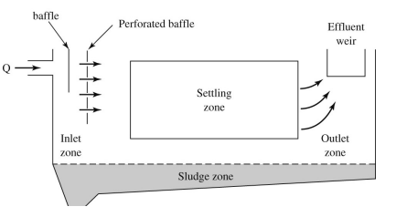Sedimentation tanks are used for the removal of particles by settling within a reasonable time period. The design of the sedimentation can be broken down into four categories: inlet, settling, outlet, and sludge storage.

Figure 4: Cross sectional view of a horizontal sedimentation tank.

SOURCE:https://learn.unm.edu/webapps/blackboard/execute/content/file?cmd=view&content_id=_2137633_1&course_id=_37034_1&framesetWrapped=true

The inlet zone evenly distributes the flow and suspended particles across the cross section of the settling zone. The inlet zone of the sedimentation tank has a series of inlet pipes and baffles that are place approximately 1m into the tank. These extend the full depth of the sedimentation tank. The settling zone is where the particles settle to the bottom of the tank. The outlet zone will remove the settled water from the basin without carrying flocs into the next stage of the process. In a sedimentation tank, there is a large amount of area that the water has to flow through. The velocity of the water is determined by Equation #.

(Equation #)

The outlet zone consists of a series of weirs which provide a large area for the water to flow through that minimizes the velocity in the sedimentation tank. The heavier the solids are it will be harder to wash out the floc and the higher the outlet velocity.

Table 7: Typical Weir Overflow Rates

|  |  |
| --- | --- |
| Type of floc | Weir overflow rate () |
| Light alum floc (low-turbidity water) | 143-179 |
| Heavier alum floc (higher-turbidity water) | 179-268 |
| Softening, 10% Solids | 268-322 |
| SOURCE: Walker Process Equipment, 1973. |  |

As mentioned in the Slow Mixing section, tt was an assumption in our design that a high-turbidity body of water is coming into the system. Therefore, the weir overflow rate will range from 179-268 .

The flow coming into the sedimentation tank is 750 gallons per minute. The flow rate can be adjusted by operators depending on the demand and output desired. The volume of the sedimentation tank is 200. The detention time for the sedimentation tank is 76 minutes. The weir overflow rate was calculate to be 200.

For our design, a unit was purchased that includes the three components as described above. The unit is from Veolia Water Technologies and is called ACTIFLO Turbo. The unit was selected by comparing the design parameters to what was calculated to what the supplier was providing.

When the water leaves the sedimentation tank, the turbidity and clarity of the water will have improved significantly. After the pretreatment process, the water moves to the filtration stage of the process. The filtration stage includes an activated carbon filter, rapid sand filter, water softener, and reverse osmosis filter.

**Filtration Process**

Following the pretreatment process is the filtration process. This includes a rapid sand filter, activated carbon filter, water softener, and reverse osmosis filter. These units will be described in detail below.

**Rapid Sand Filter**

Rapid sand filtration is common in all large water purification plants. The process requires the flocculation system to occur before hand and then send its product to either a gravity forced filter or a pumped pressure filter. The water is pushed across a series of tanks that hold silica sand. The water can then fall, or be pushed through the sand in order to improve the turbidity and begin to remove and clumps leftover by the flocculation process. For the purpose of our purification process, pumped pressure is the case.

Pressure type has been selected because the flow rate of 750 gallons per minute is a design requirement and gravity forced filters move at significantly slower rates. The company Peide will be selling us a Side Stream Filtration FQG48-6 that can filter flow rates between 400 and 1320 gallons per minute. This filter also utilizes 5160 kg of silica sand to cover the filter area of 6.78 m2.

Another option for this filtration step is slow sand filtration. Slow sand filtration does provide a more efficient energy option and lower maintenance fee, but it has a much lower flow rate limit and takes up a far greater land area. For these reasons, the rapid sand filter was selected because the high importance of the flow rate parameter. The majority of cost for the rapid sand filter comes from the large quantity of coarse sand and the need to do regular washing cycles when the plant shuts off daily.

Environmentally, this step will produce sludge in the form of dirty sand. This sludge will require appropriate care. Removing it from the system and placing it in drying beds will allow it to be non-hazardous solid waste and be carried away with the regular waste pickups at the plant.

**Activated Carbon Filter**

An activated carbon filter is the next unit that the water will go through. This unit is employed in order to remove organics and free chlorine in the water supply. Organics can be removed from a water system using varying methods. These methods can be seen in Table 8 below. Activated carbon is shown as requiring low levels of energy and maintenance, which is vital in long term operation of the purification plant. The other option that appears to be a good choice is some form of aeration. The issues with aeration are that is requires a gas supply, it is temperature sensitive, and it is typically only used in small-scale operations. Therefore, this water purification plant will be utilizing the activated carbon filter method.

Table 8: Organic removal options based on the U.S. EPA website

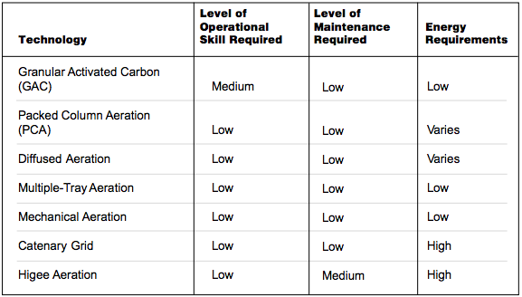

The design of activated carbon filters is highly based on the flow rate requirements for the plant. The unit selected will handle 750-1000 gpm. The reason that pore size and selection of specific filter specs is not a concern is that activated carbon forms what is called a carbon matrix. This carbon matrix have varying pore sizes throughout that all serve different purposes. The larger pores, which are typically visible as cracks, are called macro pores. Macropores are how the liquid diffuses through the filter and are vital for the speed of the filtration. The smaller pores are called mesopores and are typically from 2-50 nm in diameter. These pores continue to capture the liquid and move it through the filter, but will also capture larger molecules that may still be present. The smallest pores are called micropores, and are less than 2 nm in diameter. These pores are where the organics and free chlorine will be captured and removed from the rest of the water. A carbon matrix example can be seen below with its various sized pores.

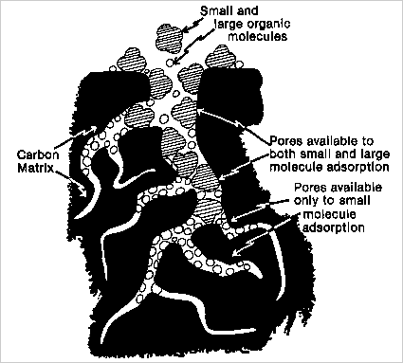

Figure 5: Carbon matrix that is formed by activated carbon filters

Activated carbon filters are highly efficient (95-99%) in the removal of chlorine and organics, but will not work to remove smaller molecules or monovalent ions, such as, sodium, fluoride, or nitrates.

**Water Softening**

The water softening unit follows the activated carbon filter. The purposed of the water softener is to remove hard water. Hard water will cause scum in bath tub areas and sinks which leaves hard, white, crusty deposits. The two main contributors to hard water are calcium and magnesium. Hard water is characterized by the sum of all polyvalent cations in consistent units. The units are in milligrams per liter as calcium carbonate, . Soft water is defined by a range of 0 to 75 mg/L as. Moderately hard water is considered to be 75 to 100 mg/L as . Hard water is considered to range from 100 to 300 mg/L as and very hard water is greater than 300 mg/L as . This can be summarized in Table #-# below.

Table 9: Hard Water Classification

|  |  |
| --- | --- |
| Hardness range (mg/L as ) | Description |
| 0 - 75 | Soft |
| 75 – 100 | Moderately Hard |
| 100 – 300 | Hard |
| >300 | Very Hard |
|  |  |

Total hardness is defined by the sum of calcium and magnesium cations. Total hardness is also defined by the sum of carbonate hardness and noncarbonated hardness. Carbonate hardness is often referred to temporary hardness because when energy in the form of heat is added to water, it will remove the carbonate hardness. Noncarbonate hardness is the total hardness in excess of alkalinity. Alkalinity is a name given to an aqueous solution for its capacity to neutralize an acid. Equations # and # show the relationship of total carbonated hardness, carbonate hardness, and noncarbonate hardness:

(Equation 2)

(Equation 3)

There are several techniques used for water softening. Prestige Worldwide Water Solutions decided to use a chelating agent for our process. A chelating agent is a specialized molecule designed to bind to metal cations which are calcium and magnesium. This allows soft water to flow through the process leaving behind calcium and magnesium that lead to hard water. The photo below is an example of the process where a chelating agent is used.

Table 10: Water softening ion removal

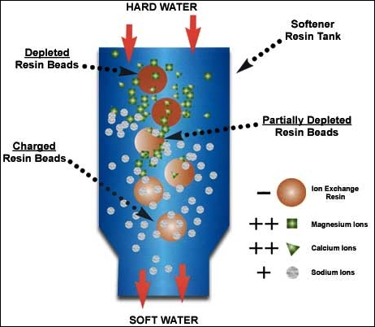

There are various techniques for water softening. PWWS used a chelating agent. Alternative techniques include lime-soda softening, ion exchange, and distillation. PWWS went with a more economical feasible technology to stay within the means of the overall budget.

**Reverse Osmosis Filter**

The reverse osmosis filtration unit is vital for the removal of all remaining small organics, and monovalent ions. Things such as sodium, microbes, and fluorides will not have been removed thus far. To design a filter that would fit these purposes, it was discovered that we would require a pore size of 1 nm. Along with the pore size, it is still important to meet the flow rate requirements to ensure that plant deliverables are met. It was also desirable to have a unit that would be capable of handling higher flow rates in case there was a desire to increase the production. The unit that was selected is provided by Evoqua Water Technologies and is called the Vantage M86N-126 RO System. The system can be seen in Figure 6 below.



Figure 6: Reverse osmosis unit purchased to meet plant requirements and design parameters.

This unit function as a single pass membrane with pore sizes of 1 nm. It also will provide 97% efficiency for the removal of dissolved solids in the water. This is accompanied by 95% efficiency for the removal of remaining naturally occurring organics. Both of these filter efficiencies will produce water that meets all of the EPA’s National Primary Drinking Water Regulations.

Another option for this filtration step included solar desalination. Solar desalination is a cleaner, more energy efficient process, but does not provide the high rate of production that is required. It is commonly used for small-scale operations or emergency relief due to its small size and low energy requirements. In the future, it may become a more viable option than reverse osmosis if the solar power technology and process are improved.

**Disinfection Process**

Prestige Worldwide Water Solutions has a two stage disinfection process including chlorination and ultraviolet disinfection. Ozonation was an alternative that was considered for the process. It was in the best interest of the company’s budget to not include ozonation as a disinfection method. Below will describe chlorination and ultraviolet disinfection along with the design parameters.

**Chlorination**

Chlorination is a required treatment step that has a lot of design required to ensure that you are treating the water heavily enough to remove the pathogens and viruses that you are targeting, but also not enough to make the water heavily chlorinated and dangerous to the customer. The acceptable level of chlorine in drinking water is 4 mg/L. To start, learning what pathogens and viruses can be killed by chlorination was vital. The Center for Disease Control provides a table for the inactivation of various targets, and what is required to achieve high percentages of inactivation. The most common pathogens in drinking water are shown in the table below with their requirements.

Table 11: Table 12: Chlorine inactivation information based on the Center for Disease Control "Table of Regulated Drinking Water Contaminants"

|  |  |  |  |
| --- | --- | --- | --- |
| **Pathogen Name** | **Exposure Time (min)** | **Chlorine Concentration (mg/L)** | **Percent Inactivation** |
| **E. Coli** | <0.5 | 0.5 | 99.98-99.99% |
| **Giardia** | 10 | 1.5 | 99.9% |
| **Cryptosporidium** | 90 | 80 | 99.9% |

Based on this table, it was determined that the removal of Cryptosporidium would not be achievable by the chlorination process if the chlorine levels are to remain within their limits. Therefore, it was determined that a tank would be designed to have an exposure time of ten minutes, and an injection at the concentration of 1.5 mg/L. A couple of other design choices were to have a perforated inlet, intra basin baffles, and outlet weirs. This would then qualify as a baffling factor of 0.7, also known as “superior baffling.” The equation below was then used to calculate the effective tank volume that is required for this process.

(Equation 4)

The volume effective is then determined to be 80% of the total tank volume. The tank volume was worked out to be 13,393 gallons. In order to have potential room for variance in the system, a 14,000-gallon tank was designed and priced with the help of Highland Tank Company. An image of what the tank will approximately look like can be seen below in Figure 7.

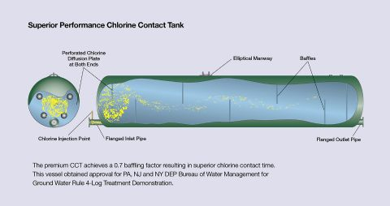

Figure 7: Generic design of chlorine contact tanks provided by Highland Tanks.

**Ultra Violet Radiation Unit**

The main purpose of using ultraviolet radiation unit in the process is to rid the water of harmful pathogens such as cryptosporidium, Giardia and many other viruses. A key point to make about the UV radiation unit is that it actually does not kill the pathogen, but rather affects the DNA of the pathogen. The UV light will be absorbed by the pathogens DNA at 200-300 nm. The absorbed UV light will alter the DNA which does not allow the pathogen to replicate leaving it harmless. The reason that this process is important is because altering the DNA takes less energy and more importantly less time than it would to actually kill the DNA with the UV light This is why it is a good option for water treatment. The most important parameter when it comes to UV radiation sterilization is dosage. Equation # shown below shows how dosage was determined for the unit.

(Equation #)

Where D is the dosage in mJ/cm2, I is the average intensity of the light in mW/cm2, and t is the average exposure time which has a units of seconds. The industry standard for dosage ranges from 20-40 mJ/cm2, so our design was implemented at a dosage of 40 mJ/cm2. The next major design characteristic is the contact time. The major parameter that effects this is flow rate which is 750gpm and also the size of the chamber that the water will flow through. Since 750gpm was a set parameter to meet the customer requirements the only parameter that could be varied is the chamber size. The size of the tank that allowed us to do 750gpm while still killing all of the pathogens is 30 ft3. The problem with using a tank this big is that the intensity of the UV light would have to be very large in order to affect the pathogens and also most companies do not make units in that large of a size. To combat this issue, it was decided that 5 UV radiation units would be put in parallel. With each unit being approximately 6 ft3. With 5 units of the size the average contact time needed to disable the pathogens is 17.95 seconds in each unit. And since our tank size was designed based on the flow rate the average time that the pathogens will be in there will be very close to this. All the calculations for the tank size and the contact time can be found in the appendix. Finally, once the dosage and the contact time were established equation # was manipulated give the average intensity of the UV light that would be needed to disable the pathogens. This number is 2.23 mW/cm2. Figure # shows a depiction of the type of UV radiation unit that will be used in the system.

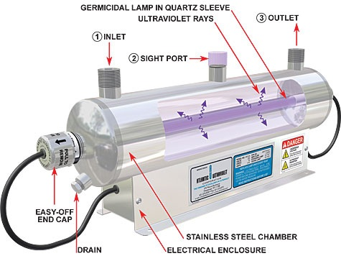

Figure 8 is the basic design for the UV radiation unit that is responsible for disabling harmful pathogens

# Economic Analysis

The economics of Prestige Worldwide Water Solutions will be discussed below. First the assumptions that were made will be discussed in detail. Then a capital cost summary, which includes that methods we used to the capital cost estimation. After that there will be a revenue and operating expense summary. Then there will be the profitability analysis, which includes whether the project is recommended by the economic analysis that was done. Finally a risk analysis will be discussed which will include a Monte Carlo analysis

Assumptions

The following assumptions were made to justify the economics of this project:

1. The biggest assumption that will be made is that will be receiving $4 million of the $100 million that Flint, Michigan requested for emergency relief.

This is important because without the initial funding coming from the government private loans will need to be taken out this will undoubtedly slow down the production of the plant. This $4 million will be used to purchase land, build building to house equipment, purchase equipment, as well as creating both a water reservoir from which to draw from and drying beds for waste material. This number has also been based off amounts, which have been quoted for other facilities, which have already been constructed.

1. The loan from the government will be interest free.

This is a big part of the economic analysis because it assumes that we will not have to pay any interest on the $4 million that we will be receiving. A viable reason for us being able to assume this is because our group would be doing this in an attempt to aid in the relief effort.

1. Tax exemptions for the first 15 years.

This is an acceptable assumption because we will be considered an emergency relief group. These groups are always tax-exempt and thus we will be until the pipes have been replaced in Flint. This is estimated to take 15 years so it is safe to assume that we will be tax exempt for at least this long. The pipes will take this long to replace because they do not have a blueprint for which pipes are made of copper and lead. Therefore all pipes will be replaced.

1. There is a flat maintenance cost of $100,000 annually

This assumption is made off looking at other plants and scaling to a plant of our size. These maintenance considerations have been made for all equipment, pipes, controls, and pumps. This is a high estimation to ensure that there will always be enough money for plant maintenance in case any unforeseen circumstances occur.

1. One piece of equipment will suffice in all situations except for pumps.

This is an important assumption because it greatly affects the equipment cost for our analysis. There are two pieces of equipment that are over $1 million and if more of them is needed it will significantly change the profit analysis. Also because of assumption 4 it allows us to believe that all equipment will be kept in the best operational condition.

1. The bottling company agrees to all of our conditions

This is important because it could greatly impact the economics of the report. If we were to need to redesign the plant or any specific piece of equipment then it could significantly impact the cost of the plant. They may also request that we transport the water to them instead of the opposite and this would impact both employee cost, equipment cost and would change the safety processes for the plant as well.

1. UV lights will consume minimal energy

This assumption has been made because the UV light utilities would cost a minimal amount compared to the rest of the of the equipment. In other words, this piece of equipment would draw a very small amount of energy as compared to the pumps, mixers, or

1. Water will be sold to us at 2015 prices.

This is a key assumption for our economic analysis because we needed a numerical value with which to base the price per gallon of water that we would be buying from the city of Flint for. They have not produced any values for price per gallon post emergency. With this in mind we had to go with the most recent value that we could find before the Flint emergency became a national story.

Other assumptions.

Capital Cost Analysis

The methods that were used include sizing the equipment for handling 750 gallons per minute of water, calling companies for quotes on equipment that was desired for use in our plant, and also examining sizing information that is given on company websites. From this information we were able to decide what type of equipment we should model based on manufacturer information in Capcost. This enabled us to get a reasonable estimate for price.

That all the equipment can handle the flow rates we needed was the most important part of the equipment specifications. Without being able to handle the flow rate the equipment would essentially be useless. The flow rate all the equipment must be able to handle is 750 gallons per minute. All the equipment is actually specified to handle more than the 750 gpm, which enables the plant to increase in size if this is needed.

Based on the 750 gpm we started looking at specific equipment needed for the plant. Our first piece of equipment is the ACTIFLO turbo system. This is a rapid mix, slow mix, and a sedimentation tank. This isn’t something that can be exactly entered into the Capcost excel sheet so we needed to model each piece of the equipment as a separate piece. By modeling the ACTIFLO system this way we were able to get the Capcost to come out to a price similar to the manufacture price that was suggested based on the information we gave them. The ACTIFLO was estimated to cost $1.25 million and Capcost gave a price that was $1.18 million, which is reasonably close. This is the best example of when information was taken in sizing and equipment type in order to estimate a cost of equipment in Capcost. This process was also necessary when modeling filters as Capcost in unable to model these. That meant we simply had to figure out the sizing of the piece of equipment, for example the reverse osmosis filter, and figure out what type of filter best described it from the choices that Capcost gives.

Revenue and Operating Expense Summary

Revenue and operating is a significant portion of the economic analysis. If the plant doesn’t turn a profit then there is no reason to even start operation and therefore this analysis being done as accurately as possible is important. The important portion of the revenue is how much we will make from selling the water to the Coca-Cola bottling company. The important portions of operating expenses include how much we spend on employees, energy, chemicals, and equipment costs. While equipment cost are initially the highest eventually the biggest expense to the company will become the employee cost. Overall the annual operating cost of the plant is $6.29 million while the overall revenue is $7.30 million annually. This means that every year PWWS will gain $1.09 million.

The only source of income we have is selling the water to the Coca-Cola bottling company. We will be doing this at $0.02 a gallon, which allowed for an annual profit of $7.3 million. By agreeing to this price Coca-Cola has also agreed that they will give away half of the water that they purchase (500,000 gallons a day) to the residents of Flint, Michigan as national relief effort. Because of this agreement with the bottling company we are also able to get the interest free loan from the government to help the construction of the plant begin in Flint as early as possible.

Employee cost is the biggest contributor to annual expenses of our company. We have decided to employ 14 operators at $45 thousand a year. This is nearly half of our employee costs but was found to be the necessary amount of employees for this type plant via the *Analysis, Synthesis and Design of Chemical Processes* book. Another large section of employee costs will be the 5 engineers that will be ensuring the plant runs at its highest potential. We will make $150 thousand annually. This is reasonable since we are en charge of all the details of the plant as well as always being on call and available to help out if anything shall occur. There will also be security personnel on the premises to ensure no contamination of the water may occur intentionally. An accountant will also be useful in keeping track of all the money that we plan on making as well as monitoring payroll to make sure everyone s getting paid and there are no lapses between pay periods. Lastly there will be an additional security consultant whose job it is to double check all plant safety concerns and to make sure the plant is always being run as safe as possible. This will help prevent unplanned stoppage as well as allow everyone to feel completely safe while working. The total annual employee cost will be $1.593 million. Figure 9 shows a pie graph of all annual employee expenses as percentages to see where the majority of the expenses are coming from.

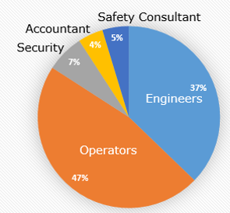

Figure 9: Employee cost as a pie chart to see annual cost of each type of employee

Chemical and energy expenses are both big enough to point out but are not significant contributors to the annual plant cost. Energy costs come from running all the equipment but it should be noted, as stated in assumption 7, that the UV light will be considered to be consuming no electricity due to the minimal amount that they actually will be taking in. The biggest contributors to the electrical cost will be the rapid and slow sand mixers in the pretreatment portion of the system. These will cost over $300 thousand per year and everything total will only cost $340 thousand per year. Because of the large contribution of the mixers we should always ensure they are being run at the most effective speed in order to minimize waste of electricity. There are only 3 chemicals that will be used in our plant and only one is a significant contributor to the annual expenses. Fluorosilicic acid, which will be added to the water to strengthen teeth enamel, will cost us $119,055 annually. Phosphoric acid and sodium hypochlorite will cost $6,004 and $34,952 annually. This means that total chemical cost will be 160,011 per year. Figure 10 shows a relative price chart of all the chemicals used.

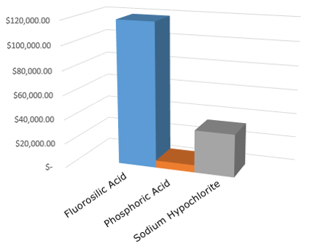

Figure 10: Price of all chemicals used in the system

Equipment cost is a major contributor in the initial cost of plant building. In order to purchase all the equipment that is needed to properly run the plant it will cost $3.037 million. This is based off of assumption 5, which enables us to have only one piece of equipment except for pumps, which there must always be a back up. There are three large contributors to the equipment cost. The first is the Actiflo Turbo, which does all of the pretreatment in one machine. This is the most expensive piece of equipment and will cost nearly $1.2 million up front. Then there is the reverse osmosis filter that will be used to filter out any bacteria and hard metals. This filter and machine will cost $1.14 million. The RO unit can be damaged if not properly cleaned and taken care of and due to the cost we must always ensure that it is running the best that it can. The storage tank is the third largest contributor to the equipment cost. It will cost $313 thousand but there isn’t much more that can be done to make it less expensive. In order for it to be able to hold the water it needs to have quite a large volume and be made of a strong metal like stainless steel. It should be noted that these three pieces of equipment contribute to over 91% of all of the equipment costs. Figure 11 shows all the equipment prices together for comparison purposes.

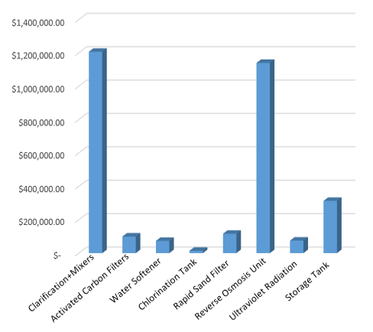

Figure 11: Shows all eqiupment prices for comparison

The profitability analysis is the most important thing a start up company can do in order to try to get funding. In our profitability analysis it will be seen that the project will gain an approximately $1.29 million every year. This means that that in year 4 all of the debt that we accrued from the government to start out the company will be paid off and we will be able to start turning a profit. In year 0 the land must be purchased in Flint. This land is a 9-acre plot that is in the southeastern quadrant of the city. It will cost $0.985 million. This can be seen in Figure 12. In year one all the equipment must be purchased which will come out to $3.037 million. For further discussion on the equipment cost see the preceding paragraph. After year one PWWS will owe slightly less than $3 million to the government. Because we will profit $7.3 million a year and the cost of manufacturing will be $6.21 million there net profit will be $1.09 million annually. It is important to note that we will not actually be gaining a real value of 1.09 million a year because of inflation. At the end of year 10 we will be able to sell back all equipment if desired. This enables us to shut down if we are unnecessary after the pipe issue is fixed in Flint. This is not what we actually plan on doing but it still lets us see what options are available after 10 years. Figure # shows the cash flow analysis graph associated with the plant proposed by PWWS.

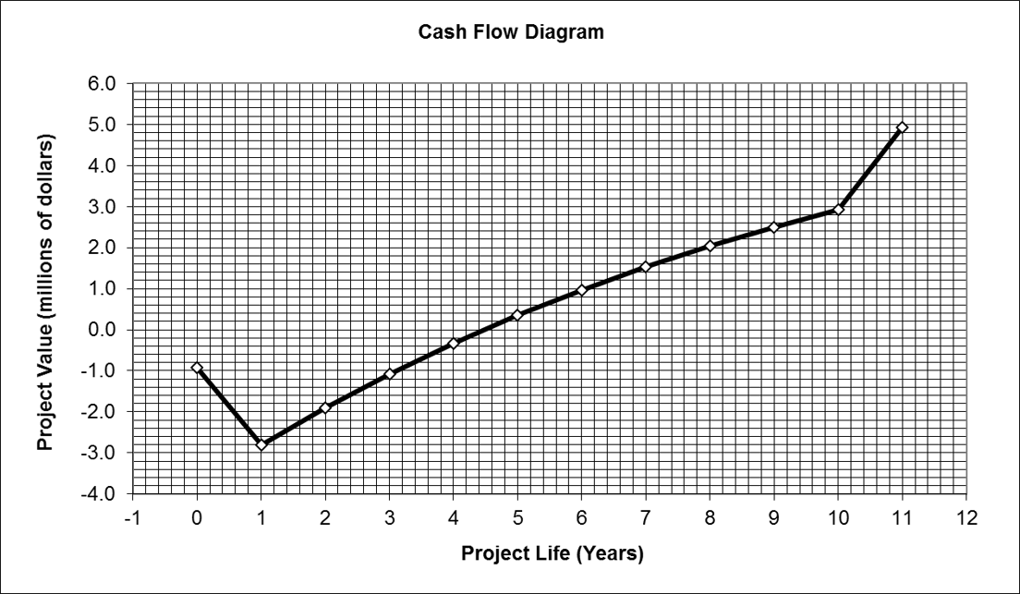

Figure 12: Shows the project value with respect to the years of operation

From Figure 12 and the discussion in the previous paragraph it is advised that PWWS continues onto stage two of the design process for the proposed plant. There is enough water being produced to service the city of Flint for as long as they will need. It will also provide some people in a lower class area of the country with good jobs and development for the future. Ideally we will become an integral part of the community of Flint for many years to come and will still be able to filter and produce clean water even after the disaster is over.

To analysis the risk of this project, PWWS ran a Monte Carlo Simulation on CAPCOST ™.. This gave the economics team for PWWS a visual representation of what the outcomes of our decisions could eventually lead to in the future. Using this method we were able to assess the impact of our decisions on things like equipment, the selling price of the water we would be purifying, as well as adjust for unexpected issues that could otherwise cause problems for our company. The two graphs and tables we focused on the most were the Net Present Value Data (NPVD). Shown below is the NPVD, what should be taken away from this, is that within 250 cumulative number of data points, the NPV breaks even and begins to grow more and more positive as the simulation completes itself. This means that values for our operations cost, as well as the amount at which we are selling our product should be considered reasonable. This graph was the main way in which we conducted our risk analysis because of its clarity. The graph is very easy to follow and because of this, PWWS was able to move on to other portions of the project.

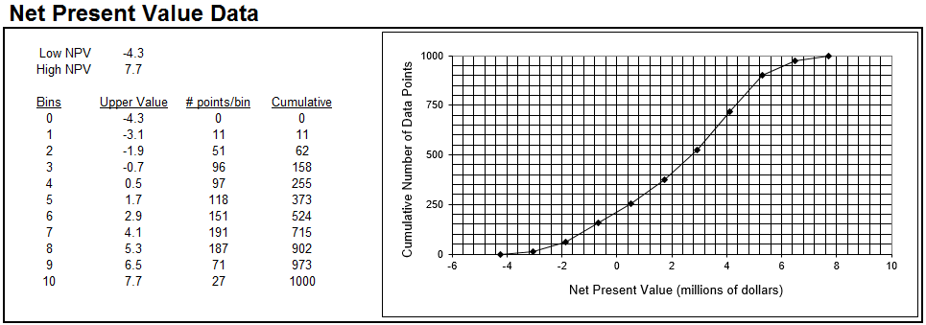

Figure 13: The NPVD that was generated using CAPCOST ™ is clearly illustrated. Note the positive trend as well as the time on the graph where PWWS will break even.

Here you can see the graph and table seen below is how CAPCOST ™ generated values to graphically depict how quickly we will repay the investment we have be given. Based on this graph it is easy to see that we chose our values very well as we will see a return on the investment relatively fast. With this in mind, it would be easy for us to be approved on the project because the investment is returned within 81 data points. This is less than 10% of the possible data points, which indicates we would be able to pay of the investment quickly and would then be able to move onto making profit. Based on the risk analysis carried out by using CAPCOST ™, PWWS knew that the project, at least at Stage 1 should be approved for Stage 2 of the design process.

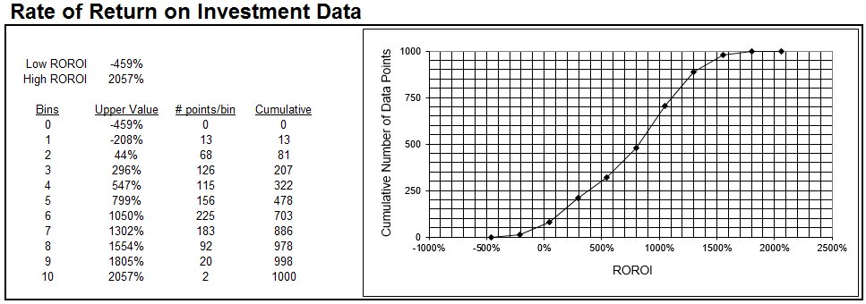

Figure 14: Seen above are the results for the ROROI from the Monte Carlo Simulation ran on CAPCOST ™. The major takeaway from this graph is that the ROROI goes from being negative to positive relatively fast.

## Safety

### **Process Flow Diagram with Basic Control Loops**

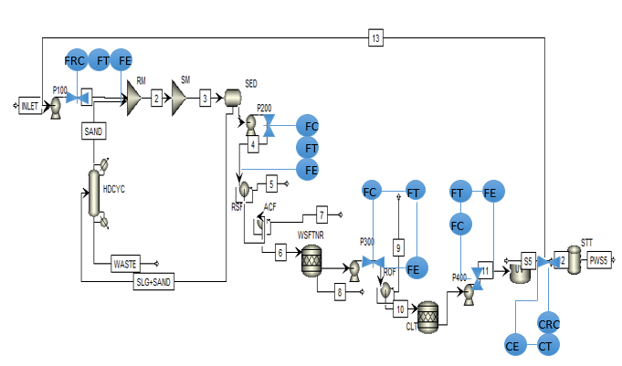

Figure 15: PFD with basic control loops added. This includes four flow rate control loops and one composition control loop.

## Facility Safety Design

## Natural Hazards

Natural disasters are not a very big concern in Michigan. The biggest issues to watch out for include tornadoes, blizzards, and rattlesnake bites. Earthquakes can also occur, but are not nearly as common. In order to deal with these natural disasters we will ensure that all our equipment can handle the situations that may that come with each of these issues.

The biggest issue that can naturally occur in Michigan is blizzards. Michigan gets an average of 82 inches of snow each year. This means that our roofs will need to be able to handle up to 7 feet of snow at a time. This is a common problem to deal with so it will be simple to handle. We will also need to hire a parking lot cleanup crew to ensure that all our employees can get into and out of the building safely so that there are no legal issues.

Tornadoes are not as common as blizzard-like conditions in Michigan, but are definitely something we will account for. In order to make our work environment safe and ensure our employees are taken care of we will have a basement in the main office building for everyone to come to if there is a tornado warning. The basement will be 4 small rooms since they are more structurally sound and will include tables to get under as this is also advised for safety. Though there will be enough room for all employees in the basement it will rarely need to actually service all 24 people that will be employed at the time. The basement can also work as a place for safety in case there is an earthquake. As stated earlier this is not a huge concern, but still something that should be addressed.

Rattlesnakes are also an issue in Michigan, but are easy to account for. We will just ensure that there are signs around the premises. Also we will ensure that every employee takes a safety class on how to handle getting bit. This will include information about not panicking if you are indeed bitten by a snake. Also about how one should react if they hear a rattling or see a snake. This is all important information for allowing our employees to work in a safe environment.

**Plant Layout Description**

Figure 16 shows Prestige Worldwide Water Solutions water treatment plant layout. This will need to adhere to safety considerations discussed in *Analysis, Synthesis and Design of Chemical Processes, 4th Edition*by *Turton.* The distance between buildings is only limited by space required for maintenance. Figure 16 shows the exact distance between buildings that meets the recommended minimum spacing requirements.

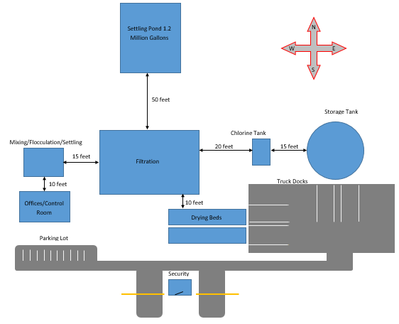

Figure 16: Plant layout for Prestige Worldwide Water Solutions

# Plant Emergency Procedure

# Evacuation Route

# Prestige Worldwide Water Solutions has two evacuation routes, a “green route” and a “red route”. The red route describes the primary evacuation route and should be used in most emergency situations. In the event the primary evacuation route cannot be used, the secondary evacuation route should be used. There will be a siren notifying to evacuate immediately along with a communication system identifying which emergency evacuation route to take. A mock emergency evacuation will take place semi-annually. The employees will not be aware of the mock evacuation plan to simulate an actual event. There will be a head count at the evacuation points during the event.

# 

Figure 17: PWWS Evacuation plan

# Fire Safety Information

# The figure above shows emergency exits, fire extinguishers, and fire pull stations. At each fire extinguisher location, a fire pull station will be available. Every building has emergency exits. Each employee will be trained to where the exits are located. They must also know how to handle a fire extinguisher and when action is required. In each building, there will be emergency phone numbers including fire department, paramedics, ambulance, police, security and plant manager.

# Blizzard Plan

# Employees will be instructed to stay calm and await instructions from the Emergency Coordinator or the designated official. They will also be instructed to say indoors. If heat is lost, ensure unneeded rooms or areas are closed off and cracks, doors, and windows are covered. There will be enough food and drinks for three days. Emergency blankets will also be provided.

# Natural Disaster Plan

# In the event a natural disaster occurs, a plan is ready to be executed. The natural disasters include earthquakes, tornadoes, and any other event where employees need shelter. There is a basement under the office building. Employees will be notified by siren to immediately stop working and proceed to basement. The basement can hold up to twenty-four employees. The basement will have four small rooms for structural support. For more detail, refer to natural hazards section.

## Effluent summary

The wastes that will be leaving the system initially include large solid waste such as leaves, rocks, animal feces and dead animals including fish and small birds. These will all be filtered from the water in the water reservoir system. This is a simple large reservoir that allows all large solids to float to the top of the water before it is treated. The water will sit in the reservoir for at least 24 hours, which is more than enough time for any large solids to accumulate at the top to be removed. These solids can also be filtered through the reverse osmosis filter if they get that far to assure that no large solids wastes will be able to get through.

Other wastes in our system will be the sludge that is produced from the micro-sand in the pretreatment portion of our treatment. This micro-sand will bind to any small solids floating around in our system that does not accumulate on the top of the water in the water reservoir. The Slow Mix portion of the pretreatment system will be important, as this is when the micro-sand will start binding and slowly sinking to the bottom of the system. When the sludge gets to the sedimentation basin portion of the pretreatment system it will then start landing on the floor of the basin. This is when the downward slope of the basin will allow for the micro-sand small solid mixture to be washed out of the system. Then this mixture will be heated and separated in order to try to reuse as much micro-sand as possible. This is both environmentally responsible and makes our plant more fiscally viable. Though the micro-sand still needs to be replaced every two weeks recycling to get the most use of the micro-sand is still the best idea.

The sludge that will be gathered from the pretreatment system will then be placed on a drying bed In order to get all the water that has been gathered with it. This sludge mixture is simply small solids that includes small dirt particles, insect eggs and any other small solids that could have got through the initial treatment. The sludge is then dried outside away from the water so that none is able to be carried back into the system. Anyone that is interacting with the sludge will be required to wear a special suit that doesn’t allow fumes to get into the lungs of either the employees or the city workers. After this sludge is gathered and dried then someone the city of Flint will be sent to gather to waste and take it to the dump. This is factored into maintenance costs of the plant.

During the filtration portion of the system there are two actual filters that will need to be cleaned and maintained. The first is the activated carbon system that is roughly halfway through the filtration system. Running clean water through the activated carbon filter for roughly 30 minutes cleans activated carbon filters. This can be done when the plant has a shift change, which will allow us to have only have one activated carbon filter in the system. The reverse osmosis filter needs only special fluid for cleaning. This means that all that needs to be done for cleaning of the reverse osmosis filter is the system needs to be shut down. This can be done roughly every two weeks when the plant is shut down during a shift change as well. This means that both can be cleaned at the same time and this can be scheduled to happen bi-weekly.

Then last part of the system that will have some sort of effluent waste will be the storage tank. This will be reasonably protected from the environment and will have clean water stored in it. Just to absolutely certain that the last place we hold the water is not contaminating all of the hard work we have done this will be cleaned monthly. This will be done right after it has been drained for the bottling company. This will simply ensure that that we are giving our business partners the best possible product.

## Safety Considerations

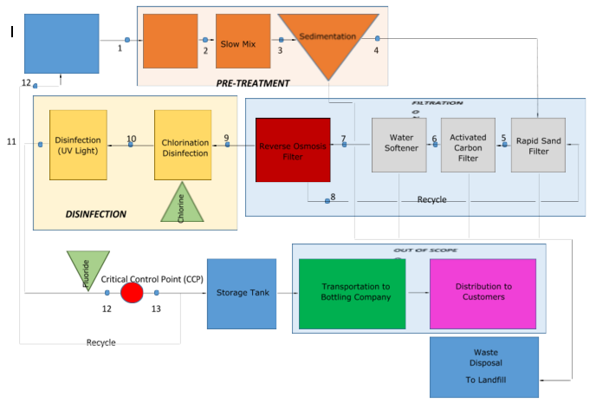

Figure 18 shows all the nodes associated with the water treatment process

Table 13 Problem scenario for node 4



Table 14 Problem description for node 9



Table 15: All the safety hazards associated with the water treatment facility

|  |  |  |
| --- | --- | --- |
| **Hazard Type** | **Hazard** | **Procedure to Control Hazards** |
| **Physical Hazards** | Exposure to UV Radiation can cause damage to eyes and skin | Always wear glasses and Lab coat when engaging with the UV disinfection system |
| Exposure to high levels of noise from pumps and other equipment | Hearing protection provided if needed |
| Fine Microsand can be breathed in and irritate lungs | Always wear provided masks when handling the Microsand |
| **Accident Hazards** | Falling into tanks when preforming routine testing | Safety railing will be installed at each tanking testing site |
| Falling from elevated platforms | Safety railing will be installed on all elevated platforms |
| Slipping on floor causes by water spills | All water must be cleaned up immediately by employees |
| Loose clothing or body parts getting caught in equipment | All clothes must be properly secured and long hair must be tied back |
| Electric shock from wires and equipment | When working on electrical equipment makes sure area is free of water and proper PPE is used |
| Explosion do to dust build up from Microsand and other particulates | Deep clean plant once per month |
| High pressure associated Reverse Osmosis filter | Pressure relief valves and controls around the RO filter are installed. |
| Fire from improper storage of chemical and chemical interaction | Label and properly store all chemicals |
| **Chemical Hazards** | Sodium Hypochlorite is toxic and poisonous when turned into a gas | Always wear proper PPE when handling Sodium Hypochlorite. Store at room temperature in a dry environment and away from incompatible chemicals |
| Phosphoric Acid can affect breathing and is corrosive | Always wear proper PPE when handling Phosphoric Acid. Store at room temperature and away from incompatible chemicals |
| Fluorosilicic Acid can affect breathing and is corrosive | Always wear proper PPE when handling Fluorosilicic Acid. Store at room temperature and away from incompatible chemicals |

Table 3 above shows all physical, chemical, and accident hazards associated with the water treatment facility. One of the main hazards associated with the plant are the elevated platform located over the equipment and tanks. The major hazards will be slipping off the elevated platform onto the floor below or into the equipment or tanks. To combat this hazard railing will be installed on all the elevated railings. The railing will be no less than 42 inches which is in concordance with U.S department of labor regulations. Another major hazard will be slipping on water. This can happen anywhere on the plant floor along with the elevated platforms. The first way this will be countered is with employee training and employee expectations. All employees will be instructed to either clean up spills immediately, if they are able, to or alert the operators immediately. A preventative measure that will be taken is the all employees must wear slip resistant shoes or boots anytime they are on the plant floor or on the elevated platforms.

There will be many different chemicals used in the plant to treat the water so safety considerations and protocols must be considered. The three main chemicals that will be used are Sodium Hypochlorite, Phosphoric Acid, and Fluorosilicic Acid. All three of these chemicals are corrosive and eye contact and skin contact should be avoided. This means that all of our employees must wear personal protective equipment when handling the chemicals. These includes pants, lab coat, and goggles or face shield. Storage of Sodium Hypochlorite, Phosphoric Acid, and Fluorosilicic Acid is also critical to plant safety. Sodium Hypochlorite reacts violently with strong acids and Phosphoric Acid reacts violently with strong bases. These means that these chemicals will be stored away from each other at all times and properly labeled. Another major safety risk with these chemicals is that around 105 °F all of them will begin to give off fumes. This is especially true with Sodium Hypochlorite because it will decompose into chlorine gas. To ensure the safety of the plant and the workers all the chemicals will be stored in specified areas that are temperature controlled. Also for a final safety measure all chemical storage areas will be equipped with gas monitors that will alert workers if any hazardous gases are somehow formed.

## Environmental Regulations

The Department of Environmental Quality (DEQ) is a specific branch in Michigan that has a guide for all environmental, health, and safety regulations. They have created the "Michigan Guide to Environmental, Health, and Safety Regulations” in coordination with the Department of Licensing and regulatory Affairs (LARA). Prestige Worldwide Water Solutions followed this guide in ensuring that all state and federal regulations are met in their entirety. Along with DEQ, the Occupational Health and Safety Administration has regulations required for both worker and environmental safety in the industrial field.

Below is a list of the most important regulations that are considered to apply directly to this water purification facility.

* Public Act of 1994, Part 115 of Act 451 – Solid Waste Regulations
* 40 Code of Federal Regulations Parts 50-59 - Federal Air Quality Regulations
* EPA Clean Air Act Amendments (CAAA) of 1990 – New Mandates
* Safe Drinking Water Act (SDWA) – Water regulations and guidance
* Clean Water Act (CWA) of 1972 - Monitor and ensure compliance
* National Primary Drinking Water Regulations (NPDWR)
* 1910 Subpart G - Occupational Health and Environmental Control (OSHA)
* 1910 Subpart I – Personal Protective Equipment (OSHA)
* 1910 Subpart J – General Environmental Controls (OSHA)

#### **Waste Management**

The water purification process does not have liquid waste run off, but it does produce solid waste that needs to be properly removed. The solid waste comes from multiple sources, including sand filters, empty chemical containers, and sedimentation tank. Our largest waste production will come from the sedimentation tank, which then requires the waste be left to dry in drying beds. These drying beds will be shielded from wind in order to prevent spread of any waste material, but allow solar drying. Our solid waste will then be stored in closed containers so that it will meet the standards of Public Act of 1994 for solid waste disposal.

#### **Air Quality Regulations**

The process designed has no gas emissions, creating a relatively safe work environment as far as air quality is concerned. The one section of concern is the creation of dust. With the use of large volumes of sand in filters and regular dust accumulation from day to day activities. This is controlled via maintaining daily air quality logs that will report the air quality within the plant. There will also be a weekly cleaning process that will remove any potentially combustible dust from surfaces within the plant. This will ensure that the plant meets air quality regulations for workers, as well as safety regulations for the plant’s workspace. This will meet requirements laid out by the Code of Federal Regulations.

Another thing that should be known is that according to the Clean Air Act (CAA), chemicals need to be inventoried if it is a potential pollutant and reported. The only chemical we are using that is listed in the EPA Consolidated List of Chemicals is chlorine. In order to be under the limit, we will have less than 2,500 pounds of chlorine present on site at a single point in time. 2,500 pounds is the listed threshold quantity for chlorine, according to the EPA Consolidated List of Chemicals.

#### **Water Quality Regulations**

Under the Safe Drinking Water Act, which is the main federal law that ensures Americans’ drinking water, is what our plant will follow to insure that contaminant regulations for drinking water are met. These regulations are required for a “public water system.” We will qualify as a public water system after serving the town of Flint, Michigan for over one year. These regulations will also be worked alongside of the regulations stated in the National Primary Drinking Water Regulations. These regulations clearly lay out what levels of organic and inorganic contaminants are acceptable in drinking water. Examples are 0 mg/L of Arsenic, 0 mg/L of Lead, and 4 mg/L of Fluoride.

The Clean Water Act is also in effect for our plant due to the use of surface water. Clean water act lays out some regulations for the plant that discuss use of surface water as well as storm water. Due to the fact that the water reservoir we pull from being on the surface, it will collect storm water. This is accounted for and the regulation is followed to ensure quality and safety of both the water and the environment.

**Occupational Safety**

The Occupational Health and Safety Administration (OSHA) has a long list of standards for the industrial workplace that this water purification plant will follow. One of these is, 1990 Subpart G discuses workplace hazards such as noise, dust levels, and ventilation. Another valuable standard is 1990 Subpart I which places rules on personal protective equipment that must be used for certain situations. For example, the employer must provide eye and face protection when workers are exposed to hazards such as liquid chemicals, acids, and light radiation.

##### **Environmental/Community Awareness**

## Community Awareness

Our company believes that our water treatment facility is an asset to the surrounding community, but does believe that the surrounding community’s concerns need to be addressed. The following areas we believe will make the community aware of our day to day plant operations and the inherent risks associated with it.

### **Chemical Usage**

The main chemicals that will be used on the site grounds are Sodium Hypochlorite, Phosphoric Acid, and Fluorosilicic Acid. These chemical pose little to no threat of combusting and are only potentially dangerous if they are vaporized in large quantities. We store all the chemicals in designated dry temperature controlled areas to avoid this. The amount of chemicals that are stored on site will also be limited in order to ensure that the plant and the surrounding community is safe. Our plant layout also ensures that our facility is an adequate distance away from the surrounding community.

### **Noise Pollution**

The most amount of noise that produced in the plant will be form the pumps located inside the factory. However we believe that building will contain almost all the noise and it will not be a hindrance to any surrounding neighborhoods. The second form noise could from the truck that are used to deliver chemicals, pick up waste, and pick up the clean water for bottling. The noise from the trucks should be minimal during most of the day. Truck drop offs and deliveries will also be scheduled at times will it will be least distributing to the surrounding community.

### **Environmental**

Our plant will have little effect on the environment that the surrounding community should be concerned about. The one potential area is the 1.2 million gallon settling pond located on the facility grounds. During the summer this can attract insects and in Flint the major insect of concern would be mosquitos. If the amount of mosquitos becomes a problem we will spray on company grounds to reduce the amount that reaches the outlying communities.

**Conclusions and Recommendations**

**References**

1. "Activated Carbon Filters." *Activated Carbon Filters*. Water Professionals, n.d. Web. 23 Mar. . 2016. Web.
2. "Alibaba Manufacturer Directory Suppliers, Manufacturers, Exporters & Importers ."*Alib. aba Manufacturer Directory -Suppliers, Manufacturers, Exporters & Importers*. . TradeManager, n.d. Web. 21 Apr. 2016.
3. "Average Annual Snowfall in Michigan." *Average Annual Snowfall Totals in Michigan*. N.p., . n.d. Web. 28 Apr. 2016.
4. *Chief Water Treatment Plant Operator*. Plainview, NY: National Learning, Civil Service . Division, 1979. *International Hazard Datasheets on Occupation*. International Labour . Organization, 20 Apr. 2009. Web.
5. "Clean Water Act (CWA) Compliance Monitoring." *EPA*. Environmental Protection . Agency, n.d. Web. 28 Apr. 2016.
6. "Clorine Contact Tanks - Highland Tank." *Clorine Contact Tanks - Highland Tank*. Highland Tanks, n.d. Web. 23 Mar. 2016. Web.
7. "Dangers, Hazards and Natural Disasters in Michigan." *About.com Travel*. N.p., n.d. . Web. . 28 Apr. 2016.
8. Davis, Mackenzie Leo, and David A. Cornwell. *Introduction to Environmental . Engineering*. . New York: McGraw-Hill, 1991. Print.
9. "Effect of Chlorination on Inactivating Selected Pathogen." *Centers for Disease Control and . Prevention*. Centers for Disease Control and Prevention, 21 Mar. 2012. Web. 23 Mar. . 2016. Web.
10. "Flint Water Study Updates." *Flint Water Study Updates*. WordPress, n.d. Web. 23 Mar. 2016. . Web.
11. *Fluorosilicic Acid*. Denver, CO: American Water Works Association, 2006.*Material Safety Data . Sheet*. ClearTech. Web.
12. "Michigan Tornadoes." *Michigan Tornadoes*. N.p., n.d. Web. 28 Apr. 2016.
13. "OSH Answers Fact Sheets." *Government of Canada, Canadian Centre for Occupational Health and Safety*. N.p., n.d. Web. 28 Apr. 2016.
14. "Rapid Mixing, Coagulation - Flocculation." *Rapid Mixing, Coagulation - Flocculation*. . N.p., n.d. Web. 21 Apr. 2016.
15. "Safety During Tornadoes." *Safety During Tornadoes*. N.p., n.d. Web. 28 Apr. 2016.
16. Shannon, Mark A., Paul W. Bohn, Menachem Elimelech, John G. Georgiadis, Benito J. . Mariñas, and Anne M. Mayes. "Science and Technology for Water Purification in the . Coming Decades." *Nature*452.7185 (2008): 301-10. Web.
17. Spangler, Todd. "U.S. Senate Plan Could Send $100 Million, Loans to Flint." *Detroit .Free Press*. USA Today Network, 24 Feb. 2016. Web.
18. "Table of Regulated Drinking Water Contaminants." *EPA*. Environmental Protection . Agency, n.d. Web.
19. Turton, Richard. *Analysis, Synthesis, and Design of Chemical Processes*. Upper Saddle River, NJ: Prentice Hall PTR, 1998. Print.
20. Tuthill, Arthur H., and Stephen Lamp. *Stainless Steel in Municipal Waste Water Treatment . Plants*. NiDI, 1998.
21. "UNITED STATES DEPARTMENT OF LABOR." *OSHA Law & Regulations*. N.p., n.d. . Web.
22. Us Epa, Oswer, Office Of Emergency Management. "List of Lists." (n.d.): n. . pag. *Environmental Protection Agency*. Office of Solid Wastes, Mar. 2015. Web.
23. "You Are HereDEQ." *DEQ*. N.p., n.d. Web.
24. "2015 Hot Sale Calcium Hypochlorite 70% Sodium Process." *Alibaba*. TradeManager, . n.d. Web.
25. "40% Fluorosilicic Acid (fluosilicic Acid)." *Alibaba*. TradeManager, n.d. Web.
26. (545138). *MATERIAL SAFETY DATA SHEET* (n.d.): n. pag. *Sodium Hypochlorite*. Allied . Universal Corporation, 7 Sept. 2007. Web.

**Appendices**

**National Primary Drinking Water Standards**

| **Microorganisms** | | | | |
| --- | --- | --- | --- | --- |
| **Contaminant** | **MCLG**[**1**](https://www.epa.gov/ground-water-and-drinking-water/table-regulated-drinking-water-contaminants#one)**(mg/L)**[**2**](https://www.epa.gov/ground-water-and-drinking-water/table-regulated-drinking-water-contaminants#two) | **MCL or TT**[**1**](https://www.epa.gov/ground-water-and-drinking-water/table-regulated-drinking-water-contaminants#one)**(mg/L)**[**2**](https://www.epa.gov/ground-water-and-drinking-water/table-regulated-drinking-water-contaminants#two) | **Potential Health Effects from Long-Term Exposure Above the MCL (unless specified as short-term)** | **Sources of Contaminant in Drinking Water** |
| [*Cryptosporidium*](https://safewater.zendesk.com/hc/en-us/sections/202346417) | zero | TT[3](https://www.epa.gov/ground-water-and-drinking-water/table-regulated-drinking-water-contaminants#three) | Gastrointestinal illness (such as diarrhea, vomiting, and cramps) | Human and animal fecal waste |
| [*Giardia lamblia*](https://safewater.zendesk.com/hc/en-us/sections/202346327) | zero | TT[3](https://www.epa.gov/ground-water-and-drinking-water/table-regulated-drinking-water-contaminants#three) | Gastrointestinal illness (such as diarrhea, vomiting, and cramps) | Human and animal fecal waste |
| [Heterotrophic plate count (HPC)](https://safewater.zendesk.com/hc/en-us/sections/202366348) | n/a | TT[3](https://www.epa.gov/ground-water-and-drinking-water/table-regulated-drinking-water-contaminants#three) | HPC has no health effects; it is an analytic method used to measure the variety of bacteria that are common in water. The lower the concentration of bacteria in drinking water, the better maintained the water system is. | HPC measures a range of bacteria that are naturally present in the environment |
| [*Legionella*](https://safewater.zendesk.com/hc/en-us/sections/202366318) | zero | TT[3](https://www.epa.gov/ground-water-and-drinking-water/table-regulated-drinking-water-contaminants#three) | Legionnaire's Disease, a type of pneumonia | Found naturally in water; multiplies in heating systems |
| [Total Coliforms (including fecal coliform and *E. Coli*)](https://safewater.zendesk.com/hc/en-us/sections/202366208) | zero | 5.0%[4](https://www.epa.gov/ground-water-and-drinking-water/table-regulated-drinking-water-contaminants#four) | Not a health threat in itself; it is used to indicate whether other potentially harmful bacteria may be present[5](https://www.epa.gov/ground-water-and-drinking-water/table-regulated-drinking-water-contaminants#five) | Coliforms are naturally present in the environment; as well as feces; fecal coliforms and *E. coli* only come from human and animal fecal waste. |
| [Turbidity](https://safewater.zendesk.com/hc/en-us/sections/202346167) | n/a | TT[3](https://www.epa.gov/ground-water-and-drinking-water/table-regulated-drinking-water-contaminants#three) | Turbidity is a measure of the cloudiness of water. It is used to indicate water quality and filtration effectiveness (such as whether disease-causing organisms are present). Higher turbidity levels are often associated with higher levels of disease-causing microorganisms such as viruses, parasites and some bacteria. These organisms can cause symptoms such as nausea, cramps, diarrhea, and associated headaches. | Soil runoff |
| [Viruses (enteric)](https://safewater.zendesk.com/hc/en-us/sections/202346137) | zero | TT[3](https://www.epa.gov/ground-water-and-drinking-water/table-regulated-drinking-water-contaminants#three) | Gastrointestinal illness (such as diarrhea, vomiting, and cramps) | Human and animal fecal waste |

| **Disinfection Byproducts** | | | | |
| --- | --- | --- | --- | --- |
| **Contaminant** | **MCLG**[**1**](https://www.epa.gov/ground-water-and-drinking-water/table-regulated-drinking-water-contaminants#one)**(mg/L)**[**2**](https://www.epa.gov/ground-water-and-drinking-water/table-regulated-drinking-water-contaminants#two) | **MCL or TT**[**1**](https://www.epa.gov/ground-water-and-drinking-water/table-regulated-drinking-water-contaminants#one)**(mg/L)**[**2**](https://www.epa.gov/ground-water-and-drinking-water/table-regulated-drinking-water-contaminants#two) | **Potential Health Effects from Long-Term Exposure Above the MCL (unless specified as short-term)** | **Sources of Contaminant in Drinking Water** |
| [Bromate](https://safewater.zendesk.com/hc/en-us/sections/202366518) | zero | 0.010 | Increased risk of cancer | Byproduct of drinking water disinfection |
| [Chlorite](https://safewater.zendesk.com/hc/en-us/sections/202346437) | 0.8 | 1.0 | Anemia; infants and young children: nervous system effects | Byproduct of drinking water disinfection |
| [Haloacetic acids (HAA5)](https://safewater.zendesk.com/hc/en-us/sections/202346317) | n/a[6](https://www.epa.gov/ground-water-and-drinking-water/table-regulated-drinking-water-contaminants#six) | 0.060 | Increased risk of cancer | Byproduct of drinking water disinfection |
| [Total Trihalomethanes (TTHMs)](https://safewater.zendesk.com/hc/en-us/sections/202346187) | --> n/a[6](https://www.epa.gov/ground-water-and-drinking-water/table-regulated-drinking-water-contaminants#six) | ========-->--> 0.080 | Liver, kidney or central nervous system problems; increased risk of cancer | Byproduct of drinking water disinfection |

| **Disinfectants** | | | | |
| --- | --- | --- | --- | --- |
| **Contaminant** | **MCLG**[**1**](https://www.epa.gov/ground-water-and-drinking-water/table-regulated-drinking-water-contaminants#one)**(mg/L)**[**2**](https://www.epa.gov/ground-water-and-drinking-water/table-regulated-drinking-water-contaminants#two) | **MCL or TT**[**1**](https://www.epa.gov/ground-water-and-drinking-water/table-regulated-drinking-water-contaminants#one)**(mg/L)**[**2**](https://www.epa.gov/ground-water-and-drinking-water/table-regulated-drinking-water-contaminants#two) | **Potential Health Effects from Long-Term Exposure Above the MCL (unless specified as short-term)** | **Sources of Contaminant in Drinking Water** |
| [Chloramines (as Cl2)](https://safewater.zendesk.com/hc/en-us/sections/202346467) | MRDLG=4[1](https://www.epa.gov/ground-water-and-drinking-water/table-regulated-drinking-water-contaminants#one) | MRDL=4.0[1](https://www.epa.gov/ground-water-and-drinking-water/table-regulated-drinking-water-contaminants#one) | Eye/nose irritation; stomach discomfort, anemia | Water additive used to control microbes |
| [Chlorine (as Cl2)](https://safewater.zendesk.com/hc/en-us/sections/202366478) | MRDLG=4[1](https://www.epa.gov/ground-water-and-drinking-water/table-regulated-drinking-water-contaminants#one) | MRDL=4.0[1](https://www.epa.gov/ground-water-and-drinking-water/table-regulated-drinking-water-contaminants#one) | Eye/nose irritation; stomach discomfort | Water additive used to control microbes |
| [Chlorine dioxide (as ClO2)](https://safewater.zendesk.com/hc/en-us/sections/202346447) | MRDLG=0.8[1](https://www.epa.gov/ground-water-and-drinking-water/table-regulated-drinking-water-contaminants#one) | MRDL=0.8[1](https://www.epa.gov/ground-water-and-drinking-water/table-regulated-drinking-water-contaminants#one) | Anemia; infants and young children: nervous system effects | Water additive used to control microbes |

| **Inorganic Chemicals** | | | | |
| --- | --- | --- | --- | --- |
| **Contaminant** | **MCLG**[**1**](https://www.epa.gov/ground-water-and-drinking-water/table-regulated-drinking-water-contaminants#one)**(mg/L)**[**2**](https://www.epa.gov/ground-water-and-drinking-water/table-regulated-drinking-water-contaminants#two) | **MCL or TT**[**1**](https://www.epa.gov/ground-water-and-drinking-water/table-regulated-drinking-water-contaminants#one)**(mg/L)**[**2**](https://www.epa.gov/ground-water-and-drinking-water/table-regulated-drinking-water-contaminants#two) | **Potential Health Effects from Long-Term Exposure Above the MCL (unless specified as short-term)** | **Sources of Contaminant in Drinking Water** |
| [Antimony](https://safewater.zendesk.com/hc/en-us/sections/202366568) | 0.006 | 0.006 | Increase in blood cholesterol; decrease in blood sugar | Discharge from petroleum refineries; fire retardants; ceramics; electronics; solder |
| [Arsenic](https://safewater.zendesk.com/hc/en-us/sections/202366558) | 0 | 0.010 as of 01/23/06 | Skin damage or problems with circulatory systems, and may have increased risk of getting cancer | Erosion of natural deposits; runoff from orchards, runoff from glass and electronicsproduction wastes |
| [Asbestos (fiber > 10 micrometers)](https://safewater.zendesk.com/hc/en-us/sections/202366548) | 7 million fibers per liter (MFL) | 7 MFL | Increased risk of developing benign intestinal polyps | Decay of asbestos cement in water mains; erosion of natural deposits |
| [Barium](https://safewater.zendesk.com/hc/en-us/sections/202346507) | 2 | 2 | Increase in blood pressure | Discharge of drilling wastes; discharge from metal refineries; erosion of natural deposits |
| [Beryllium](https://safewater.zendesk.com/hc/en-us/sections/202366528) | 0.004 | 0.004 | Intestinal lesions | Discharge from metal refineries and coal-burning factories; discharge from electrical, aerospace, and defense industries |
| [Cadmium](https://safewater.zendesk.com/hc/en-us/sections/202366508) | 0.005 | 0.005 | Kidney damage | Corrosion of galvanized pipes; erosion of natural deposits; discharge from metal refineries; runoff from waste batteries and paints |
| [Chromium (total)](https://safewater.zendesk.com/hc/en-us/sections/202366458) | 0.1 | 0.1 | Allergic dermatitis | Discharge from steel and pulp mills; erosion of natural deposits |
| [Copper](https://safewater.zendesk.com/hc/en-us/sections/202346427) | 1.3 | TT[7](https://www.epa.gov/ground-water-and-drinking-water/table-regulated-drinking-water-contaminants#seven); Action Level=1.3 | Short term exposure: Gastrointestinal distress  Long term exposure: Liver or kidney damage  People with Wilson's Disease should consult their personal doctor if the amount of copper in their water exceeds the action level | Corrosion of household plumbing systems; erosion of natural deposits |
| [Cyanide (as free cyanide)](https://safewater.zendesk.com/hc/en-us/sections/202366438) | 0.2 | 0.2 | Nerve damage or thyroid problems | Discharge from steel/metal factories; discharge from plastic and fertilizer factories |
| [Fluoride](https://safewater.zendesk.com/hc/en-us/sections/202346337) | 4.0 | 4.0 | Bone disease (pain and tenderness of the bones); Children may get mottled teeth | Water additive which promotes strong teeth; erosion of natural deposits; discharge from fertilizer and aluminum factories |
| [Lead](https://www.epa.gov/ground-water-and-drinking-water/basic-information-about-lead-drinking-water) | zero | TT[7](https://www.epa.gov/ground-water-and-drinking-water/table-regulated-drinking-water-contaminants#seven); Action Level=0.015 | Infants and children: Delays in physical or mental development; children could show slight deficits in attention span and learning abilities  Adults: Kidney problems; high blood pressure | Corrosion of household plumbing systems; erosion of natural deposits |
| [Mercury (inorganic)](https://safewater.zendesk.com/hc/en-us/sections/202366308) | 0.002 | 0.002 | Kidney damage | Erosion of natural deposits; discharge from refineries and factories; runoff from landfills and croplands |
| [Nitrate (measured as Nitrogen)](https://safewater.zendesk.com/hc/en-us/sections/202346267) | 10 | 10 | Infants below the age of six months who drink water containing nitrate in excess of the MCL could become seriously ill and, if untreated, may die. Symptoms include shortness of breath and blue-baby syndrome. | Runoff from fertilizer use; leaking from septic tanks, sewage; erosion of natural deposits |
| [Nitrite (measured as Nitrogen)](https://safewater.zendesk.com/hc/en-us/sections/202346257) | 1 | 1 | Infants below the age of six months who drink water containing nitrite in excess of the MCL could become seriously ill and, if untreated, may die. Symptoms include shortness of breath and blue-baby syndrome. | Runoff from fertilizer use; leaking from septic tanks, sewage; erosion of natural deposits |
| [Selenium](https://safewater.zendesk.com/hc/en-us/sections/202346227) | 0.05 | 0.05 | Hair or fingernail loss; numbness in fingers or toes; circulatory problems | Discharge from petroleum refineries; erosion of natural deposits; discharge from mines |
| [Thallium](https://safewater.zendesk.com/hc/en-us/sections/202346197) | 0.0005 | 0.002 | Hair loss; changes in blood; kidney, intestine, or liver problems | Leaching from ore-processing sites; discharge from electronics, glass, and drug factories |

| **Organic Chemicals** | | | | |
| --- | --- | --- | --- | --- |
| **Contaminant** | **MCLG**[**1**](https://www.epa.gov/ground-water-and-drinking-water/table-regulated-drinking-water-contaminants#one)**(mg/L)**[**2**](https://www.epa.gov/ground-water-and-drinking-water/table-regulated-drinking-water-contaminants#two) | **MCL or TT**[**1**](https://www.epa.gov/ground-water-and-drinking-water/table-regulated-drinking-water-contaminants#one)**(mg/L)**[**2**](https://www.epa.gov/ground-water-and-drinking-water/table-regulated-drinking-water-contaminants#two) | **Potential Health Effects from Long-Term Exposure Above the MCL (unless specified as short-term)** | **Sources of Contaminant in Drinking Water** |
| [Acrylamide](https://safewater.zendesk.com/hc/en-us/sections/202346527) | zero | TT[8](https://www.epa.gov/ground-water-and-drinking-water/table-regulated-drinking-water-contaminants#eight) | Nervous system or blood problems; increased risk of cancer | Added to water during sewage/wastewater treatment |
| [Alachlor](https://safewater.zendesk.com/hc/en-us/sections/202346517) | zero | 0.002 | Eye, liver, kidney or spleen problems; anemia; increased risk of cancer | Runoff from herbicide used on row crops |
| [Atrazine](https://safewater.zendesk.com/hc/en-us/sections/202366538) | 0.003 | 0.003 | Cardiovascular system or reproductive problems | Runoff from herbicide used on row crops |
| [Benzene](https://safewater.zendesk.com/hc/en-us/sections/202346497) | zero | 0.005 | Anemia; decrease in blood platelets; increased risk of cancer | Discharge from factories; leaching from gas storage tanks and landfills |
| [Benzo(a)pyrene (PAHs)](https://safewater.zendesk.com/hc/en-us/sections/202346487) | zero | 0.0002 | Reproductive difficulties; increased risk of cancer | Leaching from linings of water storage tanks and distribution lines |
| [Carbofuran](https://safewater.zendesk.com/hc/en-us/sections/202366498) | 0.04 | 0.04 | Problems with blood, nervous system, or reproductive system | Leaching of soil fumigant used on rice and alfalfa |
| [Carbon tetrachloride](https://safewater.zendesk.com/hc/en-us/sections/202366488) | zero | 0.005 | Liver problems; increased risk of cancer | Discharge from chemical plants and other industrial activities |
| [Chlordane](https://safewater.zendesk.com/hc/en-us/sections/202346457) | zero | 0.002 | Liver or nervous system problems; increased risk of cancer | Residue of banned termiticide |
| [Chlorobenzene](https://safewater.zendesk.com/hc/en-us/sections/202366468) | 0.1 | 0.1 | Liver or kidney problems | Discharge from chemical and agricultural chemical factories |
| [2,4-D](https://safewater.zendesk.com/hc/en-us/sections/202366588) | 0.07 | 0.07 | Kidney, liver, or adrenal gland problems | Runoff from herbicide used on row crops |
| [Dalapon](https://safewater.zendesk.com/hc/en-us/sections/202366418) | 0.2 | 0.2 | Minor kidney changes | Runoff from herbicide used on rights of way |
| [1,2-Dibromo-3-chloropropane (DBCP)](https://safewater.zendesk.com/hc/en-us/sections/202346547) | zero | 0.0002 | Reproductive difficulties; increased risk of cancer | Runoff/leaching from soil fumigant used on soybeans, cotton, pineapples, and orchards |
| [o-Dichlorobenzene](https://safewater.zendesk.com/hc/en-us/sections/202366288) | 0.6 | 0.6 | Liver, kidney, or circulatory system problems | Discharge from industrial chemical factories |
| [p-Dichlorobenzene](https://safewater.zendesk.com/hc/en-us/sections/202366268) | 0.075 | 0.075 | Anemia; liver, kidney or spleen damage; changes in blood | Discharge from industrial chemical factories |
| [1,2-Dichloroethane](https://safewater.zendesk.com/hc/en-us/sections/202366608) | zero | 0.005 | Increased risk of cancer | Discharge from industrial chemical factories |
| [1,1-Dichloroethylene](https://safewater.zendesk.com/hc/en-us/sections/202346557) | 0.007 | 0.007 | Liver problems | Discharge from industrial chemical factories |
| [cis-1,2-Dichloroethylene](https://safewater.zendesk.com/hc/en-us/sections/202366448) | 0.07 | 0.07 | Liver problems | Discharge from industrial chemical factories |
| [trans-1,2-Dichloroethylene](https://safewater.zendesk.com/hc/en-us/sections/202366188) | 0.1 | 0.1 | Liver problems | Discharge from industrial chemical factories |
| [Dichloromethane](https://safewater.zendesk.com/hc/en-us/sections/202366408) | zero | 0.005 | Liver problems; increased risk of cancer | Discharge from drug and chemical factories |
| [1,2-Dichloropropane](https://safewater.zendesk.com/hc/en-us/sections/202366598) | zero | 0.005 | Increased risk of cancer | Discharge from industrial chemical factories |
| [Di(2-ethylhexyl) adipate](https://safewater.zendesk.com/hc/en-us/sections/202346407) | 0.4 | 0.4 | Weight loss, liver problems, or possible reproductive difficulties. | Discharge from chemical factories |
| [Di(2-ethylhexyl) phthalate](https://safewater.zendesk.com/hc/en-us/sections/202346397) | zero | 0.006 | Reproductive difficulties; liver problems; increased risk of cancer | Discharge from rubber and chemical factories |
| [Dinoseb](https://safewater.zendesk.com/hc/en-us/sections/202346387) | 0.007 | 0.007 | Reproductive difficulties | Runoff from herbicide used on soybeans and vegetables |
| [Dioxin (2,3,7,8-TCDD)](https://safewater.zendesk.com/hc/en-us/sections/202346377) | zero | 0.00000003 | Reproductive difficulties; increased risk of cancer | Emissions from waste incineration and other combustion; discharge from chemical factories |
| [Diquat](https://safewater.zendesk.com/hc/en-us/sections/202346367) | 0.02 | 0.02 | Cataracts | Runoff from herbicide use |
| [Endothall](https://safewater.zendesk.com/hc/en-us/sections/202366398) | 0.1 | 0.1 | Stomach and intestinal problems | Runoff from herbicide use |
| [Endrin](https://safewater.zendesk.com/hc/en-us/sections/202346357) | 0.002 | 0.002 | Liver problems | Residue of banned insecticide |
| [Epichlorohydrin](https://safewater.zendesk.com/hc/en-us/sections/202346347) | zero | TT[8](https://www.epa.gov/ground-water-and-drinking-water/table-regulated-drinking-water-contaminants#eight) | Increased cancer risk, and over a long period of time, stomach problems | Discharge from industrial chemical factories; an impurity of some water treatment chemicals |
| [Ethylbenzene](https://safewater.zendesk.com/hc/en-us/sections/202366388) | 0.7 | 0.7 | Liver or kidneys problems | Discharge from petroleum refineries |
| [Ethylene dibromide](https://safewater.zendesk.com/hc/en-us/sections/202366378) | zero | 0.00005 | Problems with liver, stomach, reproductive system, or kidneys; increased risk of cancer | Discharge from petroleum refineries |
| [Glyphosate](https://safewater.zendesk.com/hc/en-us/sections/202366358) | 0.7 | 0.7 | Kidney problems; reproductive difficulties | Runoff from herbicide use |
| [Heptachlor](https://safewater.zendesk.com/hc/en-us/sections/202346307) | zero | 0.0004 | Liver damage; increased risk of cancer | Residue of banned termiticide |
| [Heptachlor epoxide](https://safewater.zendesk.com/hc/en-us/sections/202346297) | zero | 0.0002 | Liver damage; increased risk of cancer | Breakdown of heptachlor |
| [Hexachlorobenzene](https://safewater.zendesk.com/hc/en-us/sections/202366338) | zero | 0.001 | Liver or kidney problems; reproductive difficulties; increased risk of cancer | Discharge from metal refineries and agricultural chemical factories |
| [Hexachlorocyclopentadiene](https://safewater.zendesk.com/hc/en-us/sections/202346287) | 0.05 | 0.05 | Kidney or stomach problems | Discharge from chemical factories |
| [Lindane](https://safewater.zendesk.com/hc/en-us/sections/202346277) | 0.0002 | 0.0002 | Liver or kidney problems | Runoff/leaching from insecticide used on cattle, lumber, gardens |
| [Methoxychlor](https://safewater.zendesk.com/hc/en-us/sections/202366298) | 0.04 | 0.04 | Reproductive difficulties | Runoff/leaching from insecticide used on fruits, vegetables, alfalfa, livestock |
| [Oxamyl (Vydate)](https://safewater.zendesk.com/hc/en-us/sections/202366278) | 0.2 | 0.2 | Slight nervous system effects | Runoff/leaching from insecticide used on apples, potatoes, and tomatoes |
| [Polychlorinated biphenyls (PCBs)](https://safewater.zendesk.com/hc/en-us/sections/202366248) | zero | 0.0005 | Skin changes; thymus gland problems; immune deficiencies; reproductive or nervous system difficulties; increased risk of cancer | Runoff from landfills; discharge of waste chemicals |
| [Pentachlorophenol](https://safewater.zendesk.com/hc/en-us/sections/202366258) | zero | 0.001 | Liver or kidney problems; increased cancer risk | Discharge from wood preserving factories |
| [Picloram](https://safewater.zendesk.com/hc/en-us/sections/202346237) | 0.5 | 0.5 | Liver problems | Herbicide runoff |
| [Simazine](https://safewater.zendesk.com/hc/en-us/sections/202346217) | 0.004 | 0.004 | Problems with blood | Herbicide runoff |
| [Styrene](https://safewater.zendesk.com/hc/en-us/sections/202366228) | 0.1 | 0.1 | Liver, kidney, or circulatory system problems | Discharge from rubber and plastic factories; leaching from landfills |
| [Tetrachloroethylene](https://safewater.zendesk.com/hc/en-us/sections/202346207) | zero | 0.005 | Liver problems; increased risk of cancer | Discharge from factories and dry cleaners |
| [Toluene](https://safewater.zendesk.com/hc/en-us/sections/202366218) | 1 | 1 | Nervous system, kidney, or liver problems | Discharge from petroleum factories |
| [Toxaphene](https://safewater.zendesk.com/hc/en-us/sections/202366198) | zero | 0.003 | Kidney, liver, or thyroid problems; increased risk of cancer | Runoff/leaching from insecticide used on cotton and cattle |
| [2,4,5-TP (Silvex)](https://safewater.zendesk.com/hc/en-us/sections/202346537) | 0.05 | 0.05 | Liver problems | Residue of banned herbicide |
| [1,2,4-Trichlorobenzene](https://safewater.zendesk.com/hc/en-us/sections/202366618) | 0.07 | 0.07 | Changes in adrenal glands | Discharge from textile finishing factories |
| [1,1,1-Trichloroethane](https://safewater.zendesk.com/hc/en-us/sections/202346567) | 0.20 | 0.2 | Liver, nervous system, or circulatory problems | Discharge from metal degreasing sites and other factories |
| [1,1,2-Trichloroethane](https://safewater.zendesk.com/hc/en-us/sections/202366628) | 0.003 | 0.005 | Liver, kidney, or immune system problems | Discharge from industrial chemical factories |
| [Trichloroethylene](https://safewater.zendesk.com/hc/en-us/sections/202346177) | zero | 0.005 | Liver problems; increased risk of cancer | Discharge from metal degreasing sites and other factories |
| [Vinyl chloride](https://safewater.zendesk.com/hc/en-us/sections/202346147) | zero | 0.002 | Increased risk of cancer | Leaching from PVC pipes; discharge from plastic factories |
| [Xylenes (total)](https://safewater.zendesk.com/hc/en-us/sections/202366178) | 10 | 10 | Nervous system damage | Discharge from petroleum factories; discharge from chemical factories |

| **Radionuclides** | | | | |
| --- | --- | --- | --- | --- |
| **Contaminant** | **MCLG**[**1**](https://www.epa.gov/ground-water-and-drinking-water/table-regulated-drinking-water-contaminants#one)**(mg/L)**[**2**](https://www.epa.gov/ground-water-and-drinking-water/table-regulated-drinking-water-contaminants#two) | **MCL or TT**[**1**](https://www.epa.gov/ground-water-and-drinking-water/table-regulated-drinking-water-contaminants#one)**(mg/L)**[**2**](https://www.epa.gov/ground-water-and-drinking-water/table-regulated-drinking-water-contaminants#two) | **Potential Health Effects from Long-Term Exposure Above the MCL (unless specified as short-term)** | **Sources of Contaminant in Drinking Water** |
| [Alpha particles](https://safewater.zendesk.com/hc/en-us/sections/202366578) | none[7](https://www.epa.gov/ground-water-and-drinking-water/table-regulated-drinking-water-contaminants#seven) ---------- zero | 15 picocuries per Liter (pCi/L) | Increased risk of cancer | Erosion of natural deposits of certain minerals that are radioactive and may emit a form of radiation known as alpha radiation |
| [Beta particles and photon emitters](https://safewater.zendesk.com/hc/en-us/sections/202346477) | none[7](https://www.epa.gov/ground-water-and-drinking-water/table-regulated-drinking-water-contaminants#seven) ---------- zero | 4 millirems per year | Increased risk of cancer | Decay of natural and man-made deposits of  certain minerals that are radioactive and may emit forms of radiation known as photons and beta radiation |
| [Radium 226 and Radium 228 (combined)](https://safewater.zendesk.com/hc/en-us/sections/202366238) | none[7](https://www.epa.gov/ground-water-and-drinking-water/table-regulated-drinking-water-contaminants#seven) ---------- zero | 5 pCi/L | Increased risk of cancer | Erosion of natural deposits |
| [Uranium](https://safewater.zendesk.com/hc/en-us/sections/202346157) | zero | 30 ug/L as of 12/08/03 | Increased risk of cancer, kidney toxicity | Erosion of natural deposits |

**Notes**

1Definitions:

* Maximum Contaminant Level Goal (MCLG) - The level of a contaminant in drinking water below which there is no known or expected risk to health. MCLGs allow for a margin of safety and are non-enforceable public health goals.
* Maximum Contaminant Level (MCL) - The highest level of a contaminant that is allowed in drinking water. MCLs are set as close to MCLGs as feasible using the best available treatment technology and taking cost into consideration. MCLs are enforceable standards.
* Maximum Residual Disinfectant Level Goal (MRDLG) - The level of a drinking water disinfectant below which there is no known or expected risk to health. MRDLGs do not reflect the benefits of the use of disinfectants to control microbial contaminants.
* Treatment Technique (TT) - A required process intended to reduce the level of a contaminant in drinking water.
* Maximum Residual Disinfectant Level (MRDL) - The highest level of a disinfectant allowed in drinking water. There is convincing evidence that addition of a disinfectant is necessary for control of microbial contaminants.

2Units are in milligrams per liter (mg/L) unless otherwise noted. Milligrams per liter are equivalent to parts per million (PPM).

3EPA's surface water treatment rules require systems using surface water or ground water under the direct influence of surface water to

1. Disinfect their water, and
2. Filter their water, or
3. Meet criteria for avoiding filtration so that the following contaminants are controlled at the following levels:

* *Cryptosporidium*: Unfiltered systems are required to include *Cryptosporidium* in their existing watershed control provisions
* *Giardia lamblia*: 99.9% removal/inactivation.
* Viruses: 99.99% removal/inactivation.
* *Legionella*: No limit, but EPA believes that if *Giardia* and viruses are removed/inactivated, according to the treatment techniques in the Surface Water Treatment Rule, *Legionella* will also be controlled.
* Turbidity: For systems that use conventional or direct filtration, at no time can turbidity (cloudiness of water) go higher than 1 Nephelometric Turbidity Unit (NTU), and samples for turbidity must be less than or equal to 0.3 NTUs in at least 95 percent of the samples in any month. Systems that use filtration other than the conventional or direct filtration must follow state limits, which must include turbidity at no time exceeding 5 NTUs.
* Heterotrophic Plate Count (HPC): No more than 500 bacterial colonies per milliliter.
* Long Term 1 Enhanced Surface Water Treatment: Surface water systems or groundwater under the direct influence (GWUDI) systems serving fewer than 10,000 people must comply with the applicable Long Term 1 Enhanced Surface Water Treatment Rule provisions (such as turbidity standards, individual filter monitoring, *Cryptosporidium* removal requirements, updated watershed control requirements for unfiltered systems).
* Long Term 2 Enhanced Surface Water Treatment Rule: This rule applies to all surface water systems or ground water systems under the direct influence of surface water. The rule targets additional*Cryptosporidium* treatment requirements for higher risk systems and includes provisions to reduce risks from uncovered finished water storage facilities and to ensure that the systems maintain microbial protection as they take steps to reduce the formation of disinfection byproducts.
* Filter Backwash Recycling: This rule requires systems that recycle to return specific recycle flows through all processes of the system's existing conventional or direct filtration system or at an alternate location approved by the state.

4 No more than 5.0% samples total coliform-positive (TC-positive) in a month. (For water systems that collect fewer than 40 routine samples per month, no more than one sample can be total coliform-positive per month.) Every sample that has total coliform must be analyzed for either fecal coliforms or *E. coli* if two consecutive TC-positive samples, and one is also positive for *E.coli* fecal coliforms, system has an acute MCL violaton.

5 Fecal coliform and *E. coli* are bacteria whose presence indicates that the water may be contaminated with human or animal wastes. Disease-causing microbes (pathogens) in these wastes can cause diarrhea, cramps, nausea, headaches, or other symptoms. These pathogens may pose a special health risk for infants, young children, and people with severely compromised immune systems.

6 Although there is no collective MCLG for this contaminant group, there are individual  MCLGs for some of the individual contaminants:

* Trihalomethanes: bromodichloromethane (zero); bromoform (zero); dibromochloromethane (0.06 mg/L): chloroform (0.07 mg/L.
* Haloacetic acids: dichloroacetic acid (zero); trichloroacetic acid (0.02 mg/L); monochloroacetic acid (0.07mg/L). Bromoacetic acid and dibromoacetic acid are regulated with this group but have no MCLGs.

7 Lead and copper are regulated by a treatment technique that requires systems to control the corrosiveness of their water. If more than 10% of tap water samples exceed the action level, water systems must take additional steps. For copper, the action level is 1.3 mg/L, and for lead is 0.015 mg/L.

8 Each water system must certify, in writing, to the state (using third-party or manufacturer's certification) that when acrylamide and epichlorohydrin are used to treat water, the combination (or product) of dose and monomer level does not exceed the levels specified, as follows:

* Acrylamide = 0.05% dosed at 1 mg/L (or equivalent)
* Epichlorohydrin = 0.01% dosed at 20 mg/L (or equivalent)

**Chlorine Tank Design Information and Calculations**

|  |  |  |  |  |  |  |  |  |  |  |
| --- | --- | --- | --- | --- | --- | --- | --- | --- | --- | --- |
| **Chlorination Time** | **Time (min)** | **Temperature (Celcius)** | **Concetration (mg/L)** |  |  |  |  |  |  |  |
|  | **10** | **25** | **1.5** |  |  |  |  |  |  |  |
| http://www.cdc.gov/safewater/effectiveness-on-pathogens.html | |  |  | º |  |  |  |  |  |  |
|  |  |  |  |  |  |  |  |  |  |  |
| **Inactivation of Bacteria** | | | | | | | | | | |
| **Pathogen** | **From WHO guidelines for drinking water quality** | | | | **Concentration of chlorine (mg/L)** | **Time of chlorine exposure (min)** | **CT Factor** | **% Inactivation** | **Variables affecting Ct factor** | |
|
|  | **Health significance** | **Persistence in water supplies** | **Tolerance to chlorine** | **Relative infectivity** | **Temp (C)** | **pH** |
| [Burkholderia pseudomallei 2](http://www.cdc.gov/safewater/effectiveness-on-pathogens.html#two) | Low | May multiply | Low | Low | 1 | 60 | 60 | 99% | 22.0- | 6.25- |
| 25 | 7 |
| [Campylobacter jejuni 3](http://www.cdc.gov/safewater/effectiveness-on-pathogens.html#three) | High | Moderate | Low | Moderate | 0.1 | 5 | 0.5 | 99-99.9% | 25 | 8 |
| [Escherichia coli 4](http://www.cdc.gov/safewater/effectiveness-on-pathogens.html#four) | High | Moderate | Low | Low | 0.5 | <0.5 | <0.25 | 99.99% | 23 | 7 |
| *E. coli* | High | Moderate | Low | High | 0.5 | <0.5 | <0.25 | 99.98-99.99% | 23 | 7 |
| *(entero-* |
| [hemhorrhagic) 4](http://www.cdc.gov/safewater/effectiveness-on-pathogens.html#four) |
| [Salmonella typhi 5](http://www.cdc.gov/safewater/effectiveness-on-pathogens.html#five) | High | Moderate | Low | Low | 0.05 | 20 | 1 | 99.20% | 20-25 | 7 |
| *Shigella* | High | Short | Low | Moderate | 0.05 | <1 | <0.05 | 99.90% | 20-25 | 7 |
| [dysenteriae 5](http://www.cdc.gov/safewater/effectiveness-on-pathogens.html#five) |
| [Shigella sonnei 6](http://www.cdc.gov/safewater/effectiveness-on-pathogens.html#six) | - | - | - | - | 0.5 | 1 | 0.5 | 99% | 25 | 7 |
| [Vibrio cholerae (smooth strain) 7](http://www.cdc.gov/safewater/effectiveness-on-pathogens.html#seven) | High | Short | Low | Low | 0.5 | <1 | <0.5 | 100% | 20 | 7 |
| [Vibrio cholerae (rugose strain) 7](http://www.cdc.gov/safewater/effectiveness-on-pathogens.html#seven) | High | Short | Low | Low | 2 | 20 | 40 | 99.99% | 20 | 7 |
| [Yersinia enterocolitica 8](http://www.cdc.gov/safewater/effectiveness-on-pathogens.html#eight) | High | Long | Low | Low | 1 | >30 | >30 | 82-92% | 20 | 7 |
|  |  |  |  |  |  |  |  |  |  |  |
| [Top of Page](http://www.cdc.gov/safewater/effectiveness-on-pathogens.html) |  |  |  |  |  |  |  |  |  |  |
|  | | | | | | | | | | |
|  |  |  |  |  |  |  |  |  |  |  |
| **Inactivation of Viruses** | | | | | | | | | | |
| **Pathogen** | **From WHO guidelines for drinking water quality** | | | | **Concentration of chlorine (mg/L)** | **Time of chlorine exposure (min)** | **CT Factor** | **% Inactivation** | **Variables affecting Ct factor** | |
|
|  | **Health significance** | **Persistence in water supplies** | **Tolerance to chlorine** | **Relative infectivity** | **Temp (C)** | **pH** |
| **Enteroviruses** |  |  |  |  |  |  |  |  |  |  |
| [Coxsackie A 9](http://www.cdc.gov/safewater/effectiveness-on-pathogens.html#nine) | High | Long | Moderate | High | 0.46-0.49 | 0.3 | 0.14-0.15 | 99% | 5 | 6 |
| [Coxsackie B 9](http://www.cdc.gov/safewater/effectiveness-on-pathogens.html#nine) | High | Long | Moderate | High | 0.48-0.50 | 4.5 | 2.16-2.25 | 99% | 5 | 7.81- |
| 7.82 |
| [Echovirus 9](http://www.cdc.gov/safewater/effectiveness-on-pathogens.html#nine) | High | Long | Moderate | High | 0.48- | 1.8 | 0.86- | 99% | 5 | 7.79- |
| 0.52 | 0.94 | 7.83 |
| [Hepatitis A 10](http://www.cdc.gov/safewater/effectiveness-on-pathogens.html#ten) | High | Long | Moderate | High | 0.41 | <1 | <0.41 | 99.99% | 25 | 8 |
| [Poliovirus 11](http://www.cdc.gov/safewater/effectiveness-on-pathogens.html#eleven) | High | Long | Moderate | High | 0.5 | 12.72 | 6.36 | 99.99% | 5 | 6 |
| [Adenoviruses 11](http://www.cdc.gov/safewater/effectiveness-on-pathogens.html#eleven) | High | Long | Moderate | High | 0.17 | 4.41 | 0.75 | 99.99% | 5 | 7 |
| [Noroviruses 11](http://www.cdc.gov/safewater/effectiveness-on-pathogens.html#eleven) | High | Long | Moderate | High | 1 | 0.07 | 0.07 | 99.99% | 5 | 7 |
| [Rotavirus 12](http://www.cdc.gov/safewater/effectiveness-on-pathogens.html#twelve) | High | Long | Moderate | High | 0.2 | 0.25 | 0.05 | 99.99% | 4 | 7 |
|  |  |  |  |  |  |  |  |  |  |  |
| [Top of Page](http://www.cdc.gov/safewater/effectiveness-on-pathogens.html) |  |  |  |  |  |  |  |  |  |  |
|  | | | | | | | | | | |
|  |  |  |  |  |  |  |  |  |  |  |
| **Inactivation of Protozoa** | | | | | | | | | | |
| **Pathogen** | **From WHO guidelines for drinking water quality** | | | | **Concentration of chlorine (mg/L)** | **Time of chlorine exposure (min)** | **CT Factor** | **% Inactivation** | **Variables affecting Ct factor** | |
|
|  | **Health significance** | **Persistence in water supplies** | **Tolerance to chlorine** | **Relative infectivity** | **Temp (C)** | **pH** |
| [Entamoeba histolytica 13](http://www.cdc.gov/safewater/effectiveness-on-pathogens.html#thirteen) | High | Moderate | High | High | 2 | 10 | 20 | 99% | 27-30 | 7 |
| [Giardia intestinalis 14](http://www.cdc.gov/safewater/effectiveness-on-pathogens.html#fourteen) | High | Moderate | High | High | 1.5 | 10 | 15 | 99.90% | 25 | 7 |
| [Toxoplasma gondii 15](http://www.cdc.gov/safewater/effectiveness-on-pathogens.html#fifteen) | High | Moderate | High | High | 100 | 1440 | >144,000* | - | 22 | 7.2 |
| [Cryptosporidium parvum 16](http://www.cdc.gov/safewater/effectiveness-on-pathogens.html#sixteen) | High | Long | High | High | 80 | 90 | 15,300* | 99.90% | 25 | 7.5 |

|  |  |  |  |  |  |  |  |
| --- | --- | --- | --- | --- | --- | --- | --- |
| Peak Flow | Baffling Factor | Contact time | Effective Tank Volume | Cylindrical Tank Volume |  |  |  |
| 750 | 0.7 | 10 | 10714.28571 | 13392.85714 |  |  |  |
|  |  |  |  | 12378 |
| https://www.epa.gov/sites/production/files/documents/giardiaandvirusCTcalculation.pdf | | | | |  |  |  |
|  |  |  |  |  |  |  | 15.2 TH |
|  |  |  |  |  |  |  |  |

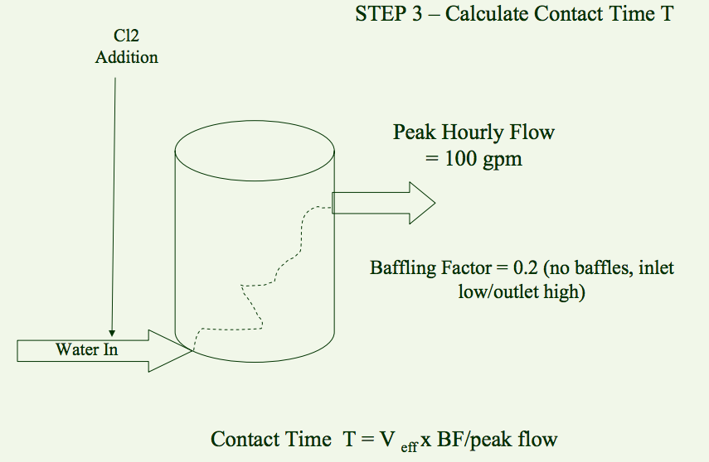

Figure 19: Calculation Example

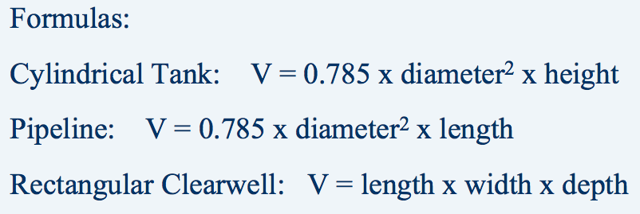

Figure 20: Cylindrical tank valume calculation

**Rapid Mix Design**

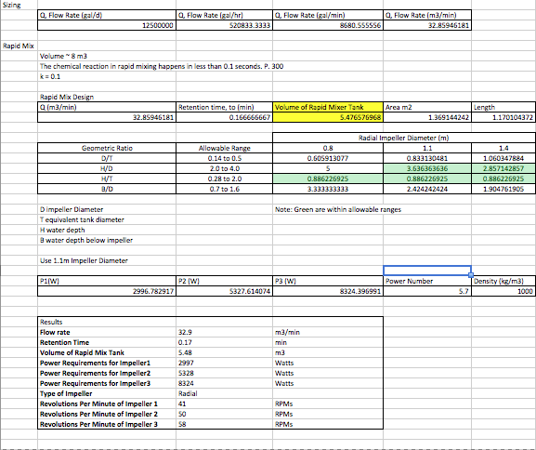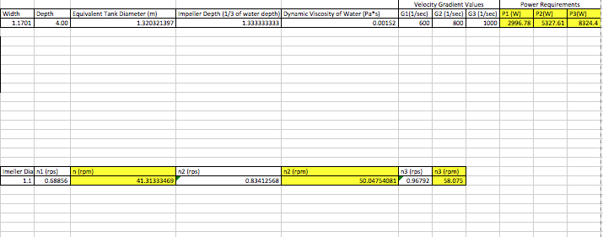

**Flocculator Design**

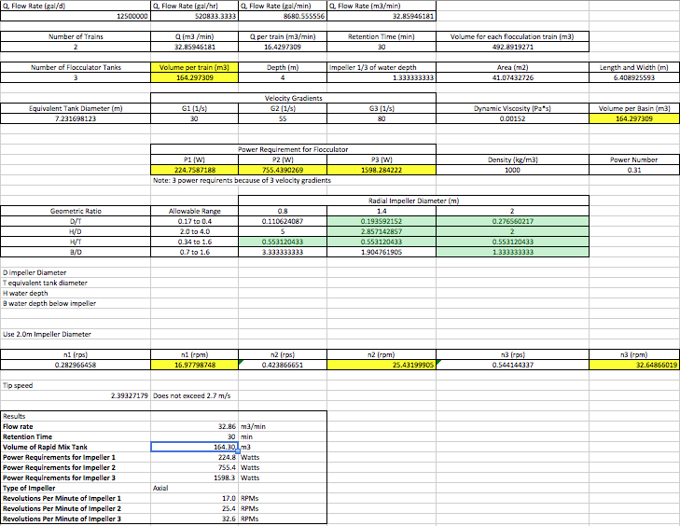

**Sedimentation Design**

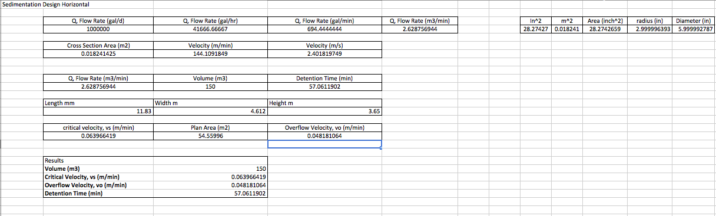

**Pump Design**

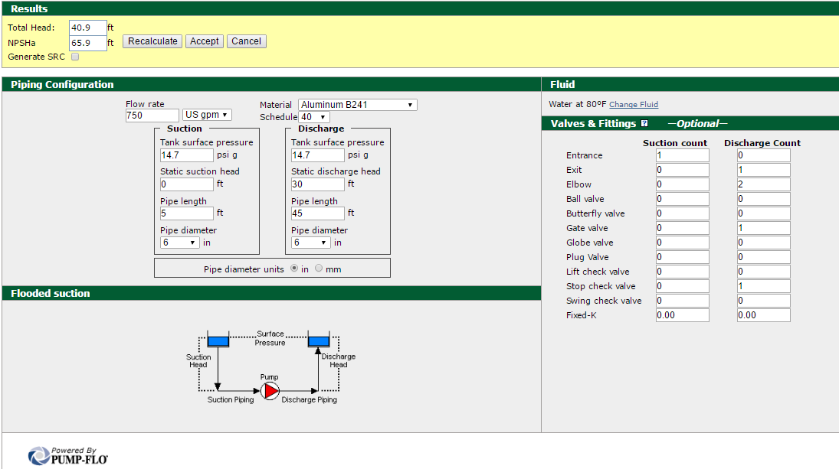

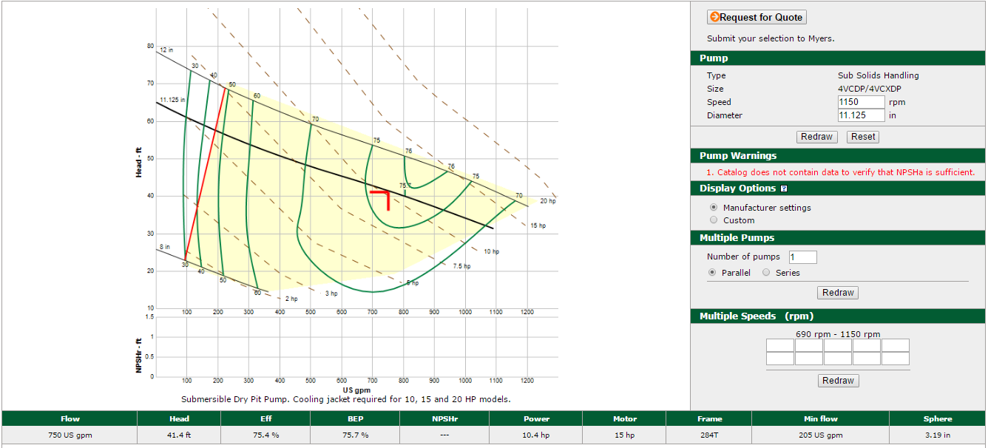

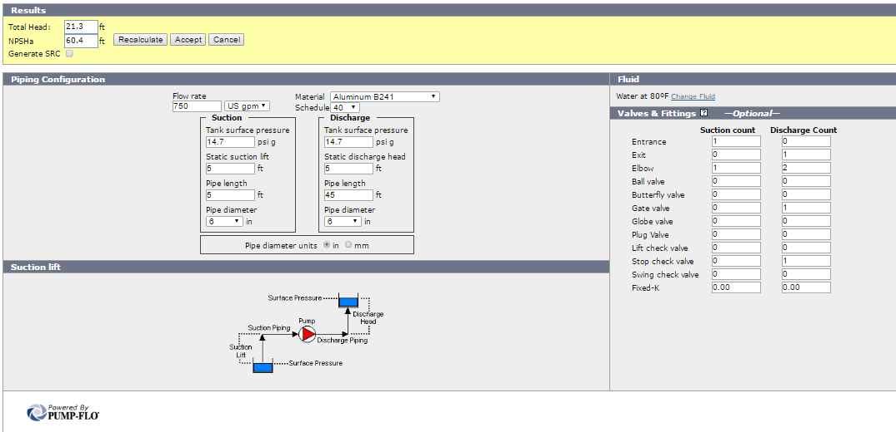

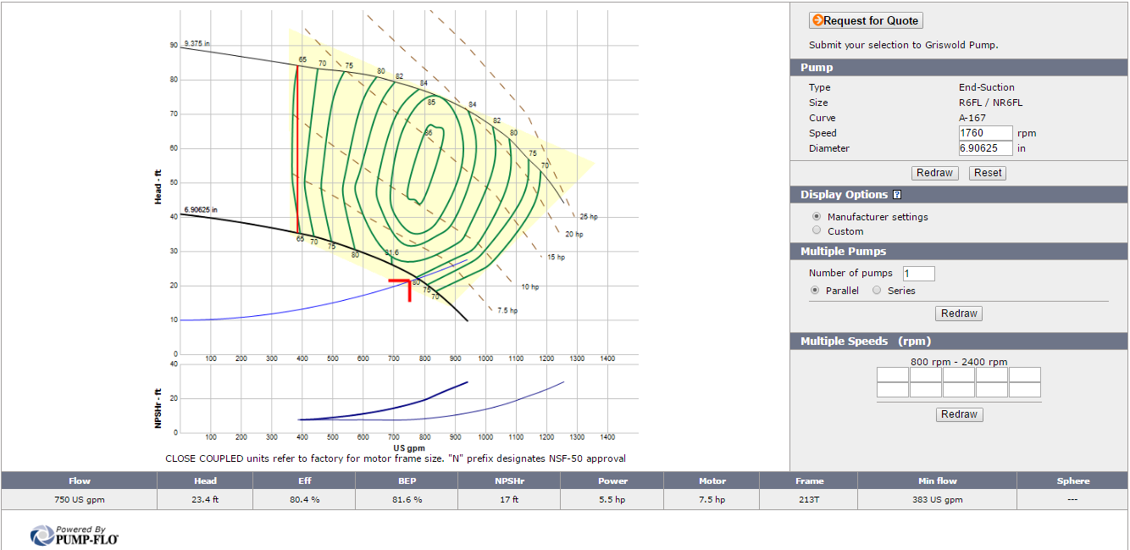

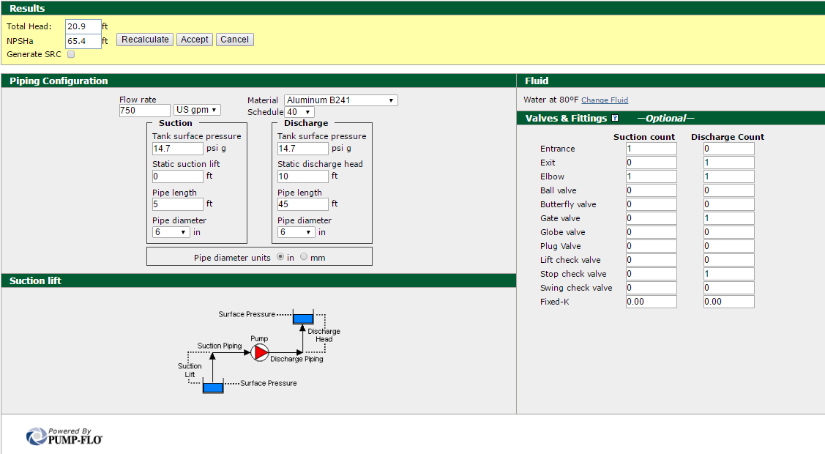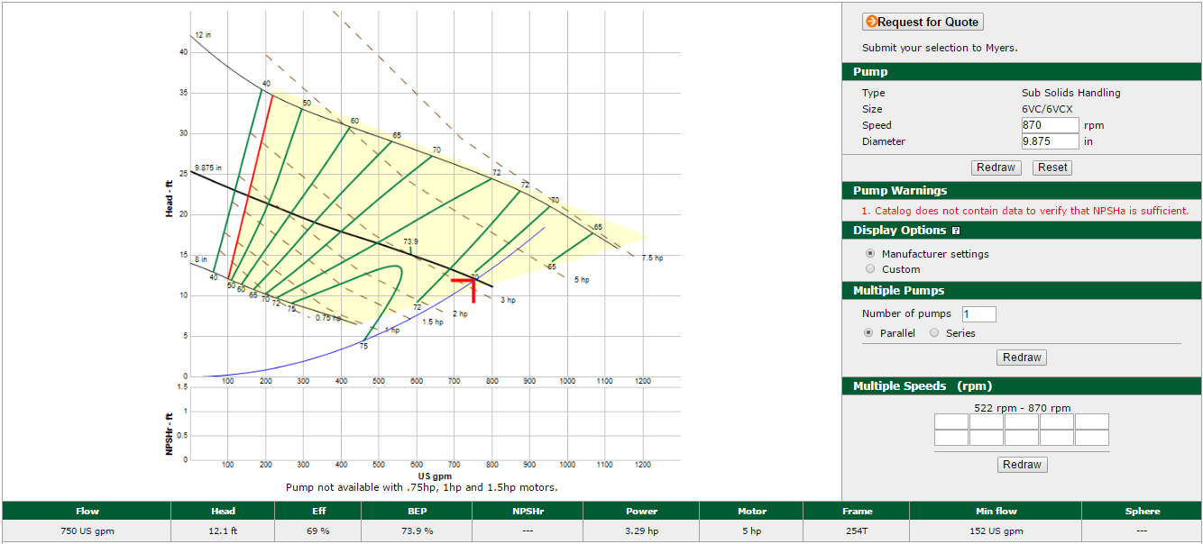

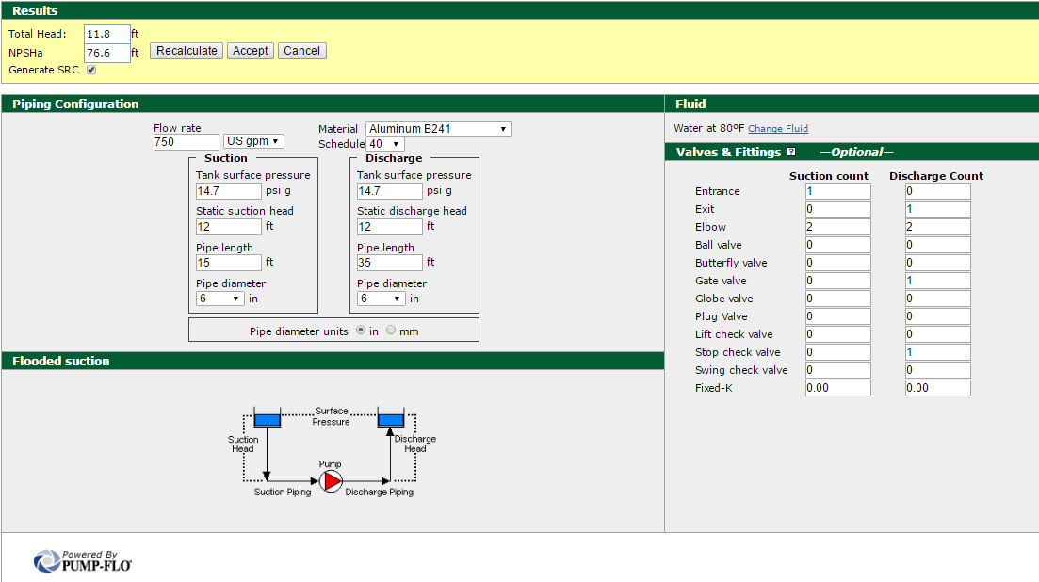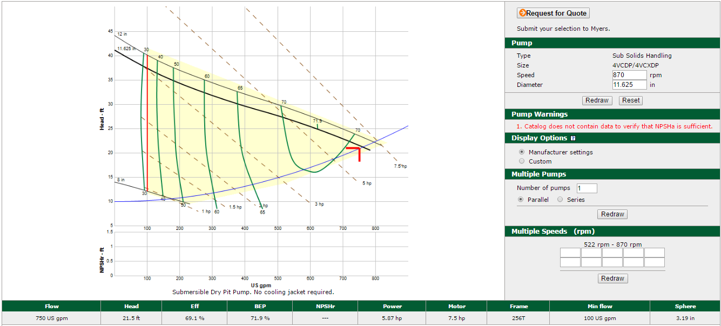

**UV Radiation Calculations**

Net chamber of volume

30 ft3 = 849.505 liters

or

6 ft3 = 169.901 liters (5 units are needed at this volume)

Flowrate

750gpm x 3.785 = 2838.75 liters/minute

or

150gpm x 3.785 = 567.75 liters/minute

Retention Time

(849.505 liters) / (2838.75 liters/minute) x (60 seconds/minute) = 17.95 seconds

or

(169.901 liters/minute) / (567.75 liters/minute) x (60 seconds/ minute) = 17.95 seconds

Intensity

I = D/t

I = (40 mJ/cm2) / (17.95 seconds)

I = 2.23 Mw/cm2