This is guide on how to setup the EventHubs if you want to demo the lab

“OPTIONAL - 04 Streaming with Event Hubs “

1)

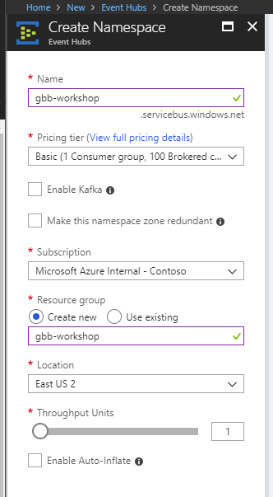

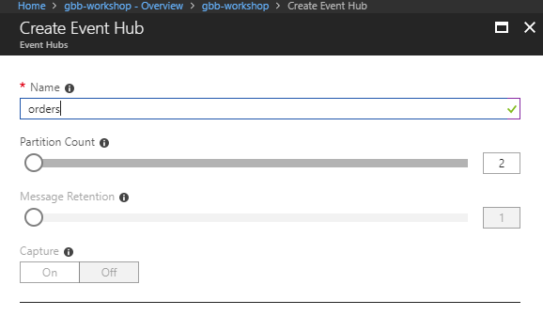

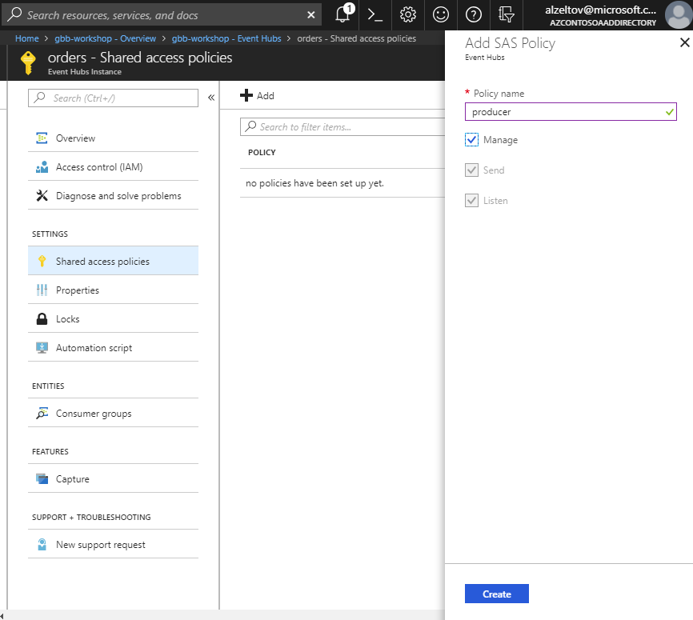

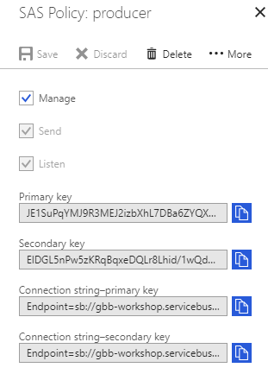

Copy the producer primary key and put it in the EventHub_OrdersProducer notebook:

val namespaceName = "gbb-workshop";

val eventHubName = "orders";

val sasKeyName = "producer";

**val sasKey = "producer_key_goes_here";**

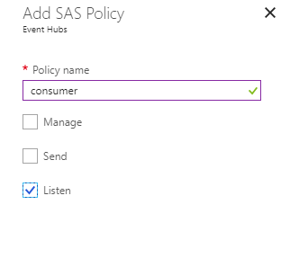

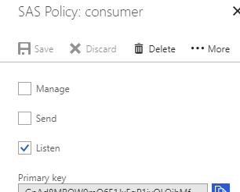

In the cmd 16 of “OPTIONAL - 04 Streaming with Event Hubs” notebook replace

eventHubNamespace = "gbb-workshop"

progressDir = "/tmp/gbb-workshop/eventhub-orders-progress"

policyName = "consumer"

**policyKey = "consumer_key_goes_here"**

eventHubName = "orders"

consumerGroup = "$Default"

Add eventhub maven library to libs folder-> create -> Library

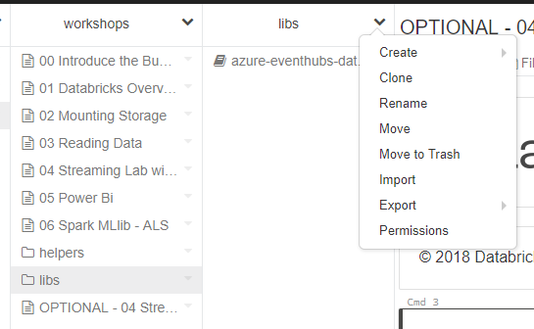

**Specify maven coordinates:**

com.microsoft.azure:azure-eventhubs-databricks_2.11:3.4.0

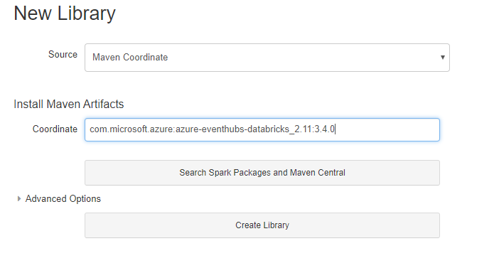

Run the EventHub_OrdersProducer notebook to generate sample data to eventhub.

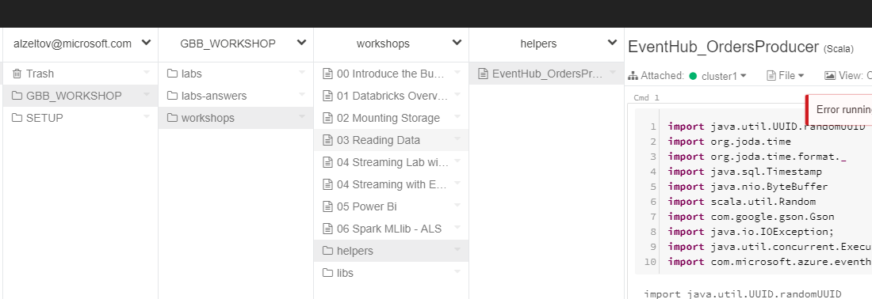

Validate the messages are coming to the orders event hub namespace

