Azure Databricks FSI Workshop Setup

Please follow the following steps prior to attending the Azure Databricks Workshop:

### Provision an Azure resource group in **US South Central**

Log in to the [Microsoft Azure portal](https://portal.azure.com/) using your Microsoft account username and password.

Click **Resource groups** from the menu of services to access the Resource Groups blade

Click **Add (+)** to create a new resource group.

Click **Create**. The resource group might take a few seconds to create. Once it is created, you see the resource group on the Azure portal dashboard.

### Provision a general purpose v2 Azure storage account in the resource group from previous step.

Click **Storage Accounts** from the menu of services to access the Storage Accounts blade

Click **Add (+)** to create a new storage account. The Create Storage Account blade appears

Provide name, use location “South Central US”, use default for all other settings.

Click “**Review + create”.** Provisioning will take a few minutes.

### Create containers in your Azure blob storage account

**Click Storage Accounts** from the menu of services to access the Storage Accounts blade

**Click on newly created storage account.**

**Click “Blobs”.**

**Click “+ Container”, to c**reate one container called “raw”- with access level of **private (no anonymous access)**

1. Record storage account name and key

**Click Storage Accounts** from the menu of services to access the Storage Accounts blade

**Click on newly created storage account.**

Click “**Shared access signature**” from left blade.

Modify “**End”**  to “2019-03-22”

Click “**Generate SAS and connection string”**.

Copy token under “**SAS Token”** and paste to onenote or notepad document.

### Provision an Azure Databricks workspace

Select "Premium" in the pricing tier

Ensure you pick the right resource group and region – US South central  
  
Leave all other options as defaults

### Provision a Databricks cluster in your workspace

Select:

* cluster mode - standard
* databricks runtime - 5.2
* enable auto-scaling - uncheck
* terminate after - 30 minutes of inactivity
* worker type - ds3v2
* worker count - 2  
    
  Leave all other entries with default values and click create.

### Download the Databricks DBC

Link : https://aka.ms/fsidbnotebooks

### Import the DBC into your Databricks workspace

Import the dbc file to create the lab folders.

1. Click the **Workspace** button Workspace Icon or the **Home** button Home Icon in the sidebar. Do one of the following:
   * Next to any folder, click the Menu Dropdown on the right side of the text and select **Import**.
   * In the Workspace or a user folder select Down Caret **Import**.

[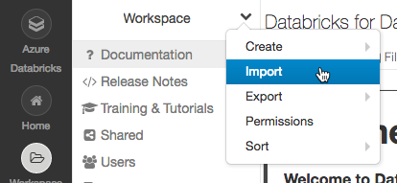](https://docs.azuredatabricks.net/_images/import-notebook.png)

1. Click **Import**.

5. You should see folder structure like this:

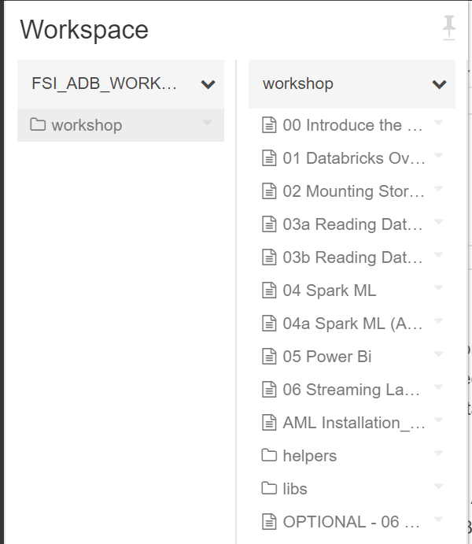

**Workshop** folder contains notebooks