**Stability in the EBM model**

**With respect to perturbations in *Q* (*D* constant)**

* Increase in *Q* => increase in input heat at all points on the globe => ice melts => *xs* should increase.
* Decrease in *Q* => decrease in input heat at all points on the globe => ice forms => *xs* should decrease.

|  |  |
| --- | --- |
| $${\left(\frac{∂x_{s}}{∂Q}\right)}_{D}>0$$ | stable |
| $${\left(\frac{∂x_{s}}{∂Q}\right)}_{D}<0$$ | unstable |

Example: see the plot of *xs* against *Q/Q0*. Start at steady-state solution *Q*/*Q0* = 1.0, *xs* = 0.225 (*D*/*D0* = 0.75). Imagine *Q* is positively perturbed, then physically the ice-edge should retreat (*xs* increases). This moves the climate to a non-steady state. *xs* would continue to increase until it reaches *xs* = 1. Note: there are additional steady-state solution branches (which I never plotted):

$$x_{s}=\left\{\begin{matrix}0.0 Q<Q(0.0,D) \\ 1.0 Q>Q(1.0,D)\end{matrix}\right.$$

Stability w.r.t *Q* can be seen in (*D*, *xs*) space too by looking along a line of constant *D* and looking at the gradient in contours of *Q*.

**With respect to perturbations in *D* (*Q* constant)**

* Not as straight-forward, because increasing *D* may make heat loss *or* heat gain at *x* = *xs* more efficient.
* This depends on the heat flux convergence at the ice edge, *h*(*xs*)
* Approximately (not exactly because *Tn = Tn*(*xs, D, Q*(*xs, D*)) depends on *D* in a non-trivial way),

$$\left|h(x_{s})\right|∝D$$

which can be seen from a plot of *h*(*xs*) for different values of *D.*

That plot shows:

* increasing *D* where heat is converging (*h* > 0) increases the rate of convergence.
* increasing *D* where heat is diverging (*h* < 0) increases the rate of divergence.

If more heat converges on the ice-edge, physically we would expect ice to melt (­*xs* increases). This corresponds to an increase in *D* where *h* > 0.

Similarly, if more heat is lost (diverges) from the ice-edge, physically we would expect ice to form (*­xs* decreases). This corresponds to an increase in *D* where *h* < 0.

Thus the following stability conditions arise based on the sign of *h,* which determines whether heat is convergent or divergent, and within each of those cases the sign of the derivative of *xs* with *D* gives the stability:

|  |  |  |
| --- | --- | --- |
| $$h(x_{s})$$ | $${\left(\frac{∂x_{s}}{∂D}\right)}_{Q}$$ | Stability |
| + | + | stable |
| − | unstable |
| − | + | unstable |
| − | stable |

Alternatively, the condition for stability with respect to perturbations in *D* at fixed *Q* is

$$s≡{\left(\frac{∂x_{s}}{∂D}\right)}_{Q}h\left(x_{s}\right)>0.$$

Example: start with steady state solution *D*/*D0* = 1.0, *xs* = 0.26, *Q*/*Q0* = 1.0.

From the plots, *h* < 0 and (∂*xs*/∂*D*)*Q* > 0. Therefore perturbations in *D* cause an irreversible change in climate state and the initial state was unstable. In this case increasing *D* would lead to global ice-cover.

I mapped the stability in (*Q*/*Q0*, *xs*) space by plotting *s*/|*s*| (actually the code uses the derivative of *D* w.r.t. *xs*, but that doesn’t affect the ratio or resulting plot). In the plot (copy below, high quality version attached separately), red is +1 (stable w.r.t. *D*), blue is -1 (unstable w.r.t. *D*) and white is where there is no solution for *D*(*xs*, *Q*).

**Comments on the plot**

1. it roughly corresponds with the branch stability w.r.t *Q* discussed before but there are some differences:
   1. stable region near (0.9, 0.4): it is not clearly stable w.r.t *Q* in previous plots
   2. near *xs* = 0.5: this is due to the structure of *h*(*xs*). The zero crossing point (*xs* such that *h* = 0) increases with *D*. Also, the stability condition used here does not account for the fact that for some small range of *xs* **increasing** *D* actually **reduces** the convergence of heat even where *h* > 0. This occurs somewhere between *xs* = 0.50 and *xs* = 0.55 (see plot of *h*(*xs*) for various *D*).
      * this is probably responsible for the apparently small stable region close to xs = 0.55.
2. it incidentally shows the limit of steady-state solutions in (*Q*/*Q0*, *xs*) space although we can’t tell directly what value(s) of *D* that corresponds to (I could probably extract this from the code actually)
3. The code to generate this plot favours the larger root (+ solution) of

$$D=\frac{-β±\sqrt{β^{2}-4αγ}}{2α}$$

if both roots are real and positive (i.e. physically meaningful), for no particular reason other than convenience. This may be influencing the stability in the approximate range 0.2 < *xs* < 0.55, but outside that it’s probably not a problem since we already know from the original plots of *Q*(*xs*) for various *D* that there are no overlaps there (i.e. single solution for *D*).

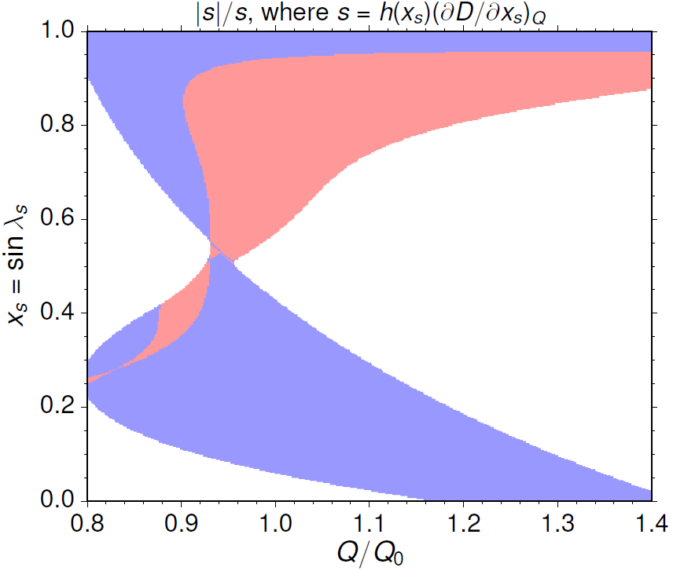

Plot of the stability with respect to *D* in (*Q*/*Q0*, *xs*)-space where red indicates stability, blue indicates instability and white indicates that there are no solutions for *D* (equivalently, if (*Q*/*Q0*, *xs*) = (*Qw*/*Q0*, *xw*) there is no *D* giving rise to a steady-state solution *Qw*(*xs*)).

Away from the region where the stability condition w.r.t. *D* becomes dubious, it seems that stability w.r.t. *Q* aligns with stability w.r.t. *D*. It may be worth trying to plot the stability w.r.t *Q* in (*Q*/*Q0*, *xs*) space in order to compare with the plot above? I think this is non-trivial to code and would definitely require some additional numerical approximations, but is probably possible nevertheless (and it may be simpler than I currently think it is).