Epidemic Structure and Predictive Accuracy of Influenza A and B: Insights from Sub-Epidemic Modeling

Jake Harmon

## Test

Test citation (Brauer, Castillo-Chavez, and Feng 2019) next (Center for Disease Control and Prevention 2025)

library(tidyverse)

── Attaching core tidyverse packages ──────────────────────── tidyverse 2.0.0 ──  
✔ dplyr 1.1.4 ✔ readr 2.1.5  
✔ forcats 1.0.0 ✔ stringr 1.5.2  
✔ ggplot2 4.0.0 ✔ tibble 3.3.0  
✔ lubridate 1.9.4 ✔ tidyr 1.3.1  
✔ purrr 1.1.0   
── Conflicts ────────────────────────────────────────── tidyverse_conflicts() ──  
✖ dplyr::filter() masks stats::filter()  
✖ dplyr::lag() masks stats::lag()  
ℹ Use the conflicted package (<http://conflicted.r-lib.org/>) to force all conflicts to become errors

library(readr)  
library(viridis)

Loading required package: viridisLite

# Downloaded from https://gis.cdc.gov/grasp/fluview/FluHospChars.html  
flu_df <- read_csv(  
 file = (paste0(getwd(),"/data/Weekly_Data_Counts_by_Virus.csv")),  
 skip = 1) %>%   
 rename(  
 "season" = 1,  
 "week_num" = 2,  
 "flu_a" = 3,  
 "flu_b" = 4,  
 "flu_ab" = 5,  
 "flu_u" = 6  
 )

Warning: One or more parsing issues, call `problems()` on your data frame for details,  
e.g.:  
 dat <- vroom(...)  
 problems(dat)

Rows: 696 Columns: 6  
── Column specification ────────────────────────────────────────────────────────  
Delimiter: ","  
chr (2): SEASON, WEEK_NUMBER  
dbl (4): INFLUENZA A, INFLUENZA B, INFLUENZA A AND B, UNKNOWN  
  
ℹ Use `spec()` to retrieve the full column specification for this data.  
ℹ Specify the column types or set `show_col_types = FALSE` to quiet this message.

# For graphing  
flu_time_series <- flu_df %>%   
 pivot_longer(cols = -c(season, week_num), names_to = "flu") %>%   
 filter(season == "2018-19")  
flu_time_series$week_num <- factor(flu_time_series$week_num,  
 levels = unique(flu_time_series$week_num)  
)  
flu_time_series$week_num <- as.numeric(flu_time_series$week_num)  
  
# Create timeseries  
ggplot(data = flu_time_series, aes(x = week_num, y = value, color = flu)) +  
 geom_point() +  
 geom_line() +  
 labs(  
 title = "Weekly Influenza A/B Counts, 2018-2019 Season",  
 x = "Flu Week",  
 y = "Number of Weekly Hospitalizations",  
 color = "Virus Type"  
 ) +  
 scale_color_viridis(  
 discrete = TRUE,   
 option = "D",  
 labels = c(  
 "flu_a" = "Influenza A",  
 "flu_b" = "Influenza B",  
 "flu_ab" = "Influenza A&B",  
 "flu_u" = "Influenza Unspecified")) +  
 theme_classic()

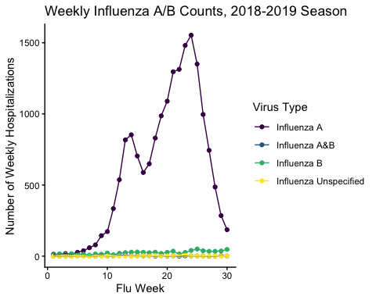

Brauer, Fred, Carlos Castillo-Chavez, and Zhilan Feng. 2019. “Models for Influenza.” *Mathematical Models in Epidemiology* 69 (June): 311–50. <https://doi.org/10.1007/978-1-4939-9828-9_9>.

Center for Disease Control and Prevention. 2025. “Laboratory-Confirmed Influenza Hospitalizations.”