A trip with MiTravels can be anything that you do that you would like to remember.  
  
  
Once you have created your trip Project, you can document your activities by creating event journals, and adding photos to enahnce the memories.  
 You can then follwo these memories by checking out the map and reliving all of your experiences!

Licenses:

<http://www.apache.org/licenses/LICENSE-2.0.txt> (graphics)

<https://creativecommons.org/licenses/by/4.0/legalcode>

Photo by [**Jess Bailey Designs**](https://www.pexels.com/@jessbaileydesign?utm_content=attributionCopyText&utm_medium=referral&utm_source=pexels) from [**Pexels**](https://www.pexels.com/photo/gold-pen-on-journal-book-745760/?utm_content=attributionCopyText&utm_medium=referral&utm_source=pexels)

Photo by [Augustine Wong](https://unsplash.com/@augustinewong?utm_source=unsplash&utm_medium=referral&utm_content=creditCopyText) on [Unsplash](https://unsplash.com/s/photos/paper-texture?utm_source=unsplash&utm_medium=referral&utm_content=creditCopyText)

Intro

Page 0

MiTravel is your personal diary that helps you document and relive special journeys that you create in your life path

Page 1

Create Journeys

Start by creating a Journey with MiTravel, so that you can remember your special times in your life Travels.

Page 2

Add Journals

Once you have a created a new journey, Enter Journal entries to document your activities and feelings

Page 3

Add photos

Add photos to your journal entries to bring them to life and enhance the journal entry

Page 4

Relive each Journey by following your journal entries on the map together with the places you visited.

MiTravels is a simple and easy to use journal app that allows you to create and relive the journeys in your life.

For each journey you can add journal entries and photos to take you back to those special moments.

You can then track the journey on an interactive map where you can follow the course of that journey, and drill down to a day-by-day view.

MiTravels keeps all your data local for your privacy.

Hi there. I have developed a really easy to use simple Travel Journal app that allows users to follow their journey on an interactive map, add journal entries and photos...

The app is in the Store at:

https://play.google.com/store/apps/details?id=com.jbsw.mytravels

I have also created a 30 second promo video:

https://www.youtube.com/watch?v=Mhz5Ka6JeHk

Would love to get your feedback!

Many thanks

MiTravels is essentially a journal app on steroids.

It allows users to create different journeys that they would like to remember.

A journey can be anything from a vacation abroad, to a family holidasy ranging through a picnic or hike or anything special that you want to remember.

What makes the app special is that within each journey, not only can you create journal records of your feelings and experiences, but you can add photos and retrace everything on an interactive map.

On the map you can see everywhere you have been filtered down by day, and where each of the journal entries happened.

# Create Journeys

Start by creating a Journey with MiTravel, so that you can remember your special times in your life Travels.



# Add Journals

Once you have a created a new journey, Enter Journal entries to document your activities and feelings.

# 

# Add photos

Add photos to your journal entries to bring them to life and enhance the journal entry.

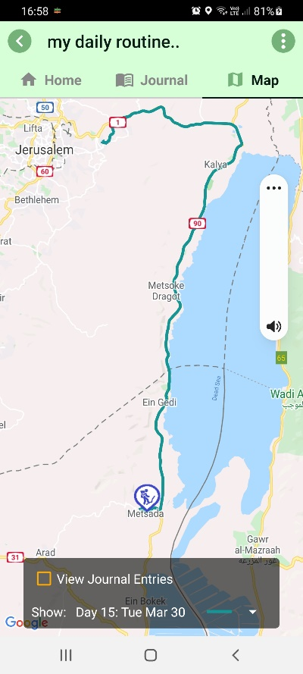

# Interactive Map

Relive each Journey by following your journal entries on the map together with the places you visited.