**ARROW STRIKE**

GAME DESIGN DOCUMENT

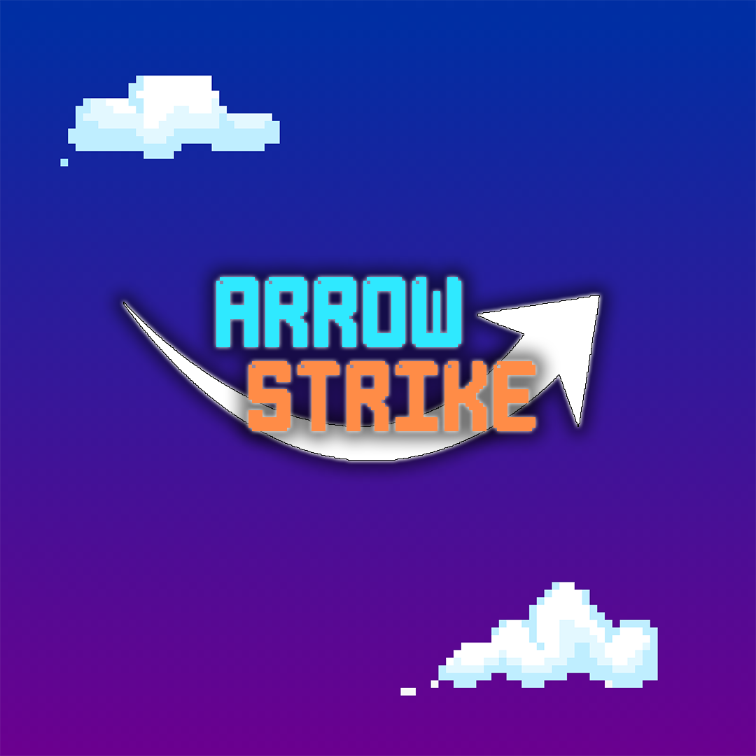

***‘Strike up a rhythm and show ‘em who’s boss!’*** – Jacob Brooks

This page: Table of Contents and Team Member Listing

|  |  |  |
| --- | --- | --- |
| Table of Contents  [1 Game Overview](https://n-xovwktmtjsnaxyc2mwes2xu7pohqedmdm6zjw5q-2lu-script.googleusercontent.com/userCodeAppPanel)  [2 High Concept](https://n-xovwktmtjsnaxyc2mwes2xu7pohqedmdm6zjw5q-2lu-script.googleusercontent.com/userCodeAppPanel)  [3 Unique Selling Points](https://n-xovwktmtjsnaxyc2mwes2xu7pohqedmdm6zjw5q-2lu-script.googleusercontent.com/userCodeAppPanel)  [4 Platform Minimum Requirements](https://n-xovwktmtjsnaxyc2mwes2xu7pohqedmdm6zjw5q-2lu-script.googleusercontent.com/userCodeAppPanel)  [5 Competitors / Similar Titles](https://n-xovwktmtjsnaxyc2mwes2xu7pohqedmdm6zjw5q-2lu-script.googleusercontent.com/userCodeAppPanel)  [6 Synopsis](https://n-xovwktmtjsnaxyc2mwes2xu7pohqedmdm6zjw5q-2lu-script.googleusercontent.com/userCodeAppPanel)  [7 Game Objectives](https://n-xovwktmtjsnaxyc2mwes2xu7pohqedmdm6zjw5q-2lu-script.googleusercontent.com/userCodeAppPanel)  [8 Game Rules](https://n-xovwktmtjsnaxyc2mwes2xu7pohqedmdm6zjw5q-2lu-script.googleusercontent.com/userCodeAppPanel)  [9 Game Structure](https://n-xovwktmtjsnaxyc2mwes2xu7pohqedmdm6zjw5q-2lu-script.googleusercontent.com/userCodeAppPanel)  [10 Game Play](https://n-xovwktmtjsnaxyc2mwes2xu7pohqedmdm6zjw5q-2lu-script.googleusercontent.com/userCodeAppPanel)  [10.1 Game Controls](https://n-xovwktmtjsnaxyc2mwes2xu7pohqedmdm6zjw5q-2lu-script.googleusercontent.com/userCodeAppPanel)  [10.2 Game Camera](https://n-xovwktmtjsnaxyc2mwes2xu7pohqedmdm6zjw5q-2lu-script.googleusercontent.com/userCodeAppPanel)  [10.2.1 HUD](https://n-xovwktmtjsnaxyc2mwes2xu7pohqedmdm6zjw5q-2lu-script.googleusercontent.com/userCodeAppPanel)  [10.2.2 Maps](https://n-xovwktmtjsnaxyc2mwes2xu7pohqedmdm6zjw5q-2lu-script.googleusercontent.com/userCodeAppPanel)  [11 Players](https://n-xovwktmtjsnaxyc2mwes2xu7pohqedmdm6zjw5q-2lu-script.googleusercontent.com/userCodeAppPanel)  [11.1 Characters](https://n-xovwktmtjsnaxyc2mwes2xu7pohqedmdm6zjw5q-2lu-script.googleusercontent.com/userCodeAppPanel)  [11.2 Metrics](https://n-xovwktmtjsnaxyc2mwes2xu7pohqedmdm6zjw5q-2lu-script.googleusercontent.com/userCodeAppPanel)  [11.3 States](https://n-xovwktmtjsnaxyc2mwes2xu7pohqedmdm6zjw5q-2lu-script.googleusercontent.com/userCodeAppPanel)  [11.4 Weapons](https://n-xovwktmtjsnaxyc2mwes2xu7pohqedmdm6zjw5q-2lu-script.googleusercontent.com/userCodeAppPanel)  [12 Player Line-up](https://n-xovwktmtjsnaxyc2mwes2xu7pohqedmdm6zjw5q-2lu-script.googleusercontent.com/userCodeAppPanel)  [13 NPC](https://n-xovwktmtjsnaxyc2mwes2xu7pohqedmdm6zjw5q-2lu-script.googleusercontent.com/userCodeAppPanel)  [13.1 Enemies](https://n-xovwktmtjsnaxyc2mwes2xu7pohqedmdm6zjw5q-2lu-script.googleusercontent.com/userCodeAppPanel)  [13.1.1 Enemy States](https://n-xovwktmtjsnaxyc2mwes2xu7pohqedmdm6zjw5q-2lu-script.googleusercontent.com/userCodeAppPanel)  [13.1.2 Enemy Spawn Points](https://n-xovwktmtjsnaxyc2mwes2xu7pohqedmdm6zjw5q-2lu-script.googleusercontent.com/userCodeAppPanel)  [13.2 Allies / Companions](https://n-xovwktmtjsnaxyc2mwes2xu7pohqedmdm6zjw5q-2lu-script.googleusercontent.com/userCodeAppPanel)  [13.2.1 Ally States](https://n-xovwktmtjsnaxyc2mwes2xu7pohqedmdm6zjw5q-2lu-script.googleusercontent.com/userCodeAppPanel)  [13.2.2 Ally Spawn Points](https://n-xovwktmtjsnaxyc2mwes2xu7pohqedmdm6zjw5q-2lu-script.googleusercontent.com/userCodeAppPanel)  [14 Art](https://n-xovwktmtjsnaxyc2mwes2xu7pohqedmdm6zjw5q-2lu-script.googleusercontent.com/userCodeAppPanel)  [14.1 Setting](https://n-xovwktmtjsnaxyc2mwes2xu7pohqedmdm6zjw5q-2lu-script.googleusercontent.com/userCodeAppPanel)  [14.2 Level Design](https://n-xovwktmtjsnaxyc2mwes2xu7pohqedmdm6zjw5q-2lu-script.googleusercontent.com/userCodeAppPanel)  [14.3 Audio](https://n-xovwktmtjsnaxyc2mwes2xu7pohqedmdm6zjw5q-2lu-script.googleusercontent.com/userCodeAppPanel)  [15 Procedurally Generated Content](https://n-xovwktmtjsnaxyc2mwes2xu7pohqedmdm6zjw5q-2lu-script.googleusercontent.com/userCodeAppPanel)  [15.1 Environment](https://n-xovwktmtjsnaxyc2mwes2xu7pohqedmdm6zjw5q-2lu-script.googleusercontent.com/userCodeAppPanel)  [15.2 Levels](https://n-xovwktmtjsnaxyc2mwes2xu7pohqedmdm6zjw5q-2lu-script.googleusercontent.com/userCodeAppPanel)  [15.3 Artificial Intelligence NPC](https://n-xovwktmtjsnaxyc2mwes2xu7pohqedmdm6zjw5q-2lu-script.googleusercontent.com/userCodeAppPanel)  [15.4 Visual Arts](https://n-xovwktmtjsnaxyc2mwes2xu7pohqedmdm6zjw5q-2lu-script.googleusercontent.com/userCodeAppPanel)  [15.5 Audio](https://n-xovwktmtjsnaxyc2mwes2xu7pohqedmdm6zjw5q-2lu-script.googleusercontent.com/userCodeAppPanel)  [15.6 Minimum Viable Product (MPV)](https://n-xovwktmtjsnaxyc2mwes2xu7pohqedmdm6zjw5q-2lu-script.googleusercontent.com/userCodeAppPanel)  [16 Wish List](https://n-xovwktmtjsnaxyc2mwes2xu7pohqedmdm6zjw5q-2lu-script.googleusercontent.com/userCodeAppPanel)   |  | | --- | |  | | Game Development Team Members    PRODUCER  Jacob Brooks    PRODUCTION MANAGER  Jacob Brooks    PRODUCTION COORDINATOR  Jacob Brooks  GAME DESIGNERS  Jacob Brooks  SYSTEMS/IT COORDINATOR  Jacob Brooks  PROGRAMMERS  Jacob Brooks  TECHNICAL ARTISTS  Jacob Brooks  AUDIO ENGINEERS  Jacob Brooks  UX TESTERS  Jacob Brooks |

|  |
| --- |
|  |

# 1 Game Overview

Title: Awesome Game Name

Platform: PC Standalone

Genre: Rhythm, Music

Rating: (10+) ESRB

Target: causal and competitive rhythm gamers (aging from 10 – 40)

Release date: November, 2020

Publisher: Jacob Brooks

Arrow Strike is a music-based rhythm game where the player may select a multitude of songs to play. The player will attempt to press their keyboard arrow keys in the order that the arrows appear on the screen. The goal of the game is to make it through the entire song while inputting the keys as close to the intended key map as possible. By landing multiple correct key inputs in a row, the player will generate a multiplier which will accrue bonus points depending on the combo length. Depending on the exactness of the player’s key input the player will accrue points based on how close to the intended input is to the player’s input. The levels of accuracy will be defined as miss, good, super, and perfect. Any missed inputs will be generated as a miss and will break combos.

# 2 High Concept

It’s time you’ve mastered what it means to have perfect rhythm in the body in mind. Choose from a multitude of songs and strike your way through riveting song challenges. Play on a difficulty that suits you best and jam out while enjoying some upbeat tunes. The world of rhythm is at your fingertips! All it takes is the strike of a key.

# 3 Unique Selling Points

* Multiple difficulties for wide range of enjoyment
* Low overhead and minimal hardware requirements
* Colorful visuals and stimulating gameplay

# 4 Platform Minimum Requirements

# 5 Competitors / Similar Titles

* Dance Dance Revolution by Konami
* Stepmania by Chris Danford

# 6 Synopsis

# 7 Game Objectives

# 8 Game Rules

# 9 Game Structure

# 10 Game Play

## 10.1 Game Controls

## 10.2 Game Camera

### 10.2.1 HUD

### 10.2.2 Maps

# 11 Players

## 11.1 Characters

## 11.2 Metrics

## 11.3 States

## 11.4 Weapons

# 12 Player Line-up

# 13 NPC

## 13.1 Enemies

### 13.1.1 Enemy States

### 13.1.2 Enemy Spawn Points

## 13.2 Allies / Companions

### 13.2.1 Ally States

### 13.2.2 Ally Spawn Points

# 14 Art

## 14.1 Setting

## 14.2 Level Design

## 14.3 Audio

# 15 Procedurally Generated Content

## 15.1 Environment

## 15.2 Levels

## 15.3 Artificial Intelligence NPC

## 15.4 Visual Arts

## 15.5 Audio

## 15.6 Minimum Viable Product (MPV)

# 16 Wish List

Bibliography

Art:

* Arrow textures – Jacob Brooks
* Game logo – Jacob Brooks
* Menu Scene – Jacob Brooks

Music:

* Surf by Hyper Potions <https://www.youtube.com/watch?v=yq9HF7D9MRY&ab_channel=HyperPotions>
* Tropical Resort by Hyper Potions

<https://www.youtube.com/watch?v=CaEpCuu0WMM&ab_channel=HyperPotions>

* Snow Day by Hyper Potions <https://www.youtube.com/watch?v=SNt41lbbs64&ab_channel=HyperPotions>