Bellabeat
How Can a Wellness Company Play It Smart?
A marketing analysis case study
By Jake Chervitz
Google Data Analytics Capstone

TL;DR
Bellabeat makes wellness products for women — an app, a few smart trackers, and a water bottle. They wanted to know how people are actually using smart fitness devices in general, and what that could mean for marketing the Bellabeat app. I worked through two months of public FitBit data from 35 users to find out.
The headlines:
- Users split pretty evenly across four activity tiers, so there's no real "average user" to market to.
- People spend about 79% of their tracked day sitting — even the active ones.
- Sitting time is the strongest thing connected to bad sleep (correlation of -0.64). Steps barely matter.
- A third of sleep-tracking users are getting under 6 hours a night, but their sleep itself is efficient. They're just not going to bed early enough.
- Activity peaks at 7 PM and dips between 1 and 4 PM — useful if Bellabeat wants to time notifications well.
Based on those, I put together five suggestions for the Bellabeat app team: build different messaging for different user types, lean harder into reducing sitting time instead of pushing workouts, time notifications around the 1–4 PM lull and 9–10 PM wind-down, make sleep duration coaching a real feature, and build a re-engagement flow for users who stop syncing.

1. Ask
Urška Sršen, one of Bellabeat's co-founders, asked the marketing team to look at smart device usage data and pull out anything that could shape the company's marketing strategy. The brief was open-ended on purpose — pick a Bellabeat product to focus on and run with it.

Why I picked the Bellabeat app
Bellabeat sells a few different products (Leaf tracker, Time watch, Spring water bottle, plus a paid membership), but they all feed into the Bellabeat app. The app is where users actually see their data, get reminders, and engage with the brand day to day. That makes it the highest-leverage place for marketing recommendations — anything I find about how people use trackers ties back to "what should the app surface, and when?"

Questions guiding the work
- What's actually trending in how people use smart devices?
- How do those trends apply to the kind of users Bellabeat is going after?
- What should that mean for how Bellabeat markets the app?

2. Prepare

The dataset
I used the FitBit Fitness Tracker Data on Kaggle (CC0 / public domain, made available through Mobius). It's 35 users who consented to share two months of activity, sleep, and heart rate data — split into two folders covering March 12 to April 11, 2016, and April 12 to May 12, 2016.

Files I ended up using
- dailyActivity_merged.csv (combined from both folders) — daily steps, distance, calories, and minutes spent at each activity intensity. This is the workhorse file.
- sleepDay_merged.csv (only in the second folder) — daily sleep totals.
- hourlySteps_merged.csv (combined) — used for the time-of-day analysis.
- weightLogInfo_merged.csv (combined) — mostly to see how few people actually log their weight.
I skipped the minute-level files. They're huge and they don't add anything the daily and hourly files don't already cover for a marketing question.

How credible is this data? (ROCCC)
- Reliable: Sort of. 35 users is a small sample, so any conclusions are pointing in a direction, not proving anything.
- Original: Not really — it's third-party FitBit data, not anything from Bellabeat.
- Comprehensive: Activity data is solid (35 users, 61 days). Sleep is thinner (24 users, 31 days). Weight is barely there (13 users).
- Current: No. It's from 2016, before the pandemic and before Apple Watches were everywhere. Behavior has probably shifted.
- Cited: Yes — properly licensed CC0 through Kaggle.

What this dataset can't tell us
- 35 users is small. Findings are directional, not statistically airtight.
- There's no demographic info — age, gender, where users live. Bellabeat targets women specifically, and there's no way to confirm the dataset matches that audience.
- It's 2016 data. Anything tied to remote work and sitting habits has likely changed.
- Only about 70% of users logged sleep, so the sleep findings probably skew toward the more health-engaged subset.
- No revenue or subscription data, so I can't directly tie behavior to what would actually make Bellabeat money. Recommendations are based on engagement logic instead.

3. Process

What I used
Python (pandas, numpy, matplotlib, seaborn) for the cleaning and analysis. The hourly file alone is over 46,000 rows, so spreadsheets weren't really an option for the heavy lifting. I used Excel and PowerPoint at the end for stakeholder-facing visuals.

Cleaning steps
- Investigated duplicates instead of just dropping them. The daily activity file had 24 apparent duplicates — all on April 12. Turned out the first folder's data extraction got cut off mid-day on the 12th, so it had partial-day records that the second folder's full-day records overlapped with. I kept the complete records and dropped the partials.
- Dropped the actual duplicates. Sleep data had 3 truly identical rows. Hourly steps had 175 dupes (350 rows total) from the same April 12 cutoff issue, but in this case both folders had captured the same hours with the same values, so they were safe to drop.
- Fixed dates. All date columns came in as strings. Converted them to proper datetime so I could sort, filter, and join.
- Filtered out non-wear days. Days with under 100 steps are almost certainly days the user didn't wear the device. That was 151 of 1,373 daily rows — about 11%. I excluded them from activity averages so non-wear days didn't drag everything down. (The fact that 11% of recorded days are non-wear is itself a finding.)
- Classified users into activity tiers. Used the Tudor-Locke step thresholds from public health research: Sedentary (under 5,000), Lightly Active (5,000–7,499), Fairly Active (7,500–9,999), Very Active (10,000+). Felt better than picking arbitrary cutoffs.
- Joined activity and sleep. Merged the daily activity and sleep files on user ID and date so I could check correlations. Got 408 paired user-days across 24 users.

4. Analyze & Share

Finding 1: There's no "typical" user
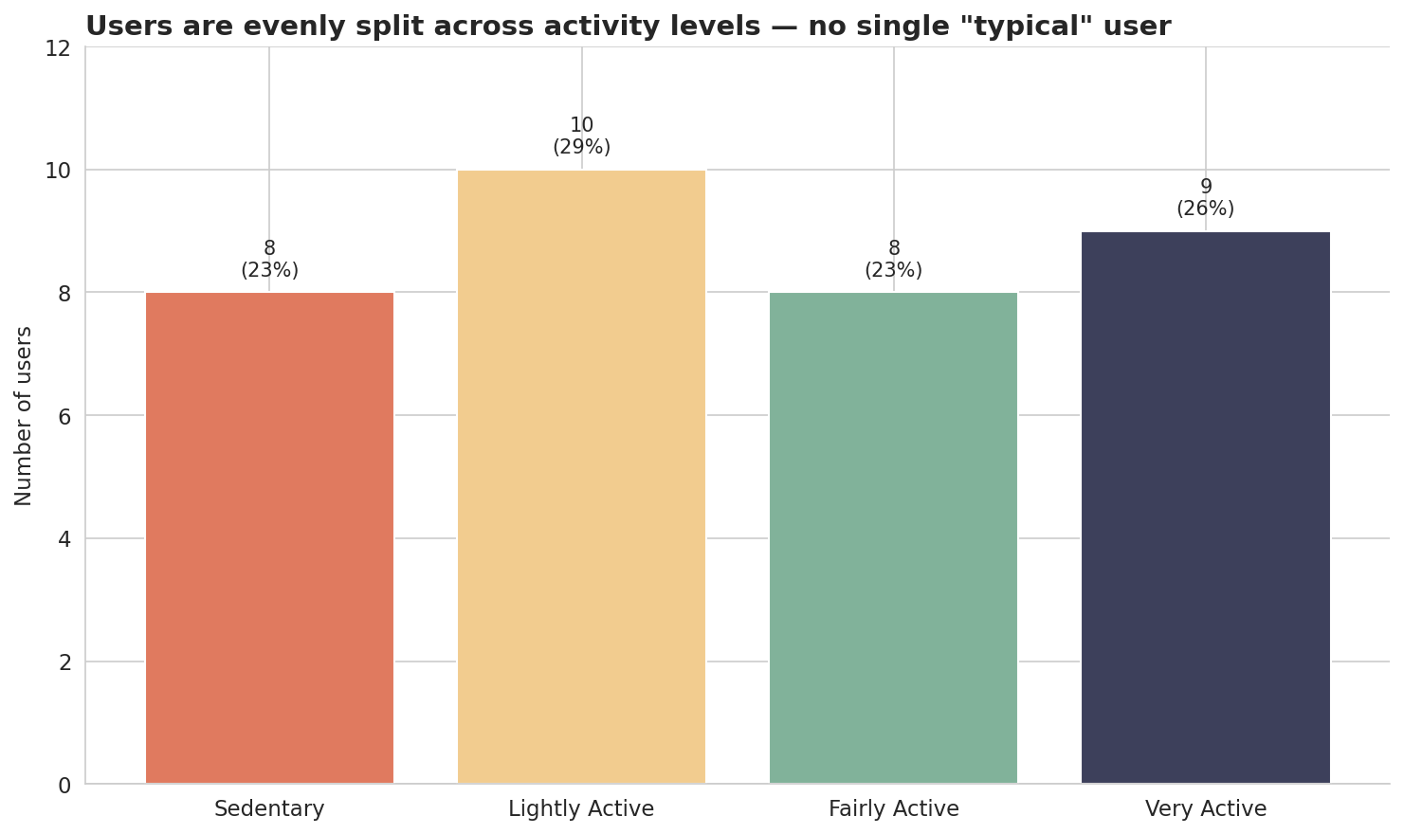
Figure 1 — How the 35 users break down by activity tier (worn days only)
When you sort users by their average daily steps, they spread surprisingly evenly across the four tiers: 23% Sedentary, 29% Lightly Active, 23% Fairly Active, 26% Very Active. No tier holds more than 30% of users.
What this means for marketing: a single message — "push yourself!" or "every step counts!" — will only land for one quarter of the audience at best. The data pretty much justifies building four distinct user personas.

Finding 2: People sit a lot. Like, a lot.
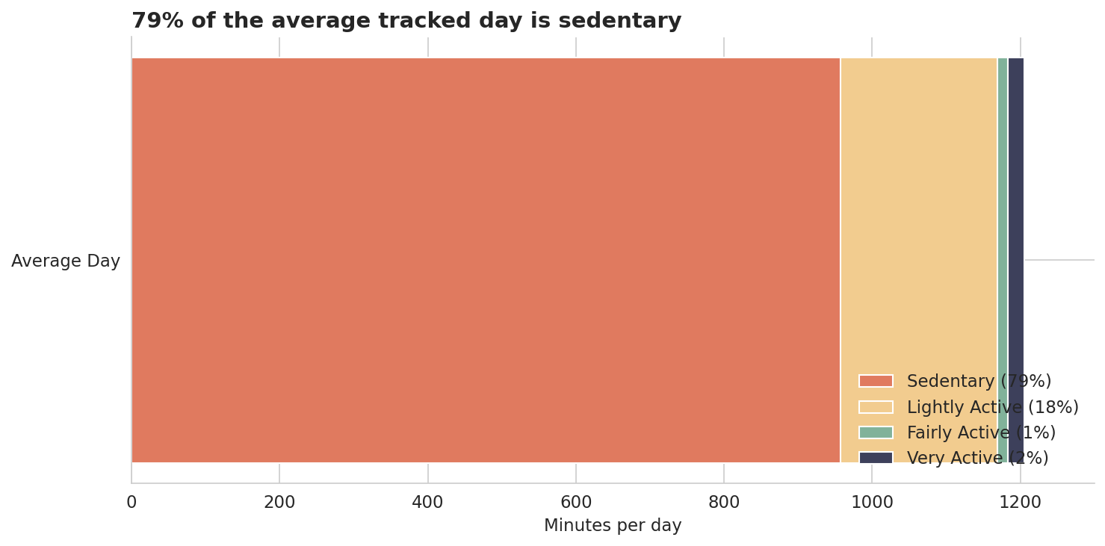
Figure 2 — Average minutes per day by intensity, on worn days
On a typical day someone wears their tracker, they spend about 957 minutes (16 hours) sedentary versus 37 minutes in genuinely active states (Very Active + Fairly Active combined). That's a 26-to-1 ratio. Even users in the Very Active tier sit for the majority of their day.
This was the finding that surprised me most. The conventional fitness app pitch is "track your workouts." But the math says the bigger health lever is breaking up sitting time, not adding more workouts on top of an otherwise sedentary day.

Finding 3: Activity peaks at 7 PM, with a clear afternoon dip
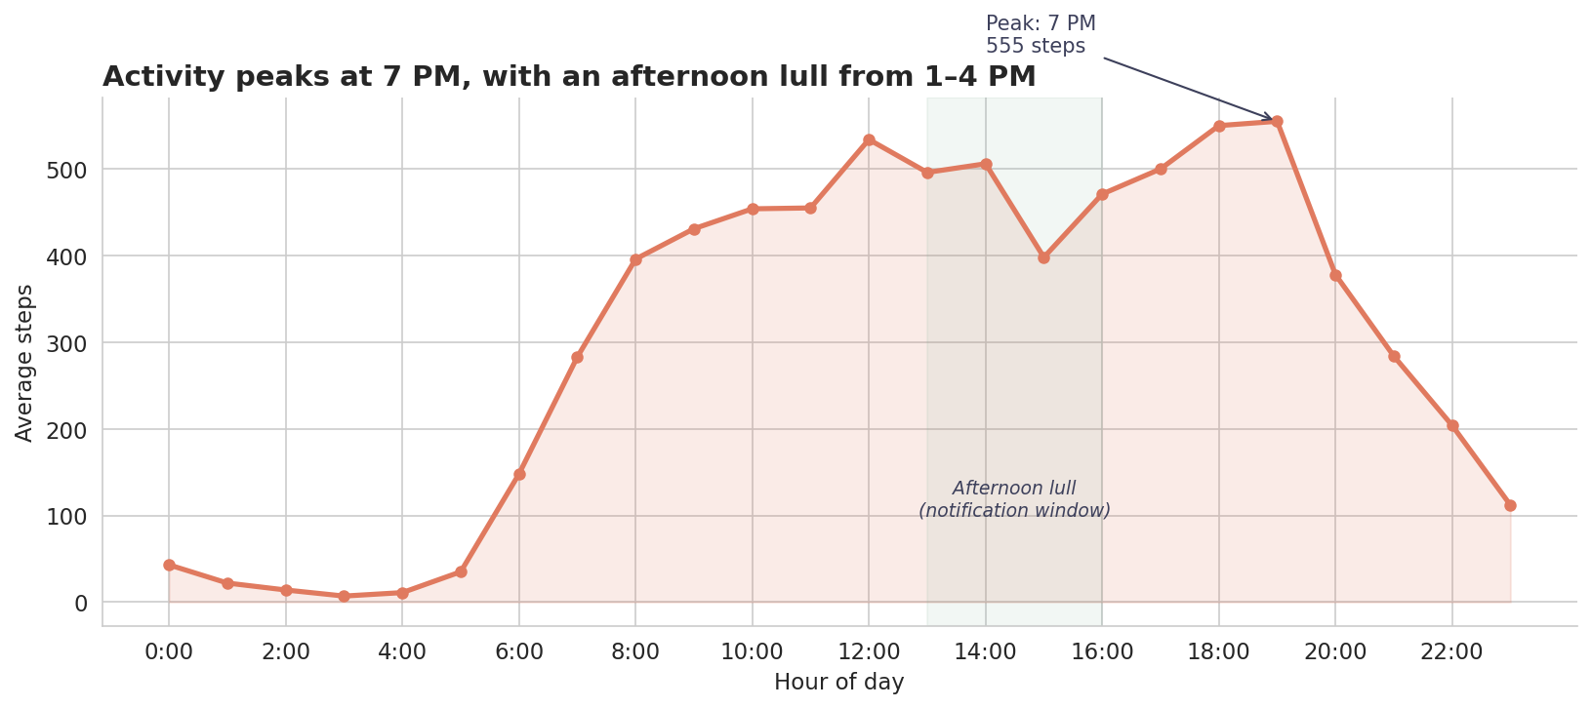
Figure 3 — Average steps by hour of day, all users averaged
Hourly step counts follow a really consistent shape: low overnight (the floor is 7 steps at 3 AM), ramp up between 6 and 8 AM (probably commute), peak around lunch at noon (534 steps), dip from 1 to 4 PM, climb to the day's high at 7 PM (555 steps), then drop off sharply after 8 PM.
That afternoon lull and the post-8 PM wind-down both line up nicely with when the app could send useful notifications — movement nudges in the dead zone, bedtime prompts when activity is already winding down.

Finding 4: A third of sleep-trackers are getting under 6 hours
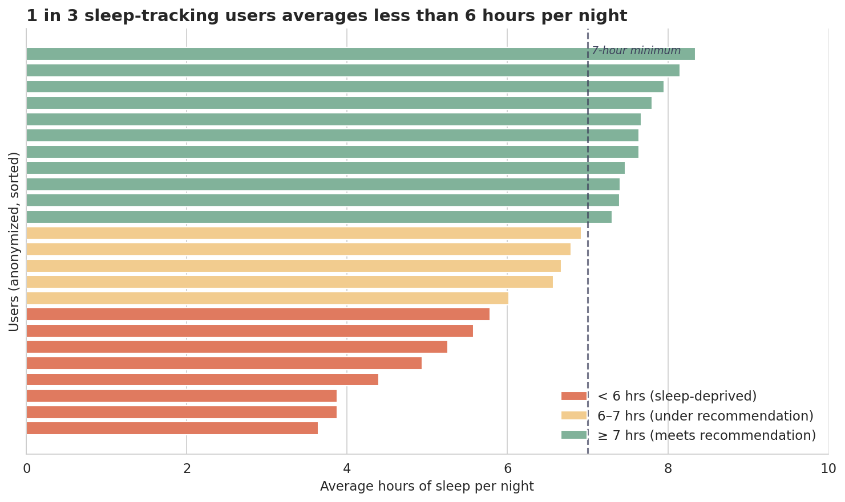
Figure 4 — Average nightly sleep per user (24 users with sleep data)
Average sleep across all sleep records is 6.99 hours, which sounds like users are basically meeting the 7-hour recommendation. They're not. Only 11 of 24 sleep-tracking users (46%) actually average 7+ hours. Eight users (33%) are averaging under 6 hours, which is the territory where serious health stuff starts happening.
The interesting twist: sleep efficiency (time actually asleep divided by time in bed) averages 91.6%. That's high. Users aren't tossing and turning — they're just not allocating enough time to sleep in the first place. That changes what an app feature should do. "Improve your sleep quality" misses the point. "Go to bed earlier" hits it.

Finding 5: Sitting more = sleeping less (the strongest signal in the data)
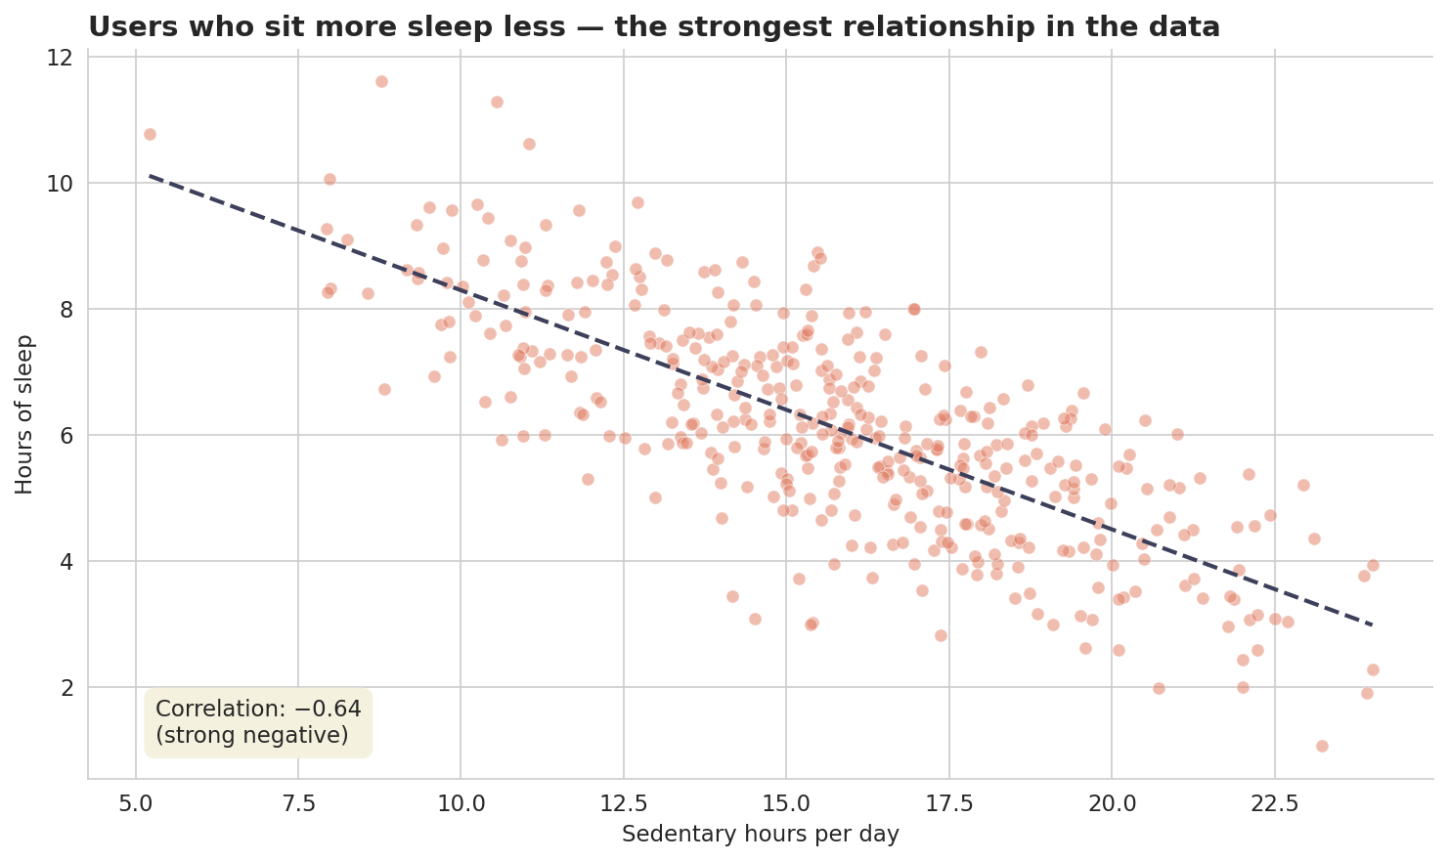
Figure 5 — Sedentary hours vs. nightly sleep (408 user-days across 24 users)
When you correlate activity metrics against sleep duration, sedentary minutes is way ahead of everything else: -0.64. Steps barely correlate (-0.20). Very-active minutes basically don't correlate at all (-0.09). It's not lack of fitness that lines up with bad sleep — it's specifically how much someone sits.
Worth noting: correlation isn't causation. People might be sedentary because they're sleep-deprived, not the other way around. But for marketing purposes, the implication still holds: a feature that helps people sit less might also help them sleep more, which is a pretty good two-for-one.

Finding 6: Engagement drops off fast
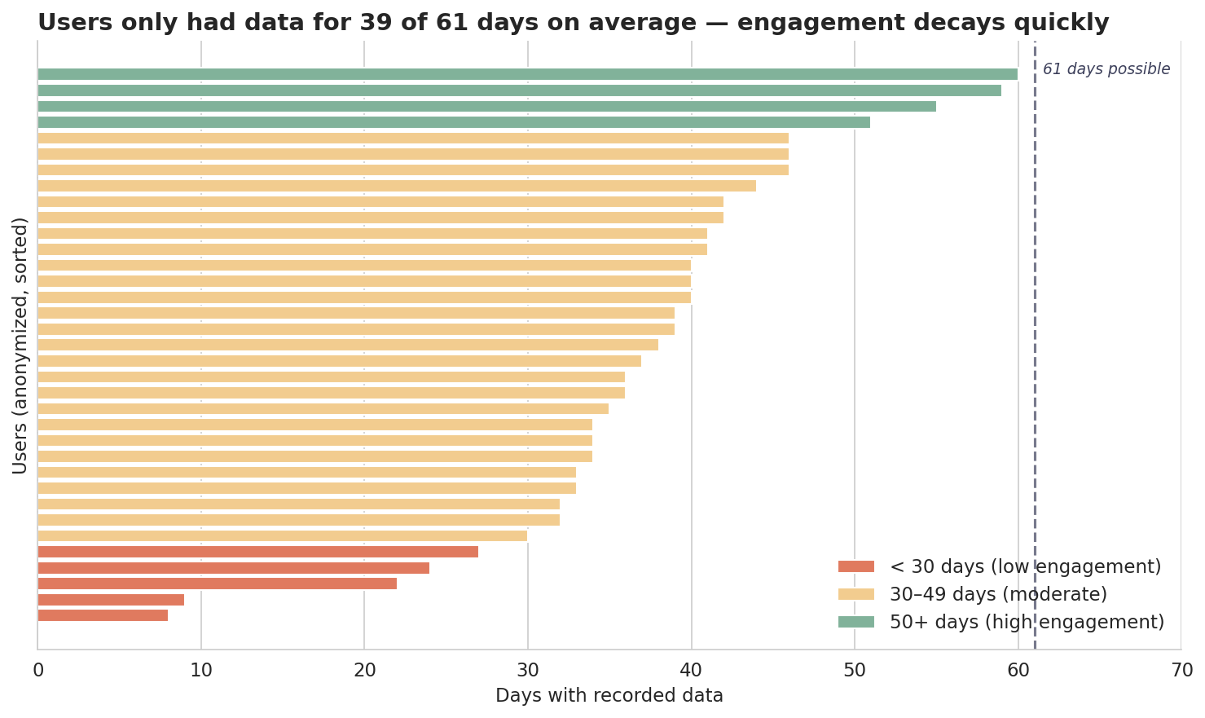
Figure 6 — Days with recorded data per user, out of 61 possible
The dataset covers 61 days, but the average user only had data for 39 of them — about 64%. Two users had under 10 days of data, basically abandoning the device early on. Combine that with the 11% non-wear rate even on "active" days, and there's a real engagement decay problem.
This matters because it's the cheapest fix on the list. Even small re-engagement efforts (notifications, weekly summaries) tend to recover meaningful chunks of lapsed users.

5. Act — Suggestions for Bellabeat
Five recommendations, each tied back to a finding and with a way to actually measure whether it's working. These are suggestions, not orders — the marketing team will know better than I do which ones are realistic given their roadmap.

1. Build different messaging for different user types
What: Treat the four activity tiers as four different audiences. The push notifications, in-app copy, and email content shouldn't be the same for someone averaging 2,000 steps a day as for someone averaging 15,000.
Why: Users split roughly 25/25/25/25 across tiers (Finding 1). A single voice can't reach more than a quarter of the audience well, and the wrong voice ("Push for a PR!" sent to a Sedentary user) probably pushes them to churn.
How to measure: A/B test segmented vs. unsegmented push notifications. Track open rate and click-through rate over 30 days.

2. Lean into reducing sitting time instead of pushing workouts
What: Make "movement minutes" or "active hours" a primary metric on the app's home screen. Add hourly stand reminders during the day. Position the app as the thing that helps you sit less, not the thing that tracks your runs.
Why: 79% of the average day is sedentary (Finding 2), and sitting time is the strongest correlate of bad sleep (Finding 5). It's the biggest available lever, and it doubles as a sleep improvement.
How to measure: Month-over-month drop in average sedentary minutes per active user. Bonus: track whether users who reduce sedentary time also see sleep improve.

3. Time notifications around the 1–4 PM lull and 9–10 PM wind-down
What: Send "get moving" prompts during the afternoon dip. Send bedtime prep prompts in the 9–10 PM window when activity is already declining.
Why: Hourly data shows a clear daily pattern (Finding 3). These windows are when users are most reachable and when nudges are most likely to actually change behavior.
How to measure: Engagement rate on time-targeted notifications vs. ad-hoc ones. Measure step lift in the hour after an afternoon notification.

4. Make sleep duration coaching a real feature, not a stat readout
What: Build something that learns each user's sleep window and prompts them when they're drifting toward a short night. Frame it around bedtime, not sleep quality.
Why: A third of sleep-tracking users are getting under 6 hours, but sleep efficiency is high (Finding 4). They're not sleeping badly — they're just not getting in bed early enough. That's a behavior problem, not a biology problem.
How to measure: Average sleep duration among users who turn on bedtime reminders. Conversion rate from free to paid Bellabeat membership among sleep-feature users.

5. Build a re-engagement flow for users who stop syncing
What: Tier the response to lapses: a friendly notification at 3 days of no sync, an email at 7 days, a "what you've been missing" digest at 14 days. Avoid streak-based shaming — research suggests it backfires for less-active users specifically.
Why: Users averaged 39 of 61 possible days of data, and 11% of recorded days were non-wear (Finding 6). Without intervention, engagement decays quickly.
How to measure: Reactivation rate within 14 days of lapse. Long-term retention at 30, 60, and 90 days post-reactivation.

6. Things I'd look at next
A few directions that would meaningfully strengthen this analysis if Bellabeat wanted to take it further:
- Get current data. 2016 FitBit users probably don't behave the same as 2025 smartwatch users, especially around sitting (remote work changed everything here).
- Use Bellabeat's own user data instead of FitBit's. The whole point is marketing to Bellabeat's actual audience.
- Layer in demographics so we can confirm the patterns hold for Bellabeat's women-focused target market specifically.
- A/B test the segmented messaging idea against the current universal copy. This is the cheapest, fastest way to validate Recommendation 1.
- Connect engagement metrics to subscription conversion, so we can actually model revenue impact instead of just engagement.
- Add heart-rate data into the mix. It opens up stress-level inferences, which tie back to Bellabeat's mindfulness positioning.

Appendix — A note on process
All the cleaning, transformation, and analysis was done in Python with reproducible cells. Cleaned CSVs are saved separately so anyone reviewing this can pick up where I left off and extend the work.
The folder structure I used: raw data, cleaned data, analysis scripts, visualizations, and final deliverables in their own subfolders. Boring but useful — it means I (or anyone else) can come back to this six months from now and not be lost.

Note: This analysis was completed with assistance from Claude (Anthropic's AI) for code structure, technical guidance, and writing polish. All analytical decisions and interpretations are my own.

