I already know and/or am certified in:
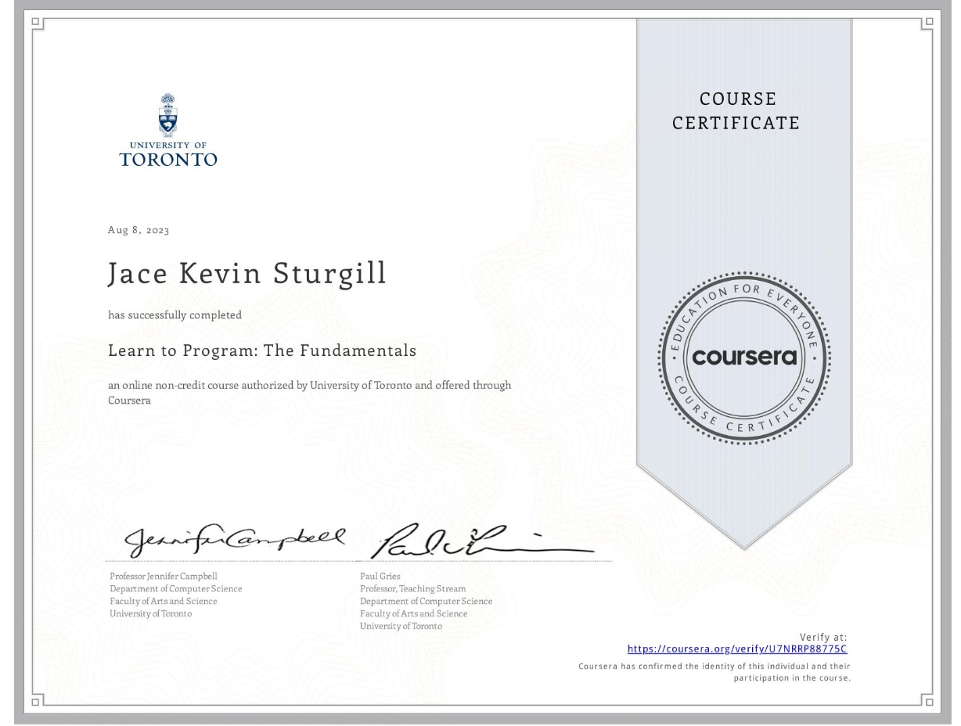Image 1 : Coursera Course Certificate for successful completion of Learn to Program: The Fundamentals at the University of Toronto

- Agile
  - Completed alison.com course 2023, sans certificate fee
  - 6 years of experience
- Scrum
- 1 year of experience
- Waterfall
  - 11 years of experience
- Python
  - Consistently pass PCEP practice tests
  - Plan to take Python Institute certification exam upon hire
  - Completed https://Coursera.org course 2023 (see Image 1)
  - Verification available at https://Coursera.org/verify/U7RRP88775C
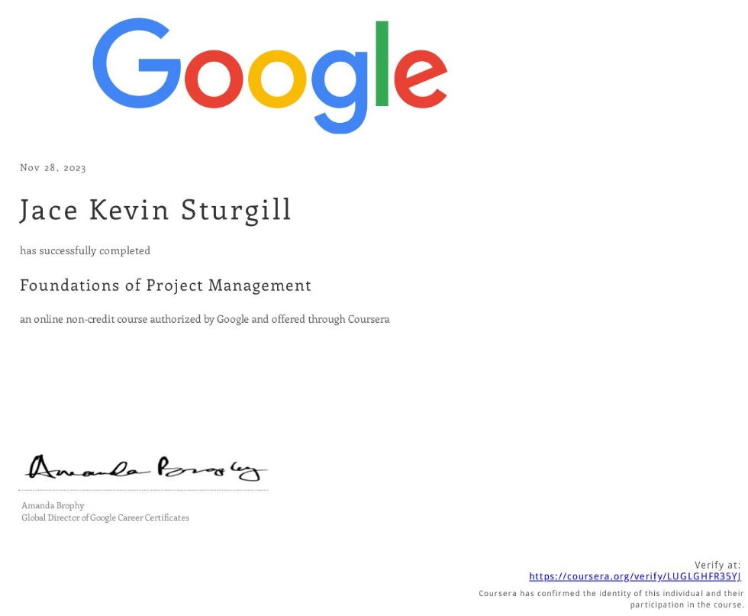Image 2 : Coursera Course Certificate for successful completion of Google Foundations of Project Management
Skills gained:
    - Python Syntax and Semantics
    - Computer Programming
    - Python Programming
    - Idle (Python)
    - Git, Git Bash
- Google Foundations of Project Management
  - See Image 2
  - Follow hyperlink for verification
- Google Foundations of Cybersecurity
  - See Image 3
  - Follow title hyperlink for verification
- Anti Money Laundering
  - Trained annually since 2017
  - Most recent: alison.com
- Java

Best Practices
- Semantic HTML
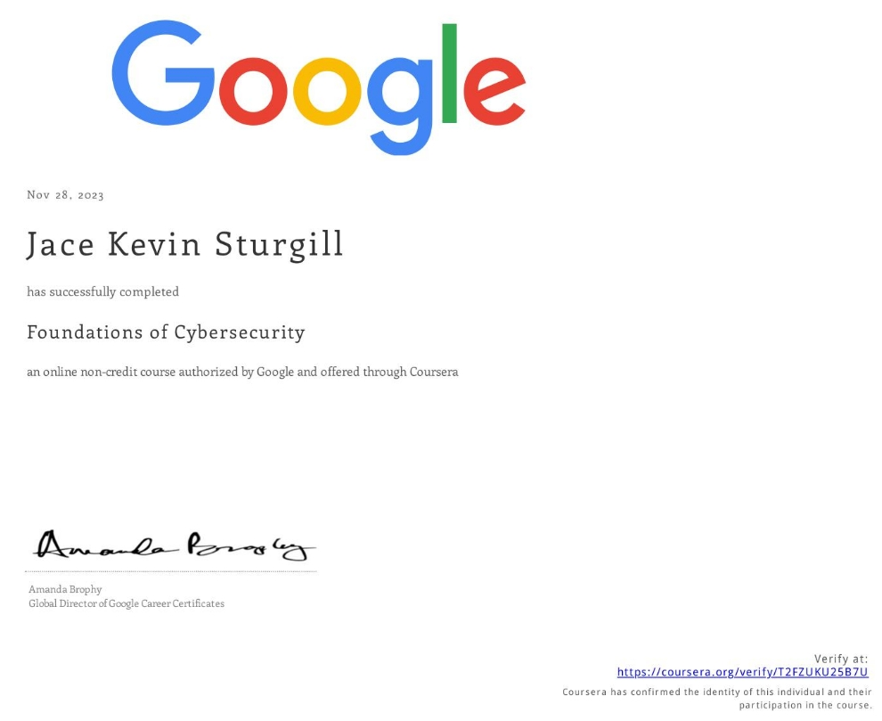Image 3 : Coursera Course Certificate for successful completion of Google Foundations of Cybersecurity
- Web Accessibility and the ADA
- Coloring for Colorblindness

I am currently learning:
- Full-Stack Web Development
Bloom Institute of Technology
Mastery:
  - HTML/CSS/Javascript Level I / III
  - Variables, Objects, Functions, Loops, Arrays
  - Best Practices
  - Commenting and Documentation
  - Sort & Manipulate Lists, Objects, and Arrays
- Project Management (Certification Path)
- Google Security (Certification Path)
- Computer Science (Certification Path)

Portfolio & Projects
https://jakesturgill.com : “it’s fine”
First Programmed Webpage :
View Page: https://jakechood.github.io/W_S1M4_Project-main/
Documentation: https://github.com/jakechood/W_S1M4_Project-main

In the near future, I plan to know how to:
- Optimize Memory
- File I/O
- Memory Stream Allocation
- Inheritance
- Recursion
- Polymorphism
- UML diagrams
- Scrum
- Kanban
- Working with Automata
- Heuristic Programming
- Data Analysis
- Mining

