Midterm Design Report

ME557 – Introduction to Robotics

**Introduction**

In the Introduction to Robotics course, we are required to build a robotic manipulator to write five letters from a user's input on a vertically mounted whiteboard that is 16" away from the robot's base. Any part of the robot must be more 10 inches away from the board in its rest position. This project is to facilitate the theoretical knowledge that we will learn in the course and reinforce practical skills in working with the electromechanical system. The purpose of this report is to provide the layout of the design ideas and planning phase.

**Components**

The project is provided with four Dynamixel AX-12A and two MX-64X servomotors. Table 1 presents the specifications of the servomotors. In addition to the servomotors, we are also provided access to the included brackets explicitly designed for Dynamixel products. The controller for the project is the OpenCM9.04, which can be programmed using the Arduino IDE. An appropriate power supply is also provided.

Table 1 Specifications of the Dynamixel servomotors.

|  |  |  |
| --- | --- | --- |
|  | **AX-12A** | **MX-64X** |
| Weight (g) | 54.6g | 135g |
| Dimension (mm) | 32 x 50 x 40 | 40.2 x 61.1x 41 |
| Resolution | 0.29° | 0.088° |
| Stall Torque (N.m) | 1.5 (at 12.0V, 1.5A) | 5.5 (at 11.1V, 3.9A)  6.0 (at 12V, 4.1A)  7.3 (at 14.8V, 5.2A) |
| Input Voltage | 9 ~ 12V (Recommended 11.1V) | 10 ~ 14.8V (Recommend 12V) |

The servomotors have built-in sensors for detecting torque and angular position. Additional external sensors are available upon request, but they will not be considered for this design. I am also donating my personal 3D printer's time and filaments; we also have access to several 3D printers on the campus.

**Problem Analysis**

1. **Physical Design**

We are provided with a total of 6 servomotors so that the robotics manipulator can have a maximum DOF of six. We do not need all six DOF to meet the design requirements. My design idea is to use four servomotors to achieve the task.

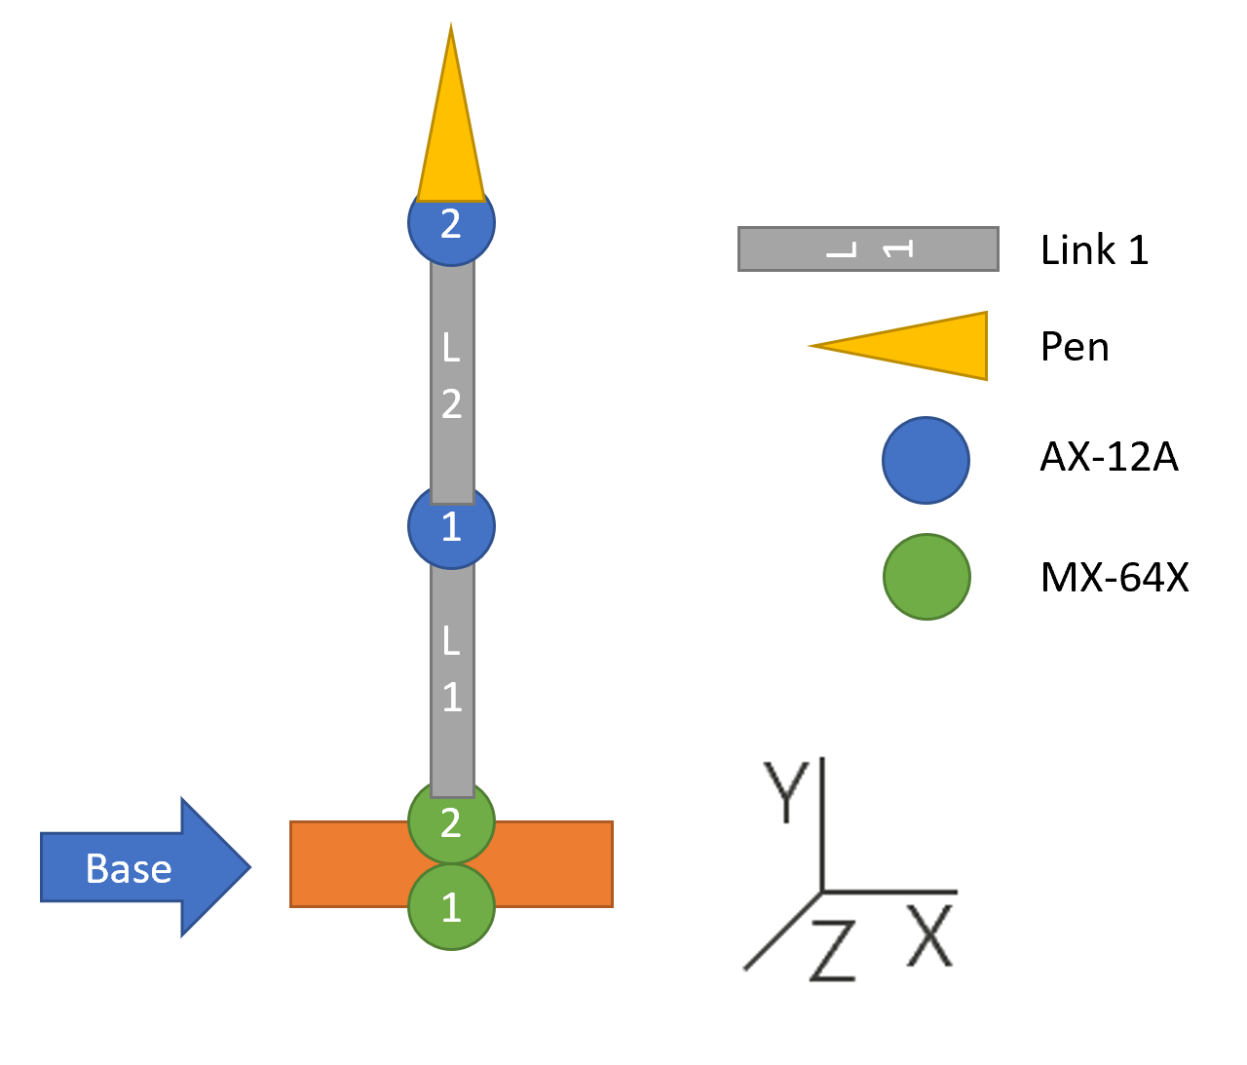

Figure 1 Design layout of the robotic manipulator.

In the design, we will be using two MX-64X and two AX-12A. Based on the reference frame of figure 1, the orientations of the servomotors are as follow:

* the MX1 rotates about the y-axis;
* the MX2 rotate about the z-axis;
* the AX1 rotates about the x-axis;
* the AX2 rotates about the z-axis.

The two MX's are in the base and shoulder, which are the weakest links. The MX2 must be able to provide enough torque to lift almost all of the mass of the robotics arm. The minimum distance from the tip of the pen to the MX1 must be 16 inches to meet the project requirements. To perform preliminary calculations, I assumed each link to be 10 inches with a cross-sectional diameter of 1.5 inches. The mass of the links can be approximated using the density of PLA filament with a 50% printing density. MX-64X can provide 6.0 Nm stall torque at 12V; if we use ¼ stall torque rule of thumb, the MX-64X should be running at 1.5 Nm torque for fluid motion. From the above information, the calculated angular acceleration is 28.6 rad/s­2. The theoretical angular acceleration at the shoulder link places a limit on how heavy the arm can be designed not to exceed the ¼ torque recommendation. From the calculated angular acceleration, it is definitely more than sufficient to run the robotic arm with the given geometrical assumptions. In the case of not having enough torque, we can use a gear system with gear ratios to favor an increase in torque.

1. **Program Design**

The OpenCM9.04 communicates directly to the Dynamixels with TTL protocol. However, the controller cannot calculate intensive matrix algebra for the inverse kinematics. The trajectory must be generated from a computer and transfer to the OpenCM9.04 via serial communication. The inverse kinematics calculation will be done in Matlab. From previous experience, serial communication is relatively slow; if the resolution of the drawing is high, it will take significantly longer to draw a character. We also need to program an algorithm to calibrate the position of the board before the drawing can be executed. The Dynamixels have built-in PID controller, so to minimize the workload, we would only focus on optimizing the built-in control algorithm if it is necessary.

**Conclusion**

The robotics manipulator is an excellent opportunity to apply the theories that we will learn in the lecture and get practical experience. The potential problems mentioned in the report is not an exhaustive list, and we should be ready to encounter more.

**References**

AX-12A: <http://emanual.robotis.com/docs/en/dxl/ax/ax-12a/>

MX-64X: <http://emanual.robotis.com/docs/en/dxl/mx/mx-64/> (the MX-64X model cannot be found, the values are using MX-64AR/ MX-64AT models)

PLA density: <http://all3dp.com/2/pla-density-what-s-the-density-of-pla-filament-plastic/>