This program manual is the version 2 of the *myIDL program manual*. This contains the programs from Summer 2017 and Summer 2018 ethane project. The repository can be found on Github https://github.com/jakechung42/PSU_Ethane_REU

**map_all_sites.pro** 2, 4

**read_noaa.pro (function)** 3

**read_ogi.pro (function)** 4

**read_uci.pro (function)** 3

**read_uci8496.pro (function)** 4

**sort_algo_check.pro** 2, 4, 6

**temporal_capegrim_latitude.pro** 2, 5

**time_vs_lat_plot.pro** 5

**What if I want to…?**

1. What if I need to map all the sites of all the data networks? map_all_sites.pro (notes: this map is not exactly the same as the AGU map because the AGU map filters out sites that are less than 30 data points (need to check on that))
2. What if I want to see how many data points of a specific coordinate of a network? Check the text file “/home/excluded-from-backup/ethane/IDL/temp_file/avail_coordn_all_network.dat”, it includes the coordinates of all the sites of all networks (no filtering of any kind). That text file is generated from map_all_sites.pro.
3. What’s the function to read in the data? read_noaa.pro, read_uci.pro, read_uci8496.pro, read_ogi.pro
4. What’s the structure of each data networks? short answer: NOAA – 29395, UCI – 3291, UCI 1984-1996 – 1790, OGI – 1253. Long answer: run map_all_sites.pro
5. How to call Cape Grim, Tasmania, Australia site from the data? For NOAA, use the site code CGO; for OGI, use the coordinate longitude 145, latitude -42 (refer to temporal_capegrim_latitude.pro)
6. Where do I find a sorting algorithm where the latitudes are sorted, and the longitudes are also sorted at each latitude in ascending order? A sorting algorithm to sort data (I call it nested sort) can be found in function uci_read8496. The sorting algorithm has been verified by the program sort_algo_check.pro
7. Where can I get a color array for plotting? There are 2 color arrays in the program temporal_capegrim_latititude.pro
8. Which program give me a complete time series of Cape Grim? time_series_capegrim.pro gives a full time series of Cape Grim from all data networks with 3 sigma filtering, error bars, deseason and everything.
9. What’s the syntax for Not A Number (NAN) value? !VALUES.F_NAN
10. How to call Barrow, Alaska site from the data? For NOAA, use site code BRW; for OGI, use coordinates 71.16, -156.5; for UCI, use the coordinate 72, -157.5
11. Everything about analyzing data from Barrow and Cape Grim? A comprehensive suite of programs that analyzes data from Barrow and Cape Grim is time_series_capegrim.pro, time_series_barrow.pro and time_series_ihr_BR_CP.pro. This suite of programs reads NOAA, UCI, OGI data and plots the interhemispheric ratio, annual means featuring 3 sigma data filtering, standard error for plots and plots of overlapping periods between data sets. The latitude band where UCI pulls the data from to represent the Cape Grim site can be changed in the time_series_capegrim.pro; more details can be found in the notes of the program.
12. What if I need to plot and compare the 2 latitude bands -44 to -40 and -46 to -38 or any other band from the UCI data set since the UCI uses data of that band to represent Cape Grim? the program time_series_capegrim can produce such a plot.

_____________________________________________________________________________________

**Template:**

Date:

Required function(s): function that I wrote, not all the functions used in a program. Just make sure that these functions are in the same folder that a program is running from.

File Input:

File Output:

Plot output:

Replacement for:

Description:

_____________________________________________________________________________________

**read_noaa.pro (function)**

Date: July 12, 2018

Required function(s): N/A

File Input: NOAA_data.dat, NOAA_locations.dat,

File Output: N/A

Plot output: N/A

Replacement for: N/A

Description: This is a function that read in all the NOAA data and build the NOAA data structure from the NOAA data. When this function is used, there is no need to give it any function input, just assign a variable to it, it will get the data and put it in that variable. Syntax example: ogi = read_ogi()

_____________________________________________________________________________________

**read_uci.pro (function)**

Date: July 12, 2018

Required function(s): N/A

File Input: modded_uci_data_v2.dat, uci_stations_v2.dat

File Output: N/A

Plot output: N/A

Replacement for: N/A

Description: This is a function that read in all the UCI data and build the UCI data structure from the UCI data. Version 2.0: (08/01/2018) This function also have a built-in sorting algorithm to sort the UCI data by latitudes and within each latitude, the longitudes are also sorted in ascending order. The sorted array has been validated with the procedure sort_algo_check.pro. The name of each site of the UCI data is not as useful as of the NOAA data, so in the data structure, the locations’ names are omitted. When this function is used, there is no need to give it any function input, just assign a variable to it, it will get the data and put it in that variable. Syntax example: ogi = read_ogi()

_____________________________________________________________________________________

**read_uci8496.pro (function)**

Date: July 12, 2018

Required function(s): N/A

File Input: modded_84_96_uci_data.dat

File Output: N/A

Plot output: N/A

Replacement for: N/A

Description: This is a function that read in all the new UCI (1984-1996) data and build the data structure. The date time conversion has been verified that it matches with the original excel file. Version 2.0: (08/01/2018) this function also have a built-in sorting algorithm to sort the UCI data by latitudes, and within each latitude the longitudes are also sorted in ascending order. The sorted array can be printed out to an ASCII file and checked with the procedure sort_algo_check.pro. When this function is used, there is no need to give it any function input, just assign a variable to it, it will get the data and put it in that variable. Syntax example: ogi = read_ogi()

_____________________________________________________________________________________

**read_ogi.pro (function)**

Date: July 12, 2018

Required function(s): N/A

File Input: KhalilEtAl_data_set.dat, KhalilEtAl_locations.dat

File Output: N/A

Plot output: N/A

Replacement for: N/A

Description: This is a function that reads in all the OGI data and build the data structure. When this function is used, there is no need to give it any function input, just assign a variable to it, it will get the data and put it in that variable. Syntax example: ogi = read_ogi()

_____________________________________________________________________________________

**map_all_sites.pro**

Date: July 6, 2018 – Version 1; July 12, 2018 – Version 2 (add output coordinates to a text file)

Required function(s): read_noaa, read_uci, read_uci8496, read_ogi

File Input: NOAA_stations_IDs.dat

File Output:

* avail_coordn_all_network.dat: coordinates of all the sites from all the data networks along with the number of data points for each site.

Plot output: map of all the sites from the 3 data networks and the new UCI

Replacement for: wmap_all_stations.pro

Description: This program will plot the locations of all the sites from the 3 data networks and the new UCI on to a world map. UCI data and UCI_new (1984-1996) data use the modified coordinates. The modified coordinates are generated from the programs *uci_mod_lat_lon.pro* and *uci_84_96_mod_lat_lon.pro*. The coordinates of OGI data are input manually. *Version 2.0:* reading the data for all network is replaced by separated functions. Output a text file that contains the coordinates of all the available sites and number of data points for all networks. The location of the output file is “/home/excluded-from-backup/ethane/IDL/temp_file/avail_coordn_all_network.dat”

_____________________________________________________________________________________

**time_vs_lat_plot.pro**

Date: 07/25/2018

Required function(s): read_uci8496, read_noaa, read_uci, read_ogi

File Input: NA

File Output: NA

Plot output: time vs latitude plot

Replacement for: NA

Description: this program plots the time vs latitude plot of all sites from all data sets. The x-axis is in decimal year. This plot ignores the longitudes of the sites and gives a representation of how the data is distributed temporal and latitudinally.

_____________________________________________________________________________________

**temporal_capegrim_latitude.pro**

Date: 07/25/2018

Required function(s): read_uci8496, read_noaa, read_uci, read_ogi

File Input: NA

File Output: NA

Plot output: a time series of the Cape Grim site for NOAA, OGI and latitude band -44 to -40 of UCI and UCI_new data set.

Replacement for: NA

Description: this program produces the plot for Cape Grim of NOAA, OGI. Since the UCI data don’t have Cape Grim, the data is pulled from latitude bands -44 to -40. The latitude band can be changed in the program (variable up_bound and low_bound). Unfortunately, the program will plot all the sites within the band in the same color, next iteration will bring in an algorithm to plot the sites within the band in different colors so the data can be represented more clearly. Version 2 (8/2/2018): now with version 2, each unique coordinate within the band is plotted with different colors and different symbol sizes so the contribution of the sites to the data set can be easily visualized.

_____________________________________________________________________________________

**sort_algo_check.pro**

Date: 08/01/2018

Required function(s): NA

File Input: modded_84_96_uci_data.dat, uci_8496_data_struct.dat

File Output: NA

Plot output: NA

Replacement for: NA (some other programs that I don’t remember)

Description: This program reads in an original data file and a sorted data file from the original data file to check to see if the sorted data has the same content as the original data. It basically run though the two data sets and check that each date, of each site has the same mixing ratio value to make sure that the sorting algorithm was working correctly. This program can be configured to read in any data set to check the sorting algorithm. As of right now, it’s reading the 8496 UCI data and the sorted 8496 UCI data.

_____________________________________________________________________________________

**time_series_capegrim.pro**

Date: 08/06/2018

Required function(s): read_uci8496, read_noaa, read_uci, read_ogi, deseason, std_dev_fgauss

File Input: NA

File Output: annual_mean_cape_grim_SECTION_B, annual_mean_capegrim_NoHeaders.dat

Plot output: time series of Cape Grim from OGI and NOAA, UCI uses either latitudes 40 to 44 or 38 to 46 south.

Replacement for: NA

Description: this program plots the annual mean of the Cape Grim site for NOAA and OGI data sets. The UCI data use either the latitude band 40 to 44 or 38 to 46 south. The annual means are calculated using the monthly averages. If one month of a year is missing, the entire year is scrapped. The program also output a report file for all data set. This program outputs an ASCII file called annual_mean_capegrim_NoHeaders.dat for the program time_series_ihr_BR_CP.pro to read. Since UCI doesn’t have Cape Grim site, it uses a latitude band with 42 as its center latitude. The boundaries of this latitude band can be changed by changing the variables low_bound1 and up_bound1; changing these two variables also changes the data that is written into the file annual_mean_capegrim_NoHeaders.dat which will affect the data that is plotted for the IHR plot in the program time_series_ihr_BR_CP.pro.

_____________________________________________________________________________________

**time_series_barrow.pro**

Date: 08/15/2018

Required function(s): read_noaa, read_uci8496, read_uci, read_ogi, std_dev_fgauss, deseason

File Input: NA

File Output: annual_mean_barrow.dat, annual_mean_barrow_NoHeaders.dat

Plot output: time series of the Barrow site from all 3 data sets, and overlapping period between NOAA and UCI from the same site.

Replacement for: potentially all the old programs that plot time series of Barrow vs either Samoa or Cape Grim.

Description: this program plots the annual means of the Barrow site from all three data sets with 3 sigma filtering, standard error calculated from the deseasonal data. The annual means are calculated using the monthly averages. If one month of a year is missing, the entire year is scrapped. The output file is a report with annual mean, standard error, standard deviation, months with data, and number of samples from each year. This program also output a file called annual_mean_barrow_NoHeaders.dat; this file is read by the program time_series_ihr_BR_CP.pro to plot the IHR time series.

_____________________________________________________________________________________

**time_series_ihr_BR_CP.pro**

Date: 08/16/2018

Required function(s): NA

File Input: annual_mean_barrow_NoHeaders.dat, annual_mean_capegrim_NoHeaders.dat

File Output: NA

Plot output: annual IHR calculated from the Barrow and Cape Grim sites.

Replacement for: temporal_ihr_w_2sites.pro, temporal_ihr_BarrowCapeGrim_Aydin_FirnAir.pro, temporal_ihr_BarrowSamoa_Aydin_FirnAir.pro

Description: This program read the output file from time_series_capegrim.pro and time_series_barrow.pro to calculate the annual interhemispheric ratio. UCI doesn’t have the Cape Grim site, so the data is being pulled from the latitude band 46 to 38. This latitude band boundaries can be changed by changing the variables low_bound1 and up_bound1 in the program time_series_capegrim.pro, recompile and rerun time_series_capegrim.pro so the output file can be updated with the new data.

_____________________________________________________________________________________

**deseason.pro (function)**

Date: 08/03/2018

Required function(s): NA

File Input: NA

File Output: NA

Plot output: NA

Replacement for: NA

Description: this function calculates the residual of seasonal time series. The input is month, year, and concentration. This function can only do one site at a time, so if want to do multiple sites, need to put it in a loop.

_____________________________________________________________________________________

**std_dev_fgauss.pro (function)**

Date: Summer 2017

Required function(s):

File Input:

File Output:

Plot output:

Replacement for:

Description:

_____________________________________________________________________________________

**time_series_ihr_global.pro**

Date: 08/27/2018

Required function(s): deseason, std_dev_fgauss, read_uci8496, read_noaa, read_ogi, read_uci.

File Input: NA

File Output: time_series_ihr_global-annual_noaa.dat, time_series_ihr_global-annual_uci.dat, time_series_ihr_global-annual_ogi.dat

Plot output: Interhemispheric ratio of global ethane.

Replacement for: potentially all programs that do interhemispheric ratio for global ethane that were written during Summer 2016 and Summer 2017. This program is much shorter even though it is more flexible, because the calculations are handled in different functions or written only one time to subroutines and carried to different data sets rather than copied and pasted with the variables changed. Any change that is made can be on in the subroutines that will carry through the entire program.

Description: this program calculates the interhemispheric ratio and the hemispheric means using the global ethane data from NOAA, UCI, OGI including the 1984-1996 UCI data obtained in Summer 2017. The method to calculate the IHR can be found in the document ihrCalculationMethod.docx. The bin_bound variable controls the latitude bins. Update Oct-18-2018: adding output to this program. The output files are for ihrSamplingSensitivity.pro to use to compare the IHR sensitivity calculated using 4-month data versus 12-month data.

_____________________________________________________________________________________

**debugger.pro (function)**

Date: 10/18/2018

Required function(s): NA

File Input: NA

File Output: a temp file that contains the data of the function’s input

Plot output: NA

Replacement for: NA

Description: this function when put in a program will halt the execution of that program using IDL’s *stop* function. The program can be resumed by using the command “.continue” in the IDL command prompt. The input for this function can be any data array. This function will spawn a text file of that input array rather than printing it out to the screen.

_____________________________________________________________________________________

**ihrSamplingSensitivity.pro**

Date: 10/16/2018

Required function(s): deseason, std_dev_fgauss, read_uci8496, read_noaa, read_ogi, read_uci.

File Input: NA

File Output: NA

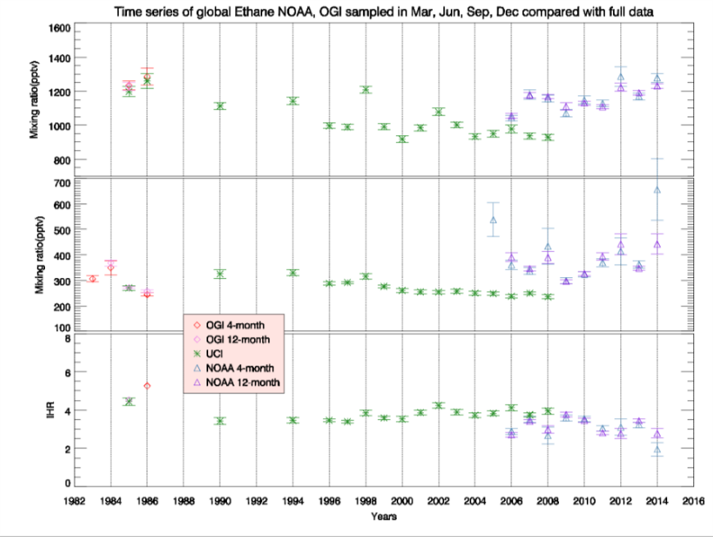 Plot output: global IHR with 4-month results compared with 12-months results

Replacement for: NA

Description: this function performs the exact same calculations as the time_series_ihr_global.pro program. The difference in the 2 programs is the data that is used. The program time_series_ihr_global.pro uses global data with NOAA and OGI data samples from all 12 months; ihrSamplingSensitivity.pro uses NOAA and OGI data only from March, June, September, and December. This method of calculating the 4-month IHR is more consistent to UCI since UCI data are only available in March, June, September, and December.