DATA SCIENCE CASE STUDY

Predicting Shipment Freight Cost on the USAID SCMS Dataset
Data Analysis Report
A gradient boosting study of USAID SCMS delivery history (2006 to 2015).

HEADLINE RESULT Gradient boosting predicts freight cost at R² = 0.756 on held-out shipments. Used as a screening tool, the top 50 over-expectation shipments flag about $2.2M in freight above the model's expectation, on donor-funded supply where every dollar saved is more medicine delivered.

Jacob Cook

Executive Summary

This study asks whether a gradient boosting model can predict USAID SCMS shipment freight cost to at least 70% R². Using roughly 6,200 shipments enriched with engineered distance and fuel-price features, we built and validated a gradient boosting regressor against a ridge baseline.
Findings
The tuned model reaches R² = 0.756 on the log scale, clearing the 70% threshold and supporting the hypothesis, roughly doubling the ridge baseline (R² = 0.354). Feature enrichment lifted accuracy from R² = 0.7335 to 0.7564. Shipment weight is the dominant cost driver (0.78 permutation-importance share), and Welch's ANOVA confirms freight cost differs significantly across shipment modes (F(3, 944) = 246.5, p < 0.001), with air and air-charter lanes concentrating cost.
Limitations
The strongest result holds on the log scale; back-transformed to dollars the model explains less (R² = 0.603), so absolute-dollar precision is lower than the log fit implies. Accuracy also declines out of period (temporal holdout R² = 0.650), the data ends in 2015, and 40% of shipments bundle freight into commodity cost and were excluded.
Recommendations
Deploy the ranked over-expectation worklist to route shipments whose actual freight sits materially above prediction to contract review; apply the model at order time to screen quoted rates; retrain on a regular cadence; and prioritize carrier renegotiation on the flagged high-cost air lanes.
Benefits
The top 50 flagged shipments alone represent about $2.2M in freight above expectation, so a dollar-weighted worklist gives reviewers a prioritized target rather than a random sample, directly supporting cost-per-unit and concession reduction. Order-time screening enables proactive budgeting, and fixing origin and line-level freight logging would recover visibility into the 40% of program spend currently excluded.
Contents
Executive Summary 1
A: Research Question 3
A1: Justification 3
A2: Context 3
A3: Hypothesis 3
B: Data Collection 4
B1: Data Collected 4
B2: Advantage of the Gathering Method 6
B3: Disadvantage of the Gathering Method 6
B4: Challenges Overcome 6
C: Data Extraction and Preparation 7
C1: Preparation Process (Screenshots) 7
C2: Tools and Techniques 14
C3: Justification (Advantage and Disadvantage) 14
D: Analysis 15
D1: Target Normality (Fig 1) 15
D2: Technique 1 (Gradient Boosting) 16
D3: Technique 2 (Ridge Regression) 17
D4: Feature-Set Comparison (Fig 3) 18
D5: Technique 3 (Welch's ANOVA, Fig 4) 19
D6: Temporal Validation 20
E: Data Summary and Implications 21
E1: Results in Context of the Research Question (Figs 5-7) 21
E2: Limitations 24
E3: Recommendations (Fig 8) 25
E4: Future Directions 26
F: Sources 27

Research Question

Justification
On donor-funded health supply, every avoidable dollar of freight is a dollar of medicine that doesn't get delivered. We asked whether a gradient boosting model could predict USAID SCMS shipment freight cost to at least 70% R², accurately enough to flag shipments priced above expectation for review. Using roughly 6,200 shipments (6,197 after cleaning) enriched with engineered distance and fuel-price features, we built and validated that model against a ridge baseline, and its top 50 over-expectation flags surface about $2.2M above what the model expects, a prioritized target list a random audit would take far longer to find. Freight is one of the larger controllable costs in a health commodity supply chain, so this worklist (developed in Section E) turns an accurate model directly into a cost-review action.

Context
The SCMS program moved health commodities across a global humanitarian supply network, where freight is a large and partly controllable share of distribution cost. That gives the research question a clear operational setting: an accurate cost model can screen quoted or actual freight against an expected value and surface the shipments worth reviewing. Prior work supports the feasibility of that goal, as machine learning, and gradient boosting in particular, has been applied to predict transport and freight cost from shipment attributes (Budzyński & Cieśla, 2025; Xu et al., 2026).

Hypothesis
H0: A gradient boosting model cannot reach at least 70% R² on this data.

H1: A gradient boosting model can reach at least 70% R² on this data.

H1 is plausible because gradient boosting handles the heavy right-skew and the nonlinear, interacting relationships (mode, weight, distance, and destination acting together) that keep a linear model well below the threshold, and because prior studies have predicted freight cost from shipment attributes with the same family of methods (Xu et al., 2026).

Data Collection

Data Collected
We used an archived version of the USAID Supply Chain Management System (SCMS) Delivery History dataset hosted on Kaggle (U.S. Agency for International Development, n.d.). It holds 10,324 shipment records, each carrying a freight cost along with shipment and product attributes. Two supplementary sources support the engineered predictors: monthly U.S. Gulf Coast diesel and jet fuel spot prices from the U.S. Energy Information Administration (n.d.-a, n.d.-b), and country centroid coordinates from Google's Dataset Publishing Language (Google, n.d.).

Variable Inventory
We began by inventorying the 33 fields, classifying each as categorical or continuous and labeling its modeling role (target, predictor, identifier, or feature source). This confirmed the target (freight cost) and the modeled predictors, and it flagged manufacturing site and delivered-to-client date as sources for engineered features rather than direct inputs. All fields and their use-case are listed below.

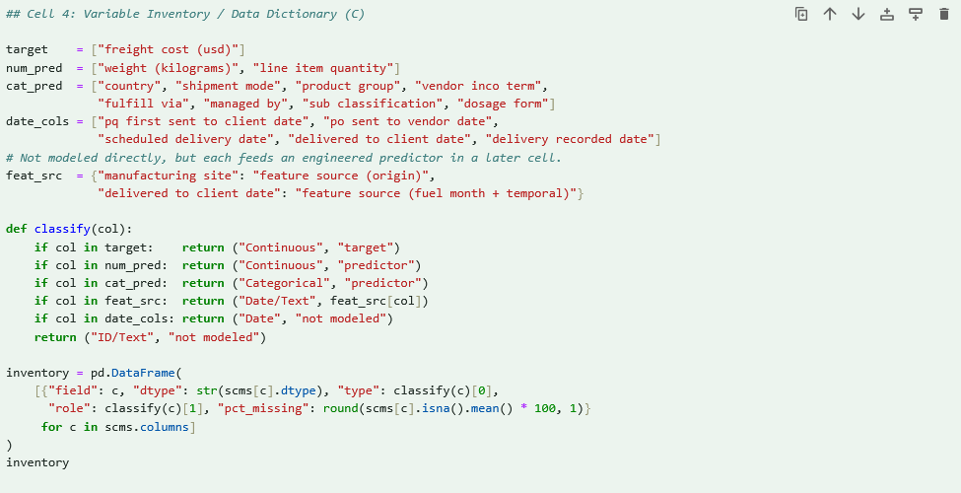
Figure B1. Feature selection and data information report.

# | field | dtype | type | role | pct_missing
31 | freight cost (usd) | str | Continuous | target | 0
5 | country | str | Categorical | predictor | 0
6 | managed by | str | Categorical | predictor | 0
7 | fulfill via | str | Categorical | predictor | 0
8 | vendor inco term | str | Categorical | predictor | 0
9 | shipment mode | str | Categorical | predictor | 3.5
13 | delivered to client date | str | Date/Text | feature source (fuel month + temporal) | 0
15 | product group | str | Categorical | predictor | 0
16 | sub classification | str | Categorical | predictor | 0
22 | dosage form | str | Categorical | predictor | 0
24 | line item quantity | int64 | Continuous | predictor | 0
28 | manufacturing site | str | Date/Text | feature source (origin) | 0
30 | weight (kilograms) | str | Continuous | predictor | 0
32 | line item insurance (usd) | float64 | ID/Text | not modeled | 2.8
0 | id | int64 | ID/Text | not modeled | 0
1 | project code | str | ID/Text | not modeled | 0
2 | pq # | str | ID/Text | not modeled | 0
3 | po / so # | str | ID/Text | not modeled | 0
4 | asn/dn # | str | ID/Text | not modeled | 0
10 | pq first sent to client date | str | Date | not modeled | 0
11 | po sent to vendor date | str | Date | not modeled | 0
12 | scheduled delivery date | str | Date | not modeled | 0
14 | delivery recorded date | str | Date | not modeled | 0
17 | vendor | str | ID/Text | not modeled | 0
18 | item description | str | ID/Text | not modeled | 0
19 | molecule/test type | str | ID/Text | not modeled | 0
20 | brand | str | ID/Text | not modeled | 0
21 | dosage | str | ID/Text | not modeled | 16.8
23 | unit of measure (per pack) | int64 | ID/Text | not modeled | 0
25 | line item value | float64 | ID/Text | not modeled | 0
26 | pack price | float64 | ID/Text | not modeled | 0
27 | unit price | float64 | ID/Text | not modeled | 0
29 | first line designation | bool | ID/Text | not modeled | 0
Table B1. SCMS delivery-history variable inventory and data dictionary.

# | field | dtype | type | role | pct_missing
0 | jet fuel spot price date | str | Date | feature source (fuel month) | 0
1 | jet fuel spot price (usd/gal) | float64 | Continuous | feature source (mode_fuel_price) | 0
2 | diesel spot price date | str | Date | feature source (fuel month) | 0
3 | diesel spot price (usd/gal) | float64 | Continuous | feature source (mode_fuel_price) | 0
4 | centroid country | str | ID/Text | join key | 0
5 | centroid latitude | float64 | Continuous | feature source (distance_km) | 0
6 | centroid longitude | float64 | Continuous | feature source (distance_km) | 0
Table B2. Supplementary data sources: fields used to engineer distance and fuel price.

Advantage of the Gathering Method
The main advantage of this method (direct download of an archived public dataset, backed by two authoritative government and industry sources) is reproducibility: every file is public and free of personal or proprietary content, so anyone can re-pull the exact inputs and reproduce the analysis end to end, which matters for both academic authenticity and any later audit of the model. Pulling from three independent sources also lets us cross-reference rather than trust a single provider, and because the inputs are fixed public artifacts the pipeline is easy to version and re-run as the analysis evolves.

Disadvantage of the Gathering Method
The main disadvantage is that the data is a static historical archive, spanning 2006 to 2015. A model trained on it reflects the cost patterns of that period, so it needs recent shipment records fed in over time to stay current, a limitation inherent to a fixed archive rather than a live feed. A second, related drawback is that fuel price and distance aren't native to the records: we derive and join them from the supplementary sources, which generalizes distance to the country level rather than an address-to-address measurement.

Challenges Overcome
Many numeric fields carried text codes in place of values (for example, "See DN-304" or "Weight Captured Separately"), so we coerced those columns to numeric and set aside the shipments whose freight cost was recorded only as a bundled or invoiced-separately note rather than a line-level figure. Country names were inconsistent across the three sources, which we reconciled with a combined country-code and keyword mapping so that origins and destinations lined up with the centroid coordinates. Fuel prices arrive as a daily series, so we aggregated them to monthly averages and aligned each shipment to the price for its delivery month, choosing the fuel type that matched the shipment mode. Section C documents each of these steps with a screenshot.

Data Extraction and Preparation

Extraction and preparation ran in Python, with pandas handling the cleaning, joins, and encoding, numpy computing great-circle distance, and scikit-learn producing the train and test split. Each step below is shown with a screenshot.

Preparation Process (Screenshots)

Step 1: Data Completeness and Sparsity (Fig C1)
We then measured completeness. Only 0.70% of cells are empty, rising to about 3.07% once the text placeholders in the numeric fields are counted as missing, and there are no exact duplicate rows and no repeated identifiers. The dataset is dense enough to model without aggressive imputation.

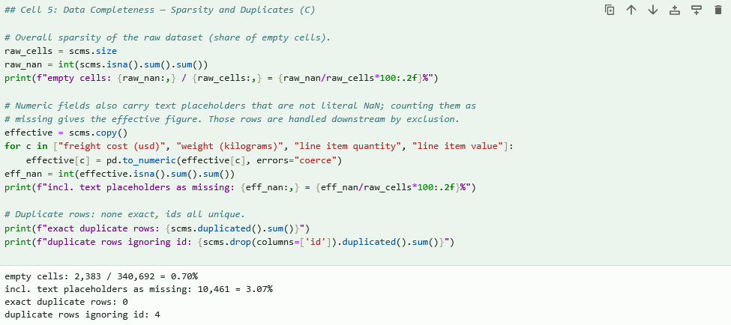
Figure C1. Data completeness: sparsity and duplicate check.

Step 2: Clean Text-Coded Numeric Fields (Fig C2)
Several numeric fields stored text codes (for example, freight recorded as "Freight Included in Commodity Cost" or "See DN-304"). We coerced freight cost, weight, line item quantity, and line item value to numeric, which turns these placeholders into missing values and leaves 6,198 shipments with a usable line-level freight cost.

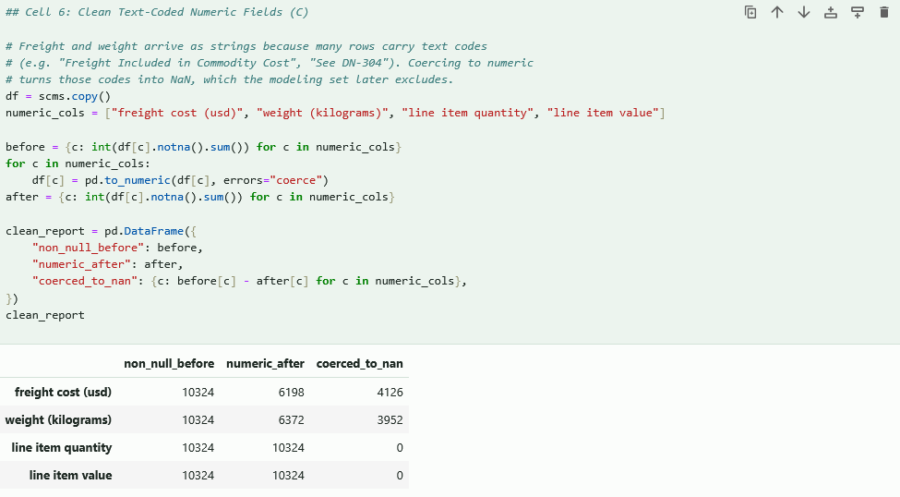
Figure C2. Cleaning text-coded numeric fields.

Step 3: Standardize Geography (Fig C3)
We derived a clean origin country from the free-text manufacturing site using a country-code and keyword mapping, and took the destination country directly from the country field. About 12.8% of origins could not be resolved and are marked Unknown.

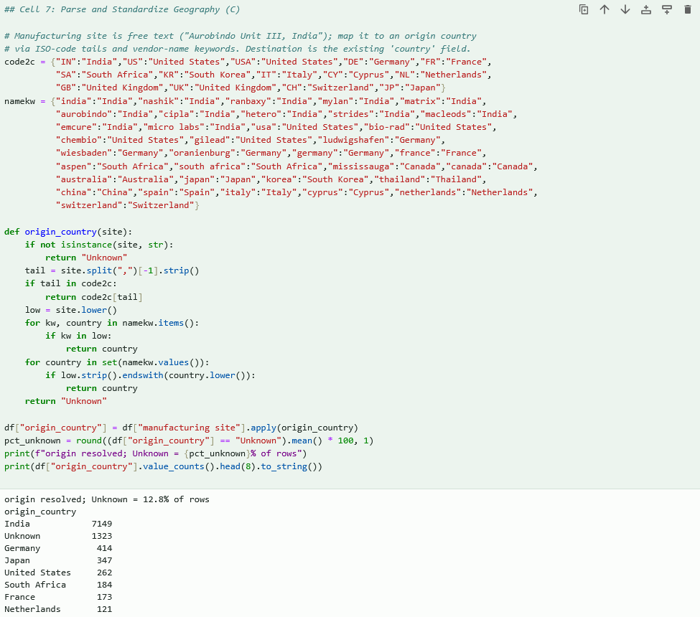
Figure C3. Origin and destination country standardization.

Step 4: Great-Circle Distance (Fig C4)
We joined latitude and longitude centroids for each origin and destination and computed the great-circle (haversine) distance in kilometers. Distance is missing for the same 12.8% of shipments whose origin was unknown.

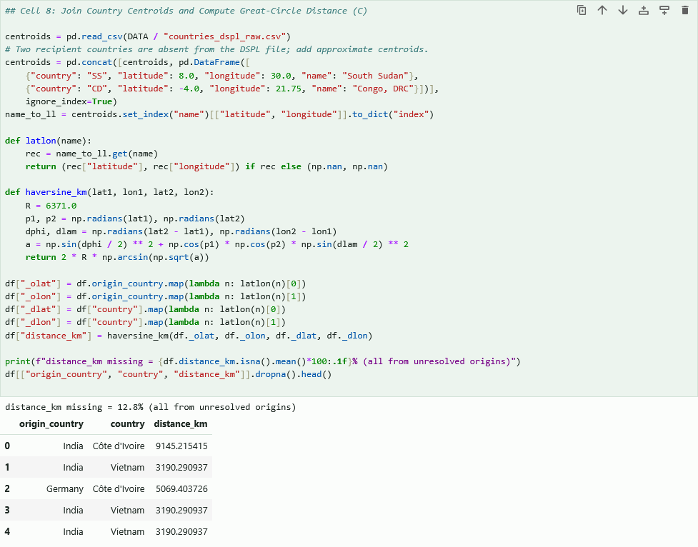
Figure C4. Country-centroid join and great-circle distance.

Step 5: Fuel-Price Join (Fig C5)
We aggregated the daily EIA spot prices to monthly averages and joined a mode-appropriate fuel price to each shipment by its delivery month: jet fuel for air and air charter, diesel for truck, and jet fuel as the proxy for ocean. The joined price is missing for the 3.5% of shipments with no recorded mode.

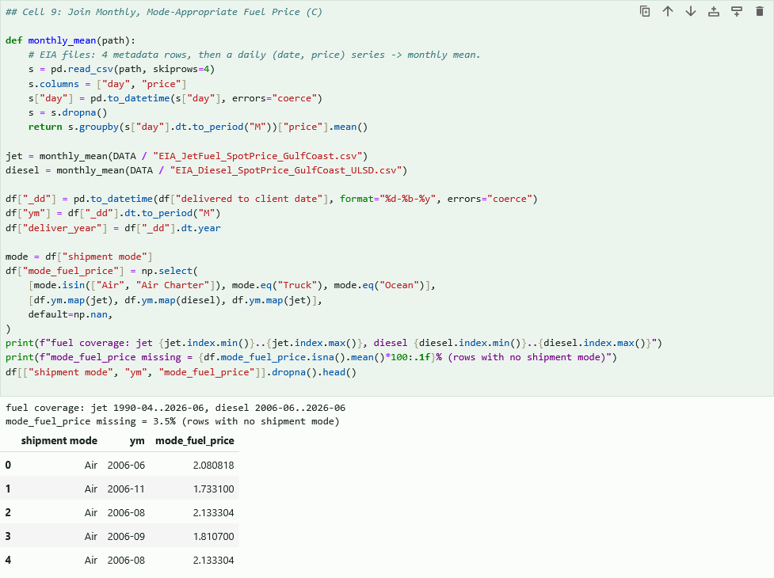
Figure C5. Monthly, mode-appropriate fuel-price join.

Step 6: Modeling Base, Missing Values, Outliers (Fig C6)
We fixed the modeling base at the 6,198 shipments with a positive freight cost, then dropped one row with a non-positive weight, leaving 6,197. Genuine missing numerics are kept as NaN (gradient boosting handles them natively) with indicator flags added for the linear model, categoricals are filled with Unknown, and high-freight outliers are retained because the log transform and the tree model absorb the spread.

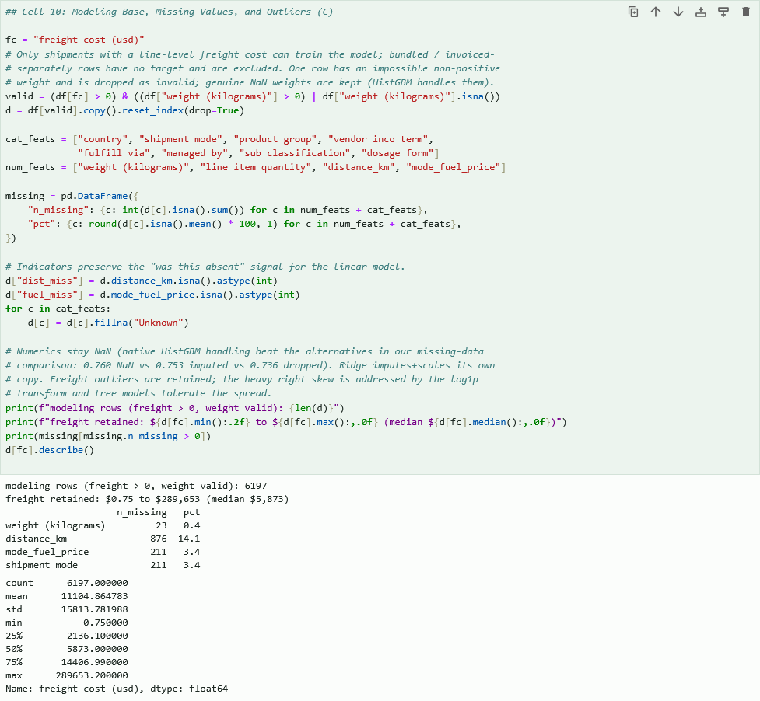
Figure C6. Modeling base, missing-value handling, and outliers.

Step 7: Feature Engineering and log1p Target (Fig C7)
We applied a log1p transform to freight cost, which pulls the target from strongly right-skewed (skew 4.69) to near-symmetric (skew -0.35). We also defined the two feature sets compared later: operational (weight, quantity, and the eight categoricals) and enriched (the same plus distance and fuel price with their missingness flags).

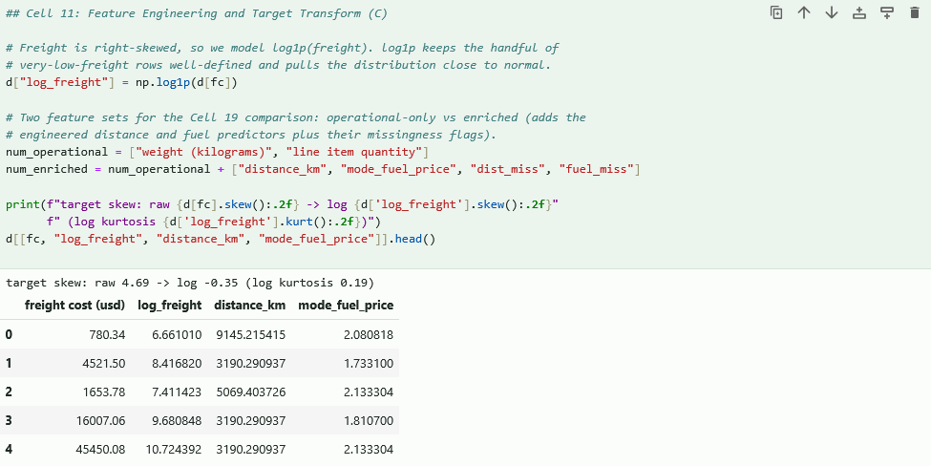
Figure C7. Feature engineering and log1p target transform.

Step 8: One-Hot Encoding (Fig C8)
We one-hot encoded the eight categorical fields into 84 indicator columns, keeping the numeric predictors with their NaN intact. This yields an operational design matrix of shape (6,197, 86) and an enriched matrix of (6,197, 90).

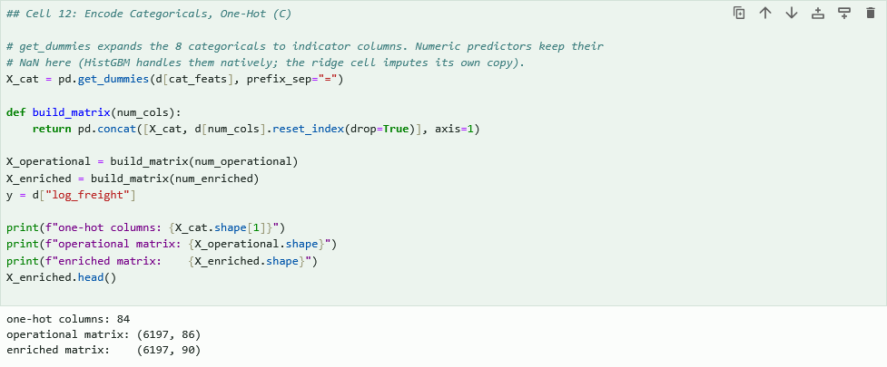
Figure C8. One-hot encoding of categorical fields.

Step 9: Train and Test Split (Fig C9)
We split the data 80/20 with a fixed random seed, giving 4,957 training and 1,240 held-out test shipments. Indexing by position lets the same split apply to both feature matrices and to the dollar-scale freight used for error metrics.

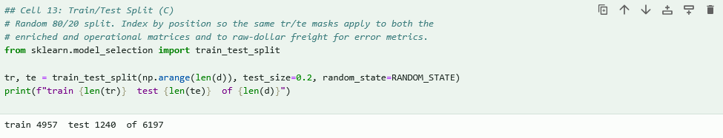
Figure C9. Train and test split.

Tools and Techniques
All preparation, analysis, and visualization ran in Python. pandas (McKinney, 2010) performed the loading, type coercion, cross-source joins, and one-hot encoding; NumPy (Harris et al., 2020) implemented the vectorized haversine distance calculation; and scikit-learn (Pedregosa et al., 2011) produced the train and test split along with the gradient boosting, ridge, and permutation-importance routines. SciPy (Virtanen et al., 2020) supplied the distribution diagnostics (skew, Shapiro-Wilk, and Q-Q), statsmodels (Seabold & Perktold, 2010) supplied Welch's ANOVA and the Breusch-Pagan test, and Matplotlib (Hunter, 2007) produced the figures. We chose these because they are the standard, well-documented tools for tabular work of this size, and they interoperate cleanly, so the pandas output feeds directly into scikit-learn.

Justification (Advantage and Disadvantage)
The pandas library is standard for tabular extraction and preparation at this scale, and the log1p transform directly addresses the skew documented in Section D, so the toolset matches both the data and the task. The advantage is that pandas operations are vectorized, readable, and fully reproducible on a dataset of roughly ten thousand rows, so the whole pipeline re-runs in seconds. The disadvantage is that pandas works in memory, so this approach would not scale to billions of rows without a distributed framework, and the manual join keys (country names across three sources) can mismatch if source naming drifts, which is why the geography step needed explicit standardization.

Analysis

Freight cost is right-skewed, so the target is modeled on a log1p scale throughout. We apply three analysis techniques (gradient boosting, ridge regression, and Welch's ANOVA), each justified below with one advantage and one disadvantage. Target normality (D1) and temporal validation (D6) are supporting diagnostics that check the modeling assumptions.

Target Normality (Fig 1)
Because both regression and analysis of variance assume an approximately normal, constant-variance response, we first examined the freight-cost distribution. Raw freight cost is strongly right-skewed (skew 4.69), driven by a small number of very large shipments. A log1p transform pulls it to near-symmetric (skew -0.35, kurtosis 0.19), and the Q-Q plot confirms the transformed values track the normal line through the body of the distribution. We therefore model on the log scale, and we read the Shapiro-Wilk statistic only as a caveated supplement, since at this sample size it over-rejects normality even for well-behaved data.

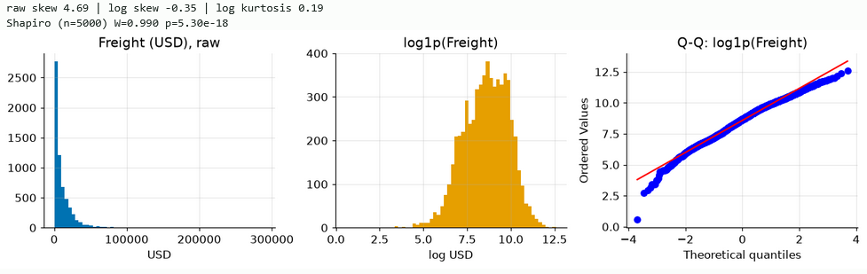
Figure 1. Freight cost distribution: raw, log1p-transformed, and Q-Q plot of the log values.

Technique 1 (Gradient Boosting)
Our primary technique is histogram-based gradient boosting (scikit-learn's HistGradientBoostingRegressor), an ensemble that fits shallow decision trees in sequence, each correcting the previous stage's errors (Friedman, 2001). We tuned three hyperparameters (learning rate, iteration count, and tree width) with a five-fold cross-validated grid search; the best configuration (learning rate 0.1, 200 iterations, 31 leaves) reached a cross-validated R² of 0.743. Refit on the training split and scored on the 1,240-shipment holdout, the model reaches R² = 0.756 on the log scale (0.603 on the dollar scale), with mean absolute error of $4,673, root mean squared error of $11,856, and a median absolute percentage error of 31%.

We selected gradient boosting because freight cost depends on nonlinear, interacting factors that a linear model cannot represent, and because the method accepts the missing distance and fuel values natively without imputation. Its advantage is high predictive accuracy with minimal preprocessing; its disadvantage is lower interpretability than a linear model, which we address with the permutation-importance analysis in Section E.

Item | Value
Best CV R² (5-fold) | 0.7425
Learning rate | 0.1
Iterations (max_iter) | 200
Max leaf nodes | 31
Holdout R² (log scale) | 0.7564
Holdout R² (dollar scale) | 0.6028
MAE | $4,673
RMSE | $11,856
Median APE | 31%
Table D2. Gradient boosting hyperparameter tuning and holdout metrics.

Residual and Homoscedasticity Diagnostic (Fig 2)
To check the assumptions behind the log-scale fit, we examined residuals on the holdout. The residuals-versus-fitted plot centers on zero with no strong curvature, but shows wider spread at low fitted values, and a Breusch-Pagan test rejects constant variance (LM = 17.6, p = 2.7e-05). The effect is statistically clear but modest, and the residual Q-Q plot shows heavier-than-normal tails from a handful of very large shipments. This heteroscedasticity is why we report median absolute percentage error alongside R², and why the group comparison that follows uses Welch's ANOVA rather than the classical form.

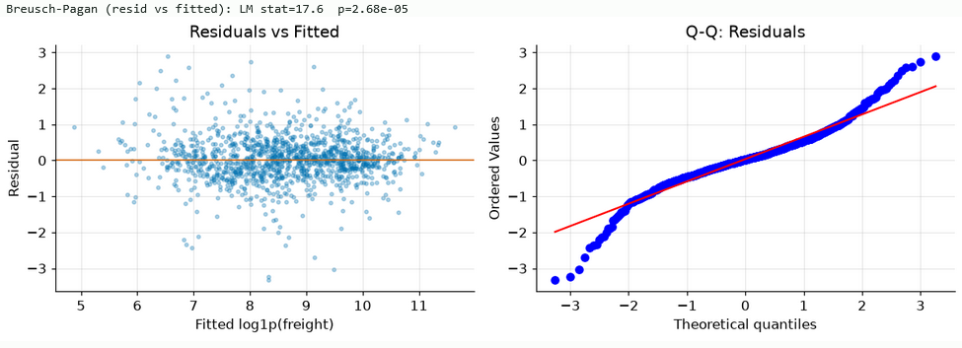
Figure 2. Residuals versus fitted values and Q-Q plot of residuals.

Technique 2 (Ridge Regression)
As an interpretable linear baseline we fit ridge regression, an L2-regularized linear model, inside a pipeline that median-imputes the engineered numerics and standardizes all predictors (ridge is scale-sensitive and cannot accept missing values). The regularization strength was tuned by cross-validation. On the holdout, ridge reaches only R² = 0.354 on the log scale (0.071 on the dollar scale), well below gradient boosting. Two structural factors explain the gap: the destination country expands into roughly fifty sparse indicator columns that a linear model fits inefficiently, and freight cost scales multiplicatively rather than additively with weight and distance.

Item | Value
Best alpha | 7.85
CV R² | 0.3214
Holdout R² (log scale) | 0.3543
Holdout R² (dollar scale) | 0.0712
MAE | $8,096
RMSE | $18,130
Median APE | 58%
Table D3. Ridge regression holdout metrics.

We included ridge to quantify how much of the accuracy genuinely requires the nonlinear ensemble. Its advantage is transparency, since the coefficients show the direction and weight of each predictor, along with stability under correlated predictors; its disadvantage is that it assumes a linear, additive relationship and cannot capture the interactions that drive freight cost.

Feature-Set Comparison (Fig 3)
To measure the value of the two engineered predictors (great-circle distance and mode-appropriate fuel price), we refit both models on an operational-only feature set and on the enriched set, holding the hyperparameters and the split fixed. Enrichment improves both models: gradient boosting rises from R² 0.7335 to 0.7564 on the log scale (0.5452 to 0.6028 on the dollar scale), and ridge from 0.338 to 0.354. The larger gap is between model families, as the trees roughly double the linear model's R².

Model | Feature set | R² (log) | R² (dollar) | MAE | Median APE
HistGBM | Operational | 0.7335 | 0.5452 | $5,117 | 35.6%
HistGBM | Enriched | 0.7564 | 0.6028 | $4,673 | 31.4%
Ridge | Operational | 0.3384 | 0.0323 | $8,212 | 59.3%
Ridge | Enriched | 0.3543 | 0.0712 | $8,096 | 58.1%
Table D4. Accuracy by model and feature set, log and dollar scale.

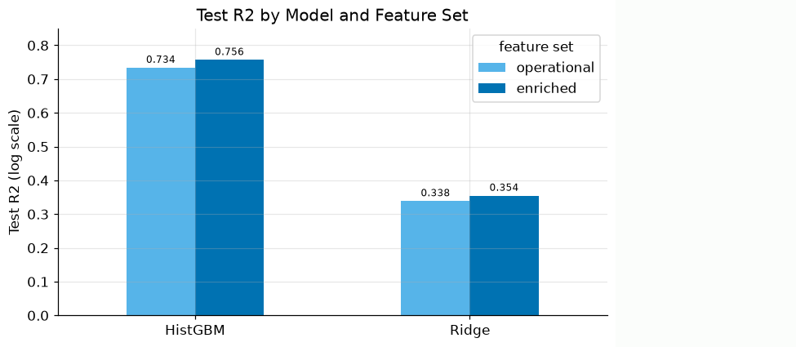
Figure 3. Test R² by model and feature set.

Technique 3 (Welch's ANOVA, Fig 4)
Our third technique tests whether mean freight cost differs across the four transportation modes (air, air charter, ocean, and truck). Because Levene's test shows the modes have unequal variance (W = 96.6, p = 4.7e-61), we used Welch's one-way ANOVA, which does not assume equal group variances, rather than the classical F-test (Delacre et al., 2019). The result is decisive: F(3, 944) = 246.5, p = 4.1e-118, so freight cost differs significantly by mode. The box plot shows air charter carrying the highest median cost and air the widest spread.

We selected Welch's ANOVA because the equal-variance assumption of classical ANOVA is violated here. Its advantage is validity when group variances and sizes differ; its disadvantage is that it tests only whether some mode differs, not which pairs, and it speaks to group means rather than prediction.

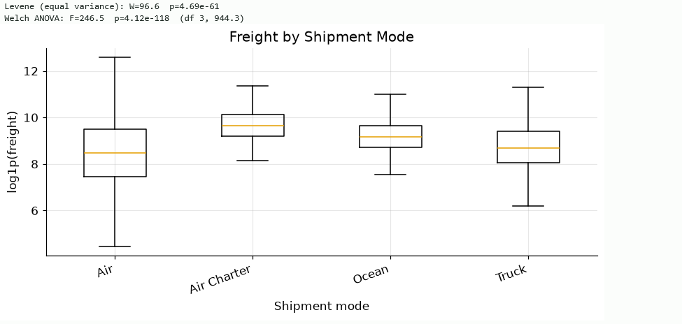
Figure 4. Freight cost by shipment mode, with Levene and Welch ANOVA output.

Temporal Validation
Finally, we validated the model against time rather than a random shuffle. Training on shipments delivered through 2013 and testing on 2014 onward gives an out-of-period R² of 0.650 on the log scale, below the random-split 0.756. The drop is expected, since future shipments carry new products, routes, and price levels, and it is the honest estimate of how the model would perform in deployment. The model still explains about two-thirds of out-of-period variance, and this result motivates the periodic-retraining limitation discussed in Section E.

Item | Value
Training shipments (≤2013) | 4,980
Test shipments (≥2014) | 1,217
Out-of-period R² (log scale) | 0.6499
Out-of-period Median APE | 38%
Reference: random-split R² (log) | 0.7564
Reference: random-split Median APE | 31%
Table D6. Temporal validation output (train through 2013, test 2014 onward).

Data Summary and Implications

Results in Context of the Research Question (Figs 5-7)
The tuned gradient boosting model reaches R² = 0.756 on the log scale, above the 70% threshold set in the research question, so we reject H0 and find support for H1. Reported on the original dollar scale it reaches R² = 0.603, which we state alongside the log-scale figure for transparency; the difference reflects a small number of very large shipments that dominate squared error once predictions are back-transformed. The model clearly outperforms the ridge baseline (0.354 on the log scale), the enriched feature set improves accuracy over the operational features alone (0.7335 to 0.7564), and Welch's ANOVA confirms that shipment mode is a significant cost driver (F(3, 944) = 246.5, p < 0.001). Figures 5 through 7 support these results: predicted-versus-actual tracks the identity line across roughly four orders of magnitude, permutation importance shows weight as the dominant driver (0.78) followed by quantity, the EXW incoterm, distance, and mode, and the error distribution centers near zero (median error -2.5%) with 70% of shipments predicted within plus or minus 50% (median absolute percentage error 31%).

Element | Value
Null hypothesis (H0) | Gradient boosting cannot reach at least 70% R² (R² < 0.70)
Alternative (H1) | Gradient boosting can reach at least 70% R² (R² ≥ 0.70)
Threshold | 0.70
Observed (log scale) | 0.756
Decision | Reject H0; H1 supported
Table E1. Hypothesis decision for the research question.

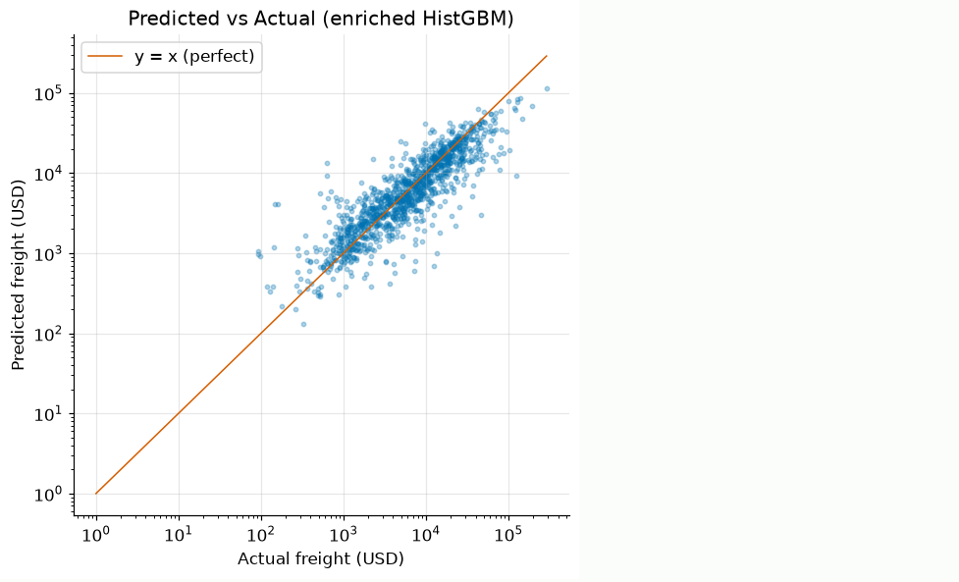
Figure 5. Predicted versus actual freight cost, log-log scale (enriched HistGBM, random holdout).

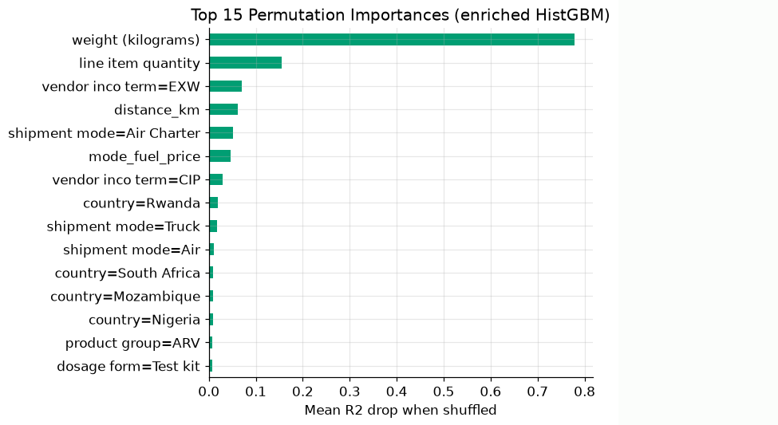
Figure 6. Top 15 permutation importances (enriched HistGBM).

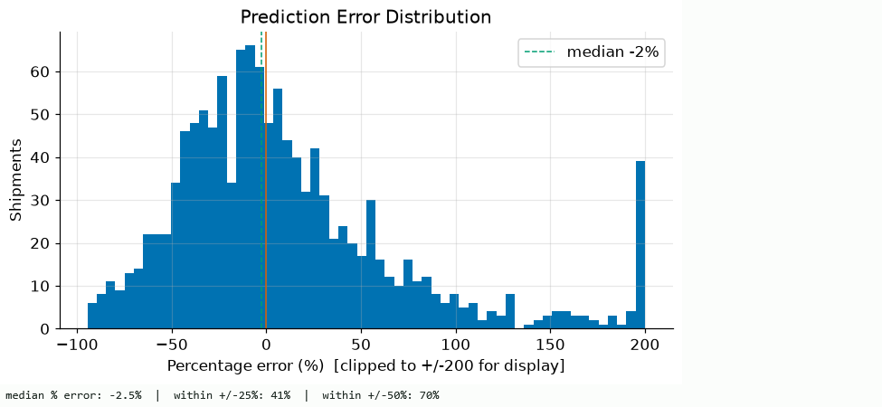
Figure 7. Prediction error distribution (signed percentage error, random holdout).

Limitations
Temporal generalization. The model is fit on 2006 to 2015 records, and on a time-ordered holdout (train through 2013, test 2014 onward) accuracy falls to R² = 0.650 on the log scale, below the random-split 0.756. Future shipments carry new products, routes, and price levels, so the model should be retrained periodically rather than treated as static.

Dollar-scale precision. Back-transformed to dollars the model explains less (R² = 0.603, median absolute percentage error 31%), because a small number of very large shipments dominate squared error. The model is well suited to screening shipments for review, not to precise cost forecasting.

Non-constant error variance. A Breusch-Pagan test rejects homoscedasticity (LM = 17.6, p = 2.7e-05), and residual spread is widest for low-cost shipments, so predictions for the smallest shipments are proportionally less reliable.

Excluded bundled freight. The model is trained only on shipments with a line-level freight cost. About 40% of records carried text-coded freight ("Freight Included in Commodity Cost," "Invoiced Separately") and were excluded, so the model may not represent shipments whose freight is bundled into commodity cost.

Tree models cannot extrapolate. Gradient boosting predicts by averaging training outcomes within learned feature regions, so a shipment heavier or farther than anything in the 2006 to 2015 training data is capped at the range the trees have seen. Freight for genuinely out-of-range shipments is systematically under-predicted, a structural limit of the method itself rather than of this dataset.

Recommendations (Fig 8)
Deploy the ranked over-expectation worklist as the primary tool. Score each shipment, compute the gap between actual and predicted freight, and route the shipments whose actual cost sits materially above expectation to contract or renegotiation review (Fig 8). The top 50 shipments alone account for roughly $2.2M in freight above the model's expectation, so this gives reviewers a prioritized, dollar-weighted target rather than a random sample.

Apply it at order time for proactive budgeting. The model uses only attributes known when a shipment is booked, so it can forecast expected freight and screen a quoted rate before the shipment moves.

Commission a contract review of the excluded bundled-freight shipments. About 40% of records had freight bundled into commodity cost or invoiced separately, so they're invisible to this model. That's a large, unmonitored share of spend, so we recommend a targeted review of those shipments' contracts, since cost hidden in commodity pricing is where savings can go unnoticed.

Target carrier renegotiation on the flagged high-cost air lanes. The worklist and the ANOVA both point at air and air-charter shipments to hard-to-reach destinations as the cost concentration. We recommend prioritizing carrier contract review on those specific lanes, and evaluating whether any air shipments could shift to ocean or truck where lead time allows, since mode is a statistically significant cost driver.

Fix data logging at the source. Require a structured origin country or coordinates and a line-level freight figure at entry, so future shipments are model-ready without free-text parsing or exclusion. This directly recovers the 12.8% of unresolved origins and the 40% of excluded freight rows.

Pair deployment with periodic retraining. Because out-of-period accuracy declines, retrain on recent shipments on a regular cadence so the expectation stays calibrated to current products, routes, and fuel prices.

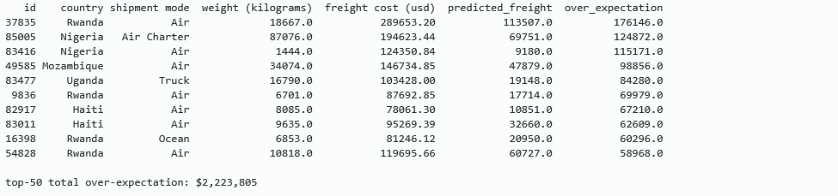
Figure 8. Ranked over-expectation worklist: top 50 shipments by actual minus predicted freight (total $2,223,805).

Future Directions
Extend the model to the current freight era. The dataset ends in 2015, but jet-fuel and diesel indices have moved substantially since (see B3, E2). Refitting on 2020 to 2025 shipments, and adding the current fuel-index and carrier-rate-card features that finance already tracks, would close the temporal gap flagged in D6 and E2 and produce a model calibrated to today's freight economics.

Add a classification or quantile-regression layer to attach intervals to the worklist. The current model returns a point estimate. A companion classifier (over-budget: yes or no) or a quantile-regression head (10th, 50th, 90th percentile predictions) would let the worklist rank shipments by probability of overrun rather than by residual magnitude alone, and would give reviewers an honest interval instead of a bare dollar figure. Building this well means capturing reviewer outcomes (was each flagged shipment genuinely overpriced?) as labels over time, so the classifier sharpens with use.

Model freight cost per kilogram rather than total freight cost. Weight carried a 0.78 importance share (see E1, Figure 6) and drives most of the heteroscedasticity we saw in the residual plot (see D2, Figure 2). Predicting freight per kilogram would let weight enter as a post-hoc multiplier instead of an in-model driver, and would likely tighten prediction intervals on small shipments (the price band we most often review).

Analyze the 40% of shipments with bundled freight as a separate stream. These shipments were excluded because freight cost was not itemized (see B4). A parallel analysis, either estimating a bundled-shipment premium against comparable line-item shipments or negotiating line-level reporting from the vendors involved, would recover the missing 40% of program spend and answer whether bundling itself is priced fairly.

Taken together, these directions extend the same worklist that flags $2.2M in over-expectation freight today toward the full program spend, once the bundled 40% is recoverable and the model is recalibrated to current freight economics.

Sources

Budzyński, A., & Cieśla, M. (2025). Enhancing road freight price forecasting using gradient boosting ensemble supervised machine learning algorithm. Mathematics, 13(18), 2964. https://www.mdpi.com/2227-7390/13/18/2964

Delacre, M., Leys, C., Mora, Y. L., & Lakens, D. (2019). Taking parametric assumptions seriously: Arguments for the use of Welch's F-test instead of the classical F-test in one-way ANOVA. International Review of Social Psychology, 32(1), Article 13. https://rips-irsp.com/articles/10.5334/irsp.198

Friedman, J. H. (2001). Greedy function approximation: A gradient boosting machine. The Annals of Statistics, 29(5), 1189-1232. https://projecteuclid.org/journals/annals-of-statistics/volume-29/issue-5/Greedy-function-approximation-A-gradient-boosting-machine/10.1214/aos/1013203451.full

Google. (n.d.). Countries CSV [Data set]. Google for Developers. https://developers.google.com/public-data/docs/canonical/countries_csv

Harris, C. R., Millman, K. J., van der Walt, S. J., Gommers, R., Virtanen, P., Cournapeau, D., Wieser, E., Taylor, J., Berg, S., Smith, N. J., Kern, R., Picus, M., Hoyer, S., van Kerkwijk, M. H., Brett, M., Haldane, A., del Río, J. F., Wiebe, M., Peterson, P., ... Oliphant, T. E. (2020). Array programming with NumPy. Nature, 585(7825), 357-362. https://doi.org/10.1038/s41586-020-2649-2

Hunter, J. D. (2007). Matplotlib: A 2D graphics environment. Computing in Science & Engineering, 9(3), 90-95. https://doi.org/10.1109/MCSE.2007.55

McKinney, W. (2010). Data structures for statistical computing in Python. In S. van der Walt & J. Millman (Eds.), Proceedings of the 9th Python in Science Conference (pp. 56-61). https://doi.org/10.25080/Majora-92bf1922-00a

Pedregosa, F., Varoquaux, G., Gramfort, A., Michel, V., Thirion, B., Grisel, O., Blondel, M., Prettenhofer, P., Weiss, R., Dubourg, V., Vanderplas, J., Passos, A., Cournapeau, D., Brucher, M., Perrot, M., & Duchesnay, É. (2011). Scikit-learn: Machine learning in Python. Journal of Machine Learning Research, 12, 2825-2830. https://jmlr.org/papers/v12/pedregosa11a.html

Seabold, S., & Perktold, J. (2010). statsmodels: Econometric and statistical modeling with Python. In Proceedings of the 9th Python in Science Conference (pp. 92-96). https://doi.org/10.25080/Majora-92bf1922-011

U.S. Agency for International Development. (n.d.). Supply chain shipment pricing data [Data set]. Kaggle. https://www.kaggle.com/datasets/princehobby/supply-chain-shipment-dataset

U.S. Energy Information Administration. (n.d.-a). U.S. Gulf Coast kerosene-type jet fuel spot price FOB [Data set]. https://www.eia.gov/dnav/pet/hist/eer_epjk_pf4_rgc_dpgD.htm

U.S. Energy Information Administration. (n.d.-b). U.S. Gulf Coast ultra-low sulfur No. 2 diesel spot price [Data set]. https://www.eia.gov/dnav/pet/hist/eer_epd2dxl0_pf4_rgc_dpgD.htm

Virtanen, P., Gommers, R., Oliphant, T. E., Haberland, M., Reddy, T., Cournapeau, D., Burovski, E., Peterson, P., Weckesser, W., Bright, J., van der Walt, S. J., Brett, M., Wilson, J., Millman, K. J., Mayorov, N., Nelson, A. R. J., Jones, E., Kern, R., Larson, E., ... Vázquez-Baeza, Y. (2020). SciPy 1.0: Fundamental algorithms for scientific computing in Python. Nature Methods, 17(3), 261-272. https://doi.org/10.1038/s41592-019-0686-2

Xu, Q., Ma, T., Li, G., Luo, Y., Yao, Z., & Wang, T. (2026). A geographically enhanced LightGBM approach to intelligent freight transportation cost prediction. Systems, 14(7), 767. https://www.mdpi.com/2079-8954/14/7/767

