**PokéBot**

*(Note: I can assist you guys in any and all areas within the scope of this project)*

*(Note: I’m open to suggestions)*

***Catch ‘Em All* System:**

* This part primarily calls for the bare basics of Python and the *Discord.py API*.
* One Discord text chat channel will be dedicated to *spawning* Pokémon every so often.
* Random Pokémon spawn at random times throughout the day.
* More Pokémon will spawn if more chatting occurs in the chat channel (this is how the original PokéCord game worked).
* In order to capture a Pokémon that spawned, one would simply need to guess the name of the Pokémon (recall “Who’s that Pokémon?” from the TV show). First come first served.
  + Example:  
    `*Image of Pikachu pops up*`  
    `**/capture pikachu**` *says Taha*`*Taha has captured Pikachu*`

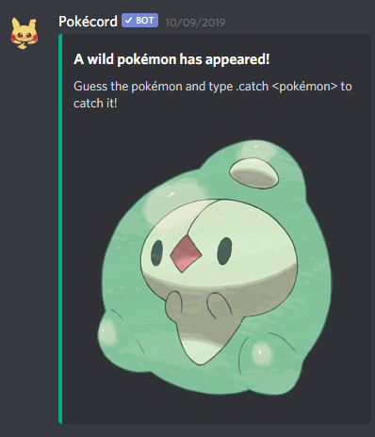

**Duel Arena System:**

* This part is probably the most complex. This part requires more in depth knowledge of the *Discord.py API*. A message and its reactions would have to be monitored constantly when a battle is in play. This part also includes the handling of Pokémon type interactions (water type Pokémon beats fire).
* Here’s the plan, in an instance of a duel, the statistics of the duel would be stored in the message itself. Players can see their Pokémons’ HP and abilities. Notice the laughing and thunder bolt emojis below. **Those** are called **reactions.** Duelists click those to fight (ex: pikachu’s thunderbolt could be that emoji).

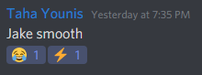

* One Discord text chat channel will be dedicated to handle Pokémon battles. For now, one battle will occur at a time.
* Battles will **not** be turn-based. In other words it will be action packed real time battles! I have 2 ideas of how this would function:
  + Duelists will be able to click emojis/reactions on a single message triggering their Pokémon to conduct an ‘action’
  + Duelists will send commands in chat representing their Pokémon’s abilities & actions. (commands will be deleted in a short time to prevent chat clutter)
* A single message or 2 messages can represent the ‘game board’. 2 messages would be 1 message per duelist.
  + What players will see are:
    - Pokémon HP & actions as reactions/emojis
    - 2 images representing the 2 Pokémon in battle
    - A combat log showing the latest actions & status
* Actions Pokémon can take consist of w/e their attacks are, head butting, dodging & blocking. Emojis can be assigned based on a Pokémon’s type.

**Data Acquirement & Organization:**

* This part requires researching for reliable data online, and retrieving said data using the *requests* library. For now we’ll focus on Gen 1 & maybe Gen 2 Pokémon.
* This part also encompasses player data. One would need to know basic Python (especially classes).
  + We’ll need to handle what Pokémon a player has, and those Pokémon’s current stats
  + Idk if the players themselves need stats.
  + For a player to level up their Pokémon’s stats they can duel or chat more in the Discord.
* We’re gonna need noice data. Possibly gathered using web scraping. And organized into files/folders and or an SQL database.
* Player data would best be stored in the SQL database. And then Pokémon data can be stored in JSON files (or SQL database too).
* Good sources to gather the data are:
  + <https://pokemondb.net/>
  + <https://pokeapi.co/>
* Thanks to Hafeth, I managed to obtain gifs of 1.2 thousand Pokémon. I thought it’d be a nice visual touch. We could use it for when Pokémon spawn and when players wana view the Pokémon in their possession. Problem is we need to filter out the Gen 1 & Gen 2 Pokémon. We don’t need the whole **1.2 thousand** Pokémon in existence.



[**Click me!**](https://gyazo.com/8eaaff259de5aef64d9d31bda5e1198d)