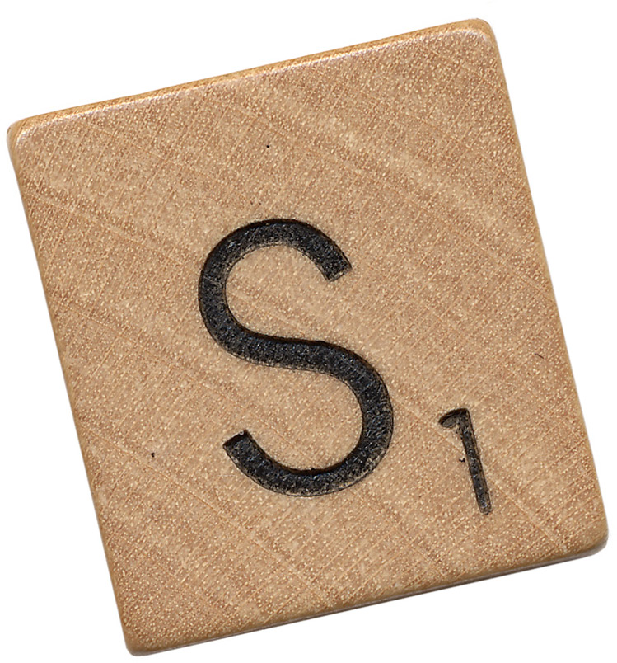

**C++ Cheat Sheet**

**Hello World**

*By now, you should know this by heart!*

#include <iostream>

using namespace std;

int main() {

cout << “Hello World!”

return 0;

}

**Comments**

*Comments are a useful way to document your program. They are ignored by the compiler. You can type in anything you want like a description of the segment of code you are writing. This is also useful for other programmers that may be using or reading your code.*

*A comment starts with two forward slashes //. Anything that comes after the // up to the end of the line is a comment. Another form of the comment is the /* */ pairing, where everything inside the start /* and end */ becomes a comment.*

int main() {

cout << “This program is a demonstration of comments.”;

// Comments are lines that are not looked at by the compiler (MS Visual Studio)

// This is a comment that has

// been put on more than

// one line

/* This is a comment that has

been put on more than

one line

*/

// cout << “Comments work great for ignoring lines of“;

// cout << “code that you’re not sure you need…”;

return 0;

}

**Variables & Math**

*Just as in algebra, variables store values. Variable names can be any combination of letters, numbers and the underscore (_) so long as it starts with a letter or an underscore. Associated with all variables is a data type (int, double, bool, char, string). A variable’s data type can never change once it has been declared.*

#include <string>

int main() {

int x = 5;

int y = 7;

int z = x + y; // ints (short for integers) are numbers **without**

// decimals

double a = 9.4;

double b = 2.333333333;

double c = a / b; // doubles are numbers **with** decimals

bool winning = true; // bools (short for Boolean) are variables

// that can only be true or false

char myFavoriteLetter = ‘j’; // chars are surrounded by ‘single quotes’

string myName = “Scrabble”; // Strings (capital S) are groups of

// chars. They are surrounded

// by “double quotes”.

}

return 0;

}

**Getting User Input**

*Input is pretty simple in C++. All we need to do is declare a variable that will store the input – it must be the proper type (if you’re expecting a number, the input should go into an int or double variable; if you’re asking the user for his/her name, it should go into a string).*

int main() {

cout << “What is your name?”;

string name;

getline(cin, name);

cout << “Nice to meet you, “ << name;

return 0;

}

**If Statements**

|  |  |
| --- | --- |
| *Less than* | *<* |
| *Greater than* | *>* |
| *Less than or equal to* | *<=* |
| *Greater than or equal to* | *>=* |
| *Equal to* | *== (i.e. 2 equal signs)* |
| *Not equal to* | *!=* |

*Be careful not to confuse the assignment operator (=) with the equal to operator (==).*

4 > 3; // this expression is true

9 != 0; // this expression is true

3 == 9; // this expression is false

&&(and) *and* || (or) *are used to compare more than one expression at the same time.*

*In* && (and)*, both expressions have to be true for the entire expression to be true.*

*In* || (or)*, at least one expression has to be true for the entire expression to be true.*

*When an expression is not true, it is false.*

-------------

*Whenever you need your program to make a decision between two or more possible actions, you can use an if statement. Note that there is no ; after the if() line. What this if statement means is that if the expression within the parentheses is true, then go and execute the lines within the body (between the { }’s). Otherwise, if the expression is false, do not go there. You can enter as many statements/expressions you want within the { }’s using* && *and/or* ||*.*

-------------

int main() {

cout << “What is your age?”;

int age;

getline(cin, age);

if(age > 70) {

cout << “Enjoy retirement!”;

} else if(age > 50) {

cout << “You must still enjoy your job…”;

} else if(age > 30) {

cout << “How are the children?”;

} else if(age > 18) {

cout << “How’s college?”;

} else if(age > 10) {

cout << “Enjoy childhood while you can.”;

} else if(age < 10 && age > 0) {

cout << “You’re too young for a computer…”;

} else {

cout << “Liar…”);

}

return 0;

}

**While Loops**

*A condition can be a comparison or any kind of Boolean value. Before, looping the code in the body of the while, the program checks to see if the condition inside the parentheses is true. If it is, the body will start executing, and keep executing until the condition becomes false.*

int main() {

int numberOfLives = 5;

while(numberOfLives > 0) { // makes sense, right?

// put your game code here….

if(dead == true) {

numberOfLives--; // a quick way to subtract one

// from numberOfLives.

}

}

return 0;

}

**For Loops**

*A for loop is a similar to a while loop, but still depends on a Boolean condition looping. You can initialize a value for counting, then compare it against another value and change the value (known as incrementing).*

int main() {

for(int i = 0; i < 4; i++) {

cout << “The number is “ << i;

}

return 0;

}

*Notice that this for loop does the same thing as the while loop example above. This is a list of steps that a for loop goes through:*

*1. initialize the counter variable (i)*

*2. check if condition is true*

*if false, loop stops*

*if true, go to step 3*

*3. execute lines in the body*

*4. increment/decrement the value*

*5. go to step 2*

**Random Numbers**

*In order to use the rand() command, we need to import the stdlib library to tell the compiler to bundle the command with your program when compiling. Once we import the stdlib library we can use rand() to come up with a “random” number (computers can’t think randomly like humans, so* ***basically*** *the number is based on the current time in milliseconds).*

*The general formula is (rand() & (max-min)) + min.*

#include <iostream>

#include <stdlib.h>

using namespace std;

int main() {

// print 10 random integers

for(int i = 0; i < 10; i++) {

int test = rand();

cout << test;

}

// print 10 random integers between 0 and 5

for(int i = 0; i < 10; i++) {

int test = rand() % 5;

cout << test;

}

// print 10 random integers between 20 and 30

for(int i = 0; i < 10; i++) {

int test = (rand() % 10) + 20;

cout << test;

}

return 0;

}

**Arrays**

*Arrays are a great tool in any language to store multiple items inside of one variable. Think of an array as a group of containers. For example, if you have an integer array of size 10, picture it as 10 containers ready to hold one integer each. In Java, we need to both declare and initialize arrays so the containers are ready for use.*

***Hints and mind-blowers:***

* *Array “indexes” start at 0 and end at the size of your array minus one. For example, if you have an array of size 5, your indexes would be 0, 1, 2, 3, and 4.*
* *Strings are really arrays of characters...deep, right?*
* *For loops and arrays are a match made in heaven…try to figure out why!*

int main() {

char[] favoriteSymbols = new char[4];

favoriteSymbols[0] = ‘*’;

favoriteSymbols[1] = ‘W’;

favoriteSymbols[2] = ‘7’;

favoriteSymbols[3] = ‘%’;

}

**Functions**

*In C++, functions are things that help avoid having to duplicate code/logic in your program. If you find yourself doing something more than once, chances are that it should be made into a function. Functions are created once and can be “called” (aka ran) multiple times from almost anywhere in your code. In fact, the “int main()” line you should have memorized right now is it’s own function declaration.*

*A function declaration includes three main parts:*

* *The return type – if your function returns an integer, type int here. If it returns nothing, type void.*
* *The name of the function*
* *The parameters (inside the parentheses) – these are variables that you can “pass into” the function and use inside*

int main() {

int mySum = addTwoNumbers(5, 7); // this should equal 12

cout << mySum;

return 0;

}

int addTwoNumbers(int a, int b) {

return a + b;

}

**Final Project Ideas**

* Blackjack
* Hangman
* Tic-Tac-Toe
* “Create Your Own Adventure” Game
* Virtual Store
* Who Wants To Be A Millionaire?
* Minesweeper
* Encryption Tool (encode/decode secret messages)
* Horse Race Game

**If you’re bored and/or “done,” ask me about…**

* Classes
* File I/O
* Recursion
* Search algorithms