Name: Chel Diane P. Fernandez Grade/Section: 10-Penero

TLE

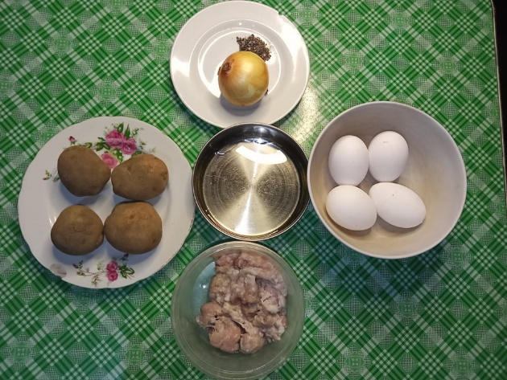Activity #1 ‘’ PREPARE AND

PRESENT NEATLY THE COOKED

EGGS’’

Activity #3 ‘’PREPARE PICTURE

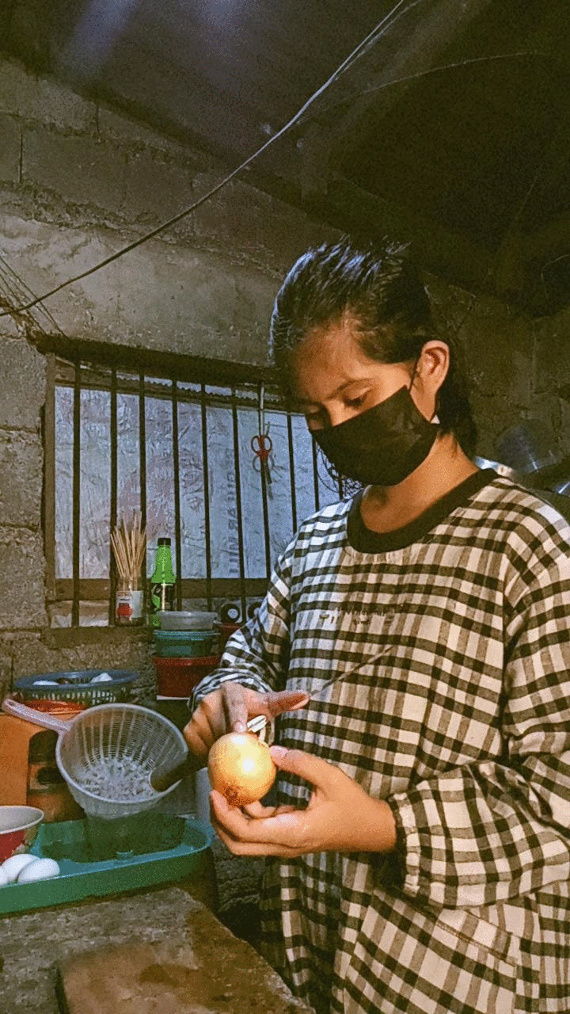INSTRUCTION NO. 1 AND 2

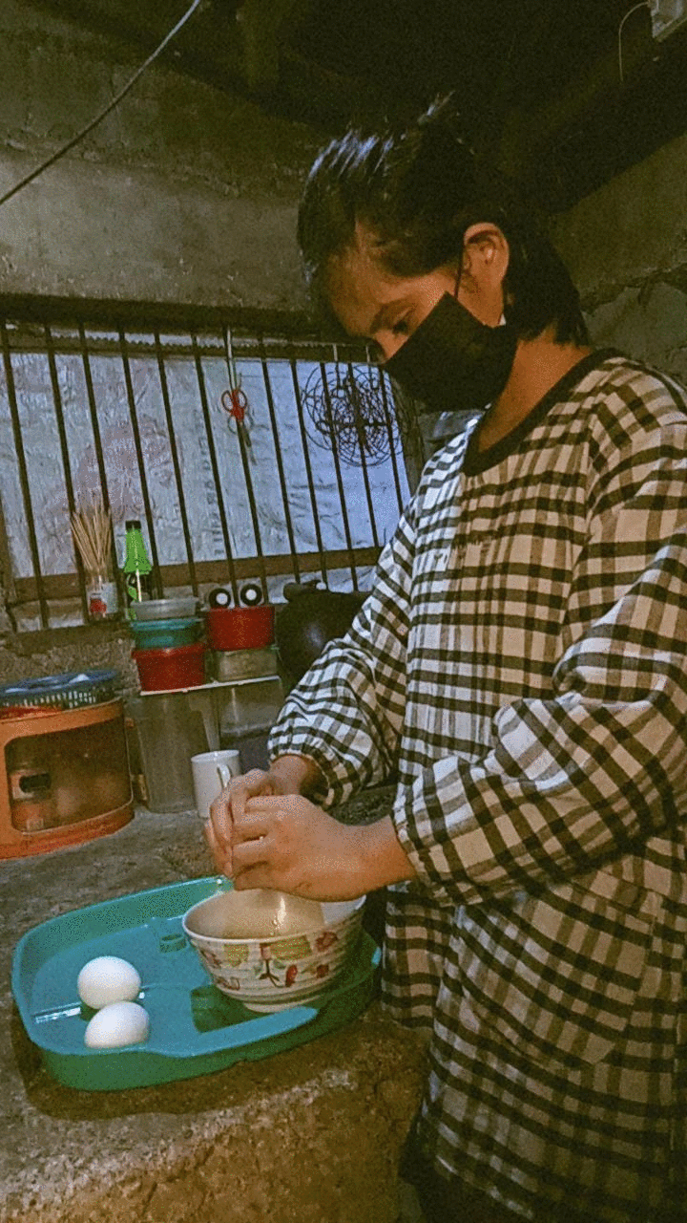AND SUBMIT’’

