Chel Diane P. Fernandez 10- Penero

QUARTER 2: LESSON 2 PREPARER VEGETABLE DISHES

Performance Task #1.1 Boiling Performance Task #1.2 Sauteing

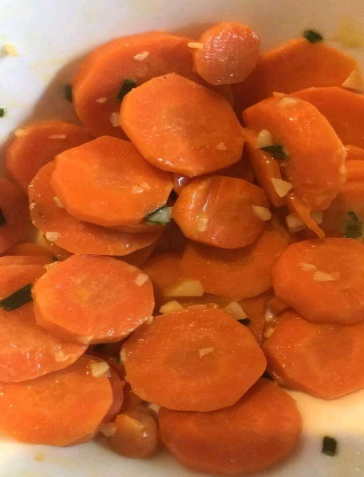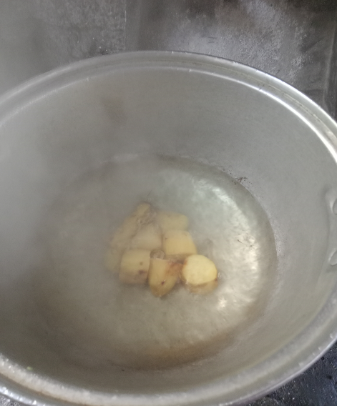

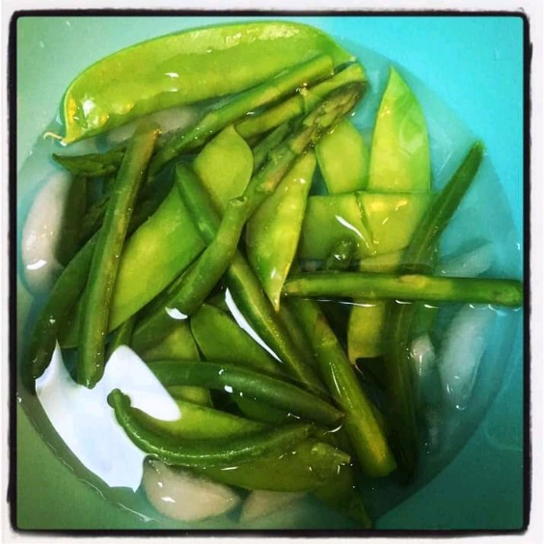Perrformance Task #1.3 Performance Task #1.4 Fried

