PANDAS

PROBLEM # 1

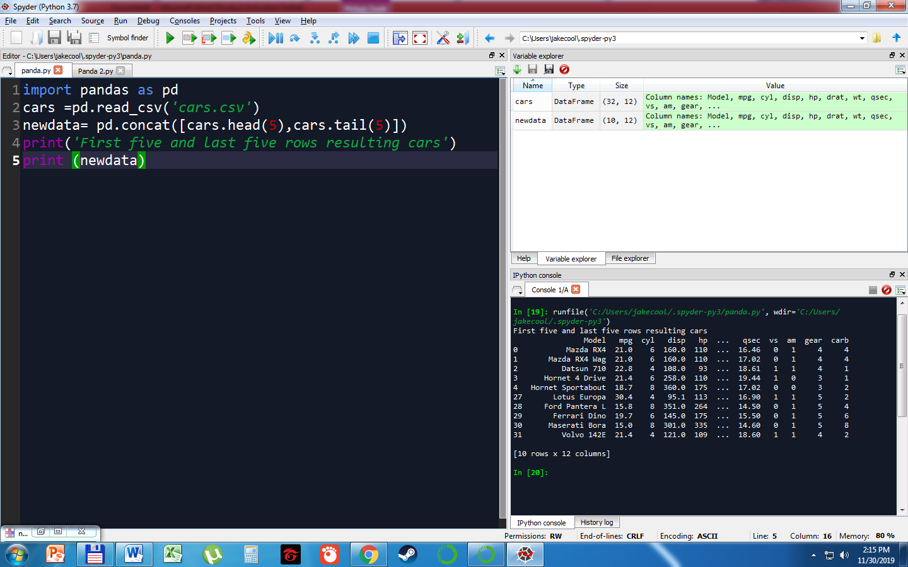

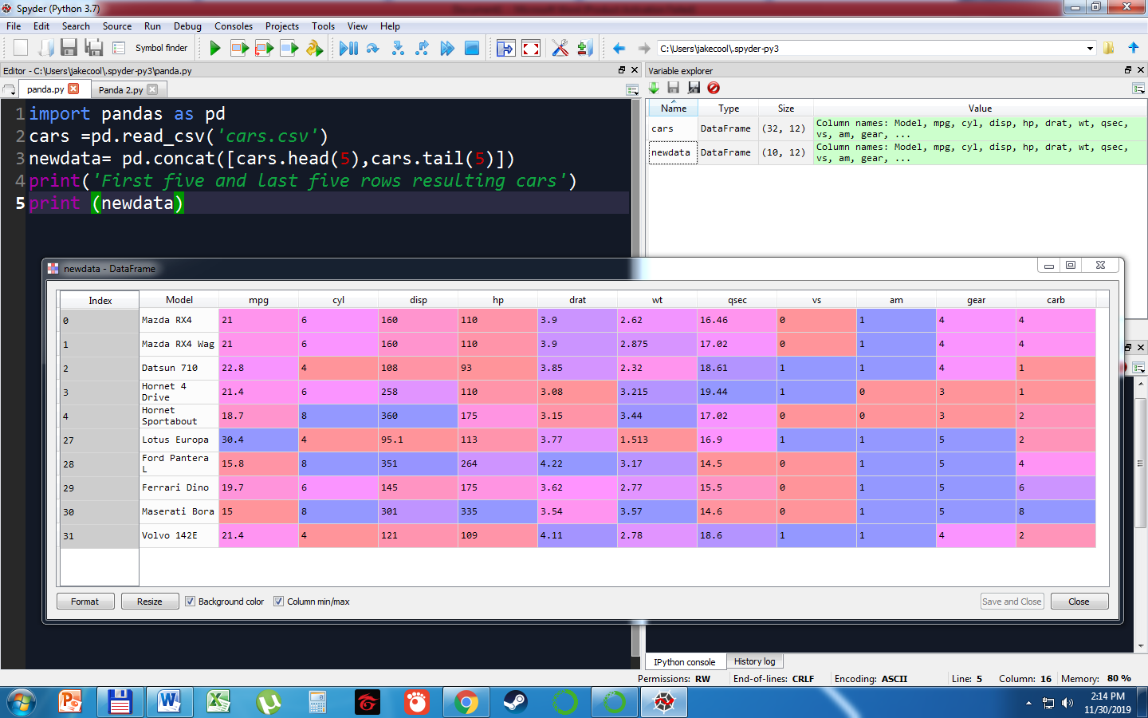

PROBLEM # 2

1. FIRST FIVE ROWS WITH ODD-NUMBERED COLUMNS

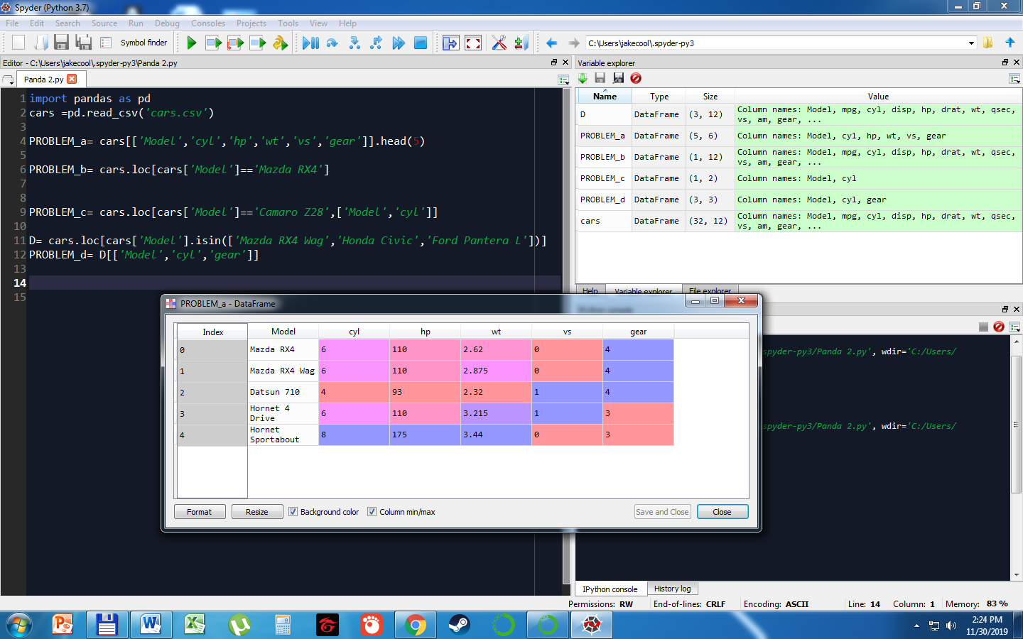

1. DISPLAY THE ROW THAT CONTAINS THE MODEL OF ‘Mazda RX4’

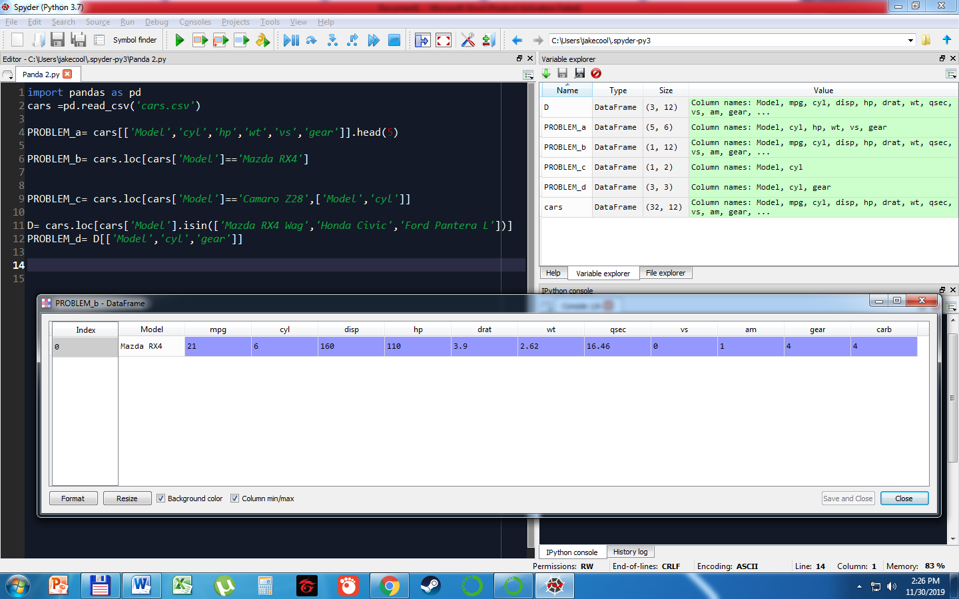

1. HOW MANY CYLINDERS (‘cyl’) DOES THE CAR MODEL ‘Camaro Z28’ HAVE?

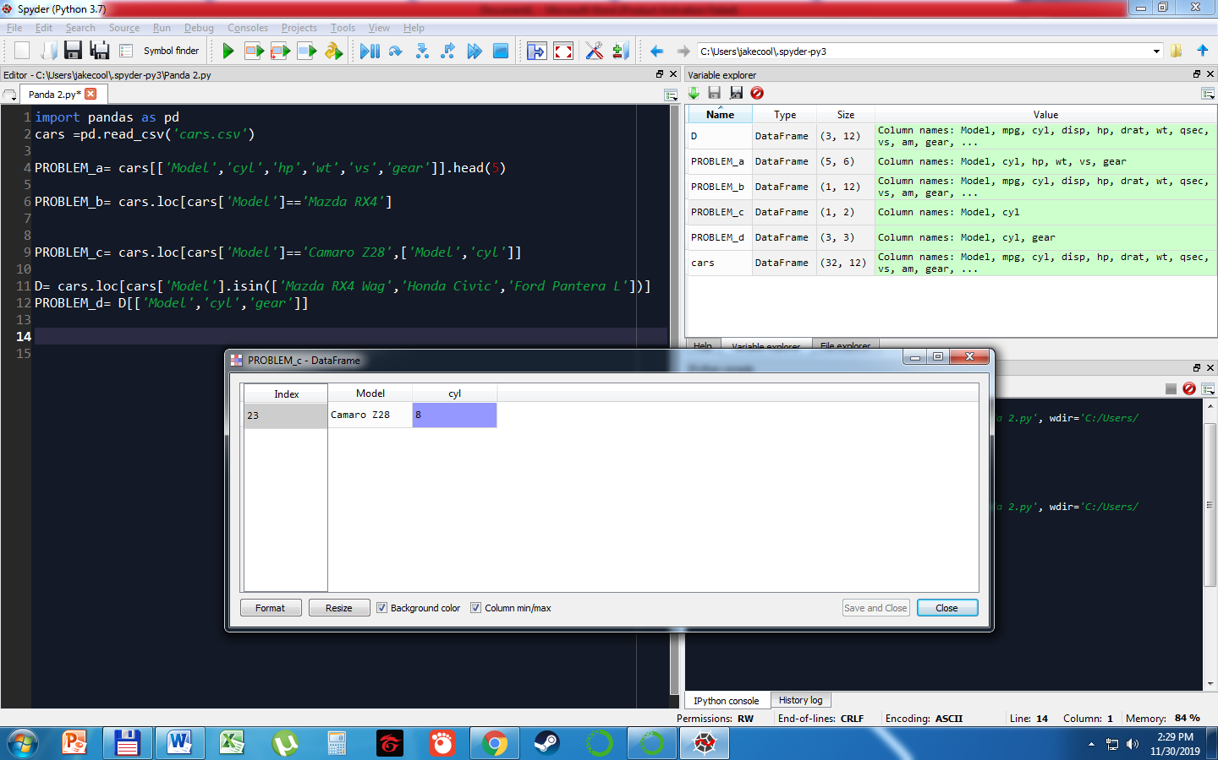

1. DETERMINE HOW MANY CYLINDERS AND WHAT GEAR TYPE DO THE CAR MODELS ‘Mazda RX4 Wag’, ‘Ford Pantera L’ and ‘Honda Civic’ HAVE.

