Psychologists’ quantitative and qualitative perspectives of their training and pathways to registration

Simone Gindidis1, Jake Kraska1,2, & Mehar Mutchall1

1 Faculty of Education, Monash University

2 Krongold Clinic, Monash University

Author note

1: 29 Ancora Imparo Way, Clayton VIC 3800 2: 2/270 Ferntree Gully Rd, Notting Hill VIC 3168

The authors made the following contributions. Simone Gindidis: Conceptualization, Writing - Original Draft Preparation, Writing - Review & Editing, Data Curation, Formal Analysis, Investigation, Methodology, Project Administration, Software, Supervision; Jake Kraska: Conceptualization, Writing - Origianl Draft Preparation, Writing - Review & Editing, Data Curation, Formal Analysis, Investigation, Methodology, Project Administration, Software, Supervision, Visualization; Mehar Mutchall: Data Curation, Formal Analysis, Investigation, Writing - Review & Editing.

Correspondence concerning this article should be addressed to Simone Gindidis, 29 Ancora Imparo Way, Clayton VIC 3800. E-mail: [simone.gindidis@monash.edu](mailto:simone.gindidis@monash.edu)

Abstract

Training and registration of psycholoigsts in Australia has undergone significant change in the last two decades. In particular, the manner in which psychologists obtain an Area of Practice Endorsement, and how this is differentially recognised by governmental bodies has been controversial. Despite ongoing consultation regarding improvements to training, registration and the Area of Practice Endorsement system, there is a paucity of empirical research about psychologists attitudes towards these changes and the ways in which psychologists in Australia are recognised. The current study utilises a mixed methods methodology to quantitatively and qualitatively examine Australian psychologists perceptions of training, Area of Practice Endorsements, and the Medicare Better Access to Mental Health Scheme. One sentence summarizing the main result (with the words “**here we show**” or their equivalent). Two or three sentences explaining what the **main result** adds to previous knowledge. One or two sentences to put the results into a more **general context**. Two or three sentences to provide a **broader perspective**, readily comprehensible to a scientist in any discipline.

*Keywords:* area of practice endorsement, aope, mixed methods, australian psychologists

*Word count:* X

Psychologists’ quantitative and qualitative perspectives of their training and pathways to registration

Psychologists’ pathways to registration has gone through several changes in the past two decades (). More recently there has been an increasing focus on Area of Practice Endorsements (AoPE) and how these relate to the Medicare Better Access to Mental Health Scheme (BAMHS). Despite frequent criticism in news and social media of what is perceived as a “two tiered” compensation system that has been enforced by Medicare and creates misconceptions within the public about the skill sets of psychologists, there is no empirical evidence regarding psychologists’ attitudes and perspectives of the efficacy and appropriateness of their training, the AoPE system and the BAMHS.

As important stakeholders in the treatment of mental health problems in Australia, psychologists are in a unique position to provide input about training, recognition of different skillsets (such as detailed in the AoPE system) and the structure of schemes designed to assist the public accessing mental health support. In order to support conceptualisation of appropriate training programs and funding schemes there needs to be empirical evidence about the effectiveness of different professions or training programs in addressing mental health problems; there is a paucity of such research, and even less research on the perspectives of psychologists. Gaining insights into psychologists perspectives of these matters would assist with development of targeted research in these domains, as well as begins to provide an empirical basis for which governmental bodies and peak professional bodies can support changes and innovation.

Discuss the research that has addressed this problem

Identify the deficiencies in the literature and what knowledge is needed

Identify audiences that will benefit from addressing this gap

The opinions of peak bodies, governmental reports and the available literature demonstrate the diversity of the psychology profession in Australia. Relying purely on qualitative methods do not provide opportunity for input from the wider profession. On the other hand, relying purely on quantitative measures is inadequate to fully describe the nuanced opinions of psychologists. Therefore the aim of this study was to obtain a large sample of psychologists opinions and perspectives via a quantitative survey, while gaining further insight into opinions via qualitative interviews.

# 1 Methods

## 1.1 Participants

Our online questionnaire was completed by 340 participants. In order to account for small *n* in certain demographics, groups were collapsed. For example Area of Practice Endorsement was collapsed into those that do and do not possess an AoPE, and all of those with a DPsych, MPsych, or MPsych/PhD were collapsed into “Higher Degree.” Further breakdown of demographics is available on our [Shiny App (https://jakekraska.shinyapps.io/psychtraining/)](https://jakekraska.shinyapps.io/psychtraining/).

There were 290 females, 48 males and 2 participants who did not provide their gender or did not identify with a binary gender. There were 278 participants with General Registration, 1 Non-Practicing Registration and 60 with Provisional Registration. There were 77 participants that identified that they were Psychology Board of Australia approved supervisors. There were 76 participants with an AoPE, 15 that did not provide a response, and 249 without an AoPE. There were 143 participants that have undergone 4+2 training, 35 participants that have undergone 5+1 training, 139 participants that have undergone higher degree training, and 22 participants still in training.

Other descriptive statistics are provided for age (Table 1), Area of Practice Endorsement (AoPE) (Table 2), training pathway (Table 3), years of experience (Table 4), work setting (Table 5), and client age (Table 6). (Simone - I would much prefer to point readers towards the Demographics tab of the online platform and remove all these tables)

There were 107 participants that provided their contact details for participation in the qualitative component of this research. While attempting to balance the inclusion of a variety fo psychologists with different training, approved AoPE and professional experiences, 29 participants were contacted for participation with 15 participants responding and ultimately participating.

Table 1: Participants by Age

|  |  |  |
| --- | --- | --- |
| Age | n | Percentage |
| 18 - 24 | 5 | 1.47 |
| 25 - 34 | 121 | 35.59 |
| 35 - 44 | 105 | 30.88 |
| 45 - 54 | 65 | 19.12 |
| 55 - 64 | 37 | 10.88 |
| 65 - 74 | 7 | 2.06 |

Table 2: Participants by AoPE

|  |  |  |
| --- | --- | --- |
| Area of Practice Endorsement | n | Percentage |
| Clinical | 27 | 7.87 |
| Community | 1 | 0.29 |
| Counselling | 10 | 2.92 |
| Ed&Dev | 25 | 7.29 |
| Forensic | 1 | 0.29 |
| Health | 6 | 1.75 |
| None | 249 | 72.59 |
| Organisational | 5 | 1.46 |
| S&E | 4 | 1.17 |
| NA | 15 | 4.37 |

Table 3: Participants by training pathway

|  |  |  |
| --- | --- | --- |
| Training Pathway | n | Percentage |
| 4+2 | 143 | 42.06 |
| 5+1 | 35 | 10.29 |
| DPsych | 4 | 1.18 |
| MPsych | 124 | 36.47 |
| MPsych/PhD | 11 | 3.24 |
| Ongoing | 22 | 6.47 |
| NA | 1 | 0.29 |

Table 4: Participants by years of experience

|  |  |  |
| --- | --- | --- |
| Years of Experience | n | Percentage |
| 0-7 | 141 | 41.47 |
| 10-15 | 40 | 11.76 |
| 15-20 | 34 | 10.00 |
| 20+ | 41 | 12.06 |
| 8-10 | 34 | 10.00 |
| Provisional | 50 | 14.71 |

Table 5: Participants by work setting

|  |  |  |
| --- | --- | --- |
| Work Setting | n | Percentage |
| Education (K-12) | 51 | 12.06 |
| Education (Tertiary) | 22 | 5.20 |
| Government | 82 | 19.39 |
| Non-profit | 53 | 12.53 |
| Private | 211 | 49.88 |
| NA | 4 | 0.95 |

Table 6: Participants by client age

|  |  |  |
| --- | --- | --- |
| Client Age | n | Percentage |
| 0-3 | 58 | 5.12 |
| 12-18 | 240 | 21.20 |
| 18-25 | 259 | 22.88 |
| 25-65 | 252 | 22.26 |
| 4-11 | 165 | 14.58 |
| 65+ | 156 | 13.78 |
| NA | 2 | 0.18 |

## 1.2 Material

A list of questions used in the online questionnaire (including variable name and question), and an example of the interview schedule are both available in the Appendix.

Design of questionnaire…

Design of interview schedule…

## 1.3 Procedure

For the purpose of our study, we invited participants to complete a series of questions about their opinion on the Better Access Scheme, perspectives about training to be a psychologist in Australia, and attitudes towards AoPE in Australia. At the end of this questionnaire, participants were offered the opportunity to provide their contact details to researchers so that they could be contacted to participate in an interview. There was no way to match a participants responses on the questionnaire to their interview data.

Participants that provided their contact details for inclusion in the qualitative component of this research were contacted via email to confirm their inclusion. Once confirmed participants selected a time of their convenience and the interviews were conducted by one of the three authors via [Zoom (https://zoom.us/)](https://zoom.us/). Interviews took approximately 20 to 60 minutes. Stuff about probing questions and structure of interview… Stuff abut the method of qualitative analysis…

Qualitative and quantitative data collection was carried out for approximately 6 months in 2020 in a concurrent manner.

## 1.4 Data analysis

We used R [Version 4.0.3; R Core Team (2020)] and the R-packages *dplyr* [Version 1.0.3; Wickham, François, Henry, and Müller (2020)], *forcats* [Version 0.5.0; Wickham (2020a)], *ggplot2* [Version 3.3.3; Wickham (2016)], *knitr* [Version 1.30; Xie (2015)], *lattice* [Version 0.20.41; Sarkar (2008)], *nFactors* (Raiche & Magis, 2020), *papaja* [Version 0.1.0.9997; Aust and Barth (2020)], *psych* [Version 2.0.12; Revelle (2020)], *stringr* [Version 1.4.0; Wickham (2019)], *tidyr* [Version 1.1.2; Wickham (2020b)], and *tinylabels* (Barth, 2020) for all our quantitative analyses. X, Y and Z were used for our qualtiative analyses.

Readers can access the R code used to generate this manuscript at [GitHub](https://github.com/jakekraska/psychtraining).

# 2 Results

Results for the this study are broken down into three categories of perspectives on (1) Training, (2) Area of Practice Endorsement (AoPE) and (3) the Medicare Better Access to Mental Health Scheme (BAMHS). As the quantitative study included 59 questions, with nine demographic categories, a total of 9 x 59 independent analyses would be required to compare all differences. Rather than blindly analysing differences in response patterns (which would likely result in a high chance erroneous inferences, particularly Type I errors), statistical analyses focused on those trends identified in previous literature, those items in which high variability was evident ( supported by high standard deviations) or where there was a clear pattern of response ( supported by extreme skew or kurtosis values and high or low mean values).

Readers can access visualisations of the response patterns on the [Shiny App (https://jakekraska.shinyapps.io/psychtraining/)](https://jakekraska.shinyapps.io/psychtraining/) developed for this research project.

## 2.1 Perspectives on Psychology Training

Questions focused on perspectives of training related to satisfaction with participants own training, whether the training equipped participants with sufficient knowledge and prepared them for practice as a psychologist, perspectives on satisfactory and preferred training pathways, and clarity surrounding pathways to registration and competencies.

Using Principal Components Analysis, analysis of a scree plot (Figure 1) and factor loadings (Table 7) suggested that the responses to questions focused in on three domains that we have labelled “Pathways to Registration” (Items 20-25 and Item 29), “Adequacy of Training” (Items 5-19 and Item 26), and “Clarity of Pathways” (Items 1-4 and Items 27-28).

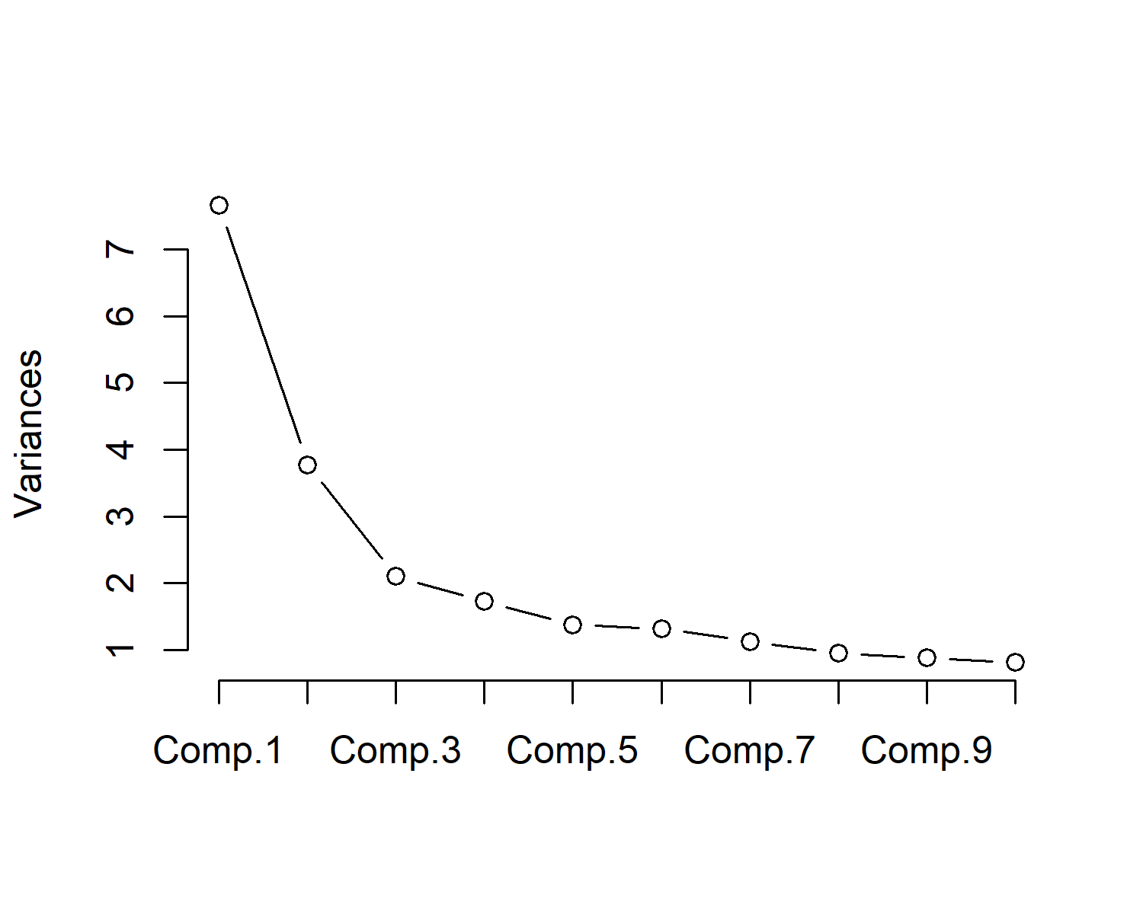

*Figure* *1.*  Screeplot of the first 10 components

Table 7: Loadings for Training Components

|  |  |  |  |
| --- | --- | --- | --- |
|  | RC1 | RC2 | RC3 |
| Choosing a particular registration pathway was an easy decision for me |  |  | -0.74 |
| It was easy to find a course relating to my area of practice interest |  | -0.38 | -0.60 |
| Given the chance, I would have opted for another registration pathway |  |  | 0.68 |
| I am considering undertaking an Area of Practice Endorsement bridging program course |  |  | 0.53 |
| The length of my training has adequately prepared me for efficient practice | 0.74 |  |  |
| I was provided with enough practical experience during my training | 0.79 |  |  |
| I was provided with enough clinical supervision during my training | 0.72 |  |  |
| My training equipped me with adequate knowledge of the discipline | 0.82 |  |  |
| My training equipped me with adequate knowledge about ethical conduct | 0.68 |  |  |
| My training equipped me with adequate knowledge about legal matters | 0.68 |  |  |
| My training equipped me with adequate knowledge about professional matters | 0.73 |  |  |
| My training adequately prepared me to conduct psychological assessments | 0.58 |  |  |
| My training adequately prepared me to understand psychological assessment and measurement | 0.59 |  |  |
| My training adequately prepared me to implement intervention strategies | 0.78 |  |  |
| Because of my training I am confident conducting research | 0.32 | -0.32 |  |
| Because of my training I am confident working with people from diverse groups and cultures | 0.59 |  |  |
| My training prepared me to confidently work with clients of all ages | 0.56 |  |  |
| My training helped refine my communication skills | 0.61 |  |  |
| I am satisfied with the extent my training pathway prepared me for practice | 0.85 |  |  |
| The 4+2 internship is a satisfactory professional training pathway to becoming a psychologist |  | 0.79 |  |
| The 4+2 internship is a preferred professional training pathway to becoming a registered psychologist |  | 0.86 |  |
| The 5+1 internship is a satisfactory professional training pathway to becoming a registered psychologist |  | 0.30 |  |
| The 5+1 internship is a preferred professional training pathway to becoming a registered psychologist |  | 0.46 |  |
| Higher Degree programs are a satisfactory professional training pathway to becoming a registered psychologist |  | -0.62 |  |
| Higher Degree programs are a preferred professional training pathway to becoming a registered psychologist |  | -0.73 |  |
| There is substantial overlap between the competencies gained during training and the competencies required for clinical practice | 0.61 |  |  |
| The pathways to becoming a registered psychologist are unclear |  |  | 0.52 |
| The pathway to becoming a registered psychologist is complicated |  |  | 0.60 |
| There should be multiple pathways to gaining registration as a psychologist |  | 0.53 |  |

### 2.1.1 Pathways to Registration.

Descriptive statistics for the items related to perspectives on pathways to registration are contained in Table 8.

Table 8: Pathways to registration items descriptive statistics

|  |  |  |  |  |  |  |
| --- | --- | --- | --- | --- | --- | --- |
|  | *n* | *m* | *SD* | Skew | Kurtosis | *SE* |
| The 4+2 internship is a satisfactory professional training pathway to becoming a psychologist | 319 | 3.57 | 1.39 | -0.47 | -1.17 | 0.08 |
| The 4+2 internship is a preferred professional training pathway to becoming a registered psychologist | 319 | 2.75 | 1.46 | 0.23 | -1.30 | 0.08 |
| The 5+1 internship is a satisfactory professional training pathway to becoming a registered psychologist | 317 | 3.71 | 1.08 | -0.64 | -0.20 | 0.06 |
| The 5+1 internship is a preferred professional training pathway to becoming a registered psychologist | 318 | 3.01 | 1.16 | -0.07 | -0.74 | 0.06 |
| Higher Degree programs are a satisfactory professional training pathway to becoming a registered psychologist | 318 | 3.92 | 1.15 | -0.96 | 0.02 | 0.06 |
| Higher Degree programs are a preferred professional training pathway to becoming a registered psychologist | 318 | 3.39 | 1.34 | -0.38 | -1.01 | 0.07 |
| There should be multiple pathways to gaining registration as a psychologist | 319 | 3.85 | 1.28 | -0.86 | -0.47 | 0.07 |

There was noticeable variation in the “satisfactory” and “preferred” pathways for registration as a general psychologist. At face value the perspectives of psychologists were that the Higher Degree programs were the most satisfactory (*m* = 3.92, *SD* = 1.15) and that the 4+2 internship was not preferred (*m* = 2.75, *SD* = 1.46). Despite not being preferred, the perspective about whether the 4+2 internship was satisfactory was somewhat neutral (*m* = 3.57, *SD* = 1.39). Obviously perspectives would be influenced by participants own training and registration status. Those with AoPE are more positive about the higher degree pathway than those without, $ΔM=−0.61$, 95% CI $[−0.86$, $−0.35]$, $t(154.45)=−4.71$, $p<.001$. This is likely related to the training pathways that those with and without AoPE have taken, as displayed in Figure 2. The opposite is found when considering perspectives about the 4+2 internship pathway, as displayed in Figure 3.

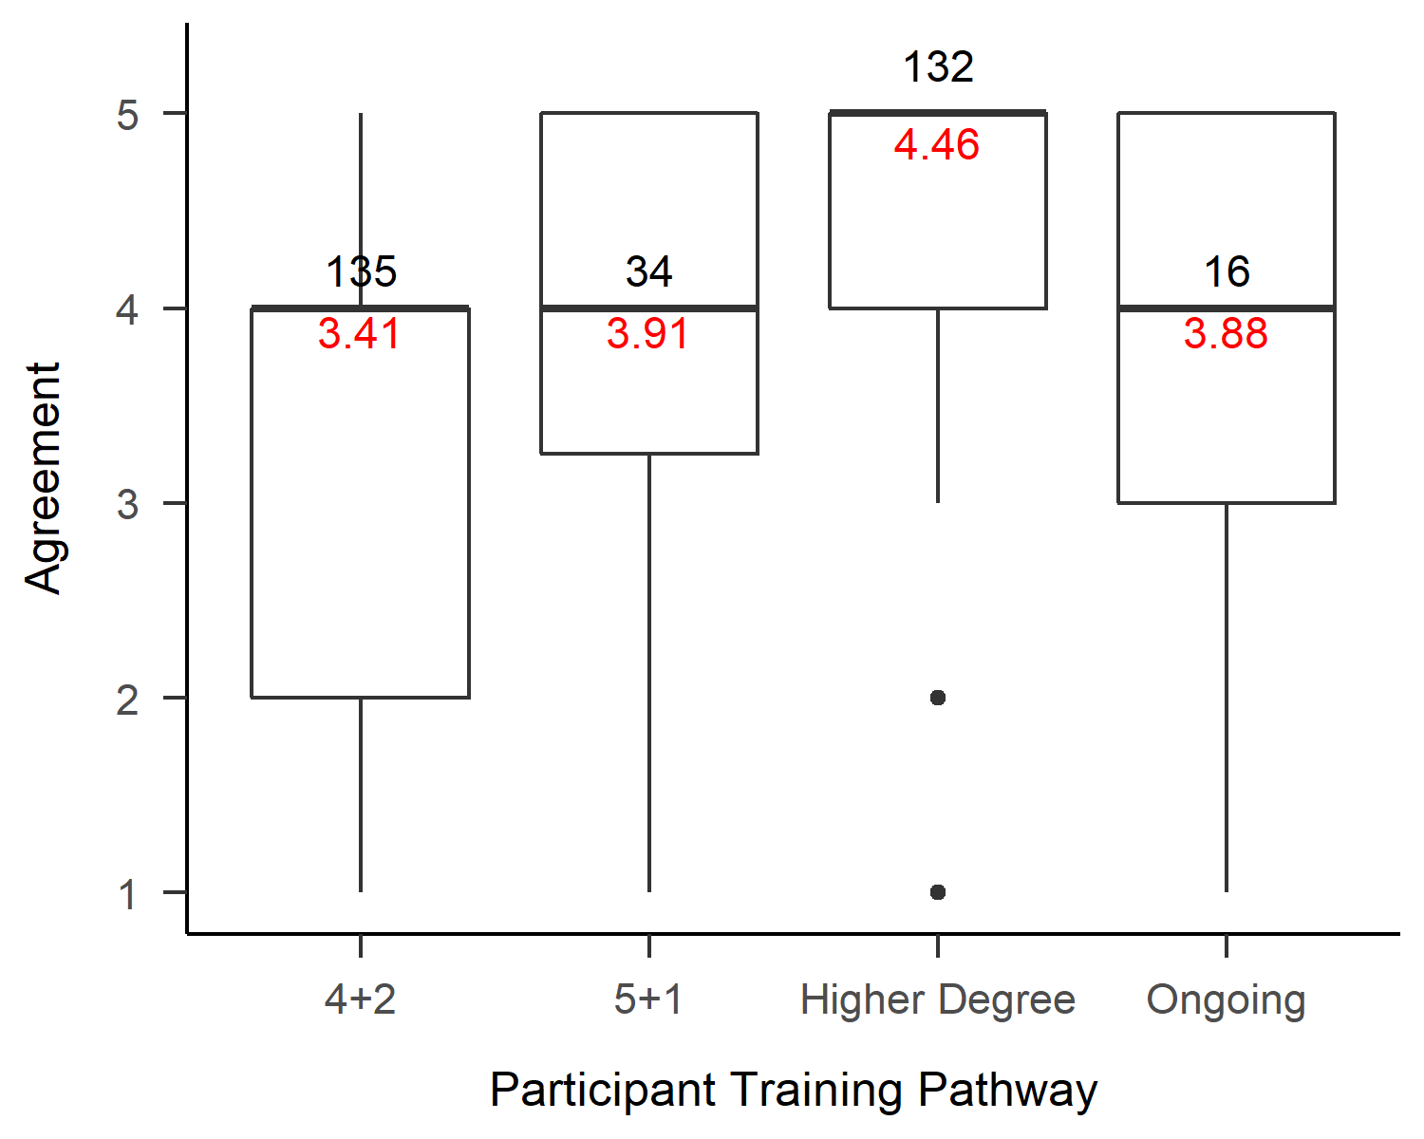

*Figure* *2.*  Higher degree programs are a satisfactory pathway by participant training

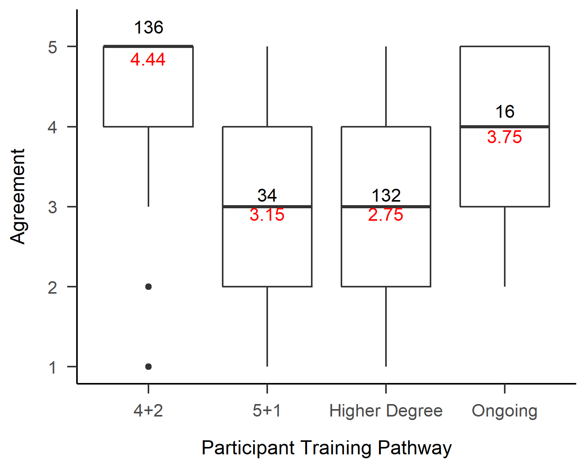

*Figure* *3.*  The 4+2 intership is a satisfactory pathway by participant training

### 2.1.2 Adequacy of Training.

Descriptive statistics for the items related to adequacy of training are contained in Table 9.

Table 9: Adequacy of training items descriptive statistics

|  |  |  |  |  |  |  |
| --- | --- | --- | --- | --- | --- | --- |
|  | *n* | *m* | *SD* | Skew | Kurtosis | *SE* |
| The length of my training has adequately prepared me for efficient practice | 319 | 3.97 | 1.18 | -1.00 | -0.07 | 0.07 |
| I was provided with enough practical experience during my training | 320 | 3.89 | 1.33 | -0.96 | -0.41 | 0.07 |
| I was provided with enough clinical supervision during my training | 319 | 4.11 | 1.23 | -1.31 | 0.50 | 0.07 |
| My training equipped me with adequate knowledge of the discipline | 319 | 4.18 | 1.01 | -1.42 | 1.49 | 0.06 |
| My training equipped me with adequate knowledge about ethical conduct | 317 | 4.54 | 0.76 | -2.31 | 6.64 | 0.04 |
| My training equipped me with adequate knowledge about legal matters | 319 | 3.52 | 1.25 | -0.44 | -1.02 | 0.07 |
| My training equipped me with adequate knowledge about professional matters | 318 | 3.98 | 1.06 | -0.98 | 0.31 | 0.06 |
| My training adequately prepared me to conduct psychological assessments | 318 | 4.29 | 0.98 | -1.60 | 2.14 | 0.05 |
| My training adequately prepared me to understand psychological assessment and measurement | 316 | 4.40 | 0.84 | -1.68 | 2.98 | 0.05 |
| My training adequately prepared me to implement intervention strategies | 318 | 3.89 | 1.20 | -0.98 | -0.12 | 0.07 |
| Because of my training I am confident conducting research | 315 | 3.79 | 1.09 | -0.65 | -0.47 | 0.06 |
| Because of my training I am confident working with people from diverse groups and cultures | 318 | 3.97 | 1.06 | -0.93 | 0.13 | 0.06 |
| My training prepared me to confidently work with clients of all ages | 318 | 3.56 | 1.26 | -0.51 | -0.96 | 0.07 |
| My training helped refine my communication skills | 317 | 4.36 | 0.80 | -1.57 | 3.11 | 0.04 |
| I am satisfied with the extent my training pathway prepared me for practice | 319 | 3.94 | 1.20 | -1.02 | -0.03 | 0.07 |
| There is substantial overlap between the competencies gained during training and the competencies required for clinical practice | 319 | 3.82 | 1.13 | -0.89 | 0.00 | 0.06 |

There was a strong agreement across participants that existing training prepares psychologists appropriately for ethical challenges (*m* = 4.54, *SD* = 0.76), but there was more variability concerning preparation for legal matters (*m* = 3.52, *SD* = 1.25). Those that trained via the 4+2 pathway appeared more confident in intervention strategies (Figure 4) but of equal confidence in assessment and measurement (Figure 5). Overall, it appears most participants feel that their training adequately prepared them, with a mean total score across these 15 items of 60.08 out of 75.

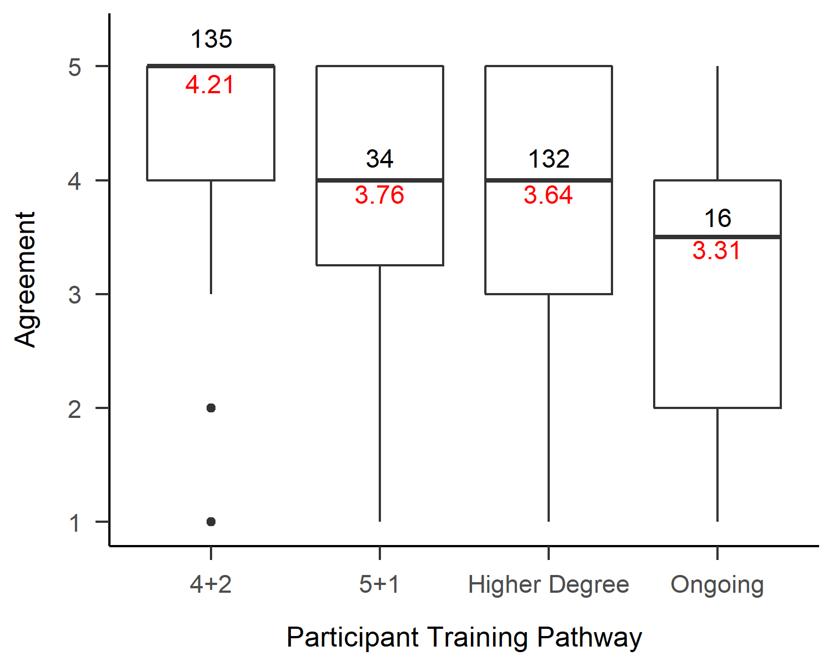

*Figure* *4.*  Training adequately prepared me to implement intervention strategies

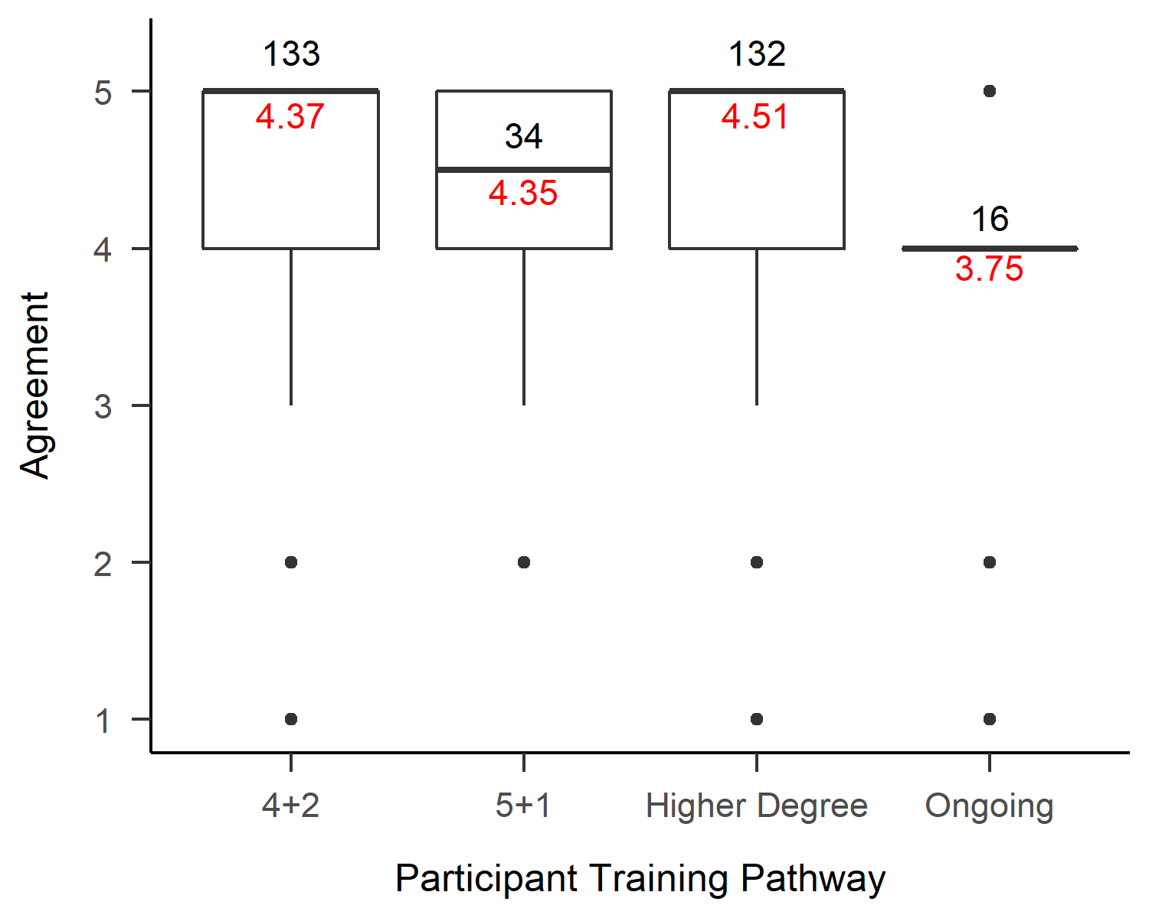

*Figure* *5.*  Training adequately prepared me to understand psychological assessemnt and measurement

### 2.1.3 Clarity of Pathways.

Descriptive statistics for the items relating to clarity of pathways are contained in Table 10.

Table 10: Clarity of pathways items descriptive statistics

|  |  |  |  |  |  |  |
| --- | --- | --- | --- | --- | --- | --- |
|  | *n* | *m* | *SD* | Skew | Kurtosis | *SE* |
| Choosing a particular registration pathway was an easy decision for me | 319 | 3.41 | 1.34 | -0.40 | -1.15 | 0.08 |
| It was easy to find a course relating to my area of practice interest | 319 | 2.99 | 1.43 | -0.03 | -1.41 | 0.08 |
| Given the chance, I would have opted for another registration pathway | 316 | 3.04 | 1.47 | -0.09 | -1.45 | 0.08 |
| I am considering undertaking an Area of Practice Endorsement bridging program course | 320 | 3.01 | 1.53 | -0.11 | -1.49 | 0.09 |
| The pathways to becoming a registered psychologist are unclear | 318 | 3.03 | 1.34 | -0.02 | -1.29 | 0.07 |
| The pathway to becoming a registered psychologist is complicated | 319 | 4.01 | 1.15 | -1.15 | 0.37 | 0.06 |

Across all participants, the most significant variability related to whether participants were considering undertaking an Area of Practice Endorsement bridging program (*m* = 3.01, *SD* = 1.53). Most psychologists appeared to agree that the pathways to become a psychologist are complicated, (*m* = 4.01, *SD* = 1.15).

When it came to choosing a pathway, those that had completed the 5+1 internship pathway seemed to be the most uncertain (Figure 6) but only those that had completed a higher degree training pathway appeared more positive about ease of finding a preferred course (Figure 7). This is reflected in a low agreement about opting for a different registration pathway (Figure 8), and Clinical Psychologists appearing to be the least likely to have chosen a different pathway (Figure 9).

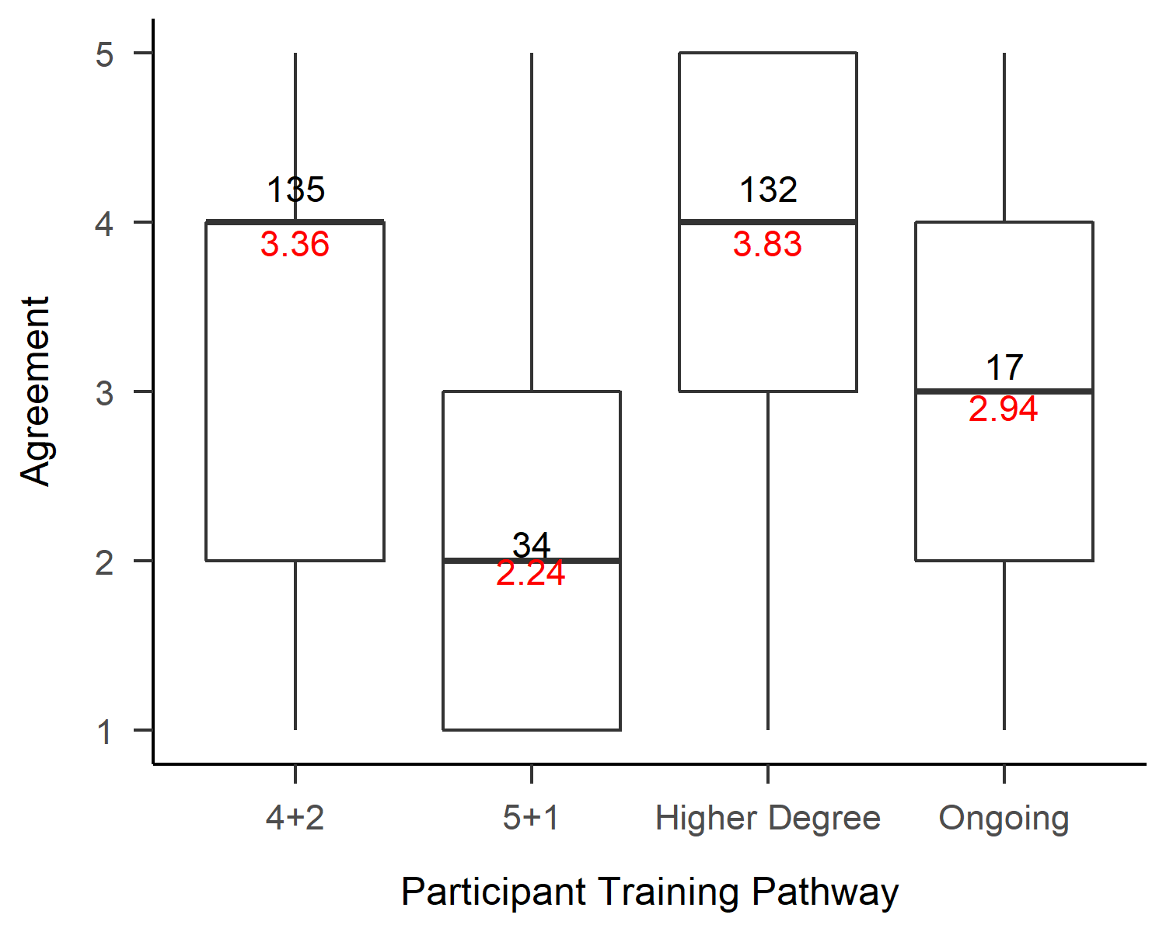

*Figure* *6.*  Choosing a particular registration pathway was an easy decision for me

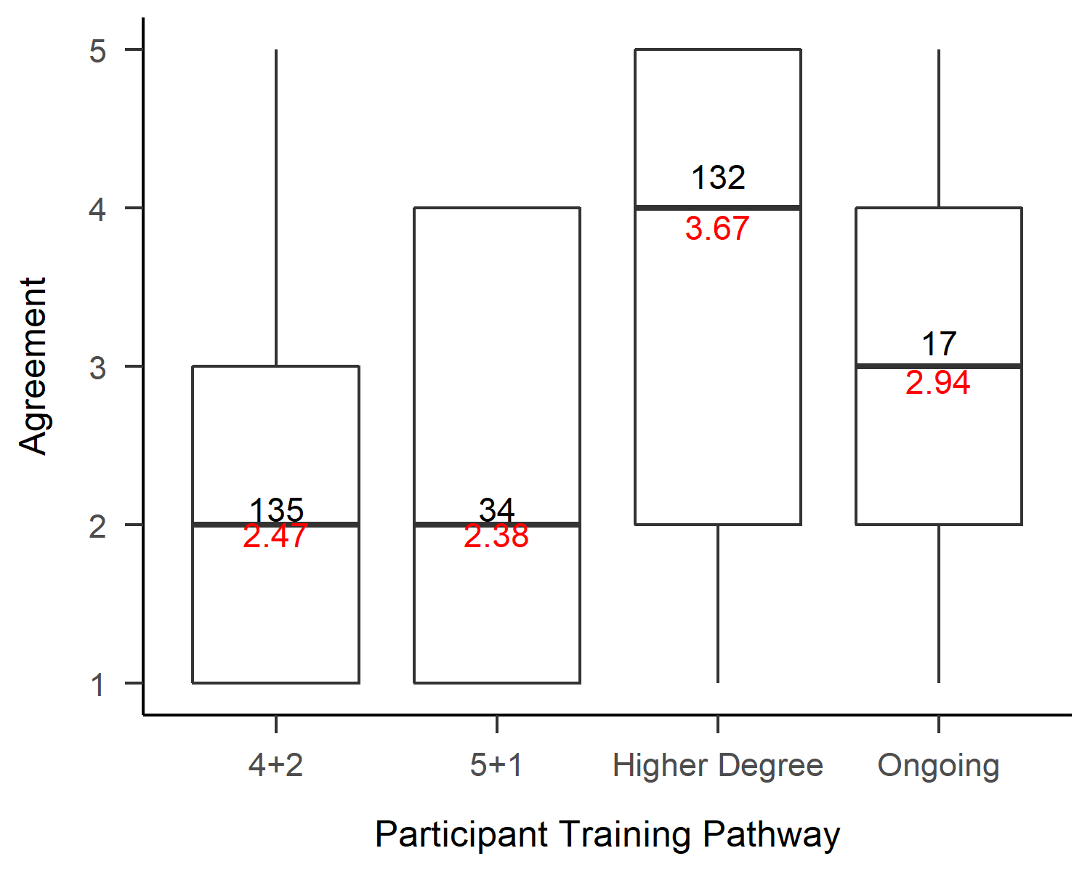

*Figure* *7.*  It was easy to find a course relating to my area of practice interest

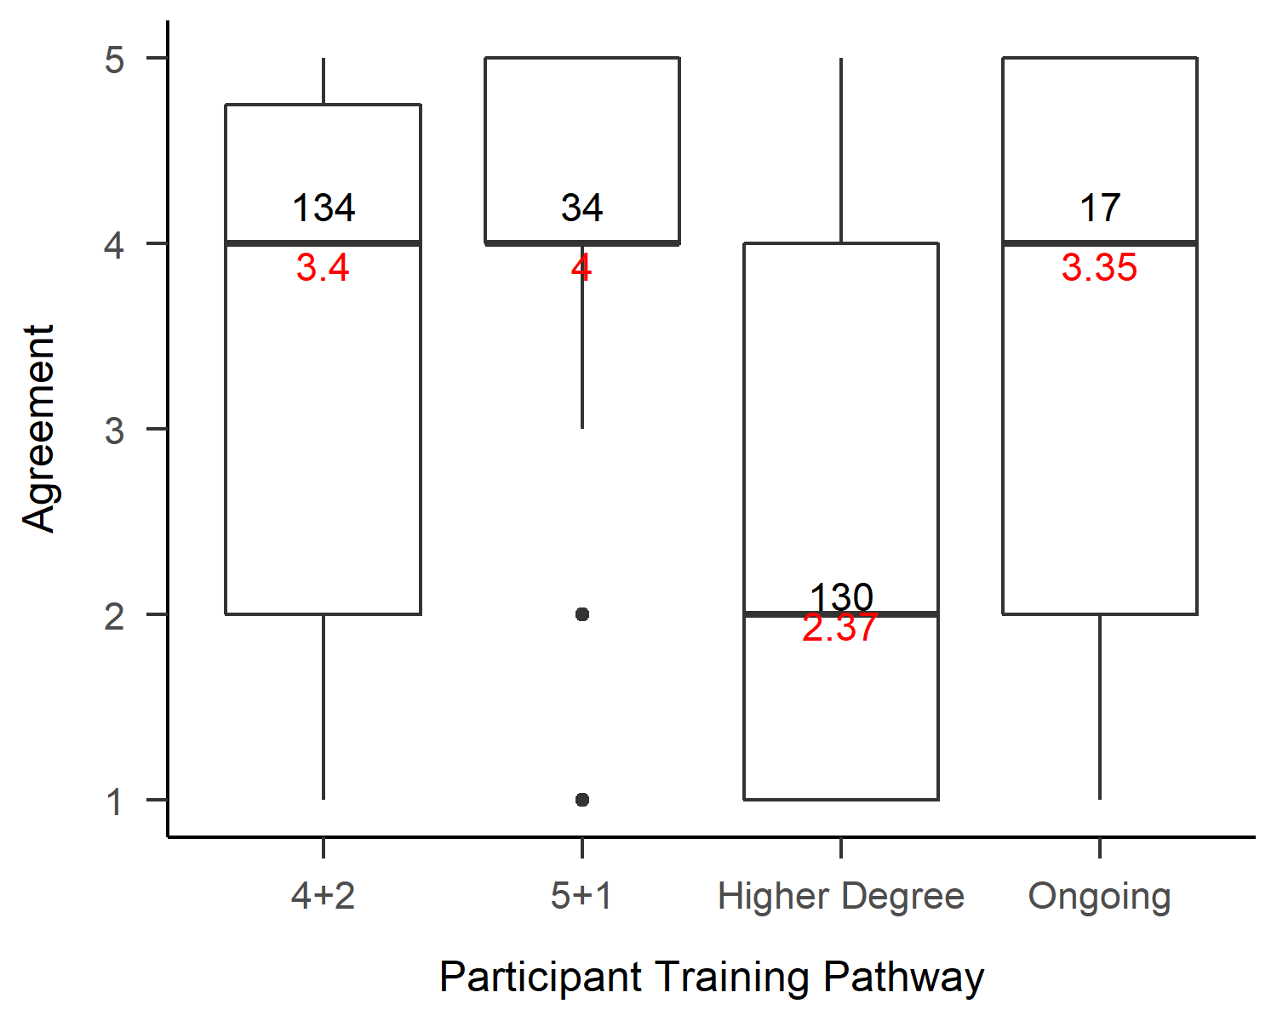

*Figure* *8.*  Given the chance, I would have opted for another registration pathway

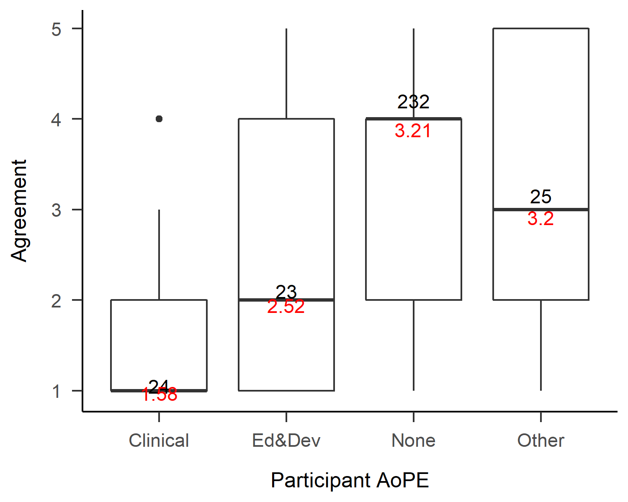

*Figure* *9.*  Given the chance, I would have opted for another registration pathway

## 2.2 Perspectives of AoPE

## 2.3 Perspectives of the Better Access Scheme

# 3 Discussion

# 4 References

Aust, F., & Barth, M. (2020). *papaja: Prepare reproducible APA journal articles with R Markdown*. Retrieved from <https://github.com/crsh/papaja>

Barth, M. (2020). *Tinylabels: Lightweight variable labels*. Retrieved from <https://CRAN.R-project.org/package=tinylabels>

R Core Team. (2020). *R: A language and environment for statistical computing*. Vienna, Austria: R Foundation for Statistical Computing. Retrieved from <https://www.R-project.org/>

Raiche, G., & Magis, D. (2020). *nFactors: Parallel analysis and other non graphical solutions to the cattell scree test*. Retrieved from <https://CRAN.R-project.org/package=nFactors>

Revelle, W. (2020). *Psych: Procedures for psychological, psychometric, and personality research*. Evanston, Illinois: Northwestern University. Retrieved from <https://CRAN.R-project.org/package=psych>

Sarkar, D. (2008). *Lattice: Multivariate data visualization with r*. New York: Springer. Retrieved from <http://lmdvr.r-forge.r-project.org>

Wickham, H. (2016). *ggplot2: Elegant graphics for data analysis*. Springer-Verlag New York. Retrieved from <https://ggplot2.tidyverse.org>

Wickham, H. (2019). *Stringr: Simple, consistent wrappers for common string operations*. Retrieved from <https://CRAN.R-project.org/package=stringr>

Wickham, H. (2020a). *Forcats: Tools for working with categorical variables (factors)*. Retrieved from <https://CRAN.R-project.org/package=forcats>

Wickham, H. (2020b). *Tidyr: Tidy messy data*. Retrieved from <https://CRAN.R-project.org/package=tidyr>

Wickham, H., François, R., Henry, L., & Müller, K. (2020). *Dplyr: A grammar of data manipulation*. Retrieved from <https://CRAN.R-project.org/package=dplyr>

Xie, Y. (2015). *Dynamic documents with R and knitr* (2nd ed.). Boca Raton, Florida: Chapman; Hall/CRC. Retrieved from <https://yihui.org/knitr/>