**“Title”**

Sammanfattning

Table of content

1. Introduction

When designing a completely new software system there are many factors to consider. One of the most important ones is the future end users. This is especially true for systems aimed a small group of end users as it will provide the possibility to tailor make the software to a much greater extent. Depending on the background of the end user, restrictions can be put on the software system and demands might vary greatly. As a result of this, involving the user in the actual software development process can produce a superior software system. The option to involve the user in the entire process might not always be available, but if it is, the user can prove to be a invaluable asset in the software development process.

Motion vision is very important for any seeing animal species. Motion vision is, for example, used to track moving targets or to estimate self motion from optic flow (Borst and Euler 2011). There are several aspects of motion vision one can study. An important one is the behavioral output of visual stimuli.

Using insects for motion vision research is easier than using vertebrates. Surprisingly enough, certain insects code for motion vision in a fairly similar manner as vertebrates do.

Getting a better understanding of motion vision is also important for advanced autonomous technology, such as self driving cars, air planes and different kinds of robots. Learning how motion vision is processed in for example insects is particularly interesting as they apparently process this rapidly despite having very limited brain capacity.

2. Background

* 1. Motion vision at Uppsala University

At the motion vision lab in the department of neuroscience at Uppsala University flies, and in particular hoverflies, are used for research. For doing behavioral studies different methods are used. For example you can film a fly's movement in a contained area while presenting visual stimuli to it and then do image analysis of the recorded material to get the behavioral data. A more novel technique and simpler technique is using a trackball setup to generate a virtual movement path.

Trackball setups are frequently used for behavioral research and not only for flies (Takalo et al) but could potentially be used for any kind of animal as long as the setup size is scaled accordingly. The setup (figure 1) in this project is built by using two optical sensors extracted from two high quality gaming mice. These are held in place in such a way that they are perpendicular to each other and aimed at the center of a cup where a light plastic ball is placed. Using light airflow streamed from the bottom of the cup the ball is hovering slightly to reduce friction to the minimum and therefore it is very easy to spin, which is necessary for the fly to be able to rotate the ball using its legs. The fly itself is tethered so that it hangs low enough to be able to walk on the ball and high enough not to be pushed into it. Thus, when the fly is trying to walk it will not move but rather the ball will move and this can then be used to reconstruct the fly’s walking behavior. Furthermore, the fly is directed at a CRT monitor, which in the experiment is going to be used for showing visual stimuli.

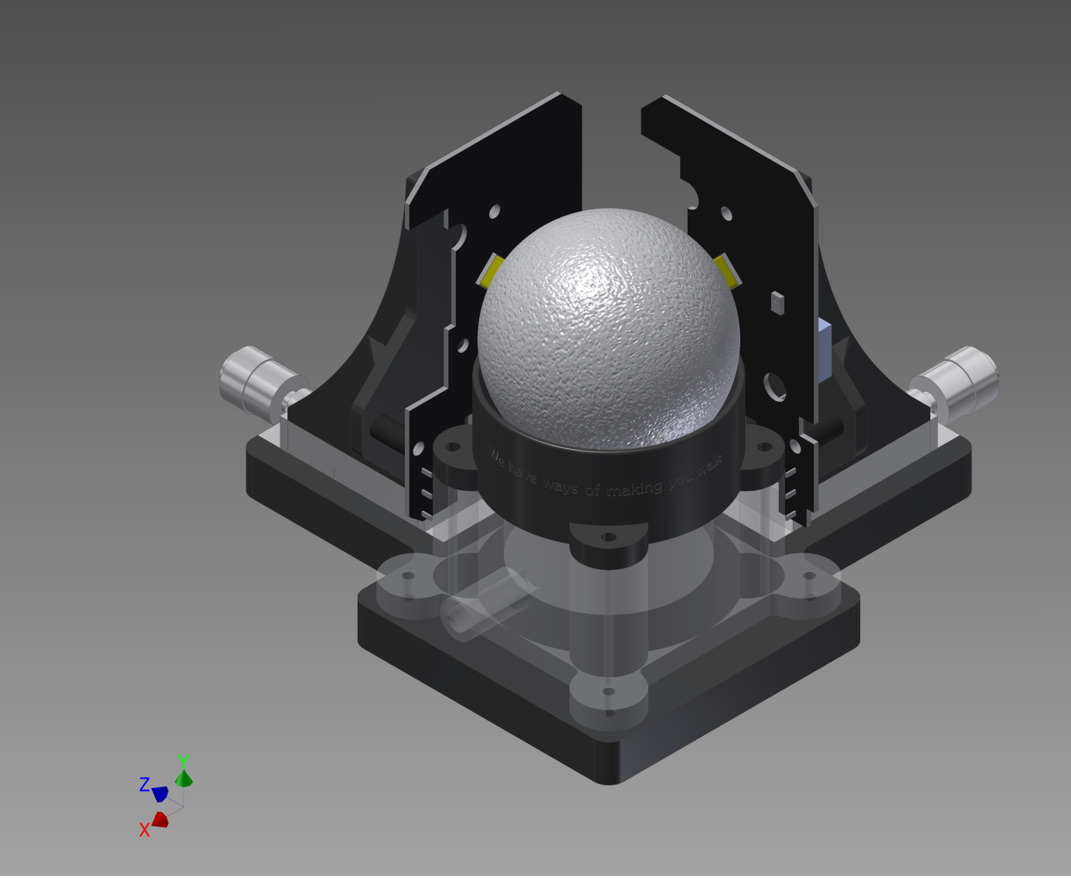

Figure 1 – Blueprint for the trackball setup, the mouse sensors are on the circuit cards placed directly next to the ball perpendicular to each other. The fly will be tethered on top of the ball.

The purpose of the experiments is to study the walking behavior of hoverflies as a function of different visual stimuli. As the fly is tethered and standing on a ball it cannot fly. It has three degrees of movement; it can translate in two dimensions namely thrust (walking forward) and sideslip (walking sideways). The third dimension of movement is yaw rotation (rotation on the spot). On the display monitor different kinds of visual stimuli will be shown and the movement of the fly will be recorded using the setup described above. The two mouse sensors on the trackball setup are used as simple motion detectors. The horizontal component of each mouse sensor (parallel to the x-z-plane in fig 1) will be used to measure yaw rotation, while the vertical components (parallel to the y-axis in fig 1) will be used to calculate translation.

For this setup there is a need for software that can read the raw mouse data and decode these to the fly’s virtual delta movement coordinates. As there are little to none ready-made and available software alternatives for this purpose a new software system needs to be developed.

* 1. Agile software development

Agile software development process is the name of software development methods that follow some certain guidelines for how he work should be performed. They are also considered to be the opposite of the other large group of software development methods, i.e. plan based processes (Beyer). In plan-based methods all activities need to be planned and scheduled extensively before they are started (Sommerville). This will make them much more sensitive to change either from the stakeholders or in the work environment. In contrast to this, trademarks of the agile methodology are rapid design, development and releases of working prototypes, welcoming changes in customer requirements rather than the opposite, and a lot of informal face-to-face communication, as opposed to communicating through large amounts of often redundant documentation (Paulk 2002). Agile methods were developed since plan based methods had poor performance. Large projects were planned ahead of time and during the project requirements changed and time schedules were too tight, which in the end lead to abandoned projects because it was not worth trying to update or restart the process (Beyer).

In many of the agile methods, for example Scrum, work is divided into shorter sprints. Sprints are initialized by choosing requirements to implement during that sprint. These requirements are then frozen for that time and when the sprint is over these should be fully implemented and testable. At the end of each sprint an evaluation session is held where the customer can test the working prototype and give feedback on the project. During this session there is potential for adding, removing or updating requirements, along with changing customer demands (Beyer).

* 1. Adding user-centered practices

Integrating user centered practices to the agile methodology will create an even more powerful development process. The definition of user-centered system design is user-involvement, as much as possible, in the entire process. Early on in the development process the goals of the user, the work environment and the work practices should be taken into account. Explicit design activities must take place and be done iteratively. Evaluation and testing of the design in the beginning before there is any working code can be done through prototyping. As the involved user often lacks knowledge of software engineering any documentation should be done in any notation that both the developers and the users can understand. Creating formal documentation is therefore not a goal in itself, much like the ideas behind agile software development. Ref Finally a user-centered attitude should inspire the entire process and not be just a part of the early design phase (Göransson, Gulliksen).

**2.3.1 Process structure**

A suggestion for structure (figure 2) of an agile user centered systems design starts with a initial phase called “phase 0”, followed by the “release planning phase” and ending with a number of sprints (Beyer).

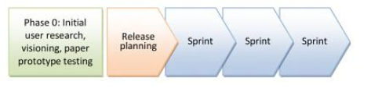

Figure 2 – A typical user-centered system design process. The release planning phase is basically just the phase where the sprints are allocated requirements or user stories. Sprints are repeated over and over again until the project is completed (Beyer).

**2.3.2 Phase 0**

One of the first things to do in the initial phase is to start the user analysis. According to Beyer (2010) the best way to extract the necessary information about the user is simply to talk to them in their work environment. There are some issues regarding the communication with the user that are brought up by Beyer that the design team needs to be aware of. The first point is that users are not good at describing their work process. Although they are domain experts and know what they are doing they still might not be able to articulate what they are doing (Beyer). A way around this issue is to observe the user in their work process, this way information they themselves had not thought about may surface (Lauesen, 480-481).

The second issue is that users want to be nice and helpful and therefore not report major issues with a system that is already far into the development process. Availability is the third point. the end users will be busy at their own work place and therefore might not be available for meetings whenever the design team needs one. However, if it is possible the user should actually be considered a part of the design team to optimize the design (Beyer 2010).

These are just a few of the issues that can arise and many of the others are mainly applicable when the system under development is an off-the-shelf product. Solving these issues as well as possible will produce a better end result (Beyer).

**2.3.3 Contextual inquiry**

There are many activities that can take place during phase 0. A more formal user analysis tool is the contextual inquiry. This means that the design team performs an analysis of the end-user by observing them doing their actual work and seeing in which manner they perform these tasks. This is called a contextual interview. In this phase, design of the system is not in focus, but rather what the working environment looks like and how work generally is done in this particular context. The objective is not to look for problems but rather to understand the users and their need (Beyer).

**2.3.4 Prototypes**

Using prototypes provide the user with a clear description of what the interface is going to look like early in the design phase. Prototypes are also letting the user try these, whether the designer is using low-tech prototypes such as paper prototypes or via some prototyping software creating an interactive interface without its actual functionalities. If the case is the former the designer can use post-it notes as pop-ups and cover invisible parts with paper and removing it as the user makes them visible by interacting with it. Paper prototypes are a good tool for giving the user a sense of the look and feel of the future system, without actually having to program a GUI. This makes it easier to do major changes to the structure of the GUI. As the project moves on these prototypes will not be sufficient. However, as the actual GUI is produced, the user can give feedback on that. Hopefully any future changes will not be major.[1]

**2.3.5 Release planning phase**

In the release planning phase the sprints are planned. First, the length of the sprints need to be decided and this can vary depending on the size of the overall project. Each requirement is allocated a cost in time and when this is done they can be allocated a sprint. The cost estimation is a good way to divide the work evenly between the sprints (Beyer 2010).

Each sprint starts with the development team planning the work for the current sprint. Although a work plan has been set up in the release planning phase it is still important to make sure that plan still is applicable. The early sprints will most likely not have changed that much from the original plan but later on as requirements change, sprint plans will change as well (Beyer 2010).

* 1. Usability

Usability is a very important concept of human-computer interaction and is a measurement you can use in an evaluation of a system’s user friendliness. Usability means that usage of the system should require as little effort as necessary when performing the tasks needed. The system should provide the user with necessary information and be organized in a natural way in the GUI. [2]

That the software has a short learning curve is also a feature of a system with high usability. Design principles are important tools for shortening the learning curve. Design principles are artifacts that are often found in similar systems that are easy to recognize for the users. This means simple artifacts such as “undo”-/”redo”-buttons, “back”-buttons for navigating, and generally just placing interface items where they would be expected to reside in a similar system.[3]

Lausen defines six factors as definition of what usability is. The first one is “fit for use”, which basically means that the system can perform the needed tasks. The second one is “ease of learning”. The third one is task efficiency which means that the system provides efficient solutions for tasks. The last three are “ease of remembering”, “subjective satisfaction” and finally “understandability”. (Lauesen)

Emphasis on usability tends to diminish in the software process for two main reasons. One is caused by the fact that the customer rarely specifies that they want a usable software system (they think it is implied). When the company delivers the software it is not as user friendly as the customer might have wanted. (Göransson)

The second issue that might arise is that usability experts normally only actively participate in the early parts of the software development process and not as much in the implementation and testing phase, since they are rarely software developers. One way to solve this is to have HCI experts that know enough programming to be able to participate actively in the implementation phase in particular, but also in the validation phase, where system requirements are validated (including usability requirements).[4]

* 1. Evaluating usability

A concrete method for evaluating a software system is by doing what is called a user review. This means that the designer goes through the system with an expert user and the user talks about the different tasks and whether there are problems with the solution or not. While this will give the developer a good grasp of the issues with the usability of the system the ease-of-use problems might not be discovered as an expert user can have learnt how to work around these issues (Lingaard).

Nielsen’s usability heuristics can be used as guidelines when evaluating a system’s or a prototype’s level of usability. The heuristics are:

* Visibility of system status
* Match between system and real world
* User control and freedom
* Consistency and standards
* Error prevention
* Recognition rather than recall
* Flexibility and efficiency of use
* Aesthetic and minimalist design
* Help users recognize, diagnose and recover from errors
* Help and documentation

(<http://intra.iam.hva.nl/content/1112/verdieping1/research_for_design/intro-en-materiaal/RfD-Heuristic-Evaluation.pdf>)

1. Purpose and methodology
   1. Purpose

The motion vision lab needs a new user friendly system, FlyTracker, that can perform the tasks needed to study the walking behavior of a fly tethered on a track ball setup. To verify the goal of high usability, an evaluation of the finished software system was done.

* 1. Choice of development process

Since I, as a developer and designer, worked in the same lab as the end users in the motion vision lab at Uppsala University, choosing an agile development process was natural. The initial phase of the project, also called phase 0, was devoted to the project description. This included finding and analyzing requirements of the software system, designing a suitable GUI and planning the implementation phase.

The implementation phase was divided into four sprints of two weeks each. Each sprint was finalized by having a walk-through of the progress so far, where FlyTracker was tested by checking off the list of requirements for that particular sprint. This made it possible to get valuable user-feedback every second week and to make sure that the development was on track. Furthermore, this also made it important to divide the work such that functions (or requirements) were completely implemented during its respective sprint. In the middle of every sprint there was also a shorter check-up meeting where we discussed potential problems or changes to the requirements before they were fully implemented.

Working according to the principles of user centered design was also a clear choice given that the end users were few and that I worked in the same lab as them. This meant that there, in addition to the scheduled meetings, were a lot of informal discussions about the project and questions could be asked about even the smallest details as they were implemented. In other words it was the perfect project for involving the user to a great extent.

* 1. Implementation

The employees in the motion vision lab at Uppsala University are familiar with Matlab and also have some experience with Python. Therefore there was a requirement that the software system was implemented in Matlab. Using Python for certain modules of the system was acceptable, as it was mandatory for a few specific functions. Furthermore, it was straightforward to call Python scripts from Matlab.

* 1. Evaluation

As FlyTracker is aimed at a small group of end-users at the motion vision lab at Uppsala University the choice of evaluation method was straightforward. Although FlyTracker will be shared with other universities the main users will still be in the motion vision lab. Evaluating the software from the perspective of the actual users is more important than evaluating the software from the perspective of naïve users in this particular case. Thus, after the implementation was done the main user tried FlyTracker for almost a month before an interview was conducted. This made it possible for her to find potential issues that needed to be fixed but not long enough so that she learnt how to circumvent them.

The interview was semi-structured. Although I knew what I wanted to find out, it was still a good idea to leave room for exploring issues that I had not thought about. The interview was not recorded. Although this is normally a good idea it was not necessary as I am working in the same lab as the interviewee and could therefore follow up on unclear notes (Lindgaard 154-160). Nielsen’s ten usability heuristics were used as a guideline when writing the interview questions and were used for setting the goals and measurements of the evaluation (see Appendix A).

In addition to the interview a user review was also performed were the main user went through the program and described the qualities of FlyTracker and what was not as good. This gave a more detailed description of issues and how to solve them.

1. User-analysis and system design

The software development process began with an initial analysis and design phase, phase 0. As the project was performed according to the guidelines of an agile user-centered systems design there was no excessively long initial phase. Nevertheless, some up-front planning needed to be done. First I did requirements engineering where requirements were identified, analyzed and prioritized.

The second step was to analyze and learn to understand the user and the environment, which was done through different kinds of work modeling techniques. The resulting work model can be described through different kinds of tools and artifact, but as stated by the agile manifesto no documentation for the sake of documentation. The final goal with the user analysis was to produce a design. In my case it was manifested by the system requirements specification and the paper prototype. The former was used to describe the overall functionality of the system. It was important that this was written down and formalized because of my lack of domain knowledge. The paper prototype was created to give the users an idea of how the GUI would look to be able to give feedback before I started implementing the system.

* 1. Requirements engineering

The requirements phase was done in iterations in the initial phase, but continued to evolve during the implementation phase. The requirements were documented thoroughly, since both me and the stakeholders lacked domain knowledge of each other’ s field the requirements specification therefore needed to be clear.

During the initial phase the end users and I had a few formal meetings where the main functionality that absolutely needed to be done was written down. These were, data recording and saving, which is natural as FlyTracker is essentially a data acquisition program. The second was that there had to be some sort of automatic triggering system as data needed to be recorded at certain time intervals.The final one was that there had to be a interactive calibration function, since hard coding calibration values would disable the possibility for the user to change the hardware setup. The less important functional requirements, as well as interface and non-functional requirements, were set during formal meetings and through informal communication. This way it was easy to optimize the requirements and along the way discover and correct any errors.

During the implementation phase the requirements were revised and reprioritized during the feedback sessions that were held during each sprint. The advantage of working at the same physical location as the stakeholders was once again evident as there was always a possibility of getting immediate feedback on even the smallest thing.

The most important requirements were that the system must be able to read data from the mouse sensors and decode this to represent virtual fly movement coordinates. When the data have been transformed into a suitable format the data should be saved to file. As the user needs to be able to get a sense of what is going on during the experiments there also needed to be a visual output in real time. The output should show instantaneous velocity of the fly and a virtual 2D-path representing the fly’s movements. Furthermore there needed to be a trigger system implemented, which automatically records data only when the visual stimulus was shown. For the full requirements specification document see appendix B.

* 1. User analysis and the paper prototype

The paper prototype was made in two iterations before the first actual GUI, by using a combination of the open source tool Pencil and hand made drawings. The prototype provided no interaction with the user but clearly specified what actions were possible and what they lead to (see figure 1). This was then displayed to the end user and they had a chance to give feedback.

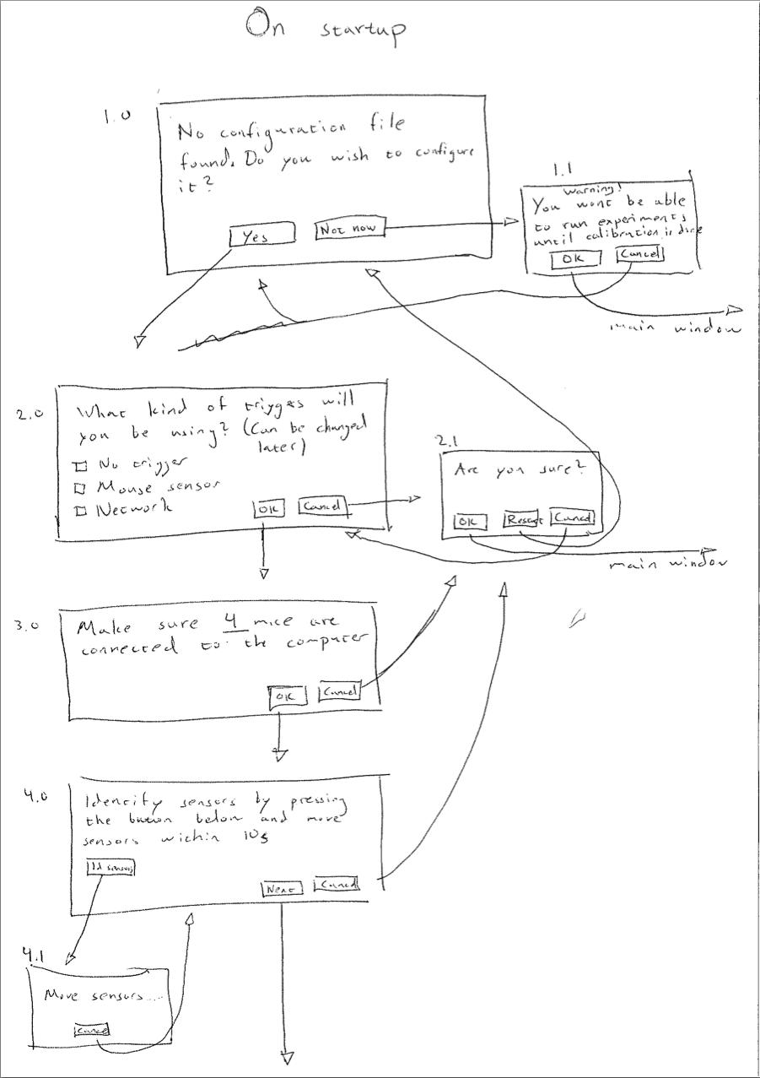

Figure 3 - The calibration wizard (1/2). The starting point of an arrow represents a possible action and the end point what pressing that button, for example, leads to.

The prototype is showing each possible outcome for the different buttons in each window. The program starts with a welcome screen. From there you can either navigate to the main window directly or start the calibration process. The user interaction is manifested in figure 3 by arrows leading from each button to the corresponding window.

As I have been working closely with the end-users in the lab I felt no need for a formal contextual interview, but rather I observed how work was performed continuously. I could ask questions about routines, issues that might arise and generally observe work as it happened.

This was especially relevant for the design of the interactive calibration wizard. The system proved to be difficult to calibrate and the process was not obvious, so creating an intuitive interactive calibration function was not easy. Therefore it was necessary to analyze how the work was performed and what steps needed to be taken to get a fully calibrated system, and particularly, in which order. Hence, before the calibration wizard was designed and implemented myself and the main user performed a manual trial calibration to calculate all the necessary values. This also made me aware of what values needed to be calculated to verify the calibration.

The main window was designed according to common design principles, gathering all the controls to the left of the frame and the output to the right (see figure 4). As this type of display is common, the selection of design is based on the fact that the user will quickly recognize the structure from other applications. The menu also provides further functionality that is not as essential to the actual experiments as the trigger, timer and control buttons are. The option to manually save data or enable/disable automatic data saving is removed to protect the user from forgetting to save experimental data. This can create redundant data files from test runs for example, but this is preferable to the risk of losing data. The user can however, set a save path themselves in the file-menu.

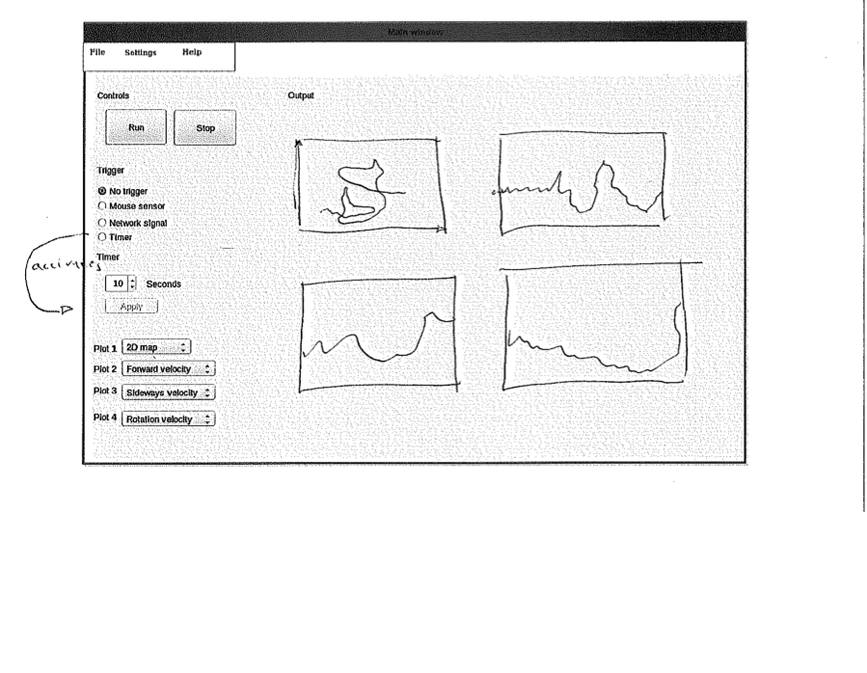

Figure 4 – The main window final prototype. The structure is clean with the controls to the left and the output to the right which means the user will not have to look all over the window for certain functions or graph.

1. Implementation

FlyTracker is implemented in Matlab and Python. The Matlab module provides the GUI and most of the calculations, while the Python module provides the core of the functionality. FlyTracker is platform dependent and can only be run in Ubuntu Linux. However, changes to the Python module could increase portability. Indeed, it would be fairly easy to replace the Python package as it is weakly coupled with the Matlab module.

* 1. The Python module

There are three files in the Python package: *DAQ.py*, *idMouse.py* and *utilities.py*. IdMouse is used purely for identifying the mice. Utilities.py provides useful classes for saving and loading to file, logging exceptions and performing some necessary data processing.

**6.1.1 DAQ.py**

This is the main file where most of the essential functionality is placed. It consists of the parent mouse class called *AbstractMouse* (though not technically an abstract class). *IdMouse* and *SensorMouse* both inherit from *AbstractMouse,* which in turn inherits from *Thread*. *SensorMouse* provides functionality for reading raw mouse deltas and storing them in the global variable coordinates. *IdMouse* is used to identify which mice are the sensors and what mouse is the desktop mouse in the calibration step.

The *MouseHandler* class runs in its own thread and is, as the name suggest, responsible for handling the mice. It initializes the mice and starts and pauses them accordingly. The *MouseHandler* is never stopped unless a stop command is sent from the Matlab application (except if you run FlyTracker with a timer - then the run times are predetermined).

As the data acquisition is run in the Python module, but the user interaction is done in the Matlab module, these need to communicate. The command is sent via a named pipe (which requires Linux) and stops the listening thread. All mouse threads are set to *daemon*, which means that when all non-daemon threads have exited, the Python process will terminate. As the terminating threads will exit abruptly there is potential for minimal data loss (one or two data points).

As data is read it is also saved into a temporary txt file. The data are saved as a json-parsed dictionary object. This object holds two x-values and two-y values, one for each mouse sensor. The final value is a timestamp of that data point. This temporary data file will be opened and read by the Matlab package, which processes and saves it in the final output format.

**6.1.2 Trigger**

The triggering system is a major part of the functionality of FlyTracker. A trigger is basically an on-/off-switch for when to record data. For example, if the user uses a network trigger the recording will not start when the user presses “Run”. Instead pressing run will open up a network socket that listens for commands from a trigger client. When a client sends a “start” command the recording commences and runs until the client sends the “pause” or “quit” command, or alternatively the user presses “Stop”.

The first triggering option is to use no trigger at all. In this case the user can manually control when FlyTracker is recording by pressing “Run” and “Stop”.

There is also an option to use a timer as a trigger. This means that the user can set a time for how long FlyTracker records data, starting when “Run” is pressed.

* 1. The Matlab module

The Matlab module consists of two subpackages, model and view.

**6.2.1 Model**

The model holds the files that process the data, first by loading the temporary data from the txt-file that is created in the Python module.

Readdata.m is (together with the GUI-files) the most important part of the Matlab module. As the name suggests, this function reads the temporary data file and parses them into the correct format. The readdata file also plots the current data continuously, updating the plot every hundred data points.

The raw data that are read are also transformed in the model package. Two equations are used to calculate virtual translation and yaw rotation from the sensors into the fly’s coordinate plane.

Algorithm 1 calculates the translation vector of length two, containing x- and y-movement. *Omega* is the angle between a sensor and the fly’s forward direction and *beta_* is the calibration factor :

*w_m = beta_.*[cos(omega),-sin(omega);sin(omega),cos(omega)]*[y2;y1];* **(Alg. 1)**

Algorithm 2 calculates yaw rotation, where *r* is the radius of the ball and *alpha_* is the calibration factor:

w_mz = alpha_*t/(r);

*t* is given by:

*t = (x1+x2)/2;*

*if sign(x1) == -1 && sign(x2) == -1*

*t = max(x1,x2);*

*elseif sign(x1)*sign(x2) == -1*

*if sign(x1) == -1*

*if abs(x1)<x2*

*if abs(x1)<t*

*t = x1;*

*end*

*else*

*if x2<abs(t)*

*t = x2;*

*end*

*end*

*elseif sign(x2) == -1*

*if abs(x2)<x1*

*if abs(x2)<t*

*t = x2;*

*end*

*else*

*if x1<abs(t)*

*t = x1;*

*end*

*end*

*end*

*elseif sign(x1) == 1 && sign(x2) == 1*

*t = min(x1,x2);*

*end*

The last algorithm processes the horizontal component of each mouse sensor to reduce the yaw signal when the fly is not rotating. This algorithm uses the hypothesis that when the values of the horizontal component of each sensor are very different or even having opposite signs the yaw signal should be reduced. This is logical since when the fly is trying to rotate the ball these values cannot have opposite signs.

Saving is also done in readdata and is done at the end of each experiment instead of continuously. However, the temporary data file holds all necessary information to recreate the data. This means that if FlyTracker should exit unexpectedly, or be closed before the recording has been stopped, all data from that experiment can be recovered on FlyTracker start-up. The user will then be prompted to either recover the data or delete the temporary data file.

**6.2.2 View**

All of the files holding functionality for the GUI and dealing with user interaction are placed in the view. The GUI was implemented using the Matlab Guide which is a drag and drop GUI building tool. This did significantly ease the interface implementation. The code for user interaction was then integrated into the auto-generated code parts.

**6.2.3 Data**

The data are saved into mat-files. Each file is initialized by pressing “Run” in FlyTracker and saved when the user presses “Stop”. Everything that is recorded in between is saved into the same data file. If the user uses the network trigger, recordings can also be paused. Each pause then creates a new data block within the same mat-file.

Data are saved into .mat-files with the filename of the current time. Each data file consists of one 5 x n cell where n is the number of data blocks. The elements of the first row in the cell consists of arrays of thrust delta position, second row is for sideslip delta position, third is for yaw delta position and the forth one is a time stamp. Each column represents data for that particular time stamp. The final row of the cell holds the starting time of that block, i.e. not an array, but rather a date and a time.

1. Results

In this chapter the result of the design and implementation, FlyTracker, is described as it is before the user evaluation. This is then followed by the result of the evaluation interview.

* 1. FlyTracker

FlyTracker is run by opening up Matlab and entering “flytracker” in the command line. This will launch the welcome screen seen in figure 5. The first thing the user needs to choose is whether or not FlyTracker needs to be calibrated. If a calibration file exists and it corresponds to the current setup the user selects “Load config file” which will load the only existing calibration file (as there is no point in having several).

If there is no calibration file or the existing file is obsolete the user can start a new calibration process by pressing “Start configuration process”.   
  
If the user just wants to get to know the program and does not intend to conduct any experiments she can choose “Not now”, which will lead you to the main window but without being able to run a recording. This way the user is protected from doing recordings with incorrect settings.

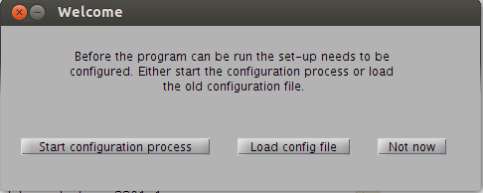

Figure 5 – Welcome screen. This is the window that is displayed at the start of FlyTracker, providing the user with the options seen above.

Figure 6 is a snapshot of the calibration wizard and arguably the most important step, together with yaw calibration. Calibration of thrust and sideslip is done by having the user rotate the ball to simulate the respective movement and using that data to calculate the calibration factor. It is therefore up to the user to make sure the distance the ball is rotated is correctly measured. As can be seen in the figure the next button is disabled. This will enable when the user has done at least three trials. The reason for this is to protect the user from thinking that it is enough to perform one run.  
  
A number of trials are necessary to reduce the effect of outliers. An average error is calculated for every run and displayed to the user. At least three runs are required to be able to proceed to the next step of the calibration wizard.

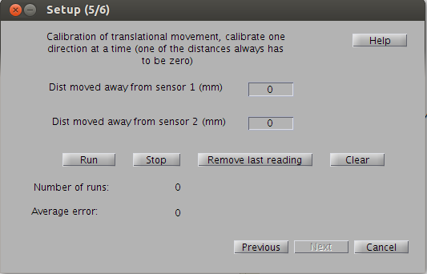

Figure 6 – Calibration of translational movement (thrust and sideslip). In this step of the calibration wizard the user should calibrate thrust and sideslip.

Figure 7 is a screen shot of the main window during a recording (which you can see by the text of the run-button which says “Running..”).

As one can see in figure 7 only minor changes were made from the earlier paper prototype (figure 4). The control buttons were moved to the bottom rather than the top, as this made it more in line with the natural flow of the task of starting a new recording. First the user selects a “trigger”, then sets the timer if that system is used, and finally the recording can be started. The user might lack control over the mouse pointer during experiments as the fly is trying to walk around, therefore both the “Run” and “Stop” buttons can be controlled via the keyboard (switching between them using tab).

The menu holds controls for setting save path, change plotting, and network settings for the network trigger.

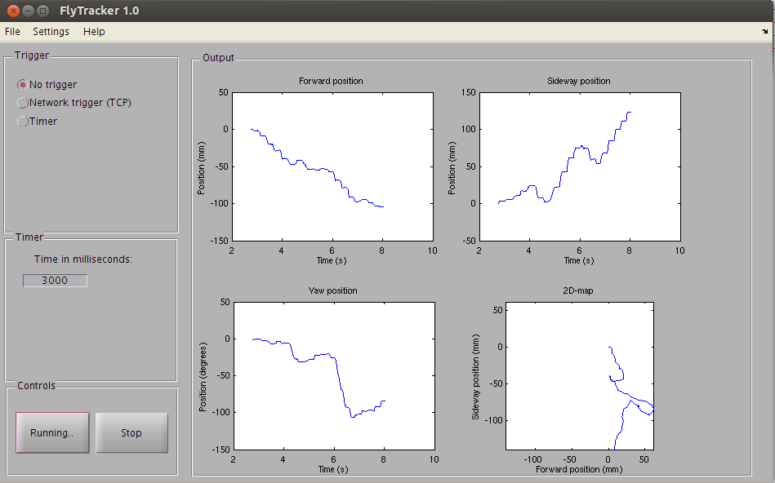

Figure 7 – Main window. This is the final version of the GUI. As in the prototype the controls are placed to the left and the output to the right. The unit of the first three plots can be changed by the user, while the bottom right plot always displays a 2D-map. The three different plots that the user can select between are delta position, cumulative position over time and instantaneous velocity.

In the help menu the user can also find a user manual for guidance to the different parts of the system. The trigger system could cause confusion for the naïve user and the help manual therefore provides a detailed explanation of the functionality.

* 1. Evaluation

The interview was conducted as a semi-structured interview. Although I had provided some very specific questions it ended up being a discussion about the qualities and weaknesses of FlyTracker.

Overall the usability was considered to be high and in particular the ability to see the fly’s movement in real time and as a 2D-plot was highly appreciated as that gave the user the ability to quickly and intuitively do a rough analysis. Also the data are saved in a, for the user, convenient format, which made the analysis solution more trivial.

A few usability issues were discovered during the interview and most were trivial. Suggestions of changing wording and moving a few menu items were brought up and also adding a bit more information of what is going on during the experiments. For example, by having FlyTracker display what data block is currently being plotted during the experiment (currently you can only select data block afterwards and thereby only then know how many there are). However, the major usability problem to be exposed was the fact that when the fly is placed on the ball and is moving the user loses control of the mouse cursor.

There are also a few issues with the user manual and the structure of it, for example how to quickly find information in it.

The calibration solution was discussed during the interview and although it was considered to be an ordeal, it was mostly due to the hardware part and not related to FlyTracker.

1. Discussion

Through the whole project I was working at the same lab as the end-users, this gave me the possibility to involve the user to a great extent. According to the guidelines of user-centered design methods the design team should involve the user as much as possible but real world scenarios often do not allow that unless you are actually working in the same physical environment. This definitely proved to be true as although formal meetings were held throughout the project but the ability to get continuous feedback was invaluable. In the beginning of the process I lacked domain knowledge completely and although I did learn a lot during the project I was by no means an expert. This means that communication with the users needed to be clear as neither they had deep knowledge of software design. Clear communication through design artifacts can shed light on uncertain requirements and as it is common for users not actually knowing exactly what they want it is important to maintain good communication. As I was working according to agile software development principles I did not focus on producing design documents as a self serving purpose. The focus was on the requirements specification and the paper prototype as these were the most important ones to communicate the early design to the users. And after the implementation started the system itself could be used for evaluation. This proved to be more than sufficient in terms of formal documentation. The paper prototype was done by hand and therefore lacked actual user interaction as a digital prototype would have provided. It was however constructed with all possible interactions and showed the user what certain actions entailed.

The relatively weak support for object oriented programming in Matlab did produce a few problems in terms of code quality. The modularity is stronger in the Python module but that part as well could certainly have been optimized further with a more thorough design. Having high code quality is important in a situation like this as I will be moving on but FlyTracker will be used for years and potentially also be extended with new functionality. To make the job easier to future developers there are without doubt elements that can be changed in the current code, without migrating from Matlab. Overall the implementation went smoothly though and given the clear requirements and design documents the implementation phase was quicker than I had initially planned for. This was good though as solving the calibration issue took more time than we initially thought. There also was some waiting time before we could start with the calibration as all the necessary parts of the track ball setup was not available from the start. This pushed the calibration design and implementation to the last sprint which was not optimal as it was considered both difficult and to be of high priority.

The majority of the minor usability problems that were brought up during the evaluation were fixed immediately as they were trivial. However, the fixing the issue with lack of control over the mouse cursor is a more complex task. It was discussed during the implementation phase but was not considered a big enough problem to deal with as the user can control FlyTracker using the keyboard. It was only when FlyTracker was actually used for real experiments that the problem was emphasized. However, a potential solution would be to get a unique cursor for the desktop mouse which means that it is only the desktop mouse that controls that one and the other cursor would move along as it does now.

1. Conclusion
   1. Issues

Although the project most of the time went smooth and followed the predefined project plan there was quite a few challenges to overcome, some more problematic than others. Deciding on a platform for the development was the first issue. While Ubuntu provided a simpler solution for reading mouse data the software for National Instruments Data Acquisition (NIDAQ) cards did not work in Ubuntu (they do have support for other Linux implementations). NIDAQ cards were my initial solution for the triggering system as there already did exist an implementation for that in another data acquisition system that the motion vision lab was using.

So when deciding to use Ubuntu, the trigger became a new issue, quite a few methods were considered but using a network trigger seemed to be the best option. In reality it may be superior to any other solution in terms of temporal precision and the only drawback is it’s portability. When using a network trigger the visual stimulus software needs to be edited so that it sends the correct signal at the correct moment.

The most difficult challenge to overcome was, however, the calibration stage. Not only how to actually do the calibration physically but also how to implement the interactive calibration wizard. There was a lot of time spent on solving issues like getting the ball to rotate around a stable axis and being able to measure the distance with high precision. While this was solvable and the error margin became smaller than five percent, a new issue followed where FlyTracker actually recorded a yaw rotation signal when the ball rotation corresponded to pure translation.

* 1. Future development

For future development of FlyTracker it could be useful to do a more thorough evaluation of the software system by letting naïve users try it out. As FlyTracker is currently being shared with other research groups at other universities there is potential for naïve users. A cooperative evaluation could be performed, where a number of naïve users (with similar background) could try it out and give feedback on usability. This way FlyTracker could be optimized even further.

A possible development of FlyTracker would make the entire experimental set-up to a closed loop system. This means that as the visual stimulus is presented to the fly, the behavior is recorded by FlyTracker, and as a function of the behavior, new visual stimuli are calculated. A closed loop experiment would set high demands on low latency on FlyTracker and as the system is developed now, with both a Matlab and Pyhon module, it would be difficult to satisfy these demands. An alternative would be to migrate all data processing to the Python module (and only display the result in Matlab). This would cut a lot of time, as transfer of data between processes is currently the most time consuming part of FlyTracker. It would still be necessary to transfer the data to the Matlab module, but as this would only be for displaying the output, the time critical element would disappear.

Migration to Python would also mean better support for increasing the modularity and decreasing coupling. There is definitely work needed to be done in this area to make extensions, that are not even thought of right now, easier to implement.

The issue that was brought up in the evaluation was the lack of control over the mouse cursor while the fly is moving. Adding a separate mouse cursor would allow the desktop mouse to always have control of its own mouse cursor and thereby the user never loses control. As there are solutions for this, adding this feature is of high priority.

* 1. Concluding remarks

Finally, the purpose of the project was to develop a user friendly and functional software system for tracking moving insects and reconstruct a virtual movement path. As the evaluation revealed the purpose has been fulfilled. The choice of methodology also proved to be satisfying as the project was perfectly suited for working in accordance with the principles behind user-centered software design. The users were involved from day one and had a major part in the final design of the system. I do think that involving users is a huge benefit for producing good software and a lot of time and money can be saved by optimizing the usage of software system. There are so many applications that are poorly designed for their purpose in which case the users end up working around the problems or not even using the application in the first place. In this thesis it was fairly easy to optimize the performance of FlyTracker and then minimize the workload for the users because they were so few. In larger projects, where the amount of end-users are hundreds or even thousands of people, designing a system that works well for everyone is a complex task as you cannot tailor make it for one person. Therefore a lot of time should be spent on user analysis, work modeling and other analysis activities.

Bibliography

Printed sources:

Borst, A and Euler, T “*Seeing Things in Motion: Models, Circuits, and Mechanisms”*, Neuron 71, September 2011

Moore, Richad, Taylor, Gavin, Paulk, Angelique, Pearson, Thomas, van Swinderen, Bruno and Srinivasan Mandyam, ”*FicTrac: A visual method for tracking spherical motion and generating fictive animal paths”, Journal of Neuroscience Methods, 14*

Benyon, David “Designing interactive systems – A comprehensive guide to HCI and interaction design”, 2010

Beyer, Hugo “User-Centered Agile Methods”, 2010

Gulliksen, Jan and Göransson, Bengt “Användarcentrerad systemdesign”, 2002

Lauesen, Soren “User Interface Design – A Software Engineering Perspective”,

Lingaard, G “Usability Testing And System Evaluation – A guide for designing useful computer systems”

Paulk, Mark, “Agile Methodologies and Process Discipline”, 2002

Takalo, Jouni, Piironen, Arto, Honkanen, Anna, Lempeä, Mikko, Aikio, Mika, Tuukkanen, Tuomas, Vähäsöyrinki, Mikko, “*A fast and flexible panoramic virtual reality system for behavioral and electrophysiological experiments*”, Scientific Reports, March 22, 2012

Web -sources:

http://intra.iam.hva.nl/content/1112/verdieping1/research_for_design/intro-en-materiaal/RfD-Heuristic-Evaluation.pdf

agile manifesto (find link)

**Appendix A:**

**Interview questions**

**General questions**

* How much have you used FlyTracker?
* Whats the best thing about the system?
* What is the worst thing?
* If you could change one thing what would that be?
* Do you feel you got a good grasp of all the functionality
* Do you feel you know where to look for specific functions in FlyTracker?

**The interface**

* Is the interface letting you know what is going on?
* Is the look and feel of the system familiar (are names of functions, buttons and texts understandable, placement of buttons and structures)?

**Functionality**

* Do you feel that you have to be careful not to cause FlyTracker to go into a errenous state?
* Do you feel that there are limitations to the functionality and you have to work around them?
* Do you feel that the documentation is sufficient?

**User manual**

* Have you used the user manual?

If yes:

* Did it answer your questions?
* Was it easily navigateable?

**Appendix B:**

**System requirement specification**

**1.Non-functional requirements**

* 1. **Usability requirements**

**1.1.1 There is a GUI**

Priority: high

**1.1.2 GUI shows relevant experimental output and let the user select which ones to view**

Priority: Medium

**1.1.3 GUI is clear and follows usability heuristics**

Priority: High

**1.1.4 What graphs to display can be selected by the user**

Priority: Low

**1.1.5 There is a specific interface for the set-up calibration system**

Priority: Low

**1.1.6 Help and documentation is available for the system**

Priority: Medium

**1.1.7 Code is well documented**

Priority: Medium

**1.1.8 System is portable**

Priority: High

* 1. **Performance requirements**

**1.2.1 Delay between mouse input and when the system records data input is low or can be calibrated for, such that it doesn't affect experimental data**

Priority: High

**1.2.2 System performs well over longer experiments**

Priority: Low

**1.2.3 System displays output in real time**

Priority: Medium

* 1. **Other**

**1.3.1 Software is easy to maintain**

Priority: Medium

**1.3.2 Data is saved in standard format**

Priority: High

**1.3.3 Timing of trigger and sensor inputs is correlated**

Priority: Low (?)

**1.3.4 All data files are timestamped at the start of recording**

Priority: High

**1.3.5 System**

Priority: High

**2. Functional requirements**

* 1. **Set-up calibration**

Precondition: Hardware setup including sensor placements relative to center must be done and known.

Trigger: Upon start up, program will alert the user in a clear fashion that calibration is a must for running the software successfully. Options between loading an existing calibration file or creating a new one is presented to the user. If no calibration file exist, the user must calibrate so its not possible to access the main functionality until this has been done.

Flow: After selecting, “create new calibration file” the calibration screen appear, here input fields for ball radius (or diameter) exists. The user can also input the sensor placement relative to each other and to the center of the ball. Finally, the user can run experiments where the ball is moved and the distance moved will be showed in form of sideways, forward and rotation.

Alternate flow: If the old calibration file is loaded, before this is executed a warning pop up appears with information emphasizing the need of correct calibration.

Result: After calibrating the system is fully functional and correctly calibrated.

Priority: High

* 1. **Mouse identification**

Precondition: Data calibration is done and both sensors are connected to the computer.

Trigger: The user selects “calibrate mouse function” in the GUI. If the user haven't identified the mice and tries to start the system the user will be prompted to do the calibration before being able to run the experiment.

Flow: A new window opens where the user can select which two mice to use to read data from for the experiment. When selecting two there will be a output showing which one is selected by activating the sensor corresponding to the given mouse selection on screen.

Alternate flow: Load old calibration from file and info pop-up appears emphasizing the importance of correct settings

Result: Sensor data will now be read from the correct mice and execution of experiment can commence.

Priority: High

* 1. **Data is saved to file**

Precondition: Directory path for where to save data is set.

Trigger: A recording is started.

Flow: Data is saved iteratively to file.

Alternate flow: Any I/O-error or errors related to corrupt data leads to an error-message for the user providing details of what went wrong.

Result: Data is saved into file and user is informed of that fact or an error message describing the problem will be provided for the user

Priority: high

* 1. **Data can be recorded using trigger**

Precondition: Set-up calibration and mouse identification is done

Trigger: “Use trigger” is selected and “start recording” is pressed.

Flow: System will wait for trigger before starting recording.

Alternate flow: -

Result: A recording is saved to file

Priority: high

* 1. **Data can be recorded without trigger**

Precondition: Data and mouse calibration is done.

Trigger: In settings, record without trigger is activated, then requirement is triggered by user pressing “start recording”.

Flow: User press start, recording is ongoing until stopped or timer runs out.

Alternate flow: -

Result: Recording is shown in plots selected by the user.

Priority: Medium

* 1. **User can set trigger threshold**

Sampsamp

* 1. **User can view object movement on a 2D map**

Precondition: A successful recording must have been made

Trigger: User has selected to view data in this particular format

Flow: As the recording starts the 2D-trajectories are drawn as long as the system keeps on recording. Stops but is still visible when the recording is terminated (for whatever reason). At any point the user can clear the map and it will start redrawing from scratch.

Alternate flow: Data is corrupted and makes no sense to present in this format. In this case an error-message will pop up informing the user what is going on.

Result: A 2D map is displayed.

Priority: Low

* 1. **User can view object movement speed, forward and sideways**

Precondition: A successful recording must have been made.

Trigger: The user has selected to view data in this particular format

Flow: As the recording starts the map is drawn as long as it keeps on recording. Stops but is still visible when the recording is terminated (for whatever reason). At any point the user can clear the map and it will start redrawing it from scratch

Alternate flow: Data is corrupted and makes no sense to present in this format. In this case an error-message will pop up informing the user whats going on

Result: Graphs for each speed dimension is shown

Priority: Low

* 1. **User can stop recording using keyboard as input device**

Precondition: A recording must be going on.

Trigger: The user presses key for stopping recording (standard space, can be set in system though)

Flow: When the user sends the stop command the recording stops and the mouse cursor is once again under the control of the user.

Alternate flow: -

Result: Recording stops

Priority: Medium

* 1. **A timer can be used to dictate recording interval**

Precondition: Set-up calibration and mouse identification must be done.

Trigger: User has selected to view data in this particular format.

Flow: As the recording starts the map is drawn as long as it keeps on recording. Stops but is still visible when the recording is terminated (for whatever reason). At any point the user can clear the map and it will start redrawing it from scratch.

Alternate flow: Data is corrupted and makes no sense to present in this format. In this case an error-message will pop up informing the user whats going on.

Result: Graphs for each speed dimension is shown.

Priority: Low

* 1. **There is a python client for network triggering**

Precondition: Network triggering is selected as trigger option

Trigger: -

Flow: -

Alternate flow: -

Result: -

Priority: High

* 1. **U****ser can set port and hostname for trigger server**

Precondition: -

Trigger: -

Flow: -

Alternate flow: -

Result: -

Priority: Low

* 1. **User can start recording**

Precondition: -

Trigger: -

Flow: -

Alternate flow: -

Result: -

Priority: High

1. **Requirements sorted by priority**

**High:**

* There is a GUI which will have necessary user input
* GUI is clear and follows usability heuristics
* Delay between mouse input....
* Data is saved in standard format
* All data files are timestamped
* Set-up calibration
* Mouse identification
* Data can be saved to file by the user
* User can start recording

**Medium**

* GUI shows relevant experimental output....
* Help and documentation is available for the system
* System displays output in real time
* Code is well documented
* Software is easy to maintain
* User can stop recording using keyboard as input device

**Low:**

* There is a data buffer for mouse inputs
* What graphs to display can be selected by the user
* System performs well over longer experiments
* User can set timer on recording via user interface
* User can view object movement speed, forward and sideways
* User can view object movement on a 2D map

1. **Sprint planning**

**Sprint 1:**

* Calibration GUI
* Main GUI
* Mouse calibration
* User can start recording
* There is a python client for network triggering
* Implement trigger solution

**Sprint 2:**

* All data is timestamped at certain interval
* Data can be saved
* User can view object movement speed (thrust, sideways, yaw)

**Sprint 3:**

* Setup calibration
* User can set timer on recording

**Sprint 4:**

* User can stop recording using keyboard as input device
* What plots to display can be selected by user in a drop down menu
* User can set port and view hostname for trigger server via the GUI
* User can view object movement on 2D-map
* User manual
* User can choose between data blocks to show
* System is portable
* User can set save-path
* GUI settings are saved at shutdown

1. Benyon, s.184-187
2. Benyon, David, *”Designing Interactive Systems”,* s. 84
3. Benyon, D s.89
4. Göransson, B, Gulliksen, J, Boivie, I, *”The Usability Design Process – Integrating User-Centered Systems Design in the Software Development Process”*