CAMARINES SUR POLYTECHNIC COLLEGES
COLLEGE OF COMPUTER STUDIES
CCCS 106: Application Development and Emerging Technologies (AY 2026-2027)
--------------------------------------------------
LABORATORY TASK REPORT 01
Environment Isolation, Modern Flet GUI & Collaborative 3-Developer Git Workflow
Group Designation: | Group No. 5
Date of Submission: | [ September 07, 2026 ]
Course Instructor: | Engr. Allan Ibo Jr. | CSPC College of Computer Studies

TEAM TRIAD MEMBERS & TECHNICAL ROLES
Student Full Name | Student ID | GitHub Username | Assigned Triad Role & Branch
Jake Laurence Pontanal | 2412878 | @jakelaurence | Developer 1 (Lead UI)  feature/dev1-profile
Joshua Benedict Bongalos | 2412190 | @jbbongalos | Developer 2 (State Logic)  feature/dev2-state
Kurt Hearick Mangente | 2412876 | @kurtmangen10 | Developer 3 (QA & Milestone)  feature/dev3-features

Section 1: GitHub Repository & Collaborator Proof
Public GitHub Repository URL: https://github.com/jakelaurence/cccs106-group05-showcase
GitHub Collaborators Settings page confirming that @jakelaurence has successfully added @jbbongalos and @kurtmangen10 as collaborator.
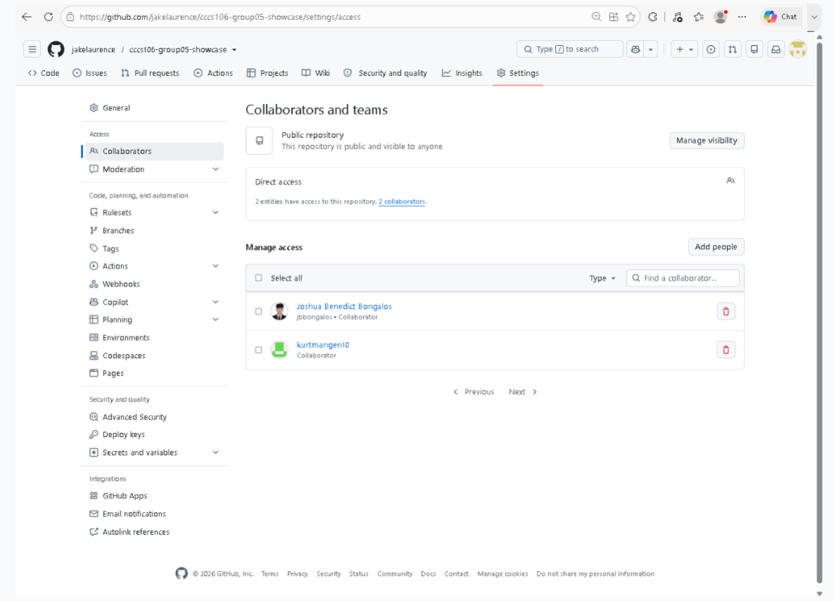Reference: GitHub Collaborators Verification (Settings > Collaborators)
Figure 1: GitHub Collaborators Verification (Settings > Collaborators)

Section 2: Automated Pre-Flight Diagnostics Audit
Environment audit (verify_setup.py) confirming that all 6 setup checks passed in the virtual environment
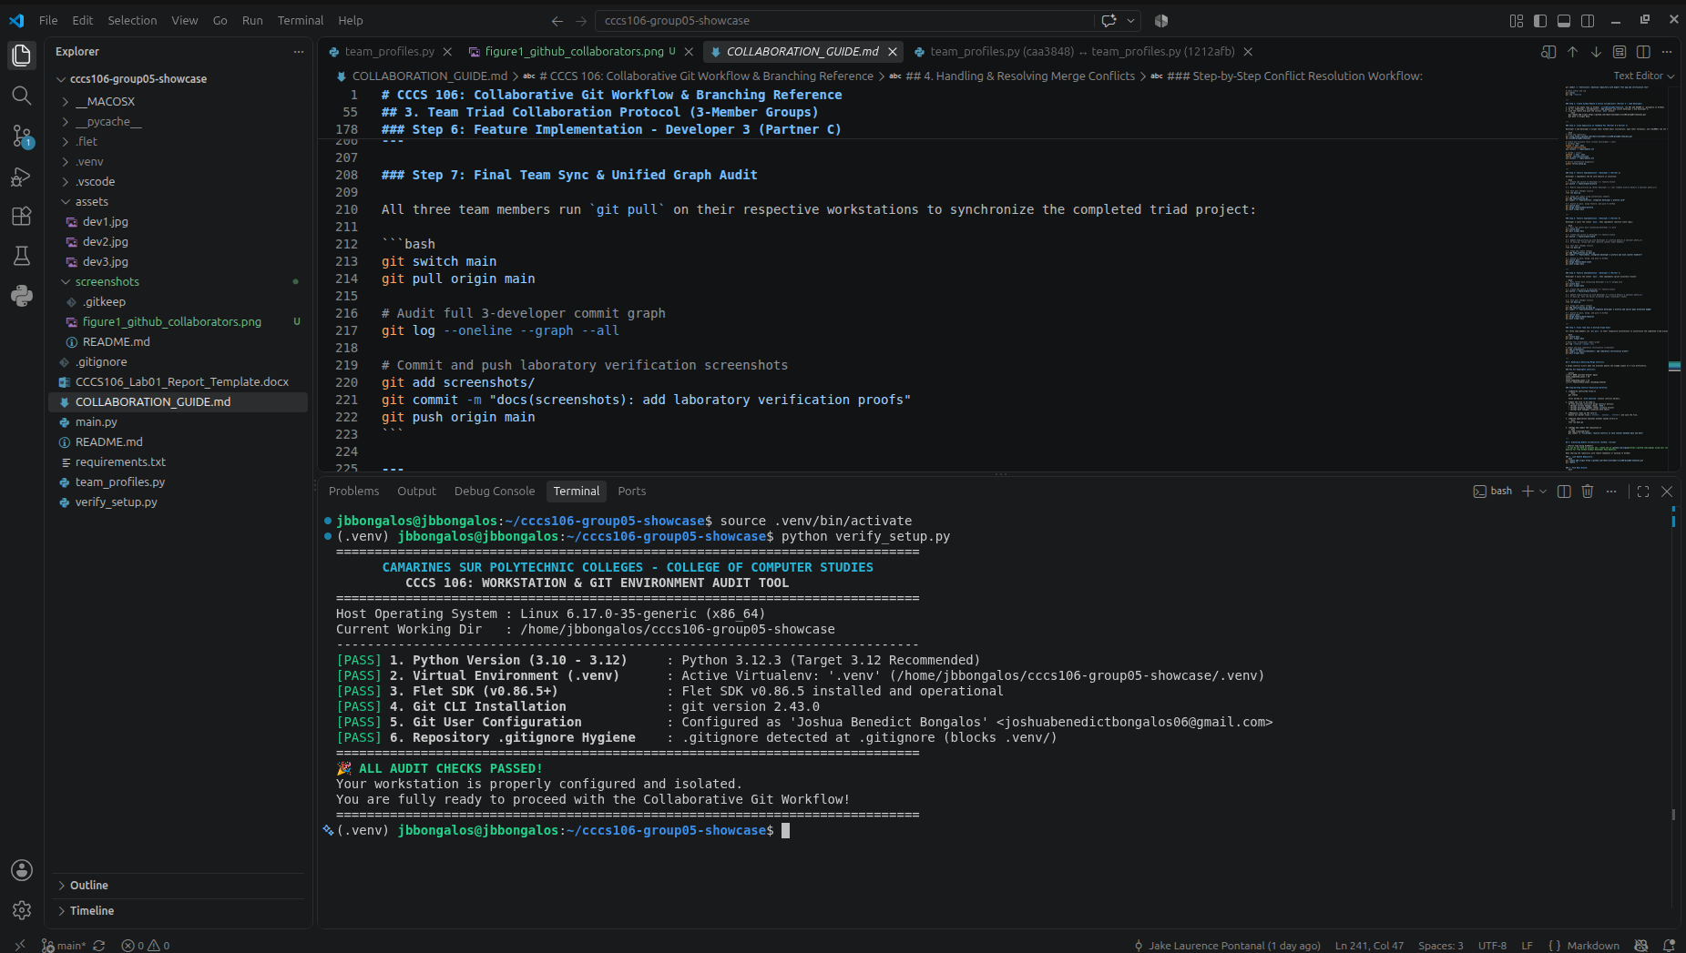
Reference: Pre-flight Environment Diagnostics Audit (verify_setup.py)
Figure 2: Pre-flight Environment Diagnostics Audit (verify_setup.py)

Section 3: Git Working Tree Cleanliness & .gitignore Audit
Terminal output verifying a clean Git status and proper exclusion of the .venv folder
Reference: Git Working Tree Cleanliness & .gitignore Hygiene Proof
Figure 3: Git Working Tree Cleanliness & .gitignore Hygiene Proof

Section 4: Running Flet v0.86.5 Application Showcase
Initial launch of the Flet desktop app showing the devs, isolated environment badge, and task counter set to 0.
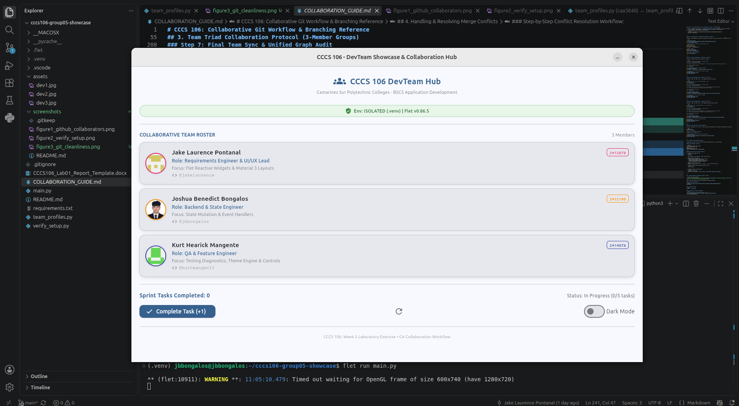
Reference: Application Initial Launch State
Figure 4: Application Initial Launch State

App window showing the completed sprint goal (5/5) with the disabled button and active status badge.
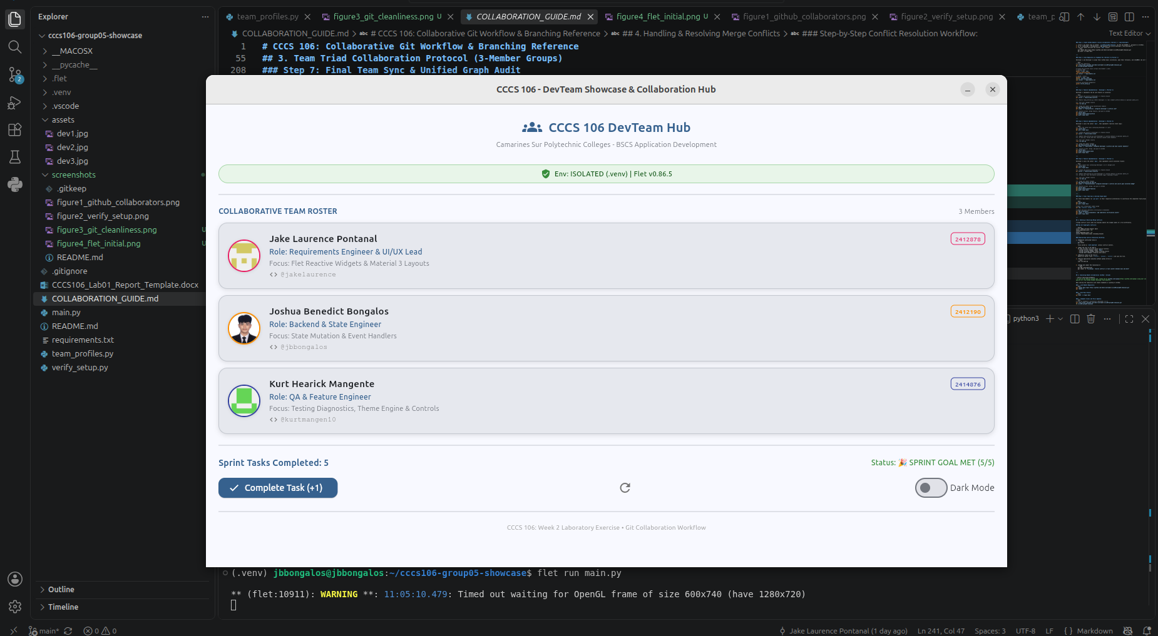
Reference: Sprint Goal Milestone Reached State
Figure 5: Sprint Goal Milestone Reached State

The application running with a dark theme toggled on.
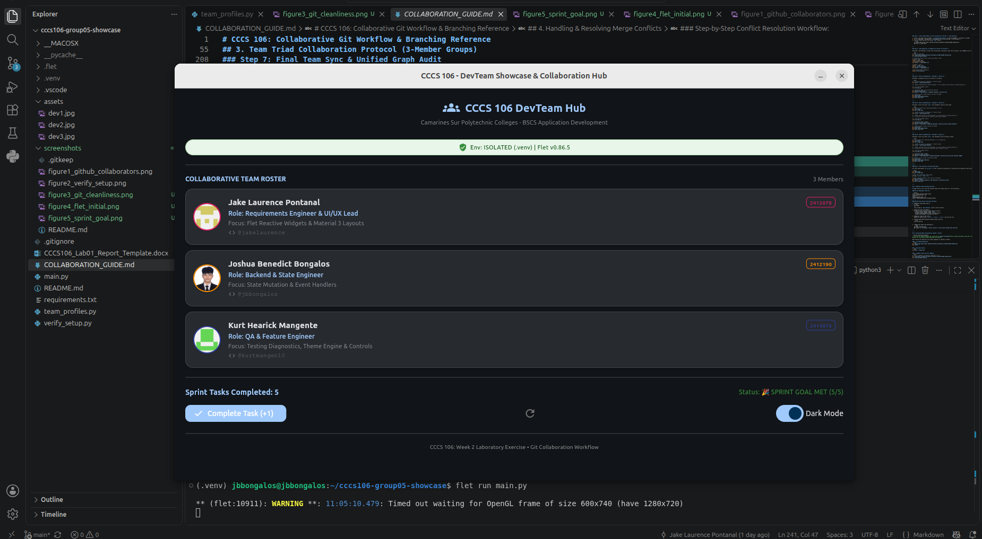
Reference: Material 3 Dark Mode Theme Toggle State
Figure 6: Material 3 Dark Mode Theme Toggle State

Section 5: Triad Contribution Matrix & Learning Reflections
Summary of individual contributions and commit accountability across all three triad developers.
Member Name | Role | Branch Name | Commit SHA | Specific Engineering Contributions
Jake Laurence Pontanal | Developer 1  (Lead UI) | feature/dev1-profile | f6e874e | Initialized repo, setup .gitignore, integrated card 1, configured remote repo & pushed main.
Joshua Benedict Bongalos | Developer 2  (State Logic) | feature/dev2-state | a2b06d9 | Synced main, integrated card 2, connected increment/reset event handlers, merged & pushed.
Kurt Hearick Mangente | Developer 3  (QA/Feature) | feature/dev3-features | 7806b2b | Synced main, integrated card 3, built milestone badge logic & boundary constraints, merged & pushed.

Individual Technical Reflections
Jake Laurence Pontanal - Developer 1 (Lead UI & Repo Architect):
I learned that using a local .venv is important as well as having your gitignore configured to exclude all large data files from being uploaded to GitHub. This helps keep the project lightweight for us devs. In my role as Lead UI Dev, this has also shown me how using an explicit Branch Name such as "Feature/dev1-profile" and commit messages like "feat", and "docs" will help keep our work organized and avoid conflicts with other developer's code on the main branch.

Joshua Benedict Bongalos - Developer 2 (State & Event Logic Engineer):
I learned how to clone a repository from GitHub and work on my own branch without directly changing the main branch. I also learned how to use git pull origin main to get the latest changes from my teammates. While working on the project, I learned how event handlers can update the task counter when the buttons are clicked. This activity helped me understand Git collaboration better and how the app responds to user actions.

Kurt Hearick Mangente - Developer 3 (QA & Sprint Goal Feature Engineer):
As the QA & Sprint Goal Feature Engineer, I learned about the use of a dedicated feature branch as a way of ensuring that my contribution is protected and nothing goes into the main branch. I have also learned how state boundary conditions ensure that every feature stays within boundaries. as working together with my groupmates we would go through the responsibility we had done together and help each other out if we found any small mistakes. It became easy for us to identify whether the features were functioning as expected and also met the sprint goal.

Appendix: Verbatim Git Commit Tree Log
Terminal screenshot of git log --oneline --graph --all showing the full commit history and feature branch merges.
jbbongalos@jbbongalos:~/cccs106-group05-showcase$ git log --oneline --graph --all
* 477d23d (HEAD -> main, origin/main, origin/HEAD) docs(git): update final commit tree proof
* 381693b docs(screenshots): correct dark mode screenshot filename
* a27bbd6 docs(git): update complete commit tree proof
* c20a0fa docs(git): add complete commit tree proof
* cb25349 docs(screenshots): add laboratory verification proofs
* 61181e3 docs(git): update ASCII commit history proof
* a3158de docs(screenshots): add laboratory verification proofs
* 7806b2b (origin/feature/dev3-features) feat(milestone): integrate developer 3 profile and sprint goal milestone badge
* 03bb85a Merge branch 'feature/dev2-state'
|\
| * 1212afb (origin/feature/dev2-state, feature/dev2-state) fix(profile): restore developer 2 profile details
| * caa3848 style(profile): clean developer 2 profile comments
* | d01dc2a style(profile): remove developer 2 example comments
* | c6f6082 Merge pull request #1 from jakelaurence/feature/dev2-state
|\|
| * a2b06d9 feat(state): integrate developer 2 profile and task counter handlers
|/
* f6e874e feat(profile): integrate developer 1 profile card
* 91953f9 chore(init): baseline repository with modern flet app and verification tool

