**Local dev env setup**

** I recommend eclipse IDE for this setup, because I worked on this project using eclipse.

1. Create your [source code repository] and [workspace repository] in your local machine.

2. The git source is located at: https://github.com/jakelee2/tic-tac-toe

3. Do “git clone” at your source code repository from the URL: https://github.com/jakelee2/tic-tac-toe.git

4. Setup IDE as follows:

(1) Open your IDE(eclipse) and go to File => Import… => Maven => Existing Maven Projects

(2) In the [Root Directory:], select your [source code repository] (e.g. C:\projects\tic-tac-toe), check the SNAPSHOT:war (in the image), and click Finish.

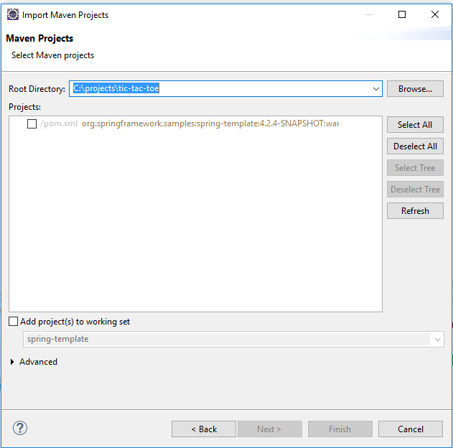

(3) Go to [Project] => and check [Build Automatically]

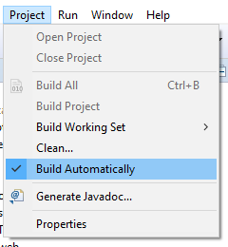

(4) In Project Explorer, right click your project. Go to Maven => click Update Project…

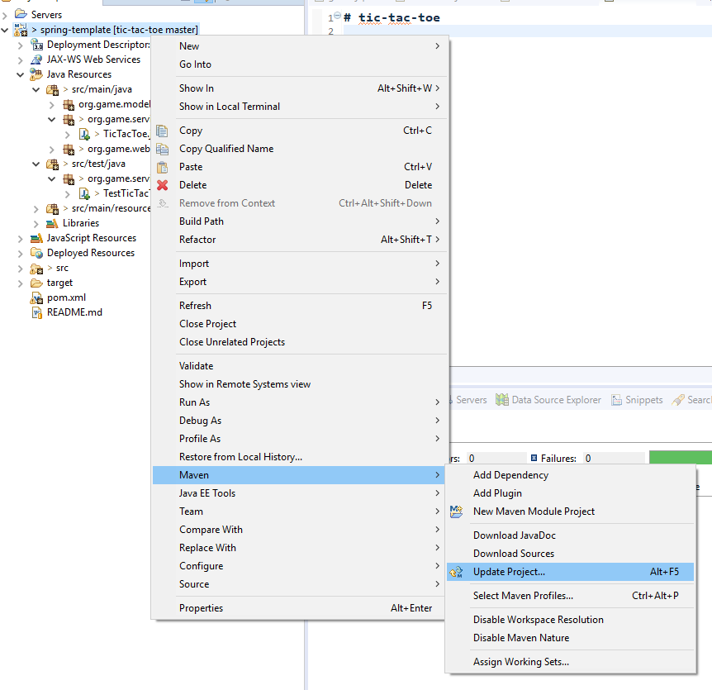

(5) Add Tomcat server in the Servers tab

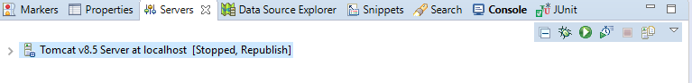

(6) After adding it, if you double click the server, setup page will be opened.



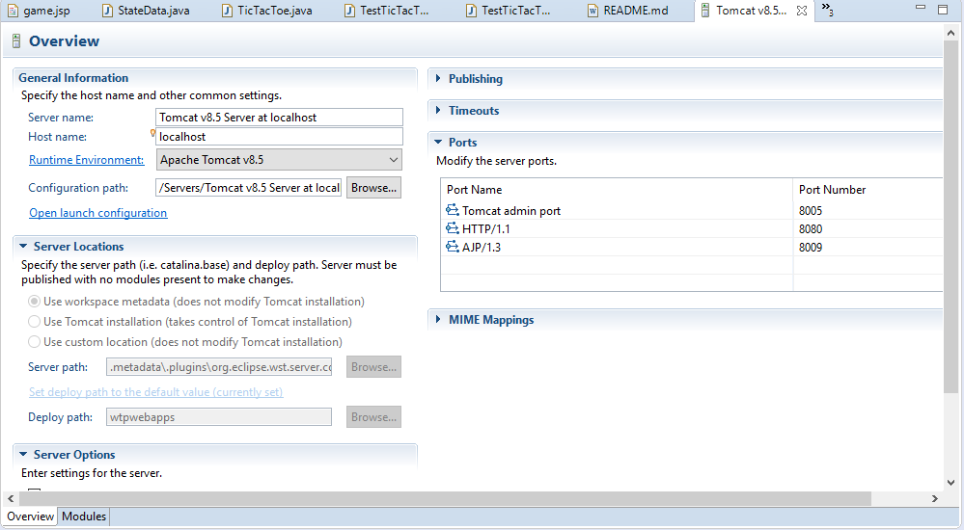

(7) Click [Modules] tab (left-dwn). After that, set Web Modules like the image by using [Add Web Module…] and [Add Web Module…] buttons.

Be cautious: [Path] value must be only “/” (It should not be “/spring-template”).

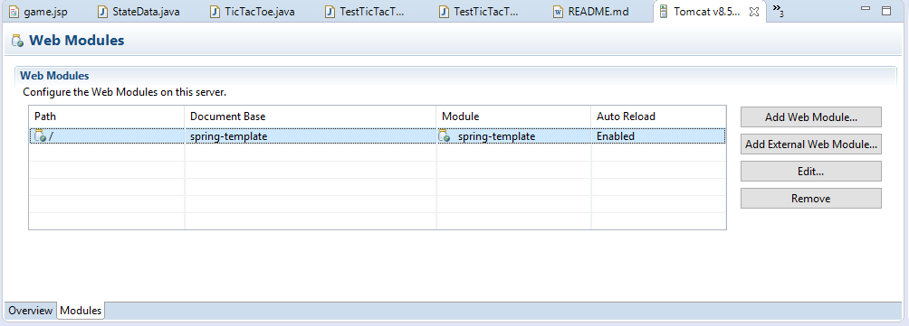

(8) Click [Clean…] and click [Start] to start the Tomcat server.

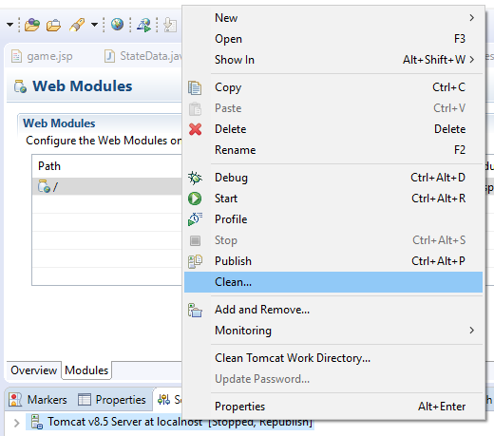

(9) Open a web browser and type in the url: <http://localhost:8080/> and press Enter. Then you will see the simple game page:

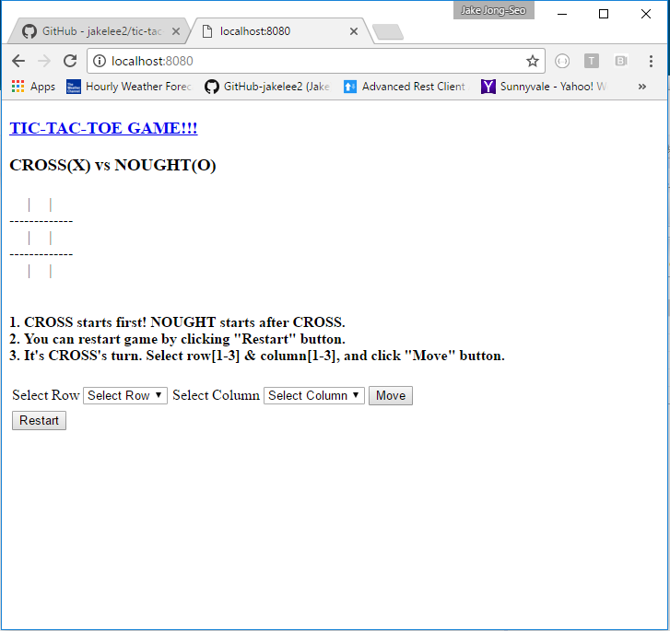

(10) You can start the game now.