User’s Guide
The player’s goal is to move them self and their shooting cursor around to kill as many zombies as they can before they die..
Controls are
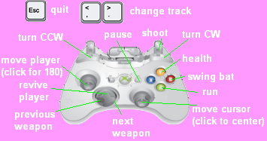
Or
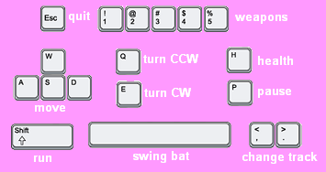

Each character’s ammo, health, stamina, weapon, and direction are visible at all times of game play in the top right portion of the screen.
Scoring is based on a points system decided by how much damage a player does to each zombie.
At any time the game can be paused and a player can reload a different level.
The high scores saved are a personal high score, a team high score, and which level the player made it to.

