HW#4, CSIT341 Data Structures Fall 2018
State University of New York at Fredonia
Total Marks 100

You may attempt this assignment with one more student. Both of you must mention each other’s name and both must submit own assignment.DO NOT SUBMIT PROGRAMS THAT DO NOT COMPILE.
Assigned: Dec 5th Due: Dec 12th
Q1.

- Write a complete C++ program to implement the hash table dictionary as in Q6 of Test-2. The table size is 50. The key,value pairs are employee ID,Name. You must implement the hash table in an array. Your program should have add function to add key,value pairs using ID folding and linear probing as in the test. Your program should also have a search function that accepts employee ID number, locates the dictionary entry and displays the name of the employee and employee’s gender. Copy the complete source code here.

#include <iostream>
#include <string>
using namespace std;

struct hashNode {

string name;
int key;
string gender;
};

int calculateLocation(int key) {

int total = 0;

while (key != 0)
{
total = total + key % 10;
key = key / 10;
}

return total;
}

int linearProbe(int total, hashNode hash[]) {

while (hash[total].name != "") {
total++;
}
return total;
}

void returnAndDisplay(int id, hashNode hash[]) {

int location = calculateLocation(id);

while (((hash[location].key) != id) && (location < 50)) {

location++;
if (hash[location].name == "") {
cout << "\nthis employee is not in the database";
break;
}

}
if (hash[location].key == id) {
cout << "\nEmployee ID: " << hash[location].key;
cout << "\nThe employee's name is: " << hash[location].name;
cout << "\nThe employee's gender is: " << hash[location].gender;
}
}

int addToHash(int key, string name, hashNode hash[], string gender) {

if (key > 9999) {
cout << "illegal value for id";
return -1;
}

int total = 0;

total = calculateLocation(key);
total = linearProbe(total, hash);

hash[total].name = name;
hash[total].key = key;
hash[total].gender = gender;
return total;

}

int main()
{
/*1124/1964/1805/1707/1313/2141/3124*/
hashNode hashArray[50];

addToHash(1124, "Arjun", hashArray, "boy");
addToHash(1964, "Elias", hashArray, "boy");
addToHash(1805, "Aaren", hashArray, "boy");
addToHash(1707, "Kimberlyn", hashArray, "girl");
addToHash(1313, "Barbora", hashArray, "girl");
addToHash(2141, "Ustinya", hashArray, "girl");
addToHash(3124, "Augustin", hashArray, "boy");

//returnAndDisplay(1124, hashArray);
//returnAndDisplay(1964, hashArray);
//returnAndDisplay(1805, hashArray);
//returnAndDisplay(1707, hashArray);
//returnAndDisplay(1313, hashArray);
returnAndDisplay(2141, hashArray);
//returnAndDisplay(3124, hashArray);

/*
cout << "\n\nthe name Arjun: " << hashArray[8].name;
cout << "\n\nthe name Elias: " << hashArray[20].name;
cout << "\n\nthe name Aaren: " << hashArray[14].name;
cout << "\n\nthe name Kimberlyn: " << hashArray[15].name;
cout << "\n\nthe name Barbora: " << hashArray[9].name;
cout << "\n\nthe name Ustinya: " << hashArray[10].name;
cout << "\n\nthe name Augustin: " << hashArray[11].name;
*/
cout << "\nworks fine!";
return 0;
}

- Copy the screenshot of the test run of the program with at least 7 employee names and their gender stored in the table. You must use the following employee ID numbers and add seven random names(Refer to https://www.behindthename.com/random/) (1124, 1964, 1805, 1707, 1313, 2141, 3124). Your program will add the seven test data items. Then it will accept ID#2141 and search for and retrieve the correct employee name and gender and display it.

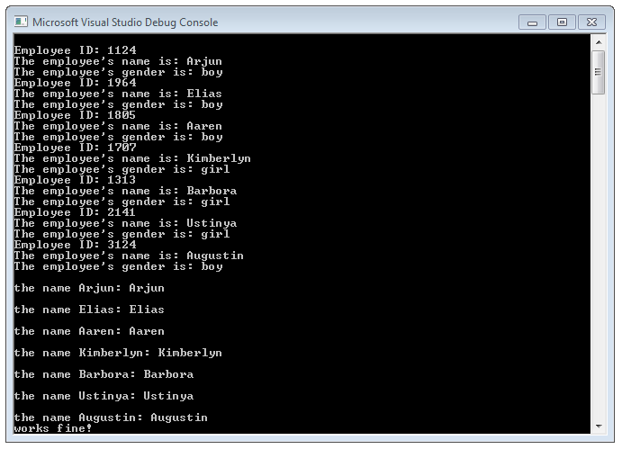

50 points

Q2.

- Write a complete C++ program to implement the graph as shown below and then implement Dijsktra’s shortest path algorithm to find the shortest path between any two nodes.

#include <iostream>
#include <string>

using namespace std;

#define SIZE 6

//finds the vertex the shortest distance from the source
int closestDistance(int distances[], bool distanceFinal[])
{

int minimum = 999999;
int minIndex;

//for each letter
for (int i = 0; i < SIZE; i++) {

//min is the shortest distance available to am unchecked vertex from the checked vertices, update is a shorter distance is found
if (distanceFinal[i] == false && distances[i] <= minimum) {

minimum = distances[i];
minIndex = i;//index of the vertex closest to checked vertices

}
}

return minIndex;
}

void printPath(int parent[], int target) {

if (parent[target] == -1) {
return;
}
printPath(parent, parent[target]);
cout << " " << target;
}

//find the shortest path between src and target
void dijkstra(int graph[SIZE][SIZE], int src, int target)
{
int distances[SIZE]; //holds distances from src to letter i (w,v,x...)
bool finalDistance[SIZE]; //true at i if shortest distance from source to i (w,v,x...) is found

// Initialize all distances as a large number (as we will be finding minimum distances) and finalDistance[] as false (none of the closest paths have been determined so far)
for (int i = 0; i < SIZE; i++) {
distances[i] = 999999;
finalDistance[i] = false;
}

// Distance of source vertex from itself is always 0
distances[src] = 0;

int parent[SIZE];
parent[0] = -1;
// Find shortest path to source for all vertices until the shortest distance to target is found
for (int j = 0; j < SIZE - 1; j++) //for each letter
{

if (!finalDistance[target]) { //if the target distance has been found, break loop

//closestVertex is the closest vertex the processed vertices
int closestVertex = closestDistance(distances, finalDistance);

// Mark the picked vertex as processed
finalDistance[closestVertex] = true;

// Update dist value of the adjacent vertices of the picked vertex.
for (int i = 0; i < SIZE; i++) {

if ((finalDistance[i] == false)) { //update i only if the final value isn't present

if (graph[closestVertex][i] && distances[closestVertex] != 999999) { //if an edge between the two exists and the distance from src to the closest vertex is there

if (distances[closestVertex] + graph[closestVertex][i] < distances[i]) { //if the total path is less than what's currently listed0

parent[i] = closestVertex;
distances[i] = distances[closestVertex] + graph[closestVertex][i]; //graph[u][i] is a distance
}

}

}

}
}
else {
break;
}

}

cout << "\n" << target << "'s distance from source: " << distances[target] << "\n"; //dist[i] is the distance away from source for vertex i
cout << "Path to target: ";
printPath(parent, target);
}

int main()
{
int u = 0;
int v = 1;
int x = 2;
int y = 3;
int w = 4;
int z = 5;

int graph[SIZE][SIZE] = { {000, 2, 1, 000, 5, 000},
{2, 000, 2, 000, 3, 000},
{1, 2, 000, 1, 3, 000},
{000, 000, 1, 000, 1, 2},
{5, 3, 3, 1, 000, 5},
{000, 000, 000, 2, 5, 000}
};
cout << "\n(u = 0; v = 1; x = 2; y = 3; w = 4; z = 5)\n";
dijkstra(graph, u, w);
cout << "\n\n";

return 0;
}

- Copy the screenshot of the test run of the program with finding the shortest path between the nodes u and w.
50 points

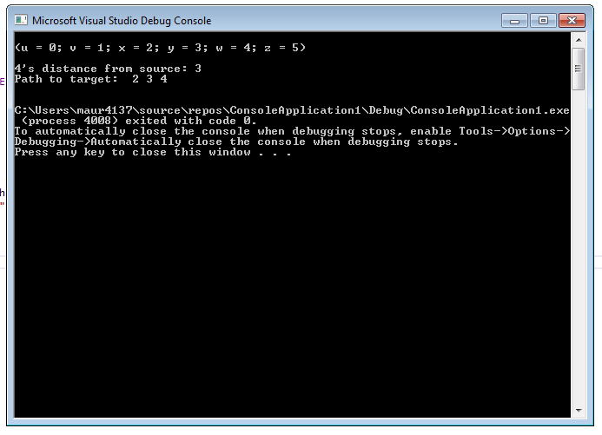
u
y
x
w
v
z
2
2
1
3
1
1
2
5
3
5

