

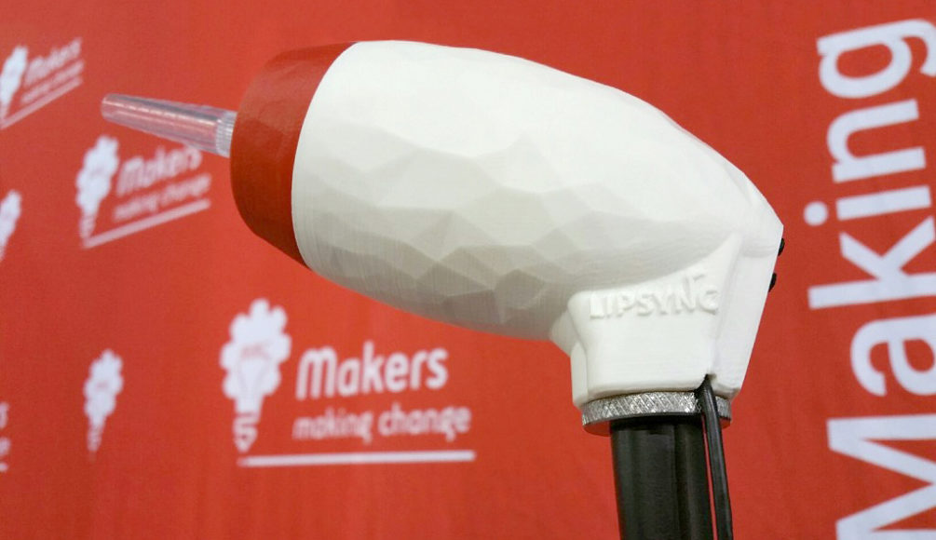

LipSync

STARTUP GUIDE

**Version 1.5 / September 2019** **www.MakersMakingChange.com**Table of Contents

About the LipSync 3

What Do You Get? 3

Types of LipSync 3

Getting Started 4

Mounting 4

Mobile Phone and Tablet Compatibility 5

External Power Bank 5

Connecting the LipSync to a Device 5

Using the LipSync 7

Functions 7

Speed Control 8

Feedback 9

Troubleshooting 9

Joystick Calibration 10



# About the LipSync

The LipSync is a mouth operated joystick that allows a person who has limited or no control of their hands and arms to control a cursor on a mobile phone, tablet or computer using only head movement. It is an open source assistive technology design by Makers Making Change, a program of the Neil Squire Society that connects volunteer makers with people with disabilities to create more affordable assistive technology.

Open source designs are freely released by their creators for people to make for themselves, modify or incorporate in their own designs for free. Join the Makers Makers Making Change to help people in your community: <http://www.makersmakingchange.com>

**Need a build -- join us.**

**Want to make a build -- join us.**

**Want to fund a build for a person with a disability -- join us.**

## What Do You Get?

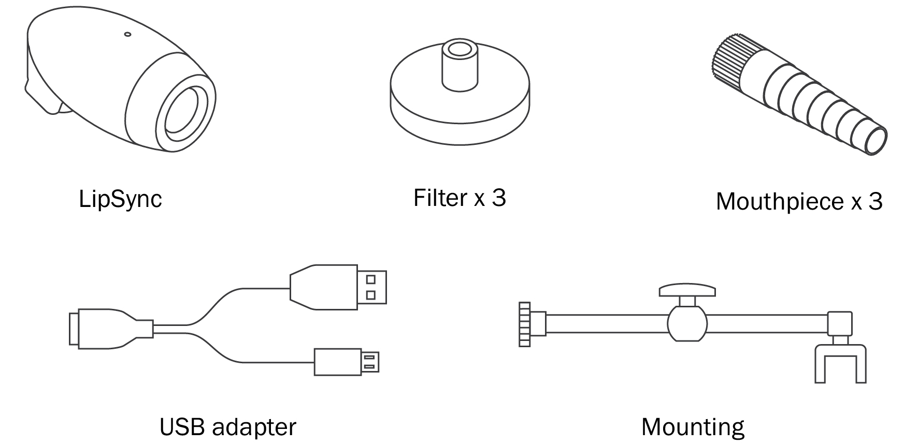

## Types of LipSync

|  |  |  |
| --- | --- | --- |
|  | Description | Connection Type |
| **LipSync** | **Works like a mouse** | **USB** |
| LipSync Wireless | Works like a mouse | USB & wireless |
| LipSync Macro | Works like a keyboard | USB & wireless |
| LipSync Gaming | Works like a gaming joystick | USB |

# 1 Getting Started

The LipSync requires the following items to get started:

* A LipSync
* Computing device (mobile phone, tablet, or laptop) which supports a USB mouse
* External power bank (optional but recommended)
* Mounting solution for securing the LipSync to a surface

Before plugging the LipSync, make sure of the following:

1. Computing device is fully charged and/or uses an external power source (e.g. power bank).
2. Computing device and LipSync are securely mounted to a stable surface.
3. LipSync USB, adapter cable and external power source are plugged together (see Plugging the LipSync in this section)

## Mounting

Wheelchair: Every wheelchair has different points available for mounting. Common mounting points available on power wheelchairs are the headrest rail, back of wheelchair, armrest rail, under chair cushion, chair rail, and footplate. Try out different areas and see what works best. If you are not familiar with mounts, consult with a local assistive technology professional.

Desk: Find a clear space on the front edge of your desk or table. Orient the mount bracket toward the user being careful not to move the LipSync. Secure the bracket and adjust the mounting arm so the LipSync is within easy reach. Tighten the knob when the arm is in the desired position.

Checklist for after mounting:

* Are the clamp and mount secure and do not move?
* Is there clearance around the wheels, wires, and chair frame with the mount attached?
* Does the wheelchair fit through doorways?
* Is the driving view of the user clear with no obstructions?
* Is the mobile device within viewing angle of the LipSync?
* Can the user easily reach the LipSync to use it?

## Mobile Phone and Tablet Compatibility

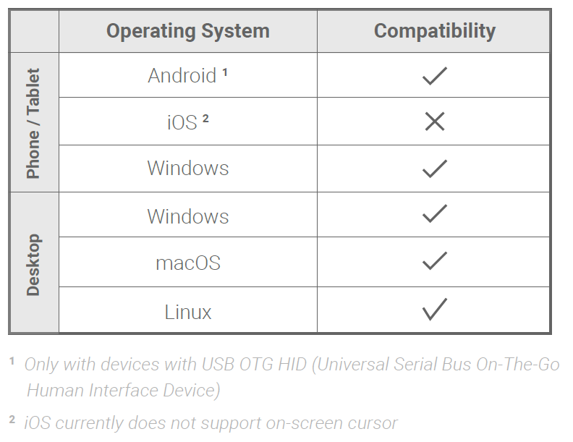Not all mobile phones and tablets support external pointing devices like the LipSync or other mouse replacements. Apple iOS phones and tablets with iOS13 and iPadOS or higher, and only some Android mobile phones and tablets support the LipSync. Check with the manufacturer before purchasing. Look to see if your device supports “USB OTG HID” or “Universal Serial Bus On the Go Human Interface Device” profile.

2 Only for iOS13+ and iPadOS. For previous iOS versions, use the *LipSync Macro*

1 Only with devices with USB OTG HID (Universal Serial Bus On-The-Go Human Interfere Device)

2 iOS currently does not support on-screen cursor

## External Power Bank

The LipSync can be powered using an external power supply like power bank of at least 2700mAH or higher. This prevents the LipSync from drawing battery from your mobile or tablet. The power bank is only supplying power to the LipSync and the mobile or tablet will not be charged.

## Connecting the LipSync to a Device

### Plugging into a Computer, Laptop or Android & Windows Device

The order in which you connect the USB cables may affect how the LipSync functions. Plug the cables in the following order:

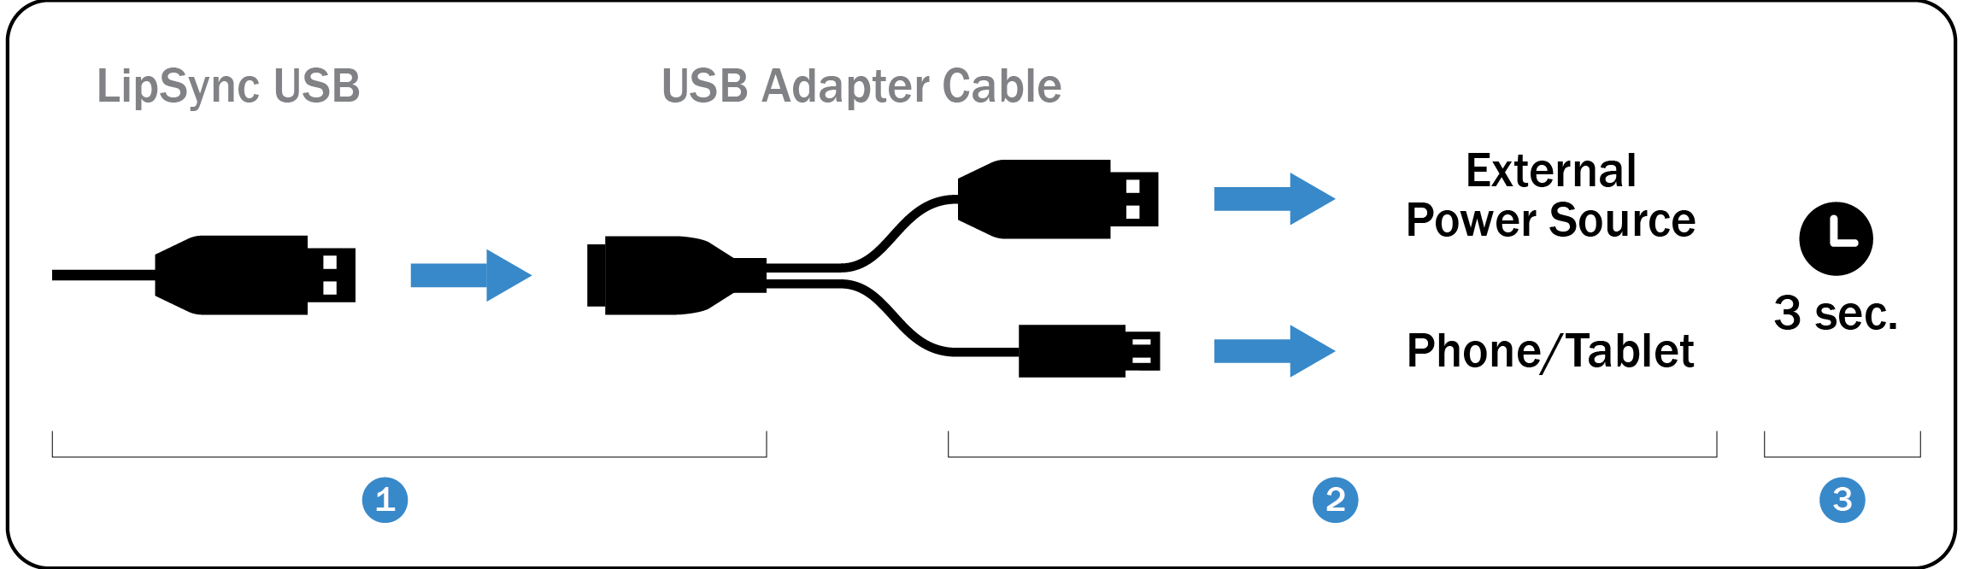

1. Connect the LipSync USB to the USB adapter cable’s receptacle.
2. Connect the other end of the adapter into the computing device and external power source.
3. Wait 3 seconds for the LipSync to initialize. Initialization is complete when the LED blinks red and green four times.

Note: If you are using a desktop or laptop the LipSync USB can be directly plugged into the computer USB port.

### Plugging into an iOS Device

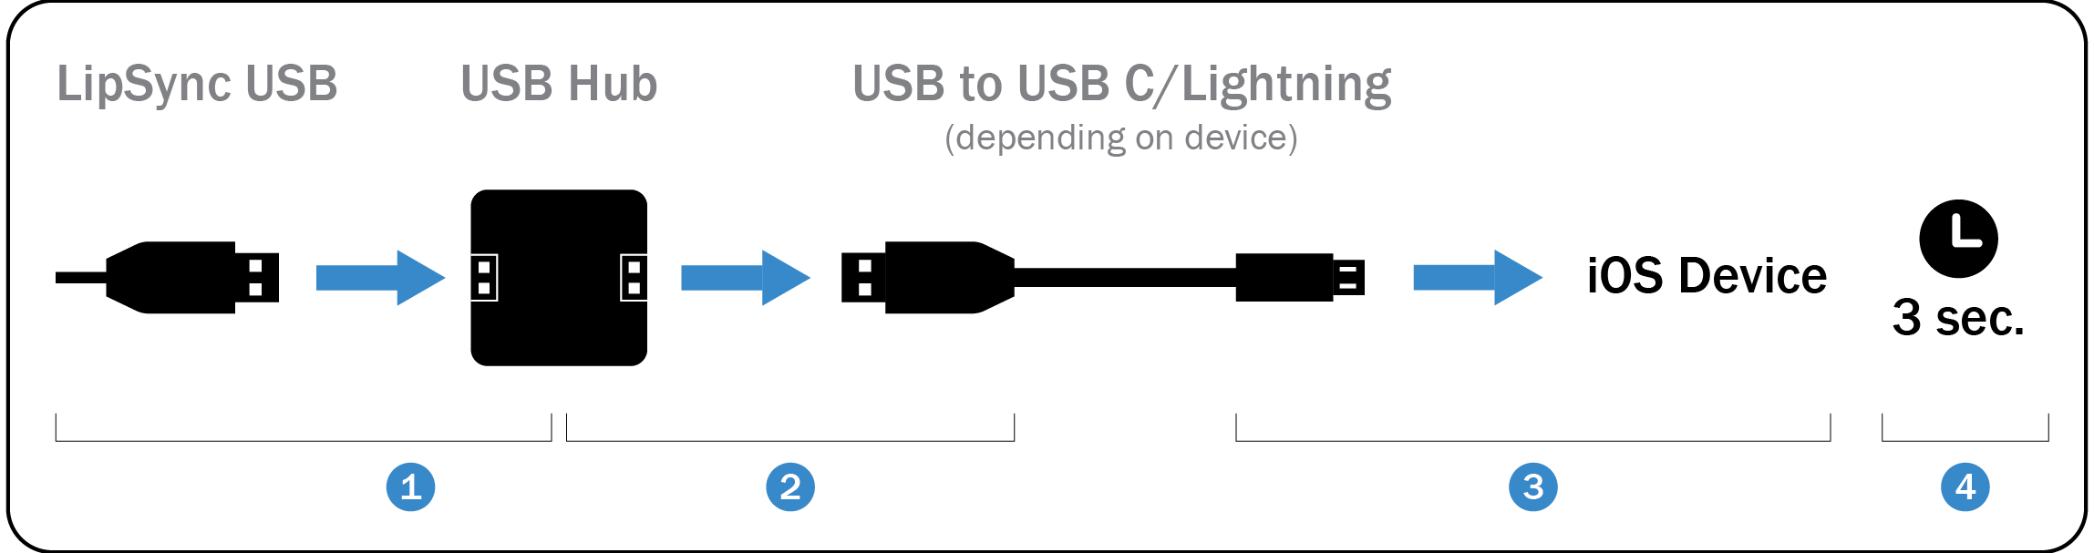

1. Connect the LipSync USB to a USB hub’s receptacle.
2. Connect the USB end of a USB to USB C/Lightning cable into the hub’s USB receptacle.
3. Connect the other end of the USB to USB C/Lightning cable into the iOS device.
4. Wait 3 seconds for the LipSync to initialize. Initialization is complete when the LED blinks red and green four times.

Supporting Applications



The Assistant Menu allows quick access to important functions that cannot be accessed without physically touching the device, like the Home button, Back, Zoom In and Out, Screen Capture, Volume, and Restart. Turn on the Assistant Menu by going to **SETTING** 🡪 **MY DEVICE** 🡪 **ACCESSIBILITY** 🡪 **DEXTERITY AND INTERACTION** 🡪 **ASSISTANT MENU.** If your phone doesn’t have Assistant Menu, apps Back Button or Handy Soft Keys can be downloaded.

A swiping action is required on some mobile device to unlock it. This can be avoided by setting SCREEN LOCK in the Settings Menu is set to NONE. Alternatively, an application called **Keep Screen On** can be downloaded from the Android Play store. It will prevent the phone from going to sleep so it doesn’t require a swipe to unlock. However, this will drain your phone battery faster.

# 2 Using the LipSync

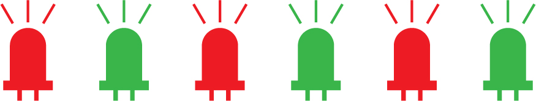.

IMPORTANT: Allow 3 seconds for the LED initialization sequence   
to flash **each time**the LipSync is connected to a device before moving the mouthpiece. Moving it before the 3 seconds is complete will affect the usage.

## Functions

|  |  |  |
| --- | --- | --- |
| FOR MOBILE DEVICES AND TABLETS | | |
| Function | Action | Time (seconds) |  |
| Tap | Puff | 1 |
| Back button1 | Sip | 1 |
| Drag2 | Puff | 3 |
| Scrolling3 | Sip | 3 |
| Cursor drift reset | Puff | 5 |
| Home button1 | Sip | 5 |

1 The back/home functions may not work if the device uses on-screen icons. In this case, move the cursor over the icon to tap.

2The red LED will stay on at all times in this mode

3 The green LED will stay on at all times in this mode

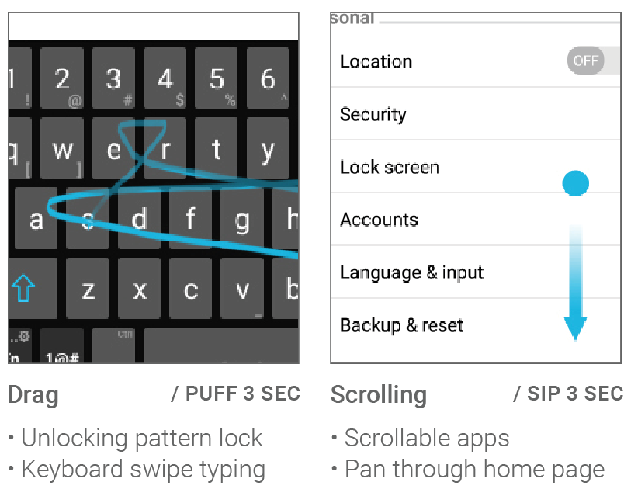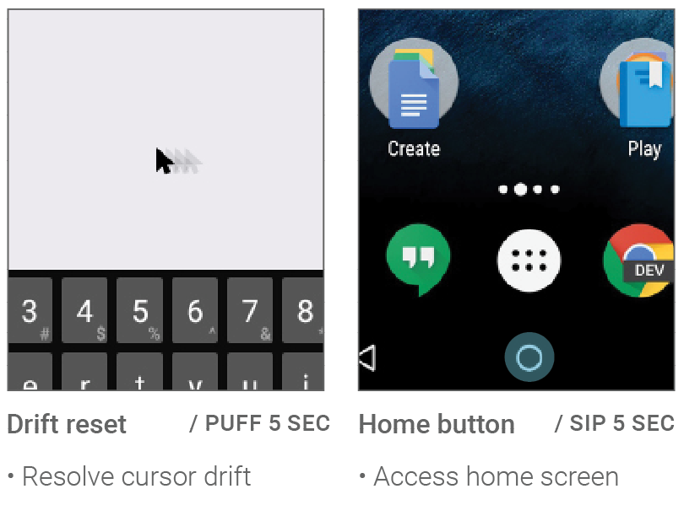Useful function examples:

|  |  |  |
| --- | --- | --- |
| FOR PCs AND LAPTOPS | | |
| Function | Action | Time (seconds) |  |
| Left click | Puff | 1 |
| Right click | Sip | 1 |
| Double-click | Puff | 1 each |
| Drag | Puff | 3 |
| Scrolling ( ↑ ↓ ) | Sip | 3 |
| Cursor drift reset | Puff | 5 |
| Scrolling ( ↑ ↓ ← → ) | Sip | 5 |

Useful function examples:

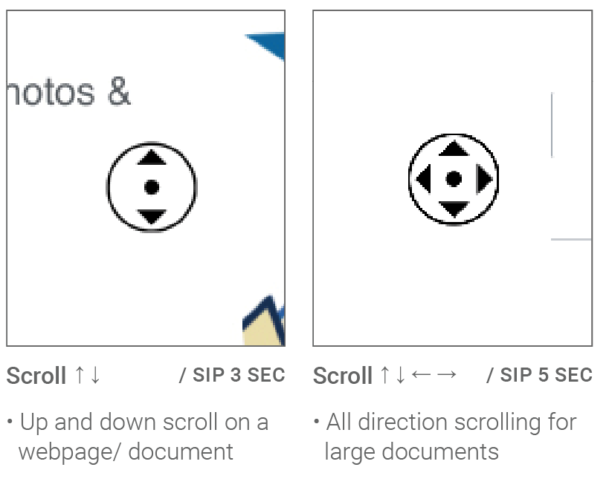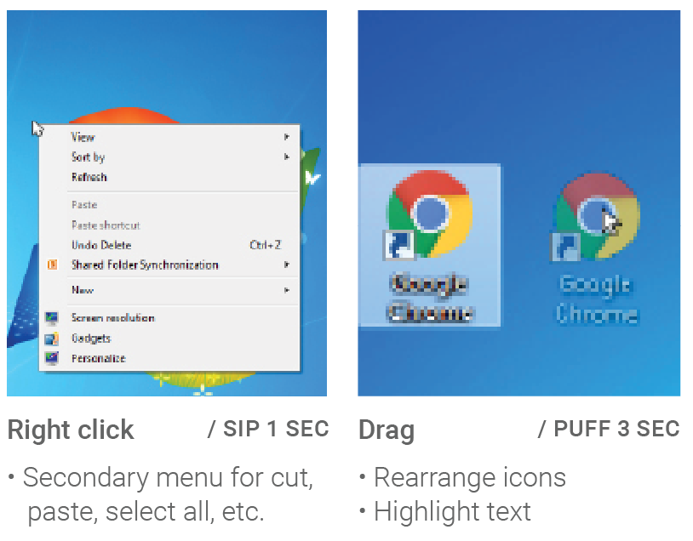

## Speed Control

The LipSync has 11 speed control levels with the default level set to 5 when first initialized.

To adjust the cursor sensitivity and speed, set the computing device’s cursor speed to its slowest setting to start, then adjust the LipSync speed control buttons until you get a speed that is comfortable for you. Press the up facing triangular button on the back of the LipSync to increase the speed and the downward facing button to decrease. If the speed is still not fast enough, gradually increase the speed on the mobile device or computer.

# 3 Feedback

**Your feedback is very important to us.** It helps to support the engineers and designers of the LipSync by learning what is working and what can be improved. It will help inform future development of the LipSync. None of your feedback will be shared publicly without your consent.

Our feedback form can be found at the following link: <https://tinyurl.com/yc57vkpr>

# Troubleshooting

Q: Why doesn’t the cursor appear on the screen when I plug in the LipSync?

**Solution 1:** Make a 5 second long puff to trigger the home position reset.

**Solution 2:** Wait 3 seconds for the LipSync to initialize. Moving the mouthpiece before the 3 seconds is complete will affect the calibration.

**Solution 3:** If the cursor does not appear after 3 seconds, disconnect the cable from the computing device, reconnect again, and let the LipSync initialize for 3 seconds.

**Solution 4:** Perform the joystick calibration found on the follow page.

Q: Why does my cursor drift across the screen when I am not moving the LipSync?

**Solution 1:** Make a 5 second long puff to trigger the home position reset.

**Solution 2:** Wait 3 seconds for the LipSync to initialize. Moving the mouthpiece before the 3 seconds is complete will affect the calibration.

**Solution 3:** If the cursor does not appear after 3 seconds, disconnect the cable from the computing device, reconnect again, and let the LipSync initialize for 3 seconds.

**Solution 4:** Perform the joystick calibration found on the follow page.

## Joystick Calibration

