How to Use the TCES 330 Homework Checker Package

The homework checker makes sure you have all the parts of the homework assignment named correctly and zipped up correctly. It does not actually check any Verilog code or open Quartus.

Start by placing the AssignmentCheck115.exe, notes_template.txt, HW1Check.bat and the zip file you are about to turn in in a temporary folder as shown below.

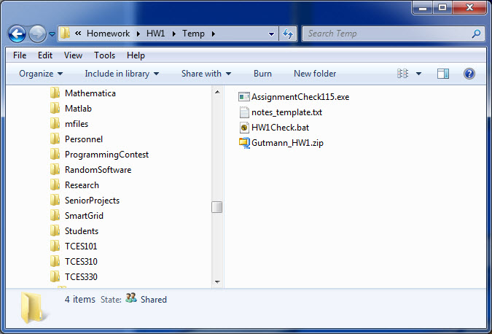

Open a command window in this folder (shift-right mouse click should bring up a context menu with ‘open command window here’ option) and run the batch file (HW1Check.bat) as shown below.

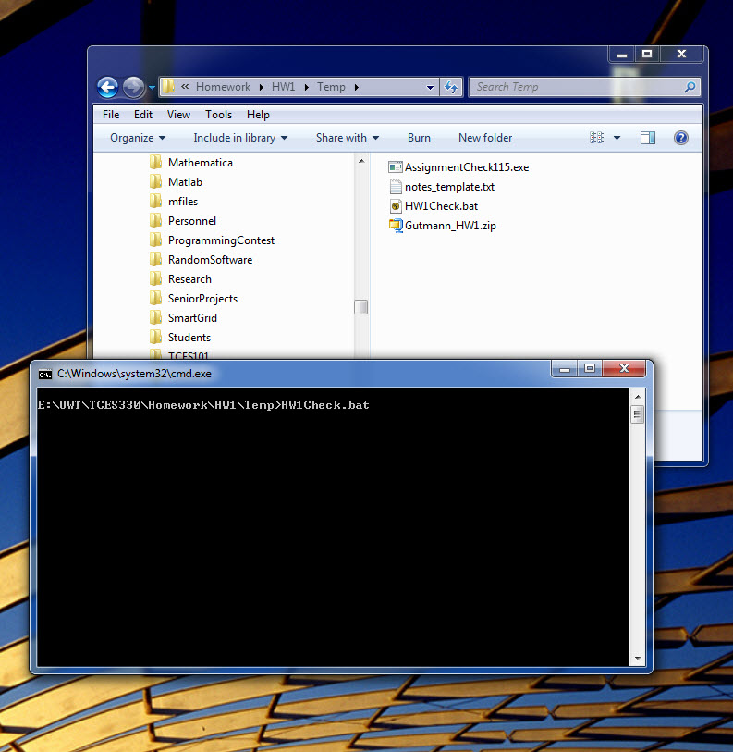

If everything is found in the right places, you should see an output similar to the one below. Otherwise some indication of what’s wrong should be printed in the command window.

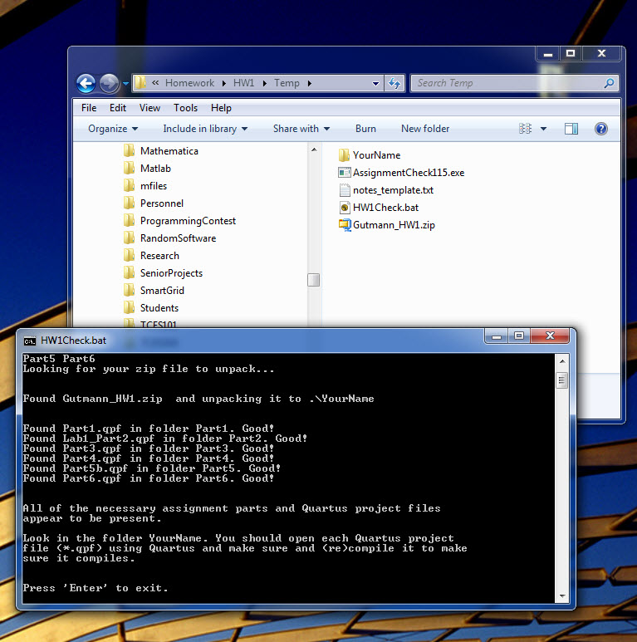

You should also find a new folder in your temp folder called (literally) YourName. As directed, open that folder as shown below.

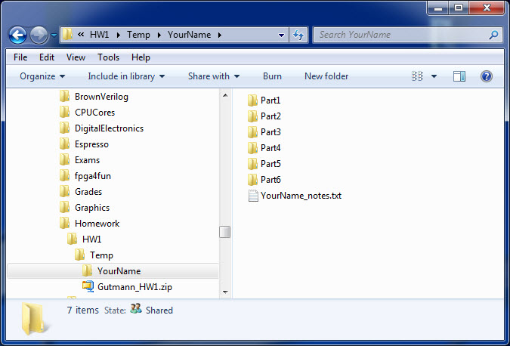

Go into each Partx folder and recompile Quartus. This will make sure all the dependencies you need are present in your zip file.

Feel free to look around at the batch file and the grading rubric, YourName_notes.txt file. I will post the C# source code for AssignmentCheck115.exe if anyone wants to see it.

This version of the assignment check script is new, so let me know if you have any issues with it. It does require that .Net 4.5 is installed in order to unzip your zip file.