# CptS 223 – Advanced Data Structures in C++

**Written Homework Assignment 4: Red-black Trees, B+ Trees**

## Problem Set:

* 1. **(10 pts)** Insert the value "9" into the following Red-Black tree; draw the result. Use Double-circle to denote to denote black nodes.

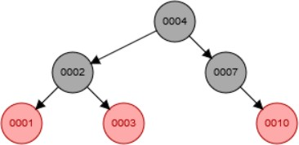

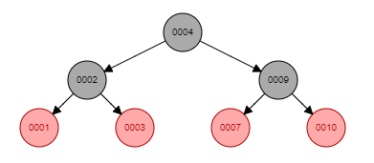After inserting 10:

* 1. **(10 pts)** Delete the value "2" from the following Red-Black tree; draw the result. Use Double-circle to denote red nodes and single circle to denote black nodes.

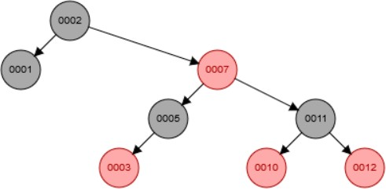

After deleting 2:

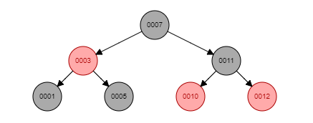

* 1. **(30 pts)** Given the following B+ tree (M = 3, L = 3):

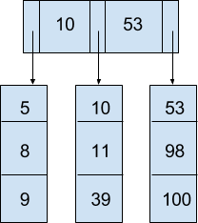

* + 1. **(15 pts)** Insert data item 101 into the tree and draw the resulting B+ Tree:

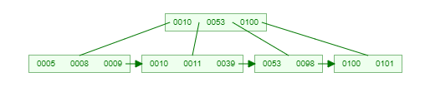

* + 1. **(15 pts)** Based on the tree resulting from part (a), now remove 10 and draw the new tree:

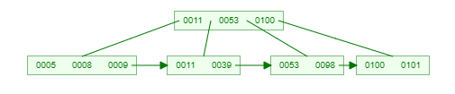

* 1. **(50 pts)** We are going to design our B+ Tree to be as optimal as possible for our hard drives. We want to keep the tree as short as we can, and pack each disk block in the filesystem as tightly as possible. We also want to access our data in sorted order for printing out reports, so each leaf node will have a pointer to the next one. See figure #1 on next page for a visualization of our tree.

*CPU architecture: Intel Xeon with 64 bit cores (pointer size = 64/8 = 8 bytes) Filesystem: Ext4 with 8KB (8196 byte) blocks*

*The customer records are keyed by a random UUID of 64 bits Customer’s Data record definition from the header file:* #include <uuid>

struct CustomerData

{

uuid_t uuid; // Customer 64 bit key

char[32] name; // Customer name (char is 1 byte each)

uint32_t ytd_sales; // Customer year to date sales

};

* + 1. **(15 pts)** Calculate the max number of children in each internal node (M) for our B-tree:

4 x M + (M-1) x K

B = 4M + (M-1)K

M = floor [ (B+K) / (4+K)] B = 8192 bytes K = 8 bytes

M = floor [ (8192+8) / (4+8)]

M = 683

* + 1. **(15 pts)** Calculate the max number of data records in each B-tree leaf node (L) to keep the list of leaf nodes:

Each char is 1 byte * 32 bytes in name string.

D = 36 bytes B = 8192 bytes

L = floor[B/D]

L = 227

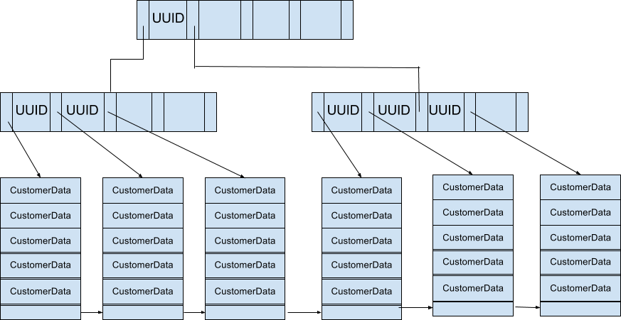

Figure #1: Visualization of our B+ Tree of height 2, customer data records, and pointers between the leaf nodes. M and L shown in this tree are not the real M and L in this question.

* + 1. **(10 pts)** How tall (on average) will our tree be (in terms of M) with N customer records?

M = 683 L = 227 X = ceil(N/L)

=

* + 1. **(5 pts)** If we insert 30,000 CustomerData records, how tall will be tree be? (You don’t have to calculate the result of log)

M = 683 L = 256 X = ceil(N/L)

=

= 1

* + 1. **(5 pts)** If we insert 2,500,000 customers how tall will the tree be? (You don’t have to calculate the result of log)

= $\log_{683}ceiling(\frac{2500000}{227})$

= 2

## Submitting Written Homework Assignments:

* 1. On your local file system, create a new directory called HW4. Move your HW4.pdf file into the directory. In your local Git repo, create a new branch called HW4. Add your HW4 directory to the branch, commit, and push to your private GitHub repo created in PA1.
  2. Do not push new commits to the branch after you submit your link to Canvas otherwise it might be considered as late submission.
  3. Submission: You must submit a URL link of the branch of your private GitHub repository to Canvas.

## Grading Guidelines:

This assignment is worth 100 points. We will grade according to the following criteria:  See above problems for individual point totals.