1. Gourad shading computes the normal vector for each vertex and calculates the lighting equation at each vertex in the polygon to define the color and then it interpolates the colors to shade the inside of the polygon. While Phong shading calculates the normal vectors at each vertex of a polygon and instead of interpolating the colors Phong interpolates the normal vectors for each point inside the polygon and then applies the lighting equation to each pixel. As a result, Phong shading has greater realism especially with regard to highlights on shiny objects as demonstrated in the pictures below.

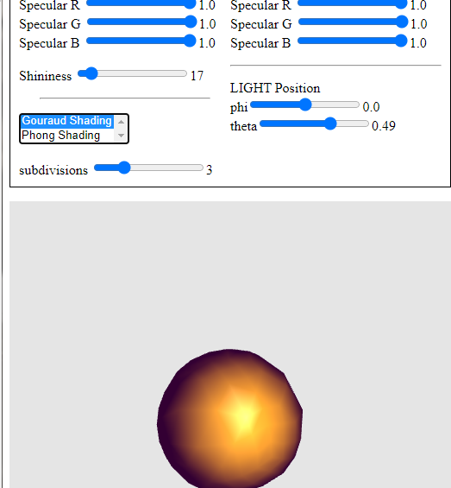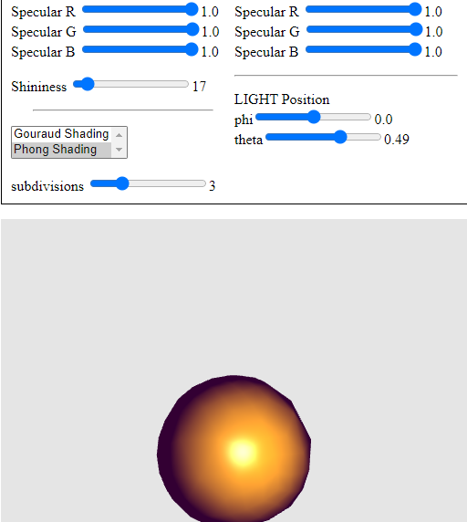

1. Some non-physical assumptions include having a Point light source or a Infinity light source and only having one reflection. These choices are made because it makes the model have efficient computations because computing real world lighting is very computationally expensive. Each object is defined with its own material properties ambient, diffuse and specular and the light-source also has ambient, diffuse, and specular properties for each primary color. This is done to obtain realistic looking renderings efficiently because the full rendering equation cannot be solved.