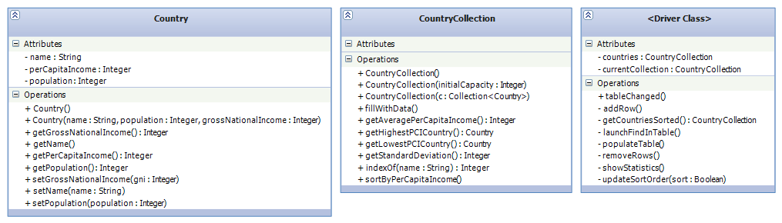
The Country class represents a country and provides access to related demographic and financial data.

Country::getGrossNationalIncome() method
START
return GNI
END
Country::getName() method
START
return name
END
Country::getPerCapitaIncome() method
START
return gni / population
END
Country::getPopulation() method
START
return population
END
Country::setGrossNationalIncome() method
START
gni := <value>
END
Country::setName() method
START
name := <value>
END
Country::setPopulation() method
START
population := <value>
END
---
The CountryCollection class represents a list of countries.
// Fills the collection with data from first 25 countries with the highest GNI in the world, removing any previous items from the list.
CountryCollection::fillWithData() method
START
Clear all items from the list
For each of the 25 countries...
Add country <n> to the list
END
CountryCollection::getAveragePerCapitaIncome() method
START
Let sum be an integer
For each country in the list
sum := sum + PCI of country <n>
return sum / number of countries
END
CountryCollection::getHighestPCICountry() method
START
Let highest be the tentative highest PCI country
For each country in the list
if the PCI of country <n> is higher than the PCI of highest
highest := country <n>
return highest
END
CountryCollection::getLowestPCICountry() method
START
Let lowest be the tentative lowest PCI country
For each country in the list
if the PCI of country <n> is lower than the PCI of lowest
lowest := country <n>
return lowest
END
// Gets the standard deviation of the countries in the list.
// Refer to http://en.wikipedia.org/wiki/Standard_deviation for an explanation of standard deviation and related formulas for calculating it.
CountryCollection::getStandardDeviation() method
START
Let sum be an integer
For each country in the list
sum := sum + (PCI of country <n> - averagePCI) ^ 2;
return sqrt(sum / number of countries)
END
CountryCollection::indexOf(String name) method
START
For each country in the list
if the name of country <n> is a case-insensitive match for n
return index of country<n>
return -1
END
CountryCollection::sortByPerCapitaIncome() method
START
Sort the list with a comparable class:
Comparable(Country a, Country b)
START
if pci of a = pci of b
return 0
else if pci of a < pci of b
return -1
else
return 1
END
END
---
Driver::Driver() constructor
START
populateTable()
END
Driver:tableChanged() method
START
Let country := the country for the cell that was changed
update PCI of country
END
Driver::addRow() method
START
Add row to GUI table
END
Driver::getCountriesSorted() method
START
Let sortedList := copy of unsorted countries list
sort sortedList
END
Driver::launchFindInTable() method
START
Launch input dialog
If user clicked OK
Find country with the name corresponding to the user's input
if found
Highlight corresponding row in GUI table
else
Erase any current highlight
Display an error message
END
Driver::populateTable() method
START
For each country in countries list
Add country <n> (name, gni, pci) to GUI table
END
Driver::removeRows() method
START
Let selectedCountries := countries corresponding to rows currently selected in the GUI table
For each country in selectedCountries
remove country from countries list
populateTable()
END
// Displays a dialog showing the country with the lowest GNI, the country with the highest GNI, the average GNI of all countries in the list, and the standard deviation.
Driver::showStatistics() method
START
Let lowestGNI := get lowest GNI from countries list
Let highestGNI := get highest GNI from countries list
Let averageGNI := get average GNI from countries list
Let standardDeviation := get standard deviation from countries list
Let message := "Lowest GNI: " + lowestGNI
"Highest GNI: " + highestGNI
"Average GNI: " + averageGNI
"Standard deviation: " + standardDeviation
Show message box with message
END
Driver::updateSortOrder() method
START
if list should be sorted
populateTable(getCountriesSorted())
else
populateTable(unsorted countries list)
END

