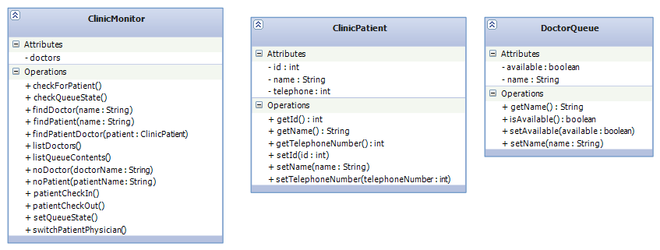
DoctorQueue::getName() method
START
return name
END

DoctorQueue::isAvailable() method
START
return available
END

DoctorQueue::setName() method
START
name := <value>
END

DoctorQueue::setAvailable() method
START
available := <value>
END

---

ClinicPatient::getId() method
START
return id
END

ClinicPatient::getName() method
START
return name
END

ClinicPatient::getTelephoneNumber() method
START
return telephoneNumber
END

ClinicPatient::setId() method
START
id := <value>
END

ClinicPatient::setName() method
START
name := <value>
END

ClinicPatient::setTelephoneNumber() method
START
telephoneNumber := <value>
END

---

ClinicMonitor::checkQueueState() method
START
Get doctor name from user
Find doctor
Print status of doctor's queue (open or closed) or error message if doctor is not found
END

ClinicMonitor::setQueueState() method
START
Get doctor name from user
Find doctor
Get "open" or "close" from user
Set queue to open or closed depending on user's input or error message if doctor is not found
END

ClinicMonitor::patientCheckIn() method
START
Get patient ID from user
Get patient name from user
Get telephoneNumber from user
Get desired doctor name from user

Find doctor
if doctor is available
Add patient to queue
else
Print error message
END

ClinicMonitor::patientCheckOut() method
START
Get patient name from user
Find doctor assigned to patient
Remove patient from doctor's queue
END

ClinicMonitor::listDoctors() method
START
For each doctor in the listDoctors
Print doctor's name
END

ClinicMonitor::listQueueContents() method
START
Get doctor name from user
Find doctor
If doctor was found
Print number of patients in doctor's queue
For each patient in doctor's list
Print patient's name
else
Print error message
END

ClinicMonitor::checkForPatient() method
START
Get doctor name from user
Get patient name from user
Find patient's doctor
Find proposed doctor
If proposed doctor was found
If patient was found
Print whether the patient is actually in the expected doctor's queue
END

ClinicMonitor::switchPatientPhysician() method
START
Get patient name from user
If patient found
Get new physician name from user
If physician found
Remove patient from current physician's queue
Add patient to new physician's queue
END

