Tornado onset from radar
  - Can the TorNet detector be re-aimed at the ten minutes before a tornado shows up?
Jake Van Slyke
Jeffrey Gregory
2026-10-15

The problem
TorNet is a tornado detection benchmark: storm-centered radar chips labeled for whether a tornado is in them, and a published CNN that looks at one scan and answers that question. Detection isn’t what’s missing in the last few minutes before a touchdown, though. What would help is a signal that shows up before the signature is obvious on the display. So the question here is a prediction one. Every TorNet sample has four consecutive scans of a storm about five minutes apart, each with its own label. We give a model the two oldest and ask how likely a tornado is in each of the two newest: roughly five and ten minutes after the last thing it saw.
The framing has to be protected from detection, because a tornado already on the radar is trivial to carry forward. So we only score on pre-onset cases: tornado samples where neither input scan is tornadic and the last target scan is. A tornado visible in an input scan makes the sample ongoing, reported separately and left out of the positives. Every non-tornadic sample stays in as a negative, and the headline negatives are the hard ones, same as the TorNet paper: storms under a tornado warning that never produced one. Telling a tornadic storm from clear air is easy; telling it from a warned storm that looked a lot like it is the job.
Two reference points turn an AUC into a result, and both come from the published detector, frozen, as released. Run it on the newest observed scan and score against the future labels: that’s the floor, what a forecaster effectively already has. Run it on the real future scan: that’s the ceiling, what detection would give if the forecast of the radar were perfect. A model lands somewhere between, and what we report is its paired bootstrap difference from the floor on the same files, with a 95% interval.

The data
TorNet v1.1 is 203,133 samples from 2013 to 2022, CC BY 4.0, split by the authors into train and test: 13,857 confirmed tornadoes, 64,510 warned storms, 124,766 random storms. A sample is four NEXRAD dual-pol scans on a storm-centered polar grid, 120 azimuths by 240 range gates at two tilts, six products plus a range-folding mask, with a label per scan. We repackaged it on the Hugging Face Hub so a year is a config and a training set is a list of years, and published the detector’s weights as a PyTorch state dict next to it.
Everything below is 2014 and 2015, cut two ways for two questions. The detection-task steps (1 and 2) use a 6,414-clip subset split by storm group, so episodes sharing radar dates stay together and clips near the detector’s own training data are excluded: 3,667 train, 1,325 validation, 1,422 test with 89 positives. The onset steps (3 and 4) use the authors’ full partitions: 37,168 training samples with 15% of days held out for validation, and the 6,448-sample test set with its 495 pre-onset cases, 208 of them already tornadic at five minutes and all of them at ten.
Every model sees a scan exactly as the published detector does: the detector’s normalization, fourteen channels with the range-folding masks, and its two coordinate channels. Keeping that representation is what lets the published weights drop in with no adapter.

The models
Both models start from the published detector’s CNN: four blocks of CoordConv 3×3 layers with 48, 96, 192 and 384 filters, each followed by 2×2 max pooling and dropout, ending in a 384-channel map over an 8 × 15 grid of cells, 4.67M parameters.
Frozen features, small head. For the detection steps the CNN stays frozen and each scan is reduced to its 384 spatially pooled features, scaled, and read by a 385-parameter linear head that predicts tornado presence in the current scan. With two scans, the current and the one five minutes earlier, the two vectors are averaged before the head. Three seeds, thirty epochs; validation picks the epoch and an operating threshold at 80% recall, and the test set is touched once after that choice is locked.
Two scans, the authors’ head, onset target. For the onset steps the CNN runs on both input scans with shared weights and the two 384-channel maps are concatenated cell by cell. On top sits a fresh copy of the authors’ own head: two 1×1 convs of 512 and 256 channels, a 1×1 conv to one logit per cell per horizon, and the max over cells, so the map before the max says where the model thinks the tornado will be. One loss, weighted binary cross-entropy of each horizon’s logit against that future scan’s label with the authors’ sample weights; AdamW, cosine schedule, mixed precision, early stopping on validation AUC with a cap of five epochs. The head is always new since its job changed; the encoder is frozen in step 3 and unfrozen at a tenth of the head’s learning rate in step 4.

The ladder
Five steps, each changing one thing; the first two stay on the task the detector was built for, to check the ingredients before the task changes.
Table 1: The five steps.
step | what changes | the question
0 | Nothing trained. The published detector as designed, one scan. | What does it already give? On the onset task, the newest observed scan is the floor and the real future scan the ceiling.
1 | A new linear head on the frozen features, current scan, detection target. | Can a retrained head beat the detector at its own job?
2 | The scan five minutes earlier added, features averaged. | Does a second scan carry anything the first doesn’t?
3 | Frozen CNN, both scans concatenated, the authors’ head retrained on the +5 and +10 labels. | Can the detector’s own features be re-aimed at “will it appear”?
4 | The CNN unfrozen at a tenth of the head’s learning rate. | Does adapting the features to the target buy more?

Steps 1 and 2 are scored by average precision on the storm-grouped test set; steps 0, 3 and 4 by pre-onset AUC on the authors’ test partition. They don’t share a number: the first pair establishes two assumptions the second pair leans on.

Results

Steps 1 and 2: frozen features on the detection task
Table 2: Detection target, 2014–2015 storm-grouped split. Validation chose step 2; the test set was scored once afterwards.
configuration | validation AP (3 seeds) | test AP | at the locked threshold
original pretrained CNN |  | 0.517 | 68 of 89 found, 276 false alarms
step 1: current scan, linear head | 0.658 ± 0.005 | 0.508 | 70 found, 571 false alarms
step 2: two-scan mean, linear head | 0.675 ± 0.001 | 0.548 | 69 found, 564 false alarms
current scan, MLP head (24,705 params) | 0.670 ± 0.007 |  | not selected
warned negatives weighted ×2 | 0.656 ± 0.005 |  | not selected

Step 1 answers its question with a no. A linear head on the frozen features lands at 0.508 test AP against the original detector’s 0.517, and neither head capacity nor reweighting moved validation: an MLP with sixty times the parameters reached 0.670 and hard-negative reweighting 0.656, both inside seed noise of the linear 0.658. The detector’s own head is about as good as its features allow, so anything more has to come from new information, not a better readout.
Step 2 answers yes, with a caveat. Averaging in the scan from five minutes earlier was the only change that moved validation, 0.658 to 0.675 at the same 385 parameters, and it carried to the test set at 0.548. But better ranking did not mean fewer false alarms: at thresholds locked for the same recall it found one more tornado than the original detector and raised 288 more false alarms, and the paired storm-group bootstrap on its AP gain, [−0.061, +0.155], includes zero on ten test storm groups. What it does establish is that the second scan carries signal the first doesn’t, which is what steps 3 and 4 lean on.
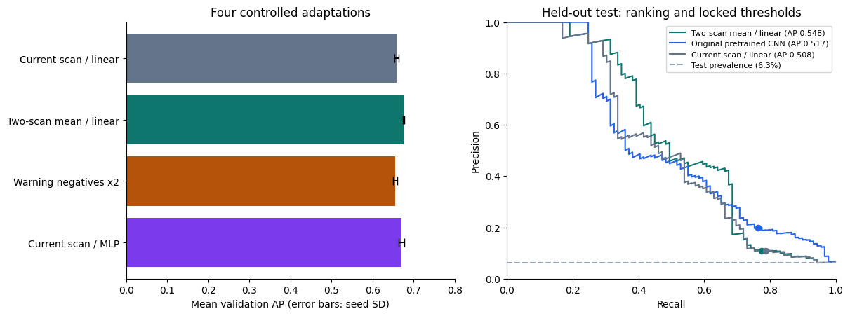
Figure 1: Step 1 and 2 configurations on validation (left) and the held-out test precision-recall curves with locked operating points (right).

Steps 0, 3 and 4: the onset task
Table 3: Pre-onset WC AUC on the 2014–2015 test partition, 95% bootstrap intervals; the paired column is the difference from the floor on the same files.
step | +5 min | paired vs floor | +10 min | paired vs floor
0, floor: detector on the newest scan | 0.731 [0.697, 0.767] |  | 0.726 [0.701, 0.750]
0, ceiling: detector on the future scan | 0.769 [0.734, 0.806] | +0.038 [+0.016, +0.063] | 0.797 [0.772, 0.822] | +0.071 [+0.048, +0.093]
3, frozen CNN, two scans, new head | 0.699 [0.662, 0.737] | −0.032 [−0.045, −0.020] | 0.710 [0.683, 0.736] | −0.017 [−0.024, −0.010]
4, fine-tuned CNN, two scans, new head | 0.724 [0.689, 0.762] | −0.007 [−0.031, +0.015] | 0.728 [0.701, 0.752] | +0.001 [−0.016, +0.018]

Step 0 sets the stakes. The detector carried forward from the newest scan already separates pre-onset tornadic storms from warned nulls at 0.73, so the signature is often half-formed five minutes before the label flips. The ceiling is only 0.04 higher at +5 and 0.07 at +10: even a perfect picture of the next scan, read by this detector, adds that much and no more, and anything steps 3 and 4 gain has to fit inside it.
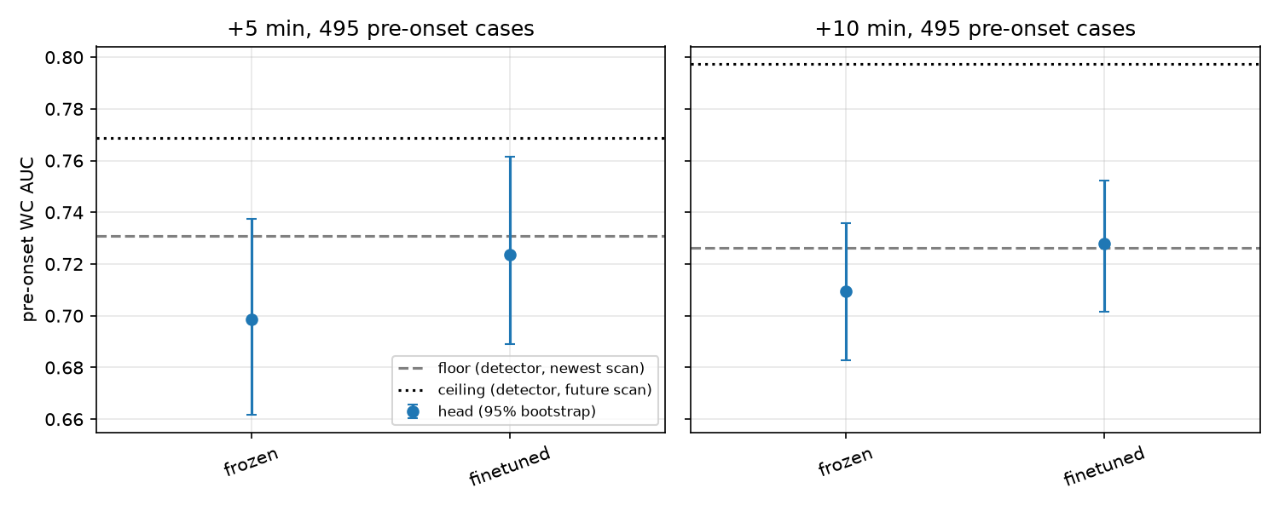
Figure 2: Each step’s AUC with its 95% interval, between the floor and the ceiling, per horizon.
Step 3 lands below the floor, and not by noise: −0.032 at +5 and −0.017 at +10, both intervals clear of zero. A fresh head on the frozen features, even with two scans to difference, does not match the published head simply carried forward. That is step 1’s answer again on the harder task: the detector’s own readout of its features is as good as those features get.
Step 4 recovers the floor and no more. Letting the CNN adapt lifts the head by 0.025 at +5 and 0.018 at +10 over the frozen version, to a tie with the detector at both horizons, with paired intervals centered on zero. Validation was still rising when the five-epoch cap hit, while the frozen head peaked at epoch two, so a longer fine-tune might take a little more; the ceiling bounds what “more” can be at 0.045 and 0.07. Per year it’s the same picture with the usual noise: the fine-tuned head ties the floor in 2015 and trails it in 2014.
Put together, the ladder says that for the ten minutes before onset, two scans read by this CNN carry about what the latest scan already carries. The second scan’s gain from step 2 is real on the detection task and does not survive the move to “will it appear”. The honest summary of a forecaster built this way is that it reproduces the detector carried forward, which is the tool a forecaster already has.

What’s next
The takeaway is simple: a detector can be pointed at the ten minutes before a tornado, and what it finds there is what it already finds in the latest scan. Its features carry a real early signal, which is why the floor sits at 0.73, but re-reading or fine-tuning them over two scans adds nothing to it, and even a perfect next scan would add only a few hundredths.
The cheap next step is the full dataset. Ten years is a config change now, and it fixes the two things that limited this round: a fine-tune that was still improving when the epoch cap hit, and test intervals wide enough to hide a gain of a couple of hundredths.
The larger step follows from where the signal isn’t. The detector is good at detecting, and that’s how it should be used. What’s missing is the history and the future around the one scan it reads. Longer storm histories than two scans give a temporal model something to learn from, the way a storm has been evolving rather than one difference. And a forecasting model that learns those patterns could do two jobs: hand the detector the context that one scan leaves out, and predict the radar itself, so that the detector reads a forecast scan rather than the latest one. The ceiling in Table 3 is exactly that model with perfect predictions, and it is the first number in this writeup that clears the floor.

Veillette et al., “TorNet: A Benchmark Dataset for Tornado Detection and Prediction Using Full-Resolution Polarimetric Weather Radar Data,” Artificial Intelligence for the Earth Systems, 2024, https://doi.org/10.1175/AIES-D-24-0006.1. Code at https://github.com/mit-ll/tornet, weights at https://huggingface.co/tornet-ml/tornado_detector_baseline_v1.
https://huggingface.co/datasets/jakeryderv/tornet: every field as Parquet, one config per year, lossless and verified against the original files.
https://huggingface.co/jakeryderv/tornet-detector-torch, checked against the Keras original’s logits to 2×10⁻⁵.

