Design Document

Remote Stethoscope

*For use in Telemedicine*

**CSE 453 Hardware/Software Integrated System Design**

Spring 2022

Andrew Burneson,

Yusuf Elazzazi,

Avi Tombak

# Table of Contents:

**Project Background 3**

Summary 3

Outcomes and Deliverables 3

Expected Timeline 3

**Specifications 3**

Requirements 3

Constraints 3

**Design 3**

Design Overview 3

Remote Stethoscope Block Diagram 4

Circuit Diagram 4

3D Printed Stethoscope Bell 5

Bill Of Materials 5

Prototyping 5

Testing/Verification 6

References Documentation 6

**Project Delivery 6**

# Project Background

**Summary:**

This project is a remote stethoscope device for use in telemedicine appointments. The remote stethoscope consists of a 3D printed stethoscope bell, a simple stethoscope diaphragm, a digital microphone, and a microcontroller. The remote stethoscope functions as a USB microphone device that can be used by patients during a telemedical appointment with a doctor. The remote stethoscope transmits audio of a patient’s heart, lung, and artery sounds for the doctor to listen to.

**Client:** Dr. Robert Gatewood

**Outcomes/Deliverables:** A Functional Prototype Remote Stethoscope

**Expected Timeline:** Delivered by end of the Spring 2022 semester

# Specifications

**Requirements:**

* The stethoscope will have a microphone to record audio input.
* The audio captured by the microphone will be amplified and converted to a digital signal.
* The digital audio will be transmitted to a computer using USB-C.
* The doctor will be able to receive the stethoscope audio over the internet.
* The stethoscope will come with a user manual for patients.

**Constraints:**

* The production cost of the stethoscope must be under $50.
* The microphone must record audio with a frequency between 20 and 2k Hz.
* The audio quality must be good enough for the doctor to diagnose the patient.

# Design

**Design Overview:**

The remote stethoscope was designed with simplicity and cost as its primary considerations. The stethoscope is to be used by patients directly, putting their health in their hands and allowing them to be more involved in their care. In its current design, the stethoscope acts very similarly to a traditional stethoscope. It must be pressed onto the chest to pick up a heartbeat or elsewhere for other bodily sounds. Instead of listening to the heartbeat via earpieces connected to the stethoscope, the remote stethoscope transmits audio of the heartbeat over USB C to a patient’s computing device. USB C was chosen as it is becoming widely used and available across multiple devices (PCs, smartphones, laptops, tablets). This model of the stethoscope consists of a 3D printed stethoscope bell, a plastic film diaphragm, a PDM MEMS microphone, and a microprocessor. The stethoscope has an overall production cost of $24.45.

**Remote Stethoscope Block Diagram:**

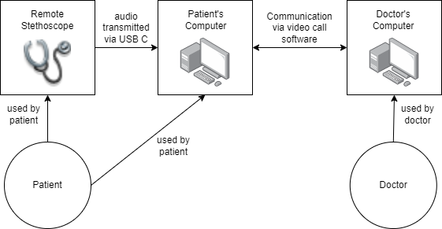

**Circuit Diagram:**

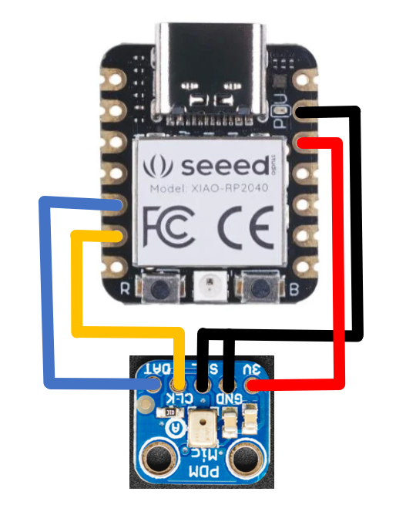 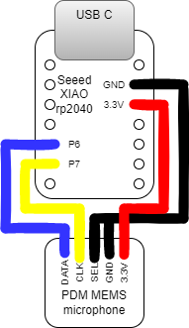

**3D Printed Stethoscope Bell:**

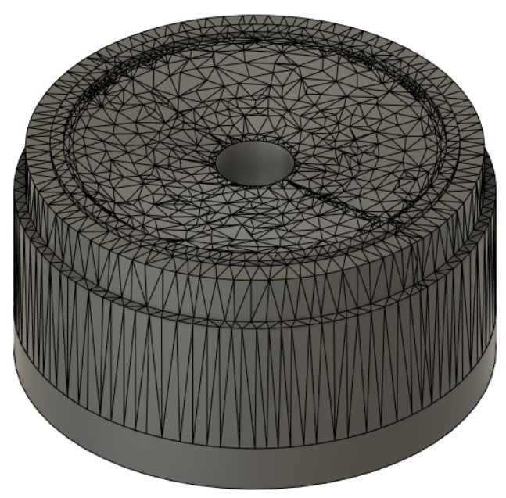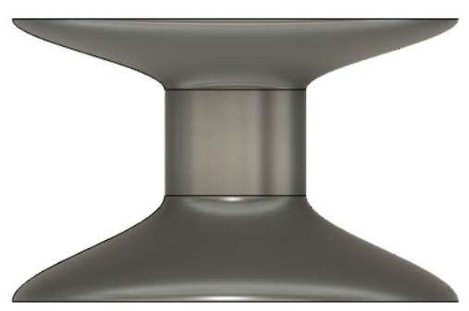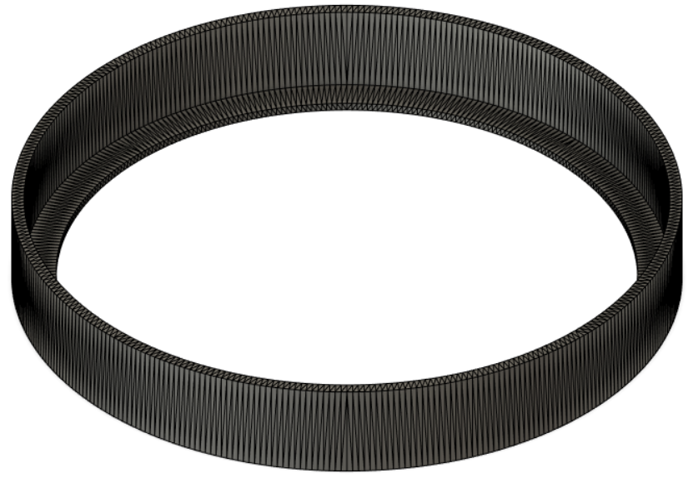

Stethoscope Head Stethoscope Handle Stethoscope Ring

**Choice of Materials:**

The following materials were chosen to ensure the stethoscope is well within the specified cost constraint.

* Seeed XIAO rp2040 Microcontroller for USB Microphone Device
* Adafruit PDM MEMS Microphone Breakout Board
* 3D Printed PLA Stethoscope Bell
* Report Cover Plastic Sheet for Stethoscope Diaphragm

**Bill of Materials:**

The bill of materials associated with this project is attached alongside this project and can also be found at: [CSE453_RemoteStethoscope_BOM.docx](https://docs.google.com/document/d/1wtiuyCxSb0sfxCKr2Fo5E8p2Mzp0vhBN)

**Prototyping:**

This project has gone through many prototyping stages. There was an iterative design process for determining various factors of the design, including the stethoscope bell, the diaphragm, the microphone model, and the use of tubing. As this project was inherited from a previous group in this course, the prototyping first stated with testing and verification of their design. This involved circuit building and analysis. Moving on from the previous group’s work, a functional prototype utilizing a 3D printed stethoscope bell, and passing the audio recordings to a laptop via audio jack was created. This prototype does not reflect the final design but has sufficient audio quality for detecting heartbeats and other bodily sounds. After developing a working prototype with audiojack ( a far simpler protocol than usb audio) the next step was to develop the working USB microphone model. This was achieved using a Digital PDM MEMS Microphone and the Seeed XIAO rp2040 Microprocessor. The microprocessor was programmed using the ARM Developer Ecosystem Microphone Library for Pico. The stethoscope bell itself went through different iterations as well, first starting with an open source 3D printed stethoscope model found on thingiverse. A cone shaped stethoscope was also tested in prototyping. This design was modified to be larger and fit the stethoscope circuit. With this larger 3D printed stethoscope and microprocessor circuit, the final prototype design was produced.

**Testing/Verification:**

In order to test and verify the behavior of the stethoscope, audio recordings were taken from the USB device using the program Audacity. A heartbeat recording can be accessed here:

<https://drive.google.com/file/d/168XsQzZ5z6yvc9MNJsx-UgUAekHpegst/view?usp=sharing>

**References Documentation:**

The following references were used throughout the development of this project:

<https://www.thingiverse.com/thing:2826304>

<https://github.com/ArmDeveloperEcosystem/microphone-library-for-pico>

<https://www.adafruit.com/product/3492?utm&gclid=CjwKCAjwyryUBhBSEiwAGN5OCKDwwzdIQs_0lFxj7LmzrSDqmjgVPmQrksxNdygoIFctDELNPU6doRoCHDYQAvD_BwE>

<https://www.seeedstudio.com/XIAO-RP2040-v1-0-p-5026.html?gclid=CjwKCAjwyryUBhBSEiwAGN5OCI7WuxWBaaORjbeqGIfqSfpMNfckhvS_kDpI4O9fUpDoT5V69NSQwBoCbkgQAvD_BwE>

# Project Delivery

This Project will be ready for final delivery with a functional prototype, however our client is yet to schedule a date for delivery. The deliverables include our functional prototype remote stethoscope, and a user guide for patients.