Assignment 1.5 – Jake Seever 02/23/2019

1. The first portfolio site I found was for a developer named Devon Stark. His portfolio was my favorite that I saw. His design was responsive and very well laid out, it looked great on a mobile device. I thought that he used his spacing excellently. He had a subtle video playing behind the dark background of coding and other technical work. His writing style made great use of the bite, snack, and meal approach. It lead you to the areas you were curious about rather than dump everything on the screen over cluttering things. I also thought he writing was concise, and not ambiguous. The site theme was consistent all of the way through. There were ways to access his blog, personal information, contact information, and resume. There were also videos of him talking about his work and his passion. You are able to get a very personal feel of what kind of person he would be to work with. Through his portfolio you could even buy some of his work through his code shop. The layout was also very symmetrical and aligned very well. The style he used developing this portfolio was very classy in my opinion with great font choice and text contrast. Everything about this site was very smooth.

<https://www.devonstank.com>

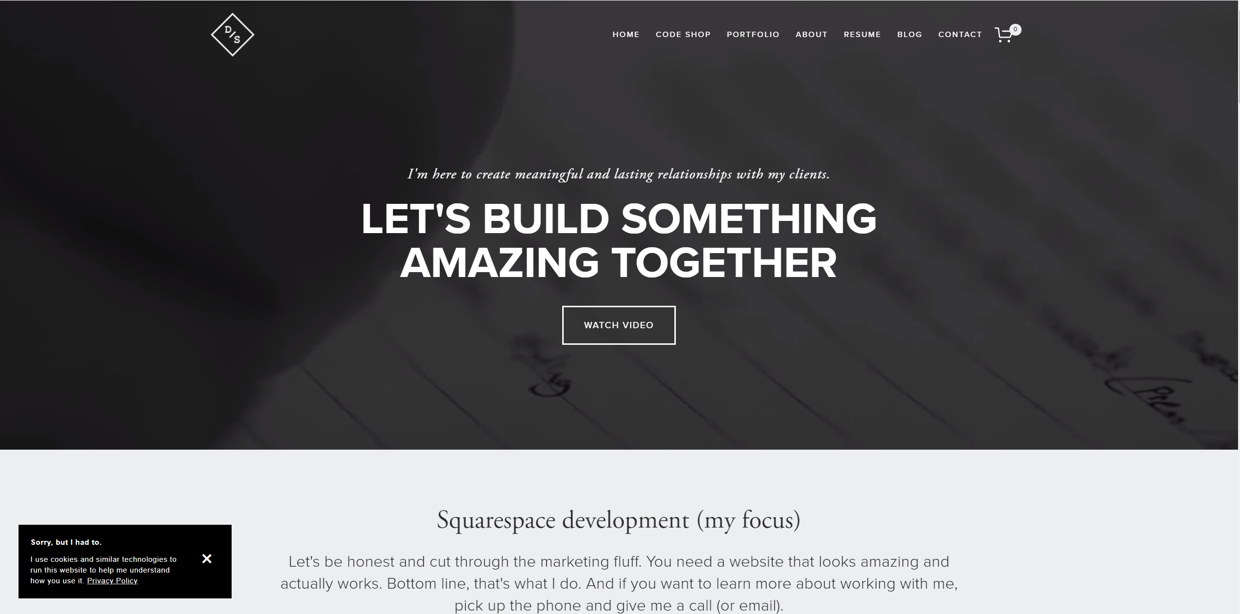

1. The second portfolio site I found was for Sarah Chang a designer/photographer who is on the business side of tech as well. The main thing that I like about Sarah’s portfolio was how clean and simple it was. It was so simple and clean with just a touch of fanciness that it looked very professional. Her main page writing was very concise but you are still able to get a feel of what kind of person she is. Her picture is small and not overbearing, although I though it should be just a tad bigger. There was plenty of real estate left on the screen to do so. She had search functionality right on the home page but it took you to another page to perform the search. Sarah also had links to contact her on various social media platforms. She included a map of all of the different places around the world that she has traveled to and worked. I thought that was a cool feature. She had a thoughts section that was kind of like a mini blog. Her layout was very consistent throughout the site and was spaced well. I personally thought her font should have been a bit larger though and she could have used a bit more of the screen. She had a mobile version of her site which looked good. The only real criticism I have for her site was that I left a little bit confused as to what exactly she does or where her “sweet spot” was with her skillset. The look of her site was very classy and clean though.

<http://www.sarahlichang.com>

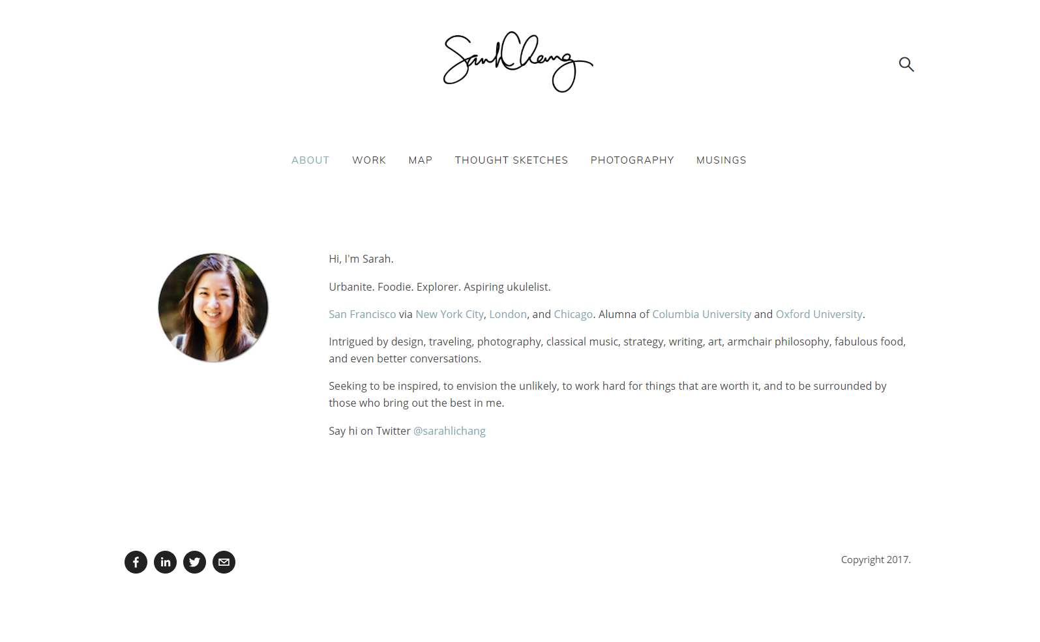

1. The third portfolio site was for a designer named Ellen Skye Riley. The first thing that you notice is a screen filling cartoonish type avatar of her that is subtly laughing and smiling while the background moves slightly. Her site had a nice bit of parallax for scrolling. When you scroll you are taken to other sections of the main page that tell a little bit about her and show of some of her projects and art. At the end of the main page there is a last section that offers a path to her blog. She has links to her presentations, illustrations, contact info and a shop link that takes you to an external site where you can buy her art. The layout was good in my opinion and she made full use of the entire screen. The animations I thought were subtle and I liked them. However, I can see how they could be distracting for some users. She also had a mobile version of her site that looked good and was well laid out. The one thing about her site that I did not agree with was the font size of her navigation links. She used larger font throughout the entire site but her navigation link fonts were very small. To the point that you barely notice them on large screens. The look of this portfolio was very unique and stood out compared to the others I had saw.

<http://ellensriley.com>

