Earth Explorer Bulk Downloader Alternative Tool, v 3.1.1, updated 3/10/2021

By Jake Slyder, jslyder@blm.gov

This tool serves as an alternative to the bulk downloader application and requires no local installation of Java. The tool is provided as both a python script (requires a version 3.x interpreter, as comes with ArcGIS Pro), as well as an executable for those with no local python installation. The script uses fairly standard packages, so it should run without issue with any python 3 installation. It is recommended that you run the tool as a script if possible, and use the executable only if no local Python installation is available. Note however, the tool does require Machine-to-Machine access approved for your Earth Explorer account. **NOTE**: This tool will work best if copied locally; running from a networked location may cause requests to timeout.

Instructions

1. If needed, request Machine-to-Machine access for your Earth Explorer Account
   1. Navigate to <https://earthexplorer.usgs.gov/> and click the setting button  in the top-right corner.
   2. On the resulting page, click the “Go To Profile” button, which will open a new tab.
   3. On this new tab, click “Access Request” then “Request Access.” Choose “MACHINE” and fill out the request form. It can take several days for approval.
2. Complete a bulk order on Earth Explorer.
   1. After M2M access is granted, head to <https://earthexplorer.usgs.gov/> and add items to a bulk order as you usually would. After all required scenes are added, click the “View Basket” then the “Start Order” button.
   2. Expand the menu next to each data type (by clicking this button ) to make changes to the specific files being requested, e.g., choosing the scanning resolution of aerial film.
   3. To make a change that applies to all records in that data type, “Options” then “Product Selection.” Any choice made in this window will apply to all scenes in that dataset. When you’re done, click “Select Products” on this window.
   4. When you have made all necessary selections, it is recommended that you enter an order name, then click the “Submit Product Selections” button. While not necessary, entering an order name will make it easier to choose the appropriate order in the download tool.   
      

**A note about how the Earth Explorer bulk download system works.**EarthExplorer bulk orders generally work by moving the requested items into a temporary location for your download. Once an item is available, a unique URL will be generated for each item, and that URL will expire once a download is initiated. After you place a bulk download order from the EarthExplorer, you must use the download tool to “stage” your order, i.e., move the items to the temporary download location. This process can take some time, especially for larger orders. Once an item is listed as “Available” on the order tracking site, then this tool can access the unique download URL and download through this tool, or write that to a text file for your preferred download manager. It is recommended that you wait until all items in your order have become “Available.” However, he tool is written such that you can start the download process, and then just hit the run button again once the first batch of items are downloaded. It’s important to note, however, that once you start a download on that URL, the status of that item will go to “Downloading” and then “Complete.” Once you start the download process and the item moves from “Available” to either “Downloading” or “Complete,” then that URL becomes inactive. If the URL becomes inactive and there was an interruption to that download, you may need to submit a new order for that item.

Start the download tool by running the BLM EarthExplorer Bulk Downloader Alternative executable file. After a few seconds, the user interface below should appear.   
  
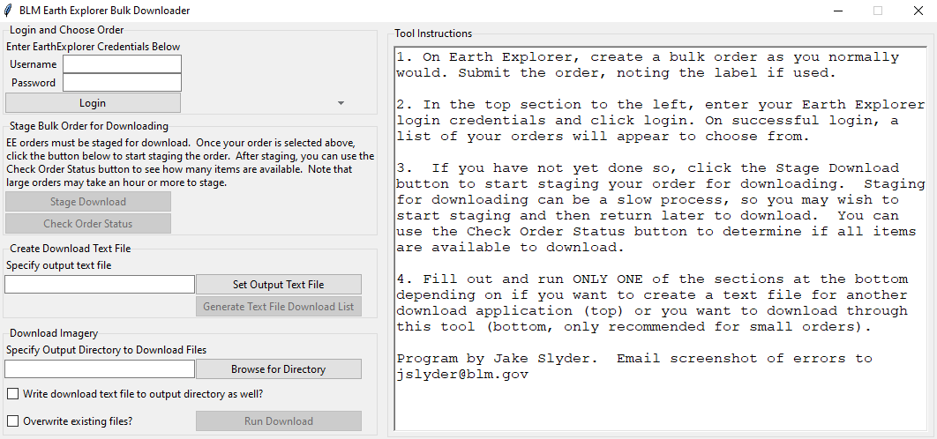

1. First, enter your EarthExplorer username and password exactly as you would on the EarthExplorer website, then click the “Login” button.
2. Note that while the login process is typically very quick, it may take some time if you have many outstanding orders, as the tool works through your available downloads to note any order that have items available for download.
3. Once this process is complete, you will receive a verification message, as well as a list of orders that have items available for download. Click the down arrow next to the first order to view the list. If you did not provide an order name, it will auto populate with a numeric value that reflets the date and time when the order was submitted. You can also find this auto populated order name in the confirmation email. Choose the order you wish to download by left-clicking the name in this list (screenshot below).   
     
   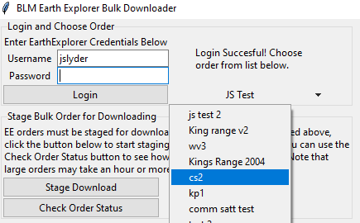

**A note on staging orders for download.**To minimize bandwith, items from EarthExplorer bulk download orders do not become available until specifically requested. Therefore, after an order is placed, you will likely need to “stage” your order, which will tell EarthExplorer to move the items to a location available for download.

1. To stage the order, you can click the “Stage Download” button once you have selected the order above that you’d like to download. Note that you only have to do this one time. You will receive a confirmation with the time at which the order was staged.   
   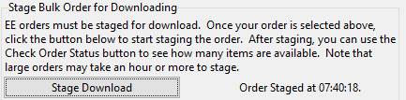
2. Once the order is staged, it is recommended that you wait until all items are available for download. You can check how many of the items are available by using the “Check Order Status” button. A message will appear showing how many items are in the available status.   
   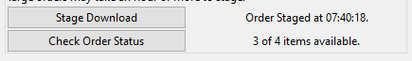

**A note on the two types of downloads available.**This tool supports two general workflows. The first is the generation of a text file with the download URLs from that order. This text file can then be fed into most common download manager software programs, such as uGet. The second is to handle the download directly through this tool. If you wish to download a larger order, you have an unstable internet connection, or you plan to login/logoff VPN during the download, then it is recommended that you generate a text file to use in a more sophisticated download manager. While this tool usually downloads your order fine, it has very little error handling, and the download process be interrupted if your internet connection cuts out, even for a brief moment (note that this happens briefly when you connect or disconnect from Pulse VPN).

1. If you plan to use a 3rd party download tool, fill in the “Create Download Text File” section of the tool.
   1. If you plan to generate a text file to use in another program, you only have to set the output location and file name. To do this, click “Set Output Text File.”
   2. In the resulting popup window, navivate to the folder where you’ll save the text file and enter a filename. When you’re done, click “Save.”
   3. **Note** that it is necessary to use the “Set Output Text File” button in order to activate the “Generate Text File Download List” button. When you are happy with the output file path and name, click the “Generate Text File Download List” button.
   4. If the tool completes successfully, a small window saying “Success!” will appear. Click the X on this window to close, and optionally close the download tool as well.   
      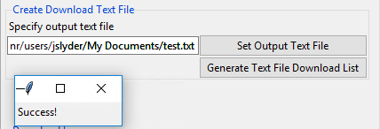
2. If you plan to run the download directly through this tool, leave the “Create Download Text File” section blank and fill in only the “Download Imagery” section of the tool.
   1. You must first specify the folder to store the downloaded scenes. To do this, click the “Browse for Directory” button.  
      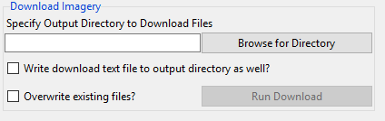
   2. On the resulting window, choose your preferred directory and then click “Select Folder.”
   3. You then have two additional options, the first is to create a text file in this directory called “EEDownloadList.txt” that contains the URLs for all items to download. This may be a helpful backup in case you start to download using this tool before switching to a 3rd party download manager.
   4. If you wish to overwrite existing files in the output directory, check the box next to “Overwrite Existing Files?” By default, this is unchecked, so the download tool will skip any items where that filename already exists in the output directory.
   5. When you are happy with your settings, click the “Run Download” button. Note that this button only becomes active once you’ve clicked on the “Browse for Directory” button.
   6. Once you click “Run Download” a progress window will appear. The window should list the current item being downloaded, as well as a progress bar for that item (top) and the overall order (bottom).   
      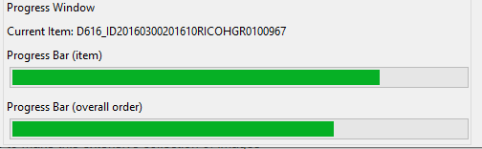
   7. Once the download is complete, you will get a “Download Complete” message in the progress window. Note that any errors for individual items will be logged to a text file in the output directory called “ScenesWithDownloadErrors.txt”

When you start the program, note that there will be a console window that will also open (screenshot below). This console window prints a lot of text that may not be interpretable, and this window can largely be ignored. However, if you have any issues with the tool, error messages will be printed to this console, and these will be helpful in diagnosing the problem. If you have issues with the tool, please capture and share a screenshot of the console. If you have any issues or feature requests, contact Jake Slyder at the email address listed at the top of this document.

