* Friction is independent of surface area
* Billy Whopper is sliding across his “Slip and Slide.” IF he has a mass of 125 kg and uk = .05 between the slip and lside and his body what is the force of riction acting on him.

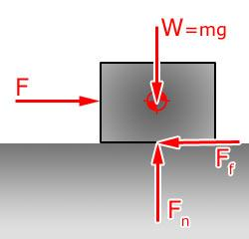

Rosa Corn is pushing a refirgerator m=150 kg with a force of 575 N. If the coeffecient of friction = .25 find a) the force of friction b) the net force, C) the accceeration

f =ufn = u(mg) = .25\*150\*10

.f= ufn

Steel ice skate