COMP 3500: Homework 2

Points Possible: 100

# Note: You do not need to submit hard copies.

**Goals:**

* To understand the principles of deadlocks.
* To learn how to solve deadlock and starvation problems.
* To collaborate and discuss deadlock problems with your group members.

# Questions:

1. [40 points]

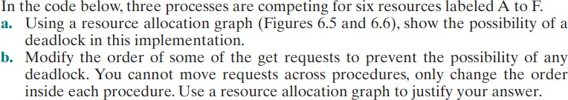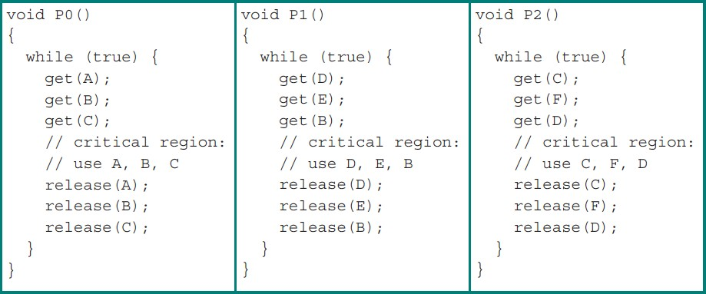

a.

P0

P2

P1

F

B

A

E

D

C

b. All processes are in a cyclic waiting state, therefore deadlock occurs.

Process P0

Get(B)

Get(C)

Get(A)

Process P1

Get(D)

get(E)

Get(B)

Process P2

get(F)

Get(D)

Get(C)

P0

P1

P2

B

C

D

1. [20 points]

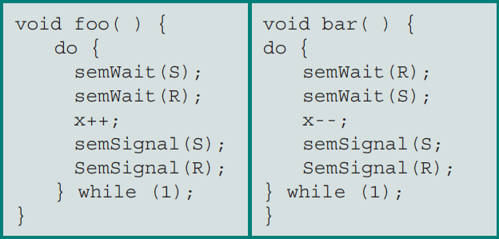Suppose the following two processes, foo and bar are executed concurrently and share the semaphore variables S and R (each initialized to 1) and the integer variable x (initialized to 0).

Can the concurrent execution of these two processes result in one or both being blocked forever? If your answer is yes, please give an execution sequence in which one or both are blocked forever.

Yes:

Foo():semWait(S); //S now 0

bar():semWait(R); //R now 0

Foo():semWait(R); //R = 0, wait until R > 0

bar():semWait(S); //S = 0, wait until S > 0

1. [20 points]

What is the difference among deadlock avoidance, detection, and prevention?

Deadlock avoidance is a technique that allows the system to dynamically decide whether to grant a request for a resource based on the current state of the system. This technique involves predicting the future requests for resources and then granting or denying the current request in a way that avoids the possibility of a deadlock.

Deadlock detection involves periodically checking the system to determine if a deadlock has occurred. This technique involves looking for circular wait, and if detected, the system takes action to break the deadlock.

Deadlock prevention involves designing a system in such a way that deadlocks cannot occur. This is usually done by eliminating one of the four conditions necessary for a deadlock to occur. For example, by ensuring that only one process can have exclusive access to a resource at a time or by implementing a protocol that prevents circular wait.

1. [20 points]

Consider a system consisting of four resources of the same type that are shared by three processes, each of which needs at most two resources. Show that the system is deadlock-free.

Each of the processes can request at most 2 of the resources, if a process has 2 of the resources then it will return them to the shared pool. There are 3 processes and 4 resources the most resources that can be taken is 3 resources so since there is an extra it will be returned thus having no deadlocks.

# Submission:

* + A heading at the top of your file contains your group ID, the names of your group members, and your Auburn UserIDs.
  + Submit your solution as a PDF file named as ““<group_ID>_hw2.pdf” through Canvas (for example, mine might read “group06_hw2.pdf”)
  + Each group must submit a single PDF file that contains:
    - Group member 1’s answers
    - Group member 2’s answers
    - Group answers after your discussion
  + If the two group members’ answers agree with one another, you simply pick the answer with better presentation as your group answers.
  + If the two members’ answers are different, the members will have to discuss and determine whose answer is correct. The correct one should be submitted as the group answer.
  + In the above two cases, your team must clarify whose answers are adopted.
  + TA will only grade your group answers. However, if you (1) do not provide each member’s individual answers or (2) you do not clarify whose answers are adopted, your team will **lose 20 points**. Although the two group members may share different answers, the members should have an agreement on the group answers.

# Late Submission Penalty:

* + Ten percent (10%) penalty per day for late submission. For example, an assignment submitted after the deadline but up to 1 day (24 hours) late can achieve a maximum of 90% of points allocated for the assignment. An assignment submitted after the deadline but up to 2 days (48 hours) late can achieve a maximum of 80% of points allocated for the assignment.
  + Assignment submitted more than 3 days (72 hours) after the deadline will not be graded.

# Rebuttal period:

* + You will be given a period of one week (i.e., seven days) to read and respond to the comments and grades of your homework or project assignment. The TA may

use this opportunity to address any concern and question you have. The TA also may ask for additional information from you regarding your homework or project.