AWM doc C22493266

If you cannot query inside the pgadmin tool, make sure to go to servers/yourDBname/databases/awm_db and ensure it is online, if not right click and reconnect…

Conceptual Flow
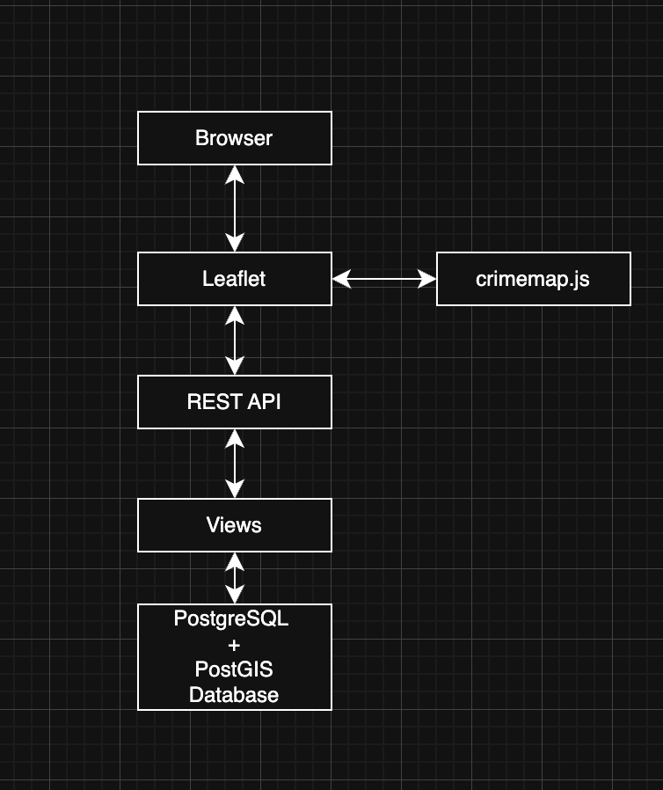

Database schema:

Table: Crime
Columns : Type Desc
id | integer | unique recorder
category | text | crime category (theft etc)
severity | integer | Severity score 1-3
occurred_at | timestamp | Date+time of crime
geom | geography(Point,4326) | Location as geo point

