PNGE 420 PRODUCTION ENGINEERING
Project Grading Sheet

NAME: Jake Westling DATE: Fall 2015

PROJECT: Project 3

CRITERIA | GRADE

Design, analyze, interpret data.  (ABET Criteria 3.b) | out of 12
Design a system or component.  (ABET Criteria 3.c) | out of 20
Identify, formulate, and solve engineering problem.  (ABET Criteria 3.e) | out of 20
Professional and ethical responsibility.  (ABET Criteria 3.f) | out of 4
Communicate effectively.  (ABET Criteria 3.g) | out of 20
Impact of engineering solutions in global and societal context.  (ABET Criteria 3.h) | out of 4
Engagement in life-long learning.  (ABET Criteria 3.i) | out of 4
Knowledge of contemporary issues.  (ABET Criteria 3.j) | out of 4
Use of modern engineering tools necessary for engineering practice.  (ABET Criteria 3.k) | out of 12

TOTAL | out of 100

PNGE 420
Project 3
Jake Westling
12/8/2015

Table of Contents
Abstract 2
Problem Statement 3
Approach 4
Results 5
Conclusions 10
Appendix 11
References 22

Abstract
After writing the program using MATLAB, the example in class was performed to determine the validity. Afterwards, inputs from the project well in the tubing were used and the outlet pressure in the tubing was calculated to be 4247 psia. Many correlations were used in addition to Beggs and Brill to calculate multiphase pressure drop in pipes and wellbores.
Problem Statement
The purpose of this project was to develop a computer program capable of calculating pressure losses in vertical, horizontal, and deviated wells and horizontal and inclined pipelines under multiphase flow conditions using the method of Beggs and Brill. The program written needed to display all inputs and outputs with the proper field units.
Approach
The approach to solve this coding project was systematic. First, a code was written following the procedure of the given handout Beggs and Brill Method. Many MATLAB functions were used including input, fprintf, while loops, and if loops. After this was completed, a sample run was done using the example used in class to verify the code was working. Correlations were found for each needed parameters. Outputs were displayed. A detailed procedure is shown in the Appendix section.
Next, input parameters were gathered from Project 1 and 2. These parameters were put into the program and the outputs were displayed.
Results
The raw code and results for the project pressure drop is displayed below. See the Appendix for the code and class example solved.
Table 1: Input Parameters^{1,2,3,4,5}
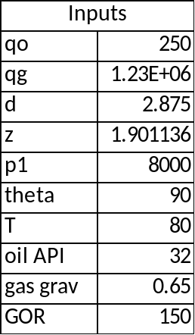

The code:
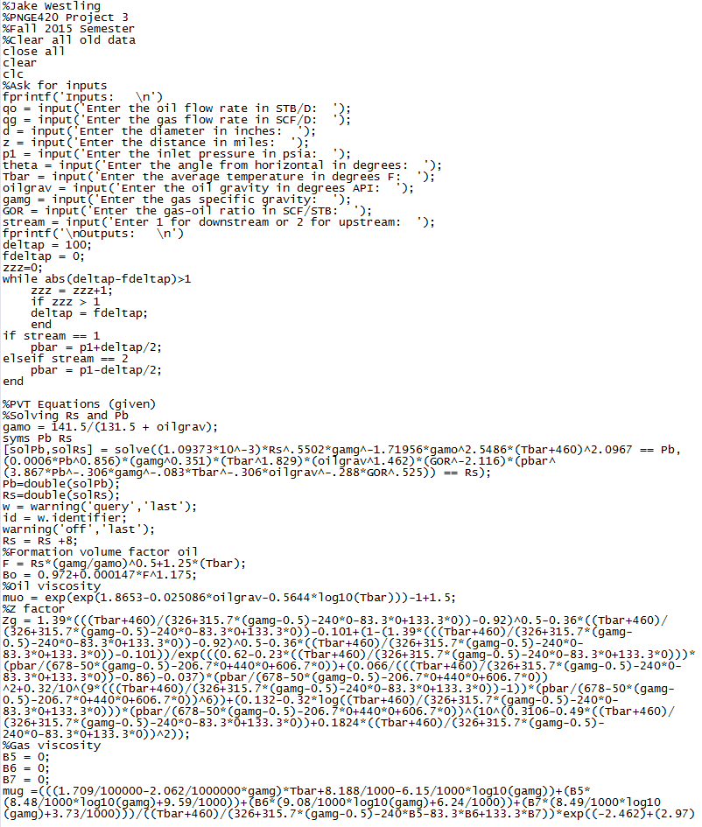
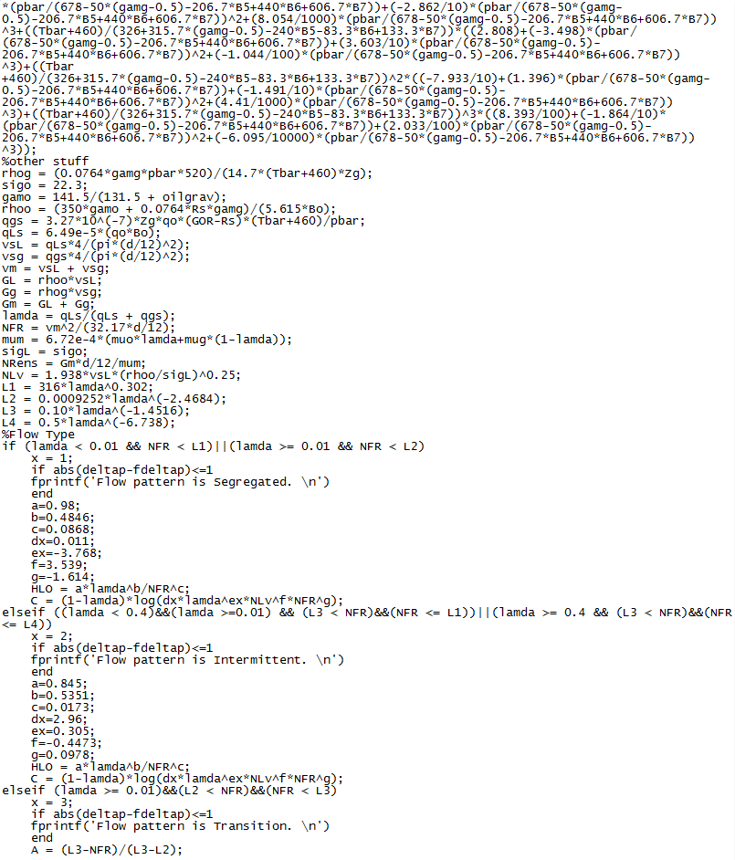
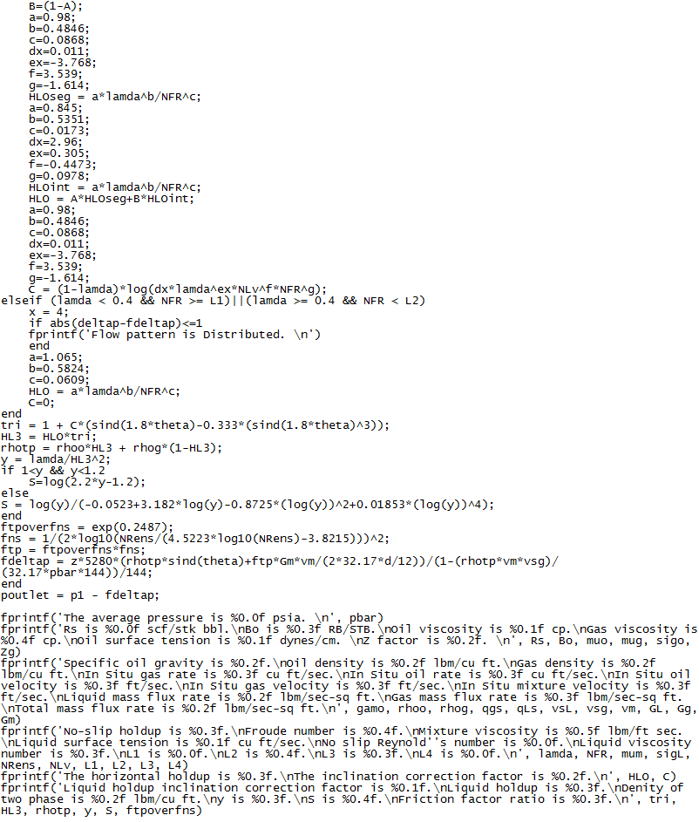

The Results:
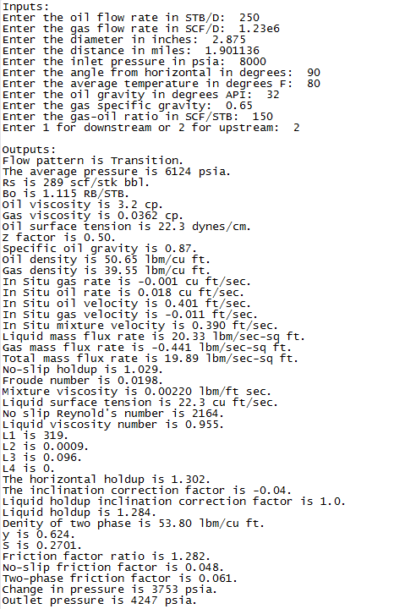

Conclusions
The purpose of this project was to write a MATLAB code which could solve pressure drop problems. After verifying the code was correct with the example problem, it was used to solve the pressure drop in the tubing of the project. It can be seen that the pressure was reduced to 4247 psia in the tubing from the multiphase flow.
Beggs and Brill method is useful in many situations including pressure losses in vertical, horizontal, and deviated wells as well as inclined pipelines under multiphase flow conditions.
Appendix
This is a comprehensive list of equations, parameters, and results used in coding the program. Also displayed is the original handout used extensively for the equation algorithims.

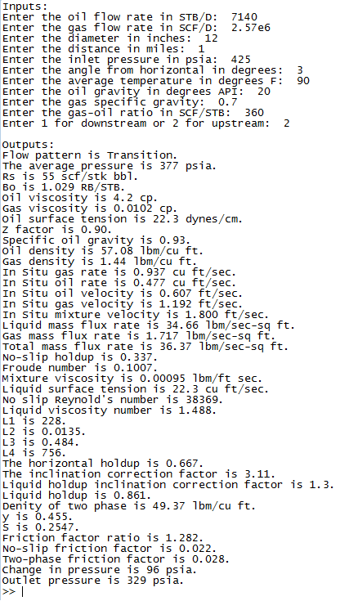
Select Design Parameter Description:
Oil flow rate, qo (STB/D)
Gas flow rate, qg (SCF/D)
Diameter, d (inches)
Distance, z (miles)
Inlet pressure, p1 (psia)
Angle from horizontal, theta (degrees)
Average temperature, Tbar (degrees F)
API oil gravity, oilgrav (deg API)
Specific gas gravity, gamg
Gas-oil ratio, GOR (SCF/STB)
Downstream or Upstream, stream
Average pressure, pbar (psia)
Solubility, Rs (SCF/STB)
Formation volume factor oil, Bo (bbl/STB)
Viscosity of oil, muo (cp)
Viscosity of gas, mug (cp)
Surface tension oil, sigo (dynes/cm)
Z-factor, Zg
Oil specific gravity, gamo
Density oil, rhoo (lbm/cu ft)
Density gas, rhog (lbm/cu ft)
In situ gas rate, qgs (cu ft/sec)
In situ oil rate, qLs (cu ft/sec)
In situ oil velocity, vsL (ft/sec)
In situ gas velocity, vsg (ft/sec)
In situ mixture velocity, vm (ft/sec)
Liquid mass flux rate, GL (lbm/sec-sq ft)
Gas mass flux rate, Gg (lbm/sec-sq ft)
Total mass flux rate, Gm (lbm/sec-sq ft)
No-slip holdup, lamda
Froude number, NFR
Mixture viscosity, mum
Liquid surface tension, sigL
No-slip Reynolds number, NRens
Liquid viscosity number, NLv
Flow pattern parameters, L1, L2, L3, L4
Flow pattern constants, a, b, c, dx ,ex, f, g
Horizontal holdup, HLO
Inclination correction factor coefficient, C
Liquid holdup inclination correction factor, tri
Liquid holdup, HL3
parameters, y, S
Friction factor ratio, ftpoverfns
No-slip friction factor, fns
Two-phase friction factor, ftp
Pressure change calculated, fdeltap (psia)
Outlet pressure, poutlet (psia)

The Beggs and Brill Handout:⁷
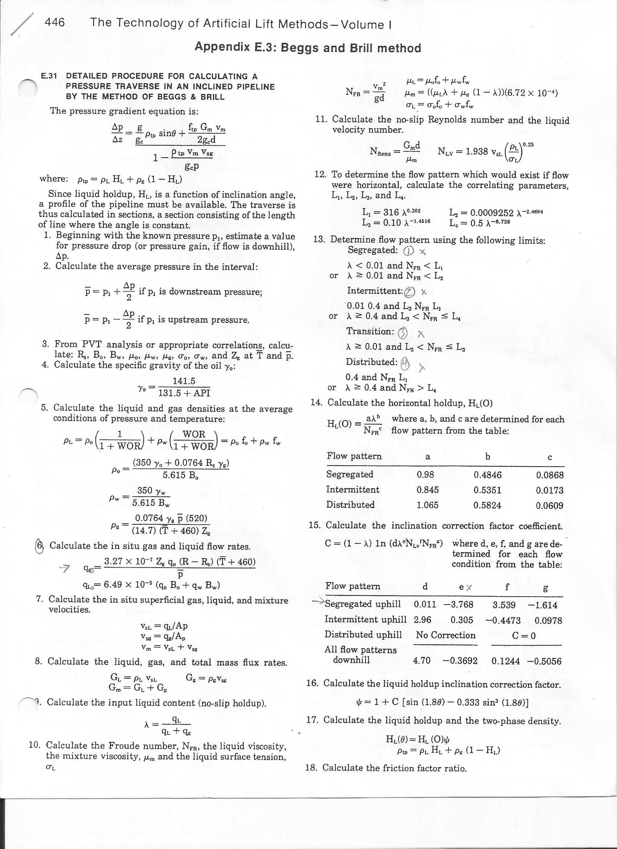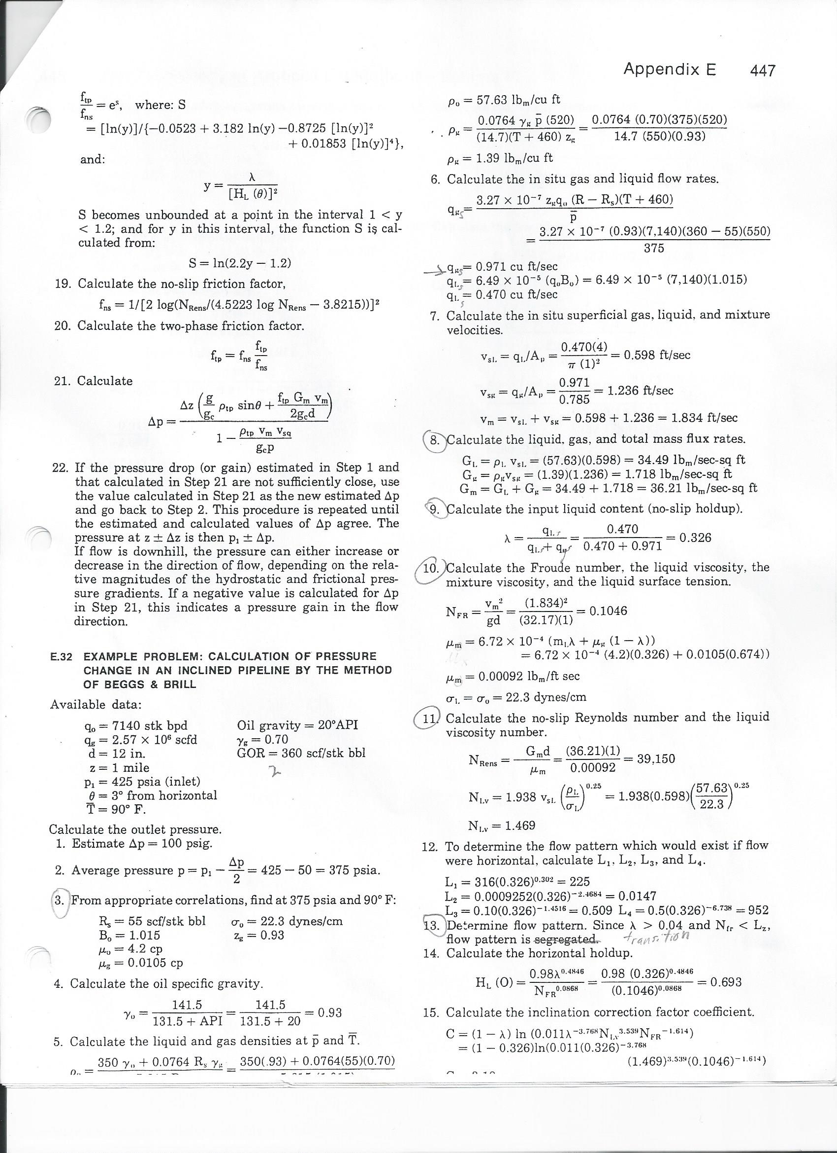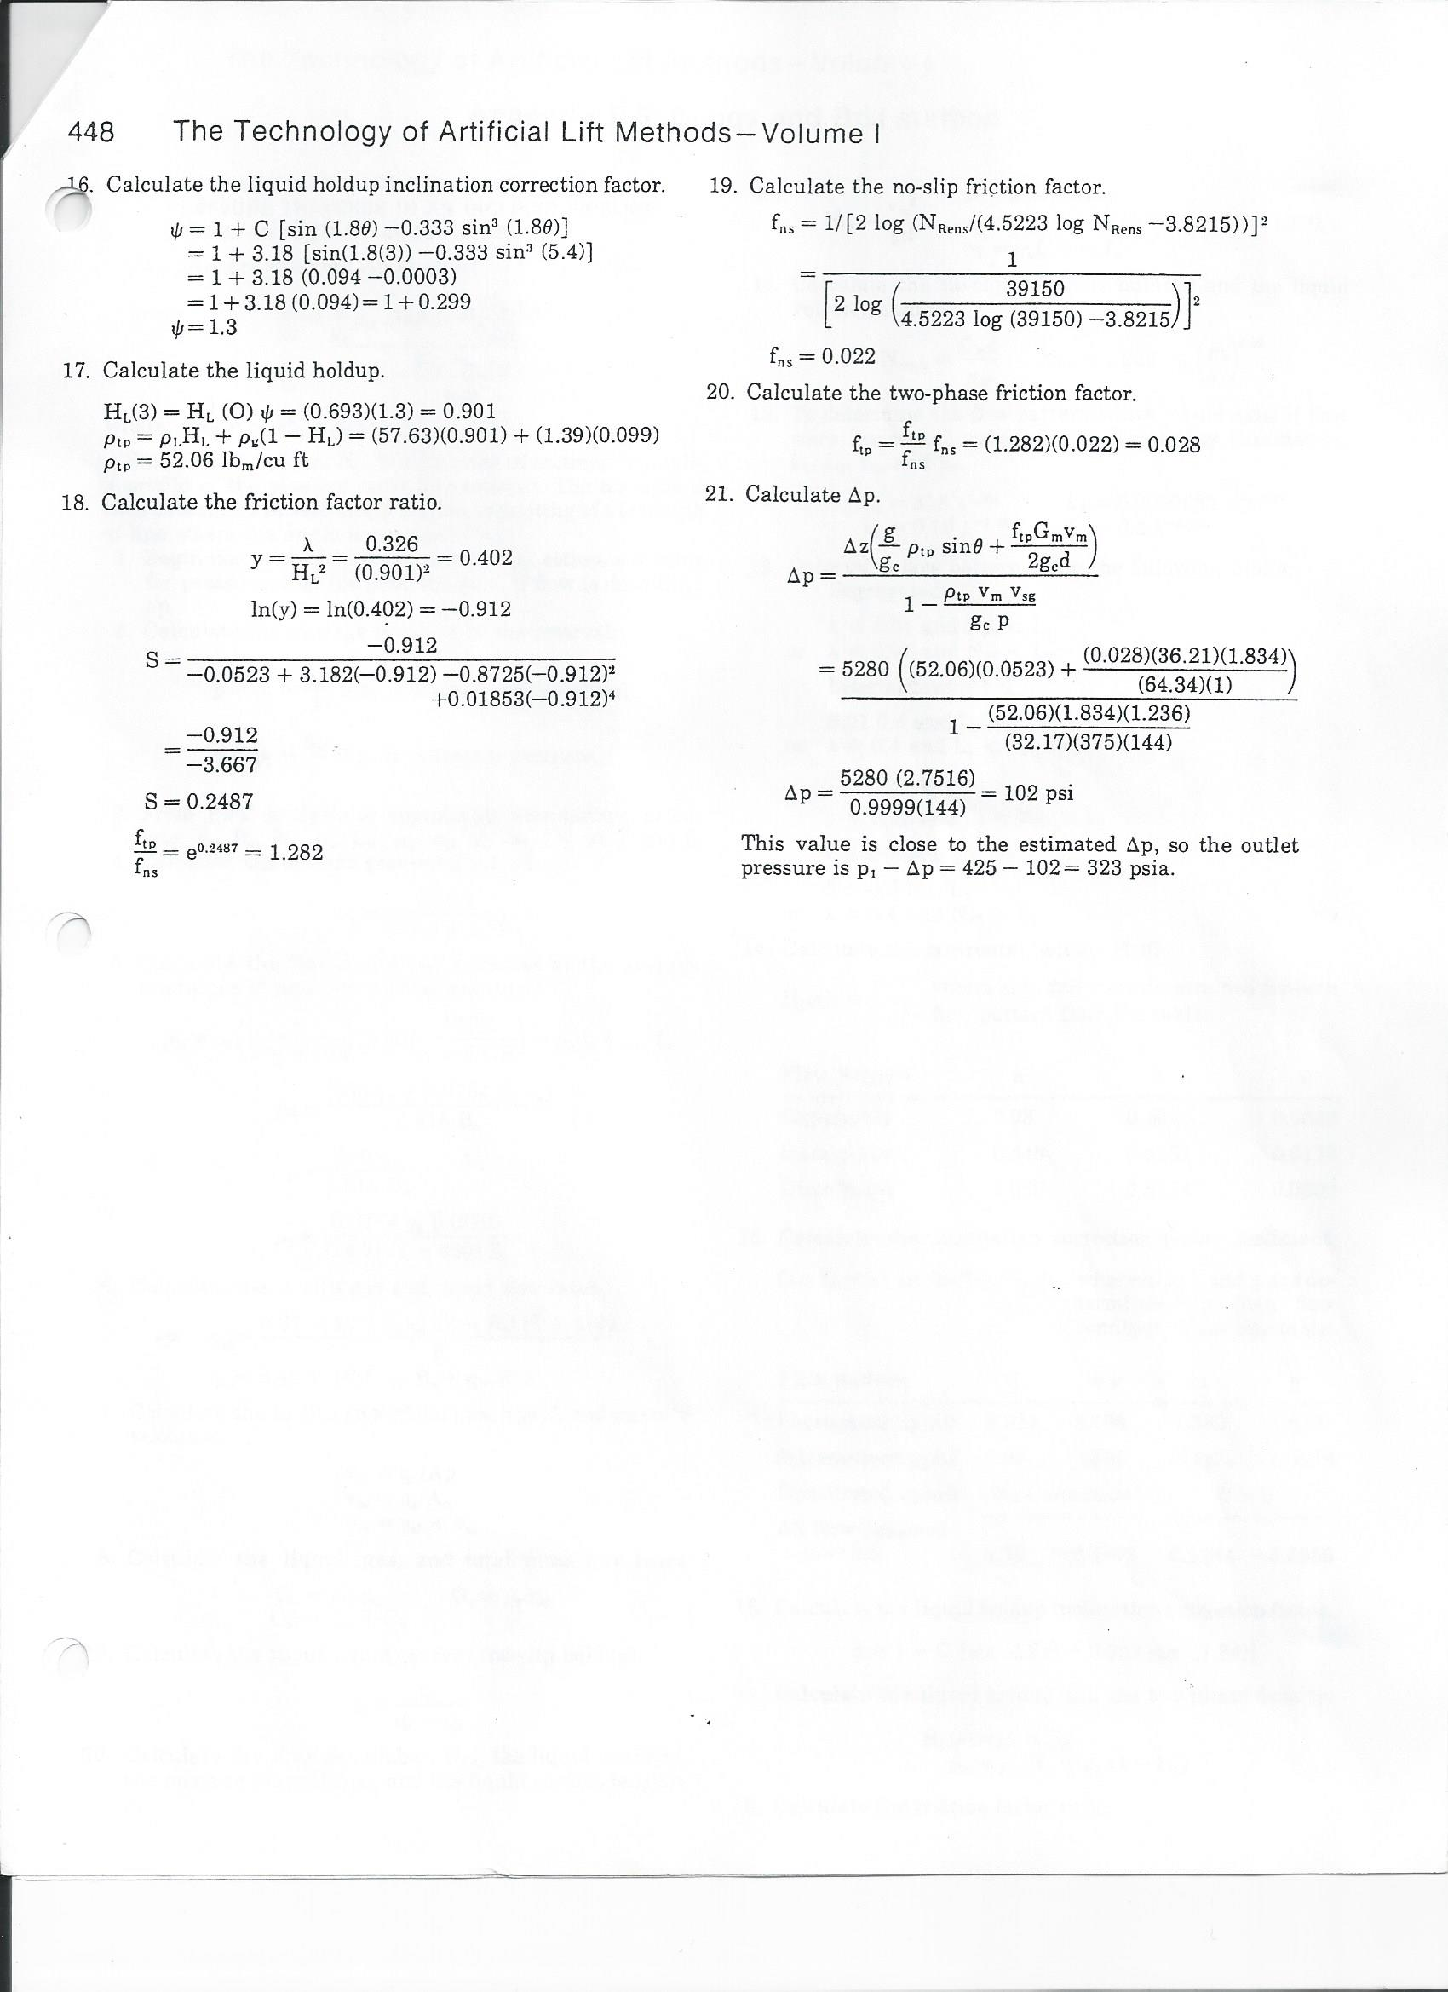
References
1. Ritch, H. J., & Kozik, H. G. (1971, January 1). Petrophysical Study Of Overpressured Sandstone Reservoirs, Vicksburg Formation Mc Allen Ranch Field Hidalgo County, Texas. Society of Petrophysicists and Well-Log Analysts.
2. Bybee, K. (2004, March 1). Underbalanced Drilling With Casing in South Texas. Society of Petroleum Engineers. doi:10.2118/0304-0055-JPT
3. Riese, W. C., & Riese, A. C. (1988, January 1). Prediction of Geochemical Formation Damage in the Vicksburg Formation of South Texas. Society of Petroleum Engineers. doi:10.2118/18132-MS
4. Simon, J. M. (1992, January 1). New Standard Set for South Texas Drilling Performance. Society of Petroleum Engineers. doi:10.2118/24602-MS
5. Gordon, D. G., Billa, R. J., Weissman, M. B., & Hou, F. J. (2005, June 1). Underbalanced Drilling with Casing Evolution in the South Texas Vicksburg. Society of Petroleum Engineers. doi:10.2118/84173-PA
6. Recommended Practice for Design Calculation for Sucker Rod Pumping Systems (Conventional Units). (1998, June 1). Retrieved November 4, 2015.
7. Brown, K. (1977). The Technology of Artificial Lift Methods (Vol. I, pp. 446-448). Tulsa: PPC Books.

