**COURSEWORK SUBMISSION**

|  |  |  |  |
| --- | --- | --- | --- |
| **STUDENT USE** | | **STAFF USE** | |
| Module Name | Internet of Things | First Marker’s  (acts as signature) |  |
| Module Code | 6COSC014C | Second Marker’s  (acts as signature) |  |
| Lecturer Name | Shirin Primkulova | Agreed Mark |  |
| UoW Student IDs |  | **For Registrar’s office use only (hard copy submission)** | |
| WIUT Student IDs | 00011843 |
| Deadline date | 01.12.2023 |
| Assignment Type | Individual |

**SUBMISSION INSTRUCTIONS**

**COURSEWORKS *must* be submitted in *both* HARD COPY (to the Registrar’s Office) *and* ELECTRONIC unless instructed otherwise.**

For hardcopy submission instructions refer to: <http://intranet.wiut.uz/Shared%20Documents/Forms/AllItems.aspx> - Coursework hard copy submission instructions.doc

For online submission instructions refer to: <http://intranet.wiut.uz/Shared%20Documents/Forms/AllItems.aspx> - Coursework online submission instructions.doc

|  |
| --- |
| **MARKERS FEEDBACK** |
|  |

**Case Introduction**

In our technologically advanced era, some industries, such as agriculture and farming, have yet to fully embrace new technology and the internet. Despite significant progress in many areas, several sectors of these businesses have yet to catch up with the most recent advancements. The Internet of Things (IoT) is constantly improving and proving to be the most effective option for addressing numerous difficulties in these industries. For example, the poultry farm under consideration acts as an important hub for egg production, meeting a significant demand in the local market. This medium-sized enterprise has several coops that house hundreds of hens. Daily tasks include meticulous care, ensuring appropriate nutrition, optimal environmental conditions, and protection from potential hazards. The existing manual processes within the farm pose several challenges:

**1. Manual Monitoring Difficulties:** Relying on manual labor for critical functions such as feeding, water supply management, temperature control, and security monitoring is time-consuming and prone to error due to human limits.

**2. Inconsistent resource utilization:** Inconsistent resource utilization, such as excessive water consumption and wasteful energy consumption, contributes to increased operational costs and environmental effect.

**3. Security Vulnerabilities:** The farm is vulnerable to external threats such as wild animals or predators, which endanger the livestock's safety and well-being.

**Proposed Solution**

Rationalized Solution:

The implementation of an IoT system using Arduino serves as an optimal solution to address the farm's challenges. By integrating an array of sensors, actuators, and communication devices, this system offers a comprehensive, responsive, and automated poultry management solution.

Effectiveness of Implementation:

The proposed solution offers multifaceted improvements:

**Enhanced Livestock Welfare:** Automation ensures precise and timely feeding, adequate water supply, and optimal environmental conditions, thereby enhancing the overall health and productivity of the chickens.

**Resource Optimization:** Controlled water supply based on water level sensors and regulated temperature using fans significantly reduce water and energy consumption, leading to substantial resource efficiency gains.

**Enhanced Security Measures:** Incorporation of motion sensors equipped with a buzzer acts as a deterrent, fortifying the farm against potential threats.

**Resource Economization**

The implementation of this IoT solution optimizes resource utilization through:

**Water Management:** The water pump activation, contingent on water level sensors, minimizes unnecessary water wastage, ensuring a more sustainable use of this critical resource.

**Energy Efficiency:** Temperature-controlled fans efficiently manage the farm's temperature, mitigating excessive energy consumption and reducing operational costs.

**Intelligent Lighting:** Automatic lighting, regulated by ambient light levels through photoresistors, optimizes electricity usage by activating only when necessary.

**Implementation of Devices**

The IoT system integrates a spectrum of devices that play critical roles in automating farm operations.

**Water supply:** For supplying water it is used water sensor to check the level of the liquid in specified container. The sensor measurement ranges are about between 0 and 700 and when it is lower than 150 it signals the system as low-level water and switches on water pump and to fill the container at maximum level value of 650-700. For water pump needs relay to switch on and off the pump and to gain the enough voltage to work smoothly.

**Temperature & Fan Control:** Monitors ambient temperature and humidity and activates fans to maintain optimal conditions for the poultry through DHT11 sensor. When temperature in the coop is more than 30-35 degrees in Celsius, it automatically turns on the FAN. It is used DC motor for FAN and driver to control the flow of current. There are so many drivers and bridges to use but I had L298N driver for usage which provides the control of speed and also direction of FAN as an addition. Furthermore, it requires to use battery like 9V and more.

**Automatic feeding system:** To feed the chickens or any kind of animals with proper amount it can be used servo motor (Tower Pro SG90) to open the door of the container to release some amount of food. With the help of ultrasonic sensor (HC-SR04) it will signals that container is filled with enough food by detecting the distance between the surface of the container and the sensor which I limited to do.

**Photoresistor & LED Lighting:** Controls lighting within the coop based on ambient light levels to minimize unnecessary energy consumption. When the value of the lightness is lower than 25 it considers that there is not enough brightness it will switch on the led for and switches off automatically when it is daylight.

Motion Sensor & Buzzer for Security: It is common that in farms which are located in rural areas, probability of threats such as killing and robbing animals is high. To resolve this issue implementation of detecting any motion in the dark time outside the farm premises is good solution. Signaling through some sound system (in this case buzzer) enhances security measures against potential threats.

Circuit Graph:

Visual representations in the form of circuit graph illustrate the interconnection and communication between these devices within the IoT framework. These diagrams provide a comprehensive understanding of the system's architecture, emphasizing the integration of sensors, actuators, and the communication infrastructure.

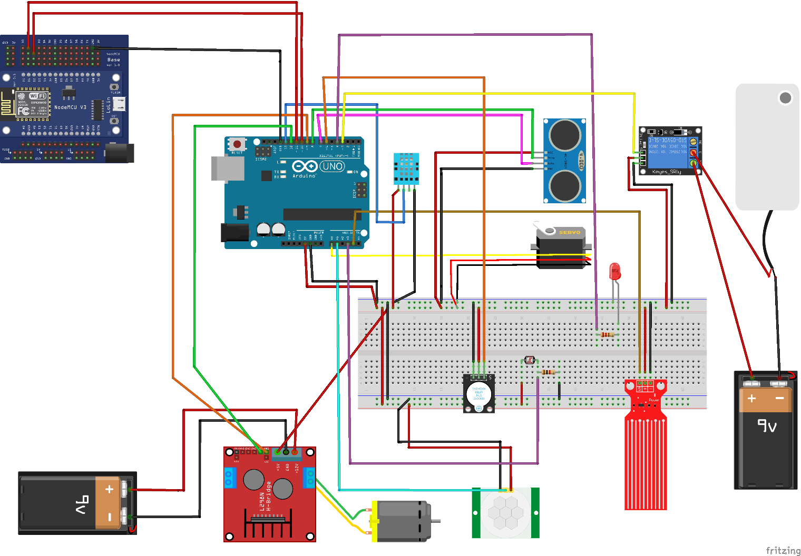

**Technology Employed**

**Integration of NodeMCU:**

The inclusion of NodeMCU plays a pivotal role in connecting the IoT system to the cloud, enabling real-time data transmission and remote control functionalities.

**NodeMCU's Role:**

Cloud Connectivity: NodeMCU acts as a bridge between the local IoT system and the cloud, facilitating seamless data transmission to a web application hosted on the cloud server.

Real-time Data Transmission: By utilizing NodeMCU's Wi-Fi capabilities, the system transmits sensor data in JSON format to the web application, ensuring real-time updates on the farm's conditions.

Web Application Interface: The cloud-hosted web application provides a user-friendly interface to monitor the poultry farm's status, access historical data, and exercise control over the automated processes.

Arduino Uno - NodeMCU Communication:

To establish communication between Arduino Uno and NodeMCU, a serial communication protocol employing JSON format facilitates data exchange.

**Data Transmission Protocol:**

JSON Format: The system employs JSON (JavaScript Object Notation) to structure and transmit sensor data between Arduino Uno and NodeMCU. This standardized format ensures compatibility and ease of data interpretation.

Serial Communication: Arduino Uno and NodeMCU communicate via serial communication protocols, exchanging JSON-formatted sensor data seamlessly.

**Reflection and Future Work**

Expanding Cloud Connectivity:

The integration of NodeMCU and the cloud-hosted web application marks a significant milestone, yet further enhancements can be considered:

Enhanced Web Application Features: Introducing additional features such as data analytics, customizable alerts, and predictive insights can empower farmers with more actionable information.

Secure Communication Protocols: Implementing robust security measures within the cloud infrastructure and data transmission protocols is crucial to safeguard sensitive farm data from potential cyber threats.

Mobile Application Integration: Developing a mobile application interface can offer farmers greater flexibility in monitoring and controlling farm operations remotely.

Advancing Communication Protocols:

While the current system successfully integrates Arduino Uno and NodeMCU, future iterations could focus on optimizing communication protocols:

Advanced Data Compression Techniques: Exploring data compression methodologies can streamline transmission, reducing latency and optimizing bandwidth utilization.

Protocol Standardization: Evaluating and adopting industry-standard communication protocols can enhance interoperability and facilitate integration with other IoT systems or platforms.

**Conclusion**

In conclusion, the integration of NodeMCU into the IoT ecosystem for poultry farm automation signifies a crucial advancement in farm management technology. The seamless connectivity to the cloud through NodeMCU enables real-time data transmission, empowering farmers with remote monitoring and control capabilities.

As technology evolves, further advancements and refinements, including enhanced cloud connectivity features and optimized communication protocols, will fortify the system's capabilities. This continuous development journey ensures the IoT-based poultry farm automation system remains at the forefront of innovation, revolutionizing agricultural practices and optimizing farm productivity.

Github link: <https://github.com/jakhongirn/00011843-iot-cw>

Web app link:

# Reference list

Instructables. (no date). Controlling a Servo With an Ultrasonic Sensor Using Arduino. *Instructables*. Available from https://www.instructables.com/Controlling-a-Servo-With-an-Ultrasonic-Sensor-Usin/.

L298n Motor driver Arduino | Motors | Motor Driver | L298n. (no date). *projecthub.arduino.cc*. Available from https://projecthub.arduino.cc/lakshyajhalani56/l298n-motor-driver-arduino-motors-motor-driver-l298n-7e1b3b.

Motion Sensor with noise and LED for beginners. (2020). *Arduino Forum*. Available from https://forum.arduino.cc/t/motion-sensor-with-noise-and-led-for-beginners/685127 [Accessed 1 December 2023].

Robotique. (2022). Control a water pump by Arduino. *Robotique.com*. Available from https://www.robotique.tech/robotics/control-a-water-pump-by-arduino/.

Yeamin, M. (2022). Send Data From Arduino To NodeMCU. *GitHub*. Available from https://github.com/MY-Sabil/Send-Data-From-Arduino-To-NodeMCU [Accessed 1 December 2023].