Hubert Jakubiak LAB1

## Plik - sin_60Hz.wav

### Fsize 256

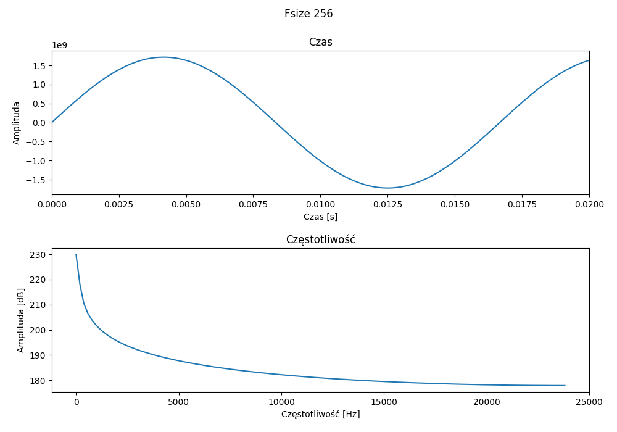

wartość losowa = [0.90017851]

Peak freq = 0.0

Peak amp = 229.85792722602494

### Fsize 4096

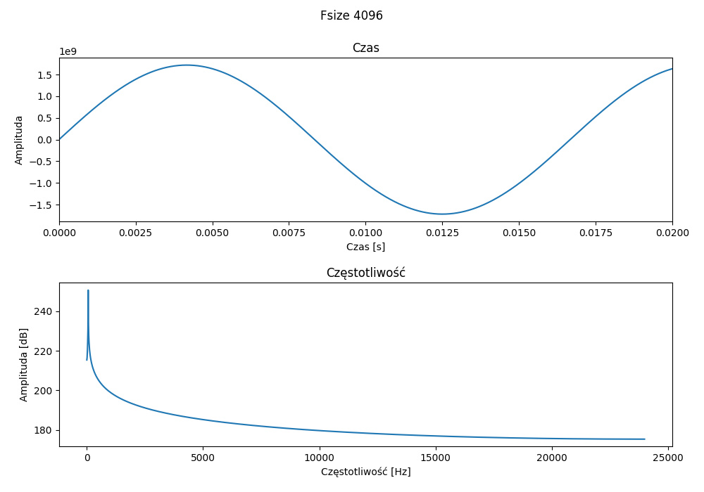

wartość losowa = [0.17197083]

Peak freq = 58.59375

Peak amp = 250.64459244678267

### Fsize 65536

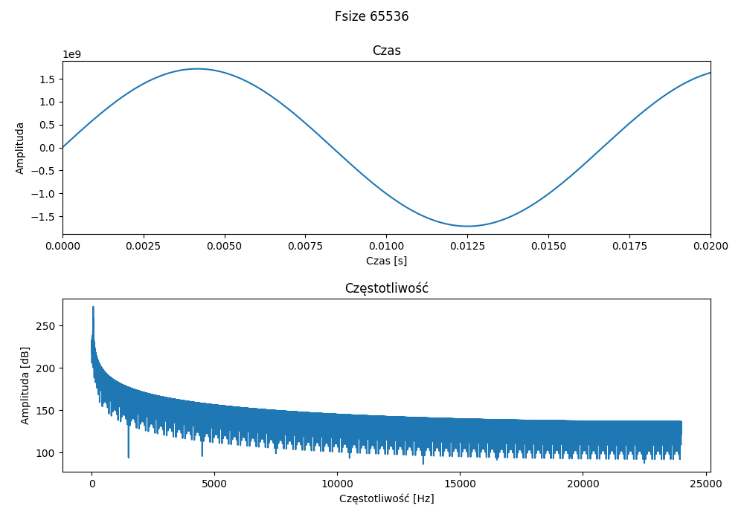

wartość losowa = [0.8806001]

Peak freq = 60.05859375

Peak amp = 272.25127336550594

## Plik - sin_440Hz.wav

### Fsize 256

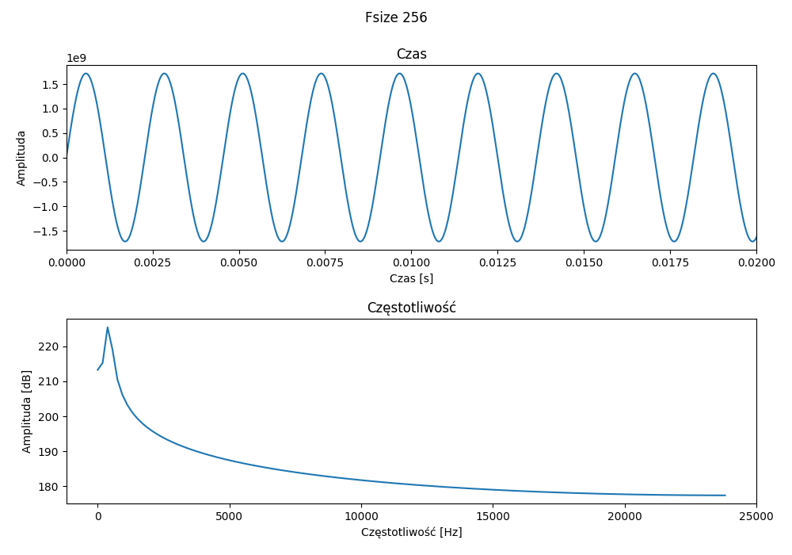

wartość losowa = [0.97151827]

Peak freq = 375.0

Peak amp = 225.42731994049382

### Fsize 4096

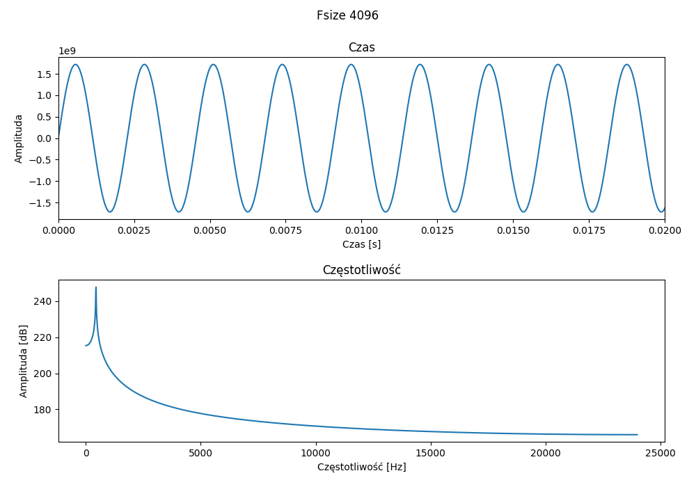

wartość losowa = [0.97528845]

Peak freq = 445.3125

Peak amp = 247.71111334820858

### Fsize 65536

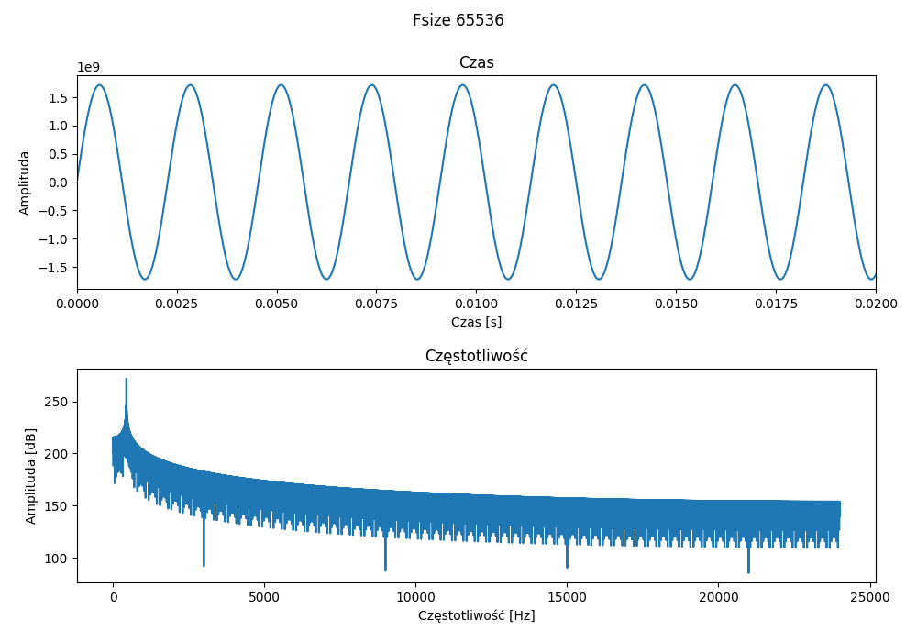

wartość losowa = [0.74425982]

Peak freq = 440.185546875

Peak amp = 271.8052057127737

## Plik - sin_8000Hz.wav

### Fsize 256

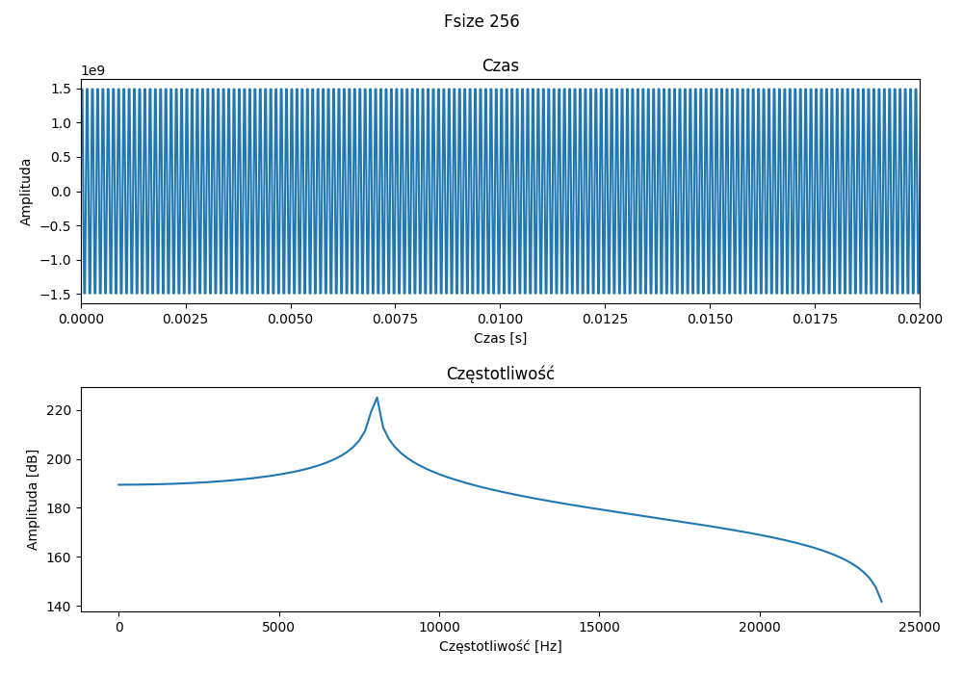

wartość losowa = [0.8927265]

Peak freq = 8062.5

Peak amp = 225.1536332391256

### Fsize 4096

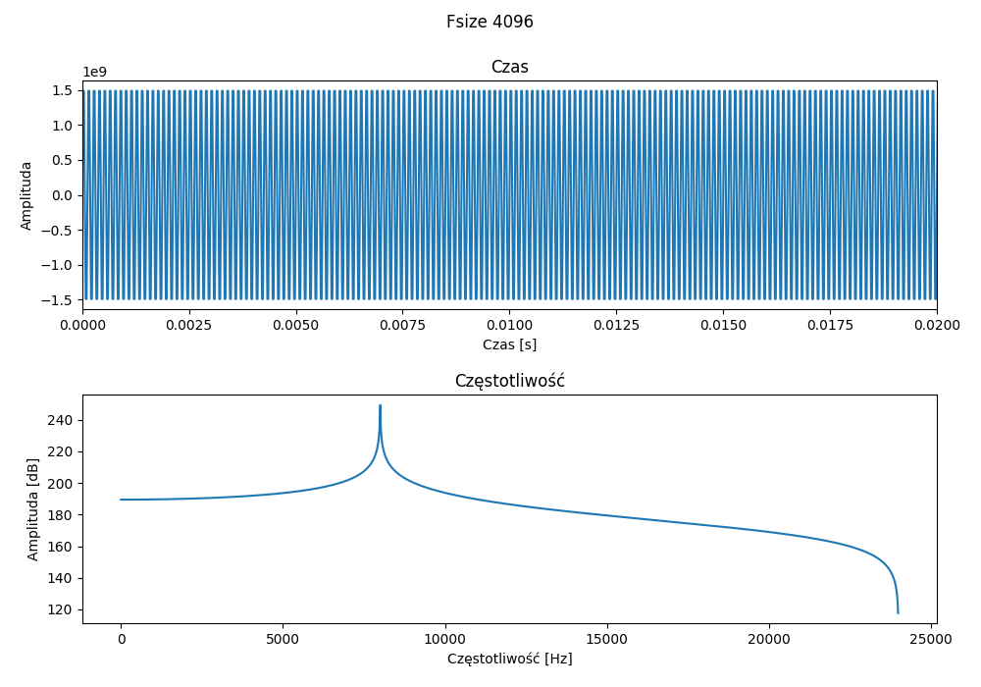

wartość losowa = [0.15736585]

Peak freq = 8003.90625

Peak amp = 249.27447210801006

### Fsize 65536

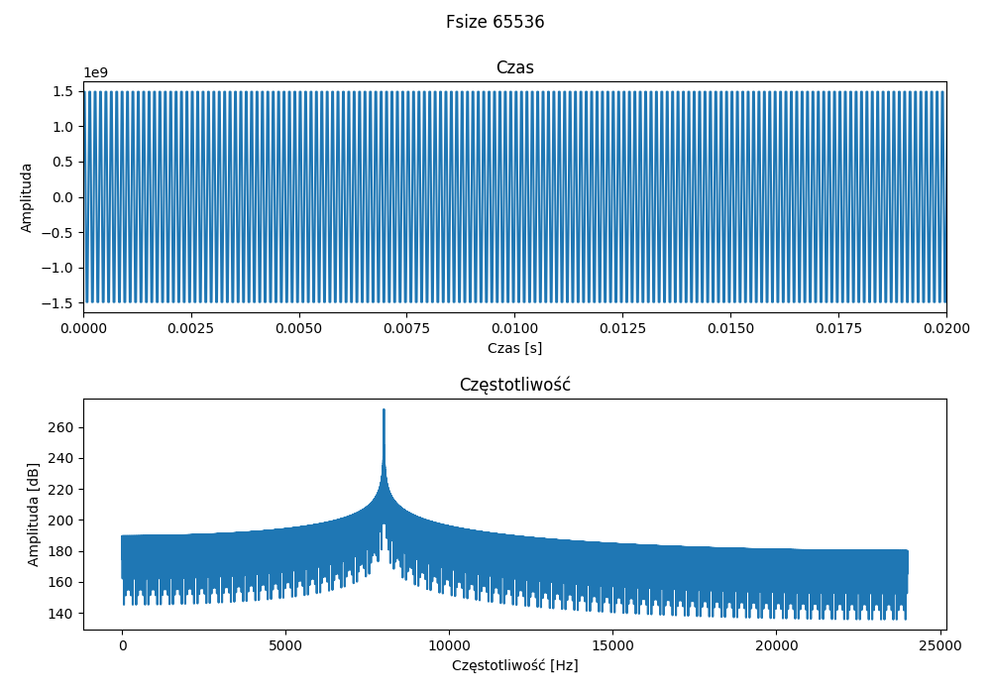

wartość losowa = [0.94434661]

Peak freq = 8000.244140625

Peak amp = 271.4355753208937