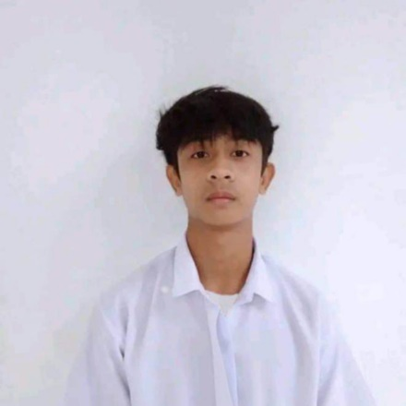
Rodary Patrimonio Tabasan
Dungeg, Santa Teresita, Cagayan
reytabasan123@gmail.com
+63 975 660 0232

OBJECTIVES

To gain valuable experience and further develop my skills for personal and professional growth. In return, I am eager to contribute my efforts and dedication to be a valuable asset to your company during my on-the-job training (OJT).

PERSONAL INFORMATION

Date of Birth: January 8, 2004
Birthplace: Santa Teresita, Cagayan
Sex: Male
Height: 1.63 m
Weight: 49 kg
Civil Status: Single
Citizenship: Filipino
Language spoken: Ilocano, Filipino, and English.

EDUCATION

Tertiary: Bachelor of Science in Information Technology
Cagayan State University – Gonzaga Campus
Flourishing, Gonzaga, Cagayan
2022 – Present

Secondary: STEM
Saint Francis Academy
Villa, Santa Teresita, Cagayan
2020 – 2022

SKILLS

TECHNICAL SKILLS

- Web Development: HTML, CSS, JavaScript, TypeScript, PHP, React, Tailwind CSS, Bootstrap
- Database Management: MySQL
- Tools & Platforms: Git, VS code
- Operating System: Windows, Linux Mint
- Troubleshooting: Hardware, Software, and Network Issues
- Microsoft Office: Word, Excel, PowerPoint

SOFT SKILLS
- Problem-Solving
- Adaptability
- Time Management
- Self-Motivation
- Critical Thinking

CERTIFICATION

- Champion Static Web Design - Technolympics CSU Gonzaga 2025

CHARACTER REFERENCE

Dr. Froilan Pacris Jr.
Campus Executive Officer
Cagayan State University – Gonzaga Campus

Dr. Clyden Charl B. Alibania
College Dean
College of Information and Computing Sciences

I hereby certify that the above information is true and correct to the best of my knowledge and belief.

RODARY P. TABASAN
Applicant

