PHILIPPINE PORK BARREL SYSTEM: A HISTORICAL ANALYSIS OF THE CULTURE OF CORRUPTION AND ITS IMPACT ON PUBLIC TRUST IN GOVERNMENT

PROPONENTS:
GATA, ANGELA C.
GALDECAN, JOYCE
IBUS, FRAYAH ALLIYAH E.
MAXIMO, ALTHEA NICOLE B.
MAXIMO, PRINCESS DIANNE A.
RAQUINIO, WENDALYN G.
REYES, FRESLYN
SEGURITAN, SHEENA S.
SOTOZA, CHOUWIE P.
TABASAN, RICHELYN P.

ABSTRACT
This study examines how the Philippines' pork barrel system has changed over time and how it has affected the nation's political culture, patterns of corruption, and the public's trust. The study traces the system's history from the Public Works Act of 1922 to its multiple versions under various administrations, including the Countrywide Development Fund, Priority Development Assistance Fund, and modern mechanisms like Unprogrammed Appropriations. No matter how the system's name and structure changed, it continued to serve as a tool for patronage and political control. Discretionary funds provide predictable opportunities for misuse, as evidenced by government audits, academic literature, and important corruption cases. This has led to historic events such as the 2013 PDAF scandal, which revealed widespread fraud involving fake NGOs and misused funds. Even after PDAF became unlawful, the study reveals that comparable practices continued under different names, which leads to sustained declines in public trust. In response, Filipinos have frequently come together through protests and community service projects, showing continued efforts to call for accountability and transparency. Overall, the research shows that this is a deeply rooted issue of pork barrel politics, and that both institutional change and ongoing public involvement are necessary for significant reform.

TABLE OF CONTENTS

Chapter Page no.
Abstract---------------------------------------------------------------------------------------------------i

Introduction----------------------------------------------------------------------------------------------1
Research Objectives----------------------------------------------------------------------------------2
Significance of the Study-----------------------------------------------------------------------------3
Methodology---------------------------------------------------------------------------------------------4
Presentation of Findings/ Data----------------------------------------------------------------------5
Early History----------------------------------------------------------------------------------6
Development Overtime---------------------------------------------------------------------7
Present Situation-----------------------------------------------------------------------------8
Analysis and Discussion------------------------------------------------------------------------------9
Conclusion-----------------------------------------------------------------------------------------------10
Recommendations-------------------------------------------------------------------------------------11
References-----------------------------------------------------------------------------------------------12

INTRODUCTION

Corruption often thrives where large sums of money, complex projects, or chaotic situations are involved—such as in disaster responses, technological contracts, or political dealings. These conditions create opportunities for manipulation and misuse of power. The government is expected to protect and serve the people—but in the Philippines, it sometimes becomes the very reason for the loss of people’s trust. For many years, corruption has been a major problem in the country. It has been called a “social cancer” because it destroys government systems and weakens moral values due to greed and lack of accountability. According to Stephen D. Morris (1991), corruption is “the illegitimate use of public power for private interest.” This wrong use of power stops national progress and makes people lose faith in their leaders. Based on the Transparency International Corruption Perceptions Index (CPI) 2024/2025, the Philippines ranks as the third most corrupt country in Southeast Asia and 114th out of 180 countries worldwide, with a score of 33 out of 100—lower than both the regional and global averages (Transparency International, 2025).

In 2013, the country faced one of its biggest corruption scandals in history—the Priority Development Assistance Fund (PDAF) or “pork barrel” scam. The issue showed how public funds were stolen through fake non-government organizations (NGOs), with Janet Lim-Napoles identified as the alleged mastermind. Well-known lawmakers such as Senators Juan Ponce Enrile, Jinggoy Estrada, and Bong Revilla were also accused. This scandal angered the public and led to a protest where thousands of Filipinos gathered to demand transparency and justice. The scandal awakened the people’s awareness and unity against corruption. It became a turning point in history when the Supreme Court declared the PDAF unconstitutional in November 2013, which many saw as a victory for truth and accountability (Inquirer, 2013).

Historically, the pork barrel system started long ago, as early as the 1922 Public Works Act, which allowed lawmakers to use government funds for local projects. However, it was often used for political favors instead of real public service (Department of Budget and Management [DBM], 2016). Culturally, the 2013 scandal brought people together through the use of social media and mass protests, showing that Filipinos are willing to fight for honest leadership. The Million People March became a strong symbol of unity and courage against corruption (Wikipedia, 2023; Silliman Journal, 2019). It also changed how people view corruption—not just as a political problem, but as something that affects every Filipino’s daily life and moral values.

Even after the scandal and the removal of the PDAF, corruption still continues in different forms, showing that it is deeply rooted in the country’s political system. While many studies have looked into the political and legal sides of the Pork Barrel issue, there are only a few that focus on its historical development and how it affects people’s trust in the government. Therefore, this study aims to analyze the historical development of the pork barrel system and examine how it contributed to the culture of corruption and the decline of public trust in government.

RESEARCH OBJECTIVES

This study aims to examine how the Pork Barrel system in the Philippines contributed to the culture of corruption and how it affected public trust in the government.
Specifically, it seeks:

1.To trace the historical origins and evolution of the Pork Barrel system in the Philippines.
2.To explain how the system contributed to the development and persistence of a culture of corruption in government.
3.To analyze the 2013 Pork Barrel Scandal as a major event that revealed the extent of political corruption.
4.To evaluate its impact on the Filipino people’s trust in government institutions.
5.To examine the cultural and social responses of Filipinos toward the scandal and their call for accountability.

SIGNIFICANCE OF THE STUDY

This study will be of advantage to the following:

To the Students: This study will help students understand how the Pork Barrel Scandal shows corruption in government and affects public trust and the economy.

To the Educators: This study will provide real-life examples of corruption to make lessons on governance and ethics more practical and relatable.

To the General Public: This study will inform citizens about the Pork Barrel Scandal and encourage them to be more aware and active in promoting honesty in government.

To the Government Officials and Policymakers: This study will show weaknesses in the political system that allow corruption to continue, and provide ideas for improving transparency and accountability.

To the Future Researchers: This study will help future researchers by giving them background information and insights on political corruption, public administration, and ethics for further studies.

METHODOLOGY

This study used a qualitative historical research design, which is suitable for examining past events and interpreting their social and cultural significance (Berg & Lune, 2017; Given, 2008). It focused on the historical development of the Pork Barrel system in the Philippines and how it contributed to the culture of corruption and affected public trust in government.

Data were collected from multiple sources, including online research, such as news articles, digital archives, and official reports; library and archival research, including books, journals, and historical documents; and documentaries and online blogs discussing the history of the Pork Barrel system and public reactions to corruption.

The data were analyzed using content analysis, a common qualitative method that involves systematically coding textual or visual materials to identify key themes, patterns, and narratives (Krippendorff, 2018; Elo & Kyngäs, 2008) related to the historical evolution of the Pork Barrel system, the emergence of a culture of corruption, and its impact on public trust in government.

PRESENTATION OF FINDINGS/DATA

Early History

A. Pre-Martial Law Era (1922–1972)
The concept of “pork barrel” originated in the United States, where by the 1870s it had become a metaphor for government spending directed to benefit local districts. In 1919, political scientist Chester Collins Maxey popularized the term in the National Municipal Review, describing “pork barrel bills” as legislative acts that rewarded political supporters with funds. By the early 20th century, pork barrel politics was settled in U.S. congressional practice, with legislators securing funds for local projects to strengthen electoral support. This American model directly influenced Philippine lawmakers during the colonial period which set a patronage-driven allocations into the country’s political system (Library of Congress, 2010).

In the Philippines, the earliest form of congressional pork barrel was introduced through the Public Works Act of 1922 (Act No. 3044) under Senate President Manuel L. Quezon and Governor-General Leonard Wood. Section 3 required that appropriated funds for public works be released only with the approval of a joint Senate–House committee, granting legislators post-enactment authority over fund distribution and realignment. This provision allowed lawmakers to influence how resources were allocated which set political discretion into budgetary processes. Quezon himself was known to use discretionary allocations to consolidate alliances during the Commonwealth era, which shows how pork barrel funds became survival tools for leaders rather than purely developmental resources (Corpuz, 1989; IBON Foundation, 2013; DBM, 2016; USAID, 2010; GMA News, 2013).

After World War II, reconstruction needs and local development demands expanded the use of discretionary funds. In 1950, the Public Works Act was amended to transfer project selection power from the Secretary of Commerce and Communications to members of Congress which allowed legislators to directly choose funded projects (PIDS, 2006). For the first time, the law carried a list of projects chosen by legislators, either independently or in consultation with local officials and civic leaders. Petitions from local councils and civic groups were integrated into legislators’ allocations, with amounts determined in caucuses before being incorporated into the administration’s public works bill.

This amendment normalized legislative discretion and strengthened patron-client politics—where loyalty, not merit, determined fund allocation. Legislators funneled money into projects that would gain voter favor or strengthen alliances, while presidents selectively released funds to secure legislative support (IBON Foundation, 2013; PIDS, 2006). Despite being part of the national budget, these allocations operated with minimal auditing and transparency weakened accountability, and made misuse seem ordinary and acceptable. The Commission on Audit (COA), though formally tasked with oversight, had limited enforcement powers during this period which allowed misuse to continue with little consequence (CenPEG, 2013).

By the 1960s, pork barrel legislation was blocked due to a tie between the House of Representatives and the Senate. Despite this pause, the practice had already established a standard: discretionary funds tied to legislators’ influence, strengthening patron-client ties in governance, and normalizing the expectation that public resources could be directed for political survival.

Emergence of a Culture of Corruption (Pre-Marcos Period)

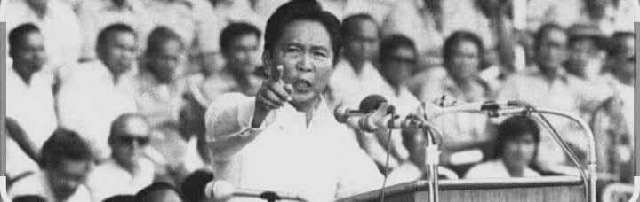
Even before the declaration of Martial Law, corruption had already taken root in Philippine politics as a cultural and systemic norm. During the Commonwealth and early Republic periods, public office was often seen as an opportunity for personal or political gain rather than as a position of public trust. The Filipino values of utang na loob (debt of gratitude) and pakikisama (smooth interpersonal relations) shaped political behavior, which fostered patron-client relationships between politicians and constituents.

By the 1960s, scholars and media critics were raising concerns about inefficiency and corruption in pork barrel allocations, noting that projects were often chosen for political gain rather than public need (Abueva, 1965; Corpuz, 1989). Citizens came to expect legislators to deliver local projects or personal favors in exchange for electoral support, while politicians viewed these acts as necessary for maintaining loyalty and survival. This reciprocal relationship blurred the line between service and self-interest, which sets corruption within everyday governance practices.
Over time, this mindset created a culture of tolerance toward corruption, where the misuse of public funds was rationalized as part of the political process. As a result, early pork barrel allocations not only shaped policy but also strengthened values and expectations that normalized the trading of public resources for personal or partisan advantage.

DEVELOPMENT OVERTIME

A. Martial Law Era (1972–1986)
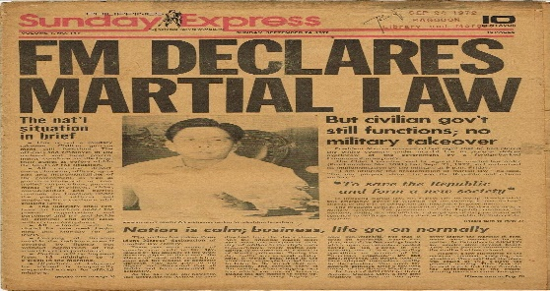
The declaration of Martial Law in 1972 temporarily stopped congressional pork barrel, as legislative powers were absorbed by the executive . Public spending became concentrated under the Office of the President, with discretionary allocations controlled directly by Ferdinand Marcos.

In 1982, the Support for Local Development Projects (SLDP) was introduced
sept 24, 1972 Project Gunita, newspaper ed/declaration-of-martial-law/; Archived from the original.
in the General Appropriations Act, which revived lump-sum allocations for legislators. Each assemblyman received ₱500,000 for infrastructure and social projects, but access depended on presidential approval (PIDS, 2006; IBON Foundation, 2013). This arrangement strengthened legislators’ dependence on the President, since their capacity to deliver projects depended on demonstrating loyalty to the regime.
The SLDP broadened pork barrel spending beyond “hard” projects like roads and bridges to include “soft” projects such as education, health, and livelihood programs. While presented as local development aid, the mechanism established patronage politics, with funds serving as instruments of control and reward (Nograles & Lagman,2013;Chu&Cruz,2013).
By centralizing discretionary funds and tying them to political loyalty, the Marcos administration reshaped the pork barrel into a tool of authoritarian governance. This period marked a turning point, rooting corruption into state operations and conditioning both politicians and citizens to view public resources as instruments of patronage rather than collective development.

Post-Martial Law Era
B. Corazon Aquino Administration (1986–1992)
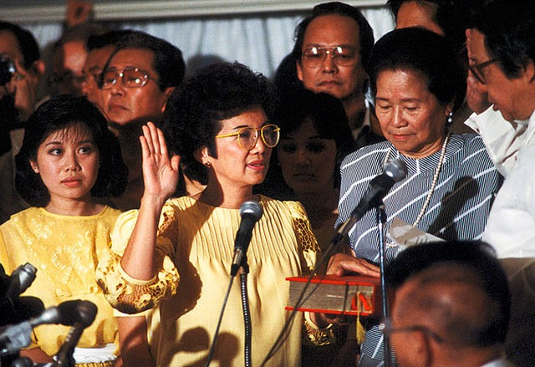
Following the 1986 EDSA People Power Revolution and the restoration of democracy, congressional pork barrel was revived through the Mindanao Development Fund and Visayas Development Fund, with lump-sum appropriations of ₱480 million and ₱240 million in 1989. Responding to demands from senators and Luzon legislators, the Countrywide Development Fund (CDF) was created in the 1990 national budget, initially allocated ₱2.3 billion for small-scale infrastructure and community projects (Ilagan,2013;Republic Act No. 6831,1989).
https://share.google/images/s9xyGhPfqFZex7s2L

By 1991–1992, CDF funds were released directly to implementing agencies with presidential approval, subject to submission of legislator-identified project lists (Republic Act No. 7078,1991;Republic Act No.7180,1992). Reports indicate that by 1992, representatives received ₱12.5 million each and senators ₱18 million each, with no restrictions on project type. Legislators could identify both “hard” projects (roads, bridges, buildings) and “soft” projects (textbooks, medicines, scholarships). These developments formalized pork barrel as a regular budgetary mechanism, which strengthened patron-client politics by allowing legislators to use funds to strengthen electoral support (Chua & Cruz 2013).

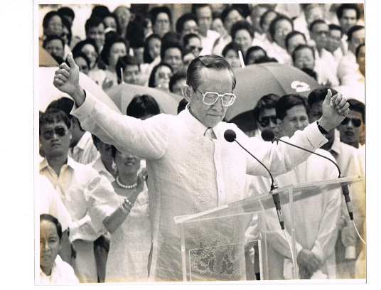
C. Fidel Ramos Administration (1992–1998)
Under President Fidel V. Ramos, the 1993 General Appropriations Act (GAA) explicitly required legislators to submit project lists before funds were released. For the first time, the Vice President also received an allocation of ₱20 million, while representatives and senators continued to receive ₱12.5 million and ₱18 million, respectively.
https://share.google/images/dfVjoEF6cm581vCN8

From 1994 to 1996, GAAs retained these provisions,(Republic Act No. 7663,1994,7845,1995,1874,1996) with the Department of Budget and Management (DBM) directed to report fund releases to Congress. In 1997, legislators were required to submit 50% of their project list at the start of the year and the remaining 50% within six months, with DBM publication serving as the basis for fund release (Republic Act No. 8250,1997). By 1998, publication was no longer required, though submission of project lists remained mandatory (Republic Act No. 8522,1998).
Beyond the CDF, other discretionary allocations known as Congressional Insertions (CIs) were inserted in the budget. These included the DepEd School Building Fund, Public Works Fund, El Niño Fund, and Poverty Alleviation Fund. Legislators exercised influence over how, where, and when these funds were spent, which made them harder to monitor and reinforcing political patronage.

D. Joseph Estrada Administration (1998–2001)
In 1999, the CDF was abolished and replaced with three separate CIs: the Food Security Program Fund, Lingap Para Sa Mahihirap Program Fund, and Rural/Urban Development Infrastructure Program Fund. Each required prior consultation with legislators before release (Republic Act No. 8745,1999).
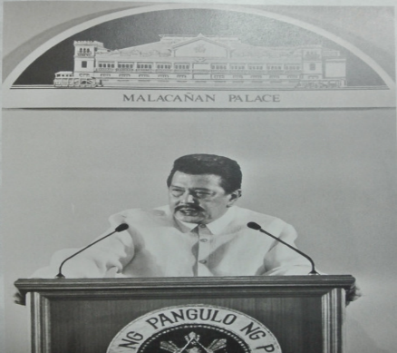
In 2000, the Priority Development Assistance Fund (PDAF) was introduced. PDAF provisions required consultation with district representatives before funds were released to implementing agencies. Realignment across expense categories was permitted, provided allocations were not used for personal services or personnel benefits (Republic Act No. 8760,2000). These provisions were carried over into 2001 through the re-enacted 2000 GAA (1987 Philippine Constitution ,Art VI sec. 25 7).
The Estrada years marked the transition from CDF to PDAF, placing discretionary allocations more deeply into the budget process. Legislators keep broad discretion in project identification, which continued the patronage dynamic established in earlier administrations.
https://share.google/images/s9xyGhPfqFZex7s2L

E. Gloria Macapagal-Arroyo Administration (2001–2010)
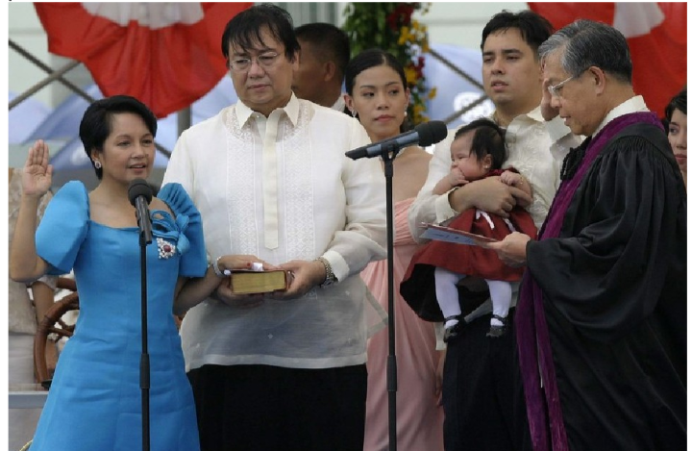
During President Gloria Macapagal-Arroyo’s term, the Priority Development Assistance Fund (PDAF) continued as the primary pork barrel mechanism.
The 2002 PDAF provision was brief, directing funds to be released directly to implementing agencies or local government units without further qualifications (Republic Act No.9162, 2002). In 2003, the same provision was retained, with expanded purposes and express authority for realignment. However, the budgets of the Department of Public Works and Highways (DPWH), and the Department of Education (DepEd) (Republic Act 9206,2003) required prior consultation with legislators for project implementation and list submission. The 2003 GAA was re-enacted in 2004,
https://share.google/images/dfVjoEF6cm581vCN8

maintaining these provisions (Philippine Supreme Court,2013).
In 2005, PDAF was explicitly tied to the government’s “ten-point agenda” and introduced the program menu concept—a list of general programs and implementing agencies from which legislators could select projects (Republic Act No 9336,2005). This framework was carried forward in the re-enacted 2006 budget (Philippine Supreme Court,2013) and consistently integrated into the GAAs of 2007 (Republic Act No. 9401,2007) ,2008 (Republic Act No. 9498,2008), 2009 (Republic Act No. 9524,2009), and 2010 (Republic Act No. 9970,2010).
Although PDAF articles from 2002 to 2010 were silent on specific allocations for individual legislators, provisions under the DepEd School Building Program and DPWH budget continued to require consultation with members of Congress (Philippine Congress,2005,2007).
Significantly, this period also formalized the participation of non-governmental organizations (NGOs) in project implementation. In the 2006 Supplemental Budget, ₱250 million of the ₱500 million for school buildings was earmarked for NGOs, including the Federation of Filipino-Chinese Chambers of Commerce and Industry’s Operation Barrio School program. Similar allocations were made in the 2007 and 2009 GAAs (Rollo G.R No. 208566,n.d). In 2007, the Government Procurement Policy Board (GPPB) (Government Procurement Policy Board[GPPB],2013), issued Resolution No. 12-2007 (Government Procurement Policy Board [GPPB],2007), amending procurement rules to allow negotiated agreements with NGOs (Philippine Congress,2003), when appropriations specifically earmarked funds for them (Philippine Congress 2011).
developments expanded the pork barrel beyond legislators, which embedded NGOs into the system. While framed as participatory governance, the arrangement opened new avenues for misuse, later exposed in scandals involving fake NGOs and ghost projects.

F. Benigno “Noynoy” Aquino III (2010-2016)

Clear Allocations and Expanded PDAF Use
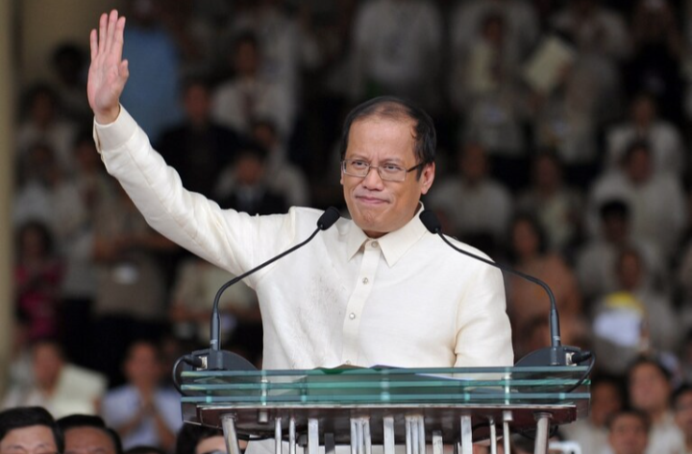
Under the succeeding administration, PDAF allocations became more explicit. The 2011 GAA specified lump-sum amounts: ₱70 million per representative (₱40 million for “hard” projects and ₱30 million for “soft” projects), and ₱200 million each for senators and the Vice President, evenly split between hard and soft projects. Realignment was permitted only once, with
https://share.google/images/45maprRjX1eAX4cCX

additional authority granted to cabinet secretaries to realign within project categories, subject to legislator concurrence (Philippine Congress,2011).
The 2012 and 2013 PDAF provisions required project identification to conform to agency-prepared priority lists (Philippine Congress,2012a,20212b). In practice, however, legislators retained discretion to choose projects from these lists (TSN,2013). Allocations for legislators remained, but the Vice President’s ₱200 million share was removed (Philippine Congress,2012a,2012b). The 2013 PDAF also allowed local government units (LGUs) to serve as implementing agencies if they had technical capacity. Legislators could identify projects outside their districts, provided they secured written concurrence from the district’s representative and endorsement from the Speaker of the House (Philippine Congress,2012b).
Realignments, modifications, and fund releases required approval from the House Committee on Appropriations or the Senate Committee on Finance. These provisions reinforced legislative influence over discretionary funds, while expanding the scope of PDAF to include LGUs and cross-district projects (Philippine Congress, 2012b).

2013 PDAF Scandal and Public Outrage
In 2013, a massive corruption scandal involving the "pork-barrel" system, known as the "PDAF Scandal," marked a crisis point for the country's legislative discretionary funds. The COA’s special audit (Report No. 2012-03) covering 2007-2009 revealed massive misuse of PDAF and VILP (Various Infrastructures including Local Projects): reports found project implementation outside legislator districts, infrastructure built on private lots, funds transferred to NGOs without competitive bidding or accountability.
The scam was first exposed in the Philippine Daily Inquirer by Nancy C. Carvajal on July 12, 2013 identifying Janet Napoles as the mastermind of the scam and allegedly in conspiracy with several lawmakers including the Senators and Congressman (Carvajal, 2013). The Philippine Commission on Audit (COA) reported that the scam involved almost ₱10 billion (about USD 230 million). Several well known senators , such as Juan Ponce Enrile, Jingoy Estrada , and Bong Revilla , were linked to the scheme , showing how deeply corruption exists within the country’s top leaders. The scandal also highlighted the weaknesses of The Philippines Anti-corruption agencies, especially the Office of Ombudsman and COA. Even though these offices were important in exposing the fraud, the work was held back by lack of resources, limited power to prosecute, and ongoing political pressure problems that go against the main principles of 2012 Jakarta Statement on Principles for Anti-corruption Agencies.
Public outrage erupted—in August 2013 the historic “Million People March” showed public anger at widespread corruption. It reveals that corruption was deeply rooted in politics. Pork barrel funds were no longer viewed as tools for development but as a way to reward loyalty, which turned public money into patronage.The involvement of important lawmakers greatly damaged the Public’s trust in both the legislative and executive branches of the government, as they saw corruption was not just a few cases of misconduct but part of a wider culture of governance. The Commission on Audit (2012) and IBON Foundation (2013) noted that the PDAF scandal revealed how corruption had become normal in practice, which shaped public perception that misuse of funds was widespread and systemic.

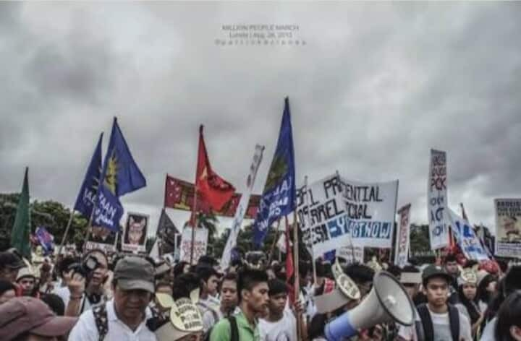
Post-PDAF Developments (2014–2016)
After the 2013 PDAF scandal, prosecutions continued against lawmakers implicated in Janet Lim Napoles’s scheme. In June 2014, the Ombudsman filed graft and plunder cases in the Sandiganbayan against Senators Juan Ponce Enrile, Jinggoy Estrada, and Bong Revilla. Enrile,
https://share.google/images/ru6WzvCtAeaYL9W7

accused of receiving ₱172.8 million in kickbacks, faced 15 counts of graft; Estrada, accused of taking ₱183.793 million, faced 11 counts; and Revilla, accused of obtaining ₱224.5 million, faced 16 counts. Enrile’s former aide, Gigi Reyes, was charged with plunder for helping direct pork barrel funds to fake foundations (PCIJ, 2014; Ombudsman, 2015; Sandiganbayan, 2015).
The PDAF scandal, commonly referred to as the pork barrel scam, exposed how billions of pesos in discretionary funds were diverted to bogus NGOs, revealing the misuse of public resources for personal gain (Wikipedia; Silliman University). Following widespread public outrage and investigative efforts, the Supreme Court ruled in 2013 that PDAF was unconstitutional, which marked a significant legal victory against systemic corruption (Wikipedia).
Meanwhile, in 2014, the Philippine Center for Investigative Journalism ruled on the Disbursement Acceleration Program (DAP), declaring certain executive acts unconstitutional and limiting unchecked discretion over public funds (Philippine Internet Freedom Alliance v. Executive Secretary et al., G.R. No. 203518, 2014). While these legal actions represented progress in formal accountability, public reactions reflected continued skepticism: surveys indicated persistent distrust in institutions responsible for anti-corruption enforcement, and it highlighted the enduring challenge of restoring public confidence in governance (Philippine Law Journal, 2025).
In 2016, the Panama Papers further heightened awareness of corruption in the Philippines. The leaks exposed offshore financial activities of Philippine elites, including politically connected individuals, which strengthened the perception that corruption was systemic and not limited to high-profile scandals like PDAF (ICIJ, 2016; GMA News, 2016). Media coverage fueled debates on transparency and accountability, it highlighted risks associated with concealed wealth, tax avoidance, and potential misuse of public funds. The revelations further deepened public inspection of government officials and reinforced the perception of long-established corruption in political and financial systems.

F. Duterte Administration (2016-2021)
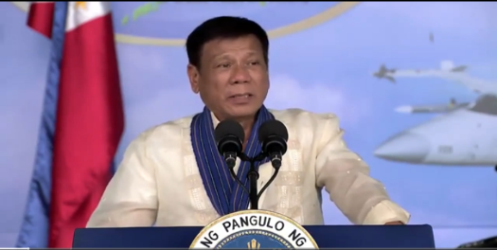
During Duterte’s presidency, corruption events continued amid high-profile rhetorics. Investigations and prosecutions were selective, with some cases pursued strongly while others were blocked or ignored, which resulted in the perception of politically biased enforcement (Focus on the Global South, 2019).
https://eastasiaforum.org/2025/02/25/dutertes-impeachment-and-the-spectacle-of-philippine-politics/
https://eastasiaforum.org/2025/02/25/dutertes-impeachment-and-the-spectacle-of-philippine-politics/

Procurement anomalies became a major corruption issue. The “Build, Build, Build” infrastructure program experienced numerous exemptions, including contracts lacking proper documentation, irregular bidding, and questionable allocations (COA, 2019; Inquirer, 2021; Senate Resolution, 2019). Moreover, during the COVID-19 pandemic, emergency procurement for medical supplies and protective equipment revealed additional risks. COA audits and civil society monitoring highlighted overpricing, advance payments without oversight, and favoritism in awarding contracts (UNAFEI, 2021; G-Watch, 2020).
Public trust during this period reflected citizens’ reactions to these corruption events. Surveys and studies indicated that confidence in institutions remained weak: Filipinos viewed enforcement as inconsistent and procurement systems as prone to misuse (Brillantes & Fernandez, 2014; Asian Journal of Criminology, 2024). Conditional trust was observed—citizens acknowledged tangible infrastructure developments but remained cautious of patronage, rent-seeking, and the slow pace of legal accountability.

PRESENT SITUATION

Marcos Jr. Administration (2022-Present)

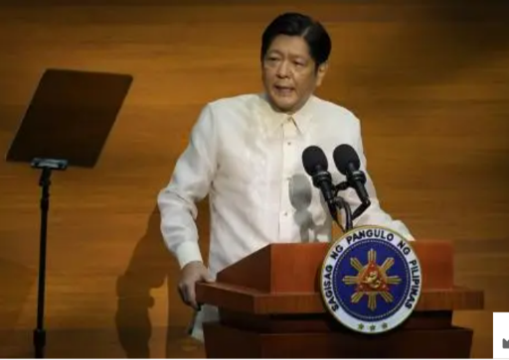
When Ferdinand Marcos Jr. assumed office in 2022, he pledged a transparent and accountable government, promising to move away from past corruption scandals and restore public confidence in state institutions. His administration emphasized fiscal discipline and responsible use of public funds. However, early inspection from watchdog groups revealed vulnerabilities in procurement processes and discretionary spending, with analysts warning that the administration’s expansive budget programs risked repeating past abuses (Straits Times, 2022). These early signals indicated governance challenges that would escalate in the following years.
https://share.google/images/0Vm02FqnzaI3i2jlN

Confidential Funds Controversy and Impeachment Issues

By 2023, the confidential funds controversy became one of the most contentious corruption issues under the Marcos Jr. administration. The Department of Education admitted it could not explain how ₱112 million in confidential funds was spent (GMA News, 2023), while the Office of the Vice President reportedly utilized over ₱375 million without detailed liquidation reports (Inquirer, 2023). These revelations triggered national debate and congressional inspections. In 2024, a second impeachment complaint against Vice President Sara Duterte was filed, alleging unconstitutional and unaccountable spending of confidential funds. Hearings exposed unclear guidelines, poor documentation, and opportunities for discretionary misuse, fueling public frustration over weak accountability mechanisms (PNA, 2024).

Infrastructure Corruption and the Flood-Control Scandal

From late 2024 to 2025, corruption allegations in flood-control projects evolved into one of the most explosive scandals of the Marcos Jr. era. Former DPWH officials testified that at least five senators were involved in kickback schemes that diverted large portions of infrastructure budgets to politicians (Manila Times, 2025; Inquirer, 2025). Senate inquiries, whistleblower testimonies, and extensive media timelines revealed systemic manipulation of project allocations, contractor favoritism, and the use of ghost or substandard projects—confirming deep-rooted vulnerabilities in infrastructure spending (ABS-CBN, 2025). This scandal severely damaged public confidence in government capacity to deliver essential disaster-mitigation infrastructure.

Persistence of Pork-Barrel Practices

Although the Priority Development Assistance Fund (PDAF) was abolished in 2013, subsequent years revealed that pork-barrel corruption did not disappear—it merely evolved. Critics pointed out that new mechanisms, such as Unprogrammed Appropriations (UA) and other discretionary budget methods, allowed officials to control large sums with limited transparency (Philstar). Analysts argued that these “standby funds” functioned similarly to the old pork-barrel system, enabling political favoritism and potential fund misuse (Politiko). Former Senate President Franklin Drilon warned that approximately ₱731.4 billion in the 2024–2025 national budget represented an “unchecked pork barrel” concealed within various allocations (Philstar). Budget watchdogs also noted that the proposed 2026 national budget continued to include pork-style funds, including expanded UA and discretionary allocations (GMA Network). These developments indicated that pork-barrel practices persisted through rebranded mechanisms that lacked clear monitoring and transparency.
Building on these structural issues, reports later estimated that at least ₱695.78 billion in “allocables” allowed lawmakers to nominate contractors and receive kickbacks—amounting to ₱230 million per congressman and ₱3.2 billion per senator (Philstar, 2025). The expansion of Unprogrammed Appropriations from ₱158 billion to ₱243 billion during budget deliberations was denounced as a “presidential blank check,” granting the DBM broad discretion to realign funds without detailed justification (Philstar, 2025). These practices further intensified public perceptions of entrenched corruption in Congress, particularly under Speaker Martin Romualdez (Palawan News, 2025).

Public Outrage, Mass Protests, and Social Mobilization
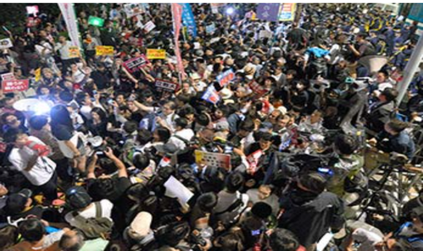
Public anger reached a peak in 2025 when tens of thousands participated in the nationwide “Trillion Peso March,” sparked by revelations that billions intended for flood-control efforts were stolen or never used for actual projects (BBC, 2025). Protests intensified after viral displays of extravagant lifestyles by contractors’ children—referred to as “nepo babies”—whose luxury cars, private flights, and lavish spending symbolized the widening gap between corrupt elites and ordinary
https://share.google/images/8IhJFQ0HO65v6TzDE

Filipinos. Stories like that of teacher Crissa Tolentino, who paddled through flooded streets while undergoing cancer treatment, fueled outrage and demands for justice, asset recovery, and systemic reforms.

Civil Society Critiques and Systemic Corruption Problems

Civil society organizations emphasized that the corruption scandals were not isolated but reflective of a broader, entrenched system. The IBON Foundation argued that Marcos Jr. remained complicit by allowing pork-barrel allocations to flow through the budget process in exchange for political loyalty. They also criticized the administration’s failure to address other corruption vectors, such as confidential funds, tax evasion, and regulatory capture (Inquirer, 2025). COA reports remained delayed and incomplete, prosecutions were rare, and impunity among powerful officials persisted. Public participation in governance was limited, while critical NGOs faced judicial harassment—further weakening accountability (IBON Foundation, 2025).

Emergency Spending, Disaster Governance, and Calls for Vigilance

The declaration of a national calamity after Typhoon “Tino” in 2025 exposed risks in emergency spending. Over ₱500 billion in funds became available, but implementation slowed as government workers feared being implicated in corruption investigations. Former DBM officials warned that projects might spill over into 2026 because of bureaucratic caution and ongoing probes. In response, lawmakers such as Chel Diokno called for strict oversight measures, including independent audits, public reporting of negotiated contracts, local government participation, and sunset clauses to prevent the misuse of emergency powers (Daily Tribune, 2025). These recommendations highlighted the need for transparency even in urgent relief operations.

Continuing Erosion of Public Trust

By 2025, the combined impact of the confidential funds controversy, pork-barrel insertions, infrastructure kickback schemes, and weak oversight mechanisms significantly eroded public trust in government. The Philippines’ stagnation in global governance rankings reinforced this sentiment, with the country scoring only 33 out of 100 and ranking 114th in the 2024 Corruption Perceptions Index (Transparency International, 2025; BusinessWorld, 2025). Although Marcos Jr. publicly vowed to “cleanse the ranks of government,” public skepticism persisted—intensified by high-profile acquittals of figures implicated in past corruption cases. The administration continued to face widespread calls for accountability, transparency, and structural reform, as corruption remained deeply entrenched across institutions.

ANALYSIS AND DISCUSSION
Evolution of the Pork Barrel System

The study reveals that the pork barrel system in the Philippines has been a continuously evolving mechanism across administrations. It began with the Public Works Act of 1922 (Act No. 3044), which allowed legislators to influence local public works projects (Querubin, 2016). During Martial Law, the study shows that Marcos centralized control through the Special Infrastructure Fund, giving the executive significant power over the release of funds and increasing legislators’ dependence on presidential approval (Diaz, 2018). After 1986, the Countrywide Development Fund (CDF) restored congressional participation under President Aquino, and later, the Priority Development Assistance Fund (PDAF) formalized legislators’ role in proposing local projects during the Estrada and Arroyo administrations.

The study shows that despite changes in name, structure, or implementing rules, the underlying function of discretionary funds—political control and patronage—remained intact.

Culture of Corruption

The study shows that the pork barrel system contributed to a persistent culture of corruption by creating predictable pathways for fund misuse. The flowchart of discretionary allocations demonstrates how funds flowed from national agencies to legislators, local projects, and sometimes NGOs, with corruption occurring at multiple points. From Pre‑Martial Law discretionary funds to CDF and PDAF, legislators were able to direct funds for political or personal advantage, often without proper auditing or accountability (PIDS, 2006; IBON Foundation, 2013).

The study reveals that even after PDAF was abolished, new mechanisms such as Unprogrammed Appropriations allowed the same patterns of patronage and fund misuse to continue.

The 2013 PDAF Scandal

The study shows that the 2013 PDAF scandal was a critical event revealing the scale of systemic corruption. COA audits exposed ghost projects, fake NGOs, and billions of pesos diverted from intended purposes, implicating multiple legislators and government agencies (COA, 2013). The study reveals that this scandal triggered a shift in public perception, as ordinary citizens recognized that what was previously tolerated as routine political practice had become unacceptable. Mass mobilizations like the Million People March demonstrated public insistence on accountability.

The study also shows that history repeated itself with the 2025 Trillion-Peso March, reflecting that although PDAF was abolished, discretionary fund abuse continued under new labels.

Declining Public Trust

The study reveals that public trust in government has steadily declined over the decades as discretionary funds were repeatedly misused. The study shows that early irregularities in CDF and PDAF allocations, combined with recurring scandals and new mechanisms like Unprogrammed Appropriations, reinforced perceptions of systemic corruption. Citizens’ participation in mass protests, such as the Trillion-Peso March, indicates that public trust erodes not because of single events but due to repeated patterns of governance failure.

Filipino Responses and Calls for Accountability

The study shows that despite systemic corruption, Filipinos have actively mobilized to demand accountability. Civic organizations, investigative media, and public protests demonstrate social resilience and engagement. Events such as the Million People March (2013) and Trillion-Peso March (2025) illustrate that citizens continue to challenge corruption, expose wrongdoing, and demand transparency (IBON Foundation, 2013; Philippine Center for Investigative Journalism, 2014).

CONCLUSION

RECOMMENDATIONS

REFERENCES

Morris, S. D. (1991). Corruption and politics in contemporary Mexico. University of Alabama Press. https://en.wikipedia.org/wiki/Corruption

Transparency International. (2025). Corruption Perceptions Index 2024/2025. https://www.transparency.org/en/cpi/2024

Inquirer. (2013). The Supreme Court declares PDAF unconstitutional. Philippine Daily Inquirer. https://newsinfo.inquirer.net/530223/sc-declares-pdaf-unconstitutional

Department of Budget and Management. (2016). Budget process. https://en.wikipedia.org/wiki/Janet_Lim-Napoles

Silliman Journal. (2019). Title of relevant article. Silliman University. https://sillimanjournal.su.edu.ph/index.php/sj/issue/archive/2

Wikipedia. (2023). Million People March. Note: While Wikipedia can be a starting point, it's best to find more authoritative sources for academic writing. https://en.wikipedia.org/wiki/Million_People_March

Berg, B. L., & Lune, H. (2017). Qualitative research methods for the social sciences (9th ed.). Pearson Education. https://www.vitalsource.com/products/qualitative-research-methods-for-the-social-howard-lune-bruce-l-berg-v9780134416229

Given, L. M. (Ed.). (2008). The Sage encyclopedia of qualitative research methods. Sage Publications. https://sk.sagepub.com/ency/edvol/research/toc#_

Elo, S., & Kyngäs, H. (2008). The qualitative content analysis process. Journal of Advanced Nursing, 62(1), 107–115. https://doi.org/10.1111/j.1365-2648.2007.04569.x

Krippendorff, K. (2018). Content analysis: An introduction to its methodology (4th ed.). Sage Publications. https://books.google.com.ph/books/about/Content_Analysis.html?id=nE1aDwAAQBAJ&redir_esc=y#:~:text=Content%20Analysis:%20An%20Introduction%20to,Methodology%20%2D%20Klaus%20Krippendorff%20%2D%20Google%20Books

Fogel, R. W. (1790-1870). The Industrial Revolution in the United States: SSRN. https://papers.ssrn.com/sol3/papers.cfm?abstractid=5455865

Maxey, C. C. (1919). Pork barrel. In Wikipedia. Retrieved September 9, 2025, from https://en.wikipedia.org/wiki/Pork_barrel

Library of Congress. (2010). National Book Festival history: Past festivals.
https://www.loc.gov/programs/national-book-festival/history/past-festivals/2010/

Philippine Legislature. (1922, March 8). Public Works Act of 1922, Act No. 3044. Supreme Court E-Library.
https://elibrary.judiciary.gov.ph/thebookshelf/showdocs/28/55191

Corpuz, (1989); IBON Foundation, (2013); Department of Budget and Management, (2016); USAID, (2010); GMA News, (2013).
https%3A%2F%2Fwww.seaanticorruption.org%2F2025%2F04%2F29%2Fpork-barrel-scam-philippines%2F&h=AT0nwb0RkFavoRN2BfXTPFoi8n9-MZB-Uuft1zB-x5klMuN0pKhFxLZiMeVL_6fZVcvpiNSrsTsWwbPlSTnYn7wZM7ok2Y5Y0C4XEubmyWUtX1yiAw1gb1AFwjo5p_16uSh8KhFDGEWHaWo&s=1

Philippine Legislature. (1950, June 9). Public Works Act of 1950, Republic Act No. 472. Supreme Court E-Library.
https://elibrary.judiciary.gov.ph/thebookshelf/showdocs/2/12100

Philippine Institute for Development Studies. (2006). Annual report.
https://pidswebs.pids.gov.ph/CDN/ANNUALREPORTS/ATTACHMENTS/pidsar2006.pdf

IBON Foundation. (2013). Philippine Institute for Development Studies. Annual report 2006. https://pids.gov.ph/details/empty-plate-lunchbreak-protest-highlights-demand-for-living-wage

CenPEG. (2012, October 3). Election 2013: Horizontal and vertical expansion of political dynasties. Issue Analysis No. 08 Series of 2012. https://www.cenpeg.org/post/election-2013-horizontal-and-vertical-expansion-of-political-dynasties

Abueva, J. V. (1965) & Corpuz, O. D. (1989). Various works.
https://papers.ssrn.com/sol3/papers.cfm?abstract_id=4861660

Supreme Court of the Philippines. (2013, November 19). Greco Antonious Beda B. Belgica, Jose M. Villegas, Jr., Jose L. Gonzalez, Reuben M. Abante, and Quintin Paredes San Diego v. Hon. Executive Secretary Paquito N. Ochoa, Jr., Secretary of Budget and Management Florencio B. Abad, National Treasurer Rosalia V. De Leon, Senate of the Philippines, and House of Representatives [G.R. Nos. 208566, 208493, 209251]. Supreme Court E-Library. https://elibrary.judiciary.gov.ph/thebookshelf/showdocs/1/56517#:~:text=Examples%20of%20these%20CIs%20are,appropriations%20were%20to%20be%20spent

Commission on Audit (COA). (2012). Press Statement on Special Audit Report No. 2012-03: Priority Development Assistance Fund (PDAF) and Various Infrastructures Including Local Projects (VILP).
https://www.coa.gov.ph/wpfd_file/press-statement-on-special-audit-report-no-2012-03-priority-development-assistance-fund-pdaf-and-various-infrastructures-including-local-projects-vilp/

Wikipedia. (2013). Gezi Park protests. Retrieved from https://en.wikipedia.org/wiki/Gezi_Park_protests

Commission on Audit (COA). (2012). Annual Report.
https://www.coa.gov.ph/2013/

Department of Social Welfare and Development (DSWD). (2013, October 1). DSWD clarifies IBON Foundation's claim of corruption in CCT.
https://old.dswd.gov.ph/dswd-clarifies-ibon-foundations-claim-of-corruption-in-cct/

Inquirer News. (July 12, 2013). NBI probes P10-B scam.
https://newsinfo.inquirer.net/443297/nbi-probes-p10-b-scam

Carvajal, N. C. (2013, July 12). PDAF Scam Exposé (Parts 1-6). Philippine Daily Inquirer. https://en.wikipedia.org/wiki/Pork_barrel_scam

United Nations Office on Drugs and Crime (UNODC). (2012). Jakarta statement on principles for anti-corruption agencies. https://www.unodc.org/documents/corruption/WG-Prevention/Art_6_Preventive_anti-corruption_bodies/JAKARTA_STATEMENT_en.pdf

Philippine Center for Investigative Journalism. (2014, July 20). The story of DAP. Philippine Center for Investigative Journalism. https://pcij.org/article/2014/the-story-of-dap

Office of the Ombudsman. (2015). Annual report 2015. Office of the Ombudsman. https://www.ombudsman.gov.ph/docs/annualreport/Annual%20Report%202015.pdf

Sandiganbayan. (2015). Decisions and resolutions, 2015. https://sb.judiciary.gov.ph/decisions-2015-2/

Wikimedia Foundation, Inc. (2025, February 23). Silliman University. https://simple.wikipedia.org/wiki/Silliman_University

Philippine Center for Investigative Journalism. (2014, July 20). The story of DAP. https://pcij.org/article/2014/the-story-of-dap

Supreme Court of the Philippines. (2014, July 1). Philippine Internet Freedom Alliance v. Executive Secretary et al., G.R. No. 203518. Supreme Court of the Philippines. Retrieved from LawPhil: https://lawphil.net/judjuris/juri2014/feb2014/gr_203335_2014.html

University of the Philippines College of Law. (2025, July 2). Philippine Law Journal faculty examination committee [Announcement]. UP College of Law. https://law.upd.edu.ph/philippine-law-journal-faculty-examination-committee/

International Consortium of Investigative Journalists. (2016). Panama Papers – Offshore Leaks Database: Philippines. International Consortium of Investigative Journalists. https://offshoreleaks.icij.org/investigations/panama-papers?c=PHL

GMA News Online. (2016, April 5). Solon urges immediate probe of Filipinos implicated in ‘Panama Papers’. GMA News Online. https://www.gmanetwork.com/news/money/companies/561541/solon-urges-immediate-probe-of-filipinos-implicated-in-panama-papers/story/

Focus on the Global South. (2019, May 8). Selective transparency, inconsistent accountability: Unpacking Duterte’s anti-corruption campaign. Focus on the Global South. https://focusweb.org/selective-transparency-inconsistent-accountabilityunpacking-dutertes-anti-corruption-campaign/

Senate of the Philippines. (2019). Resolution citing COA report on NIA contracts. Senate of the Philippines. https://legacy.senate.gov.ph/lisdata/3385030660!.pdf

Philippine Daily Inquirer. (2021, September 16). Corruption scandals under Duterte: From whiff to helplessness. Inquirer News. https://newsinfo.inquirer.net/1488894/corruption-scandals-under-duterte-from-whiff-to-helplessness

Cabatingan, L. I. M. (2021). Corruption – The secondary “pandemic” in the time of COVID, and the challenge of facing dual pandemics. United Nations Asia and Far East Institute (UNAFEI). https://www.unafei.or.jp/publications/pdf/GG16/23_GG16_CP12_Philippines.pdf

Government Watch (G-Watch). (2020, July 6). How vulnerable are COVID-19 procurements to corruption? Government Watch. https://g-watch.org/think-piece/how-vulnerable-are-covid-19-procurements-corruption

Brilliantes, A., & Fernandez, M. (2024, September). Trust in legal institutions: An examination of the Philippines. Asian Journal of Criminology, 19(4), 527–550.
https://www.researchgate.net/publication/384072978_Trust_in_Legal_Institutions_An_Examination_of_the_Philippines
The Straits Times. (2022, July 5). Will Marcos’ war on corruption put an end to ‘pork barrel’ scandals or be his undoing? The Straits Times. https://www.straitstimes.com/asia/se-asia/will-marcos-war-on-corruption-put-an-end-to-pork-barrel-scandals-or-be-his-undoing

GMA News Online. (2024, September 2). DepEd unaware of how liquidated ₱112M 2023 confidential fund was used. GMA News Online. https://www.gmanetwork.com/news/topstories/nation/919003/deped-unaware-of-how-liquidated-p112-million-2023-confidential-fund-was-used/story/

Philippine Daily Inquirer. (2024, December 2). OVP spent over ₱375M in confidential funds in 2023 — COA. Inquirer News. https://newsinfo.inquirer.net/2011615/ovp-spent-over-p375m-in-confidential-funds-in-2023-coa

Philippine News Agency. (2024, December 4). 2nd impeachment complaint vs. VP Sara filed in House. Philippine News Agency. https://www.pna.gov.ph/articles/1239313

The Manila Times. (2025, November 14). Former DPWH official links 5 former, incumbent senators to flood control fund scandal. The Manila Times. https://www.manilatimes.net/2025/11/14/news/former-dpwh-official-links-5-former-incumbent-senators-to-flood-control-fund-scandal/2223914

Philippine Daily Inquirer. (2025, November 14). Bonoan, Cabral operated kickback system in DPWH – Ex-Usec. Bernardo. Inquirer News. https://newsinfo.inquirer.net/2140029/bonoan-cabral-operated-kickback-system-in-dpwh-ex-usec-bernardo

ABS-CBN News. (2025, September 11). A timeline of the Philippine flood control scandal. ABS-CBN News. https://www.abs-cbn.com/news/nation/2025/9/11/a-timeline-of-the-philippine-flood-control-scandal-0600
Persistence of Pork Barrel Practices

Philstar. (2025, October 24). Pork barrel alive in 2026 budget. https://www.philstar.com/headlines/2025/10/24/2482148/pork-barrel-alive-2026-budget

Palawan News. (2025). The history of pork barrel. https://palawan-news.com/the-history-of-pork-barrel-2/ fbclid=IwZXh0bgNhZW0CMTEAc3J0YwZhcHBfaWQPMjc1MjU0NjkyNTk4Mjc5AAEeMFzNhWiJmuTXBPzQeu4vFn6beRoK2gTNfuldYVTAgrCKTbzae4QzGgUObB0_aem_u30scCiHZtuLyPnwgbAufw

GMA Network. (2025, October 15). The Pork Barrel System still remains in the 2026 National Budget bill, minority lawmakers say. YouTube. https://youtu.be/1zQuCRFJfSc?si=P6Gg1KZ4U9KB7PcL

Asia Media Centre. (2025). Flood-Control Corruption and Youth Uprising in the Philippines. https://www.asiamediacentre.org.nz/flood-control-corruption-and-youth-uprising-in-the-philippines

Inquirer. (2025). House bloc warns gov’t pricing system still allows ‘pork’.
https://newsinfo.inquirer.net/2133081/house-bloc-warns-govt-pricing-system-still-allows-pork

IBON Foundation. (2025). PH govt closed and opaque to protect pork barrel. https://www.ibon.org/ph-govt-closed-and-opaque-to-protect-pork-barrel/?tztc=1
Daily Tribune. (2025, November 12). Warning up vs 1-year ‘unli’ pork. https://tribune.net.ph/2025/11/12/warning-up-vs-1-year-unli-pork

Transparency International. (2025). Philippines – Corruption Perceptions Index 2025. https://www.transparency.org/en/countries/philippines

BusinessWorld Online. (2025, February 12). Philippines ranking inches up in global Corruption Perceptions Index. BusinessWorld Online. https://www.bworldonline.com/top-stories/2025/02/12/652702/philippines-ranking-inches-up-in-global-corruption-perceptions-index/

