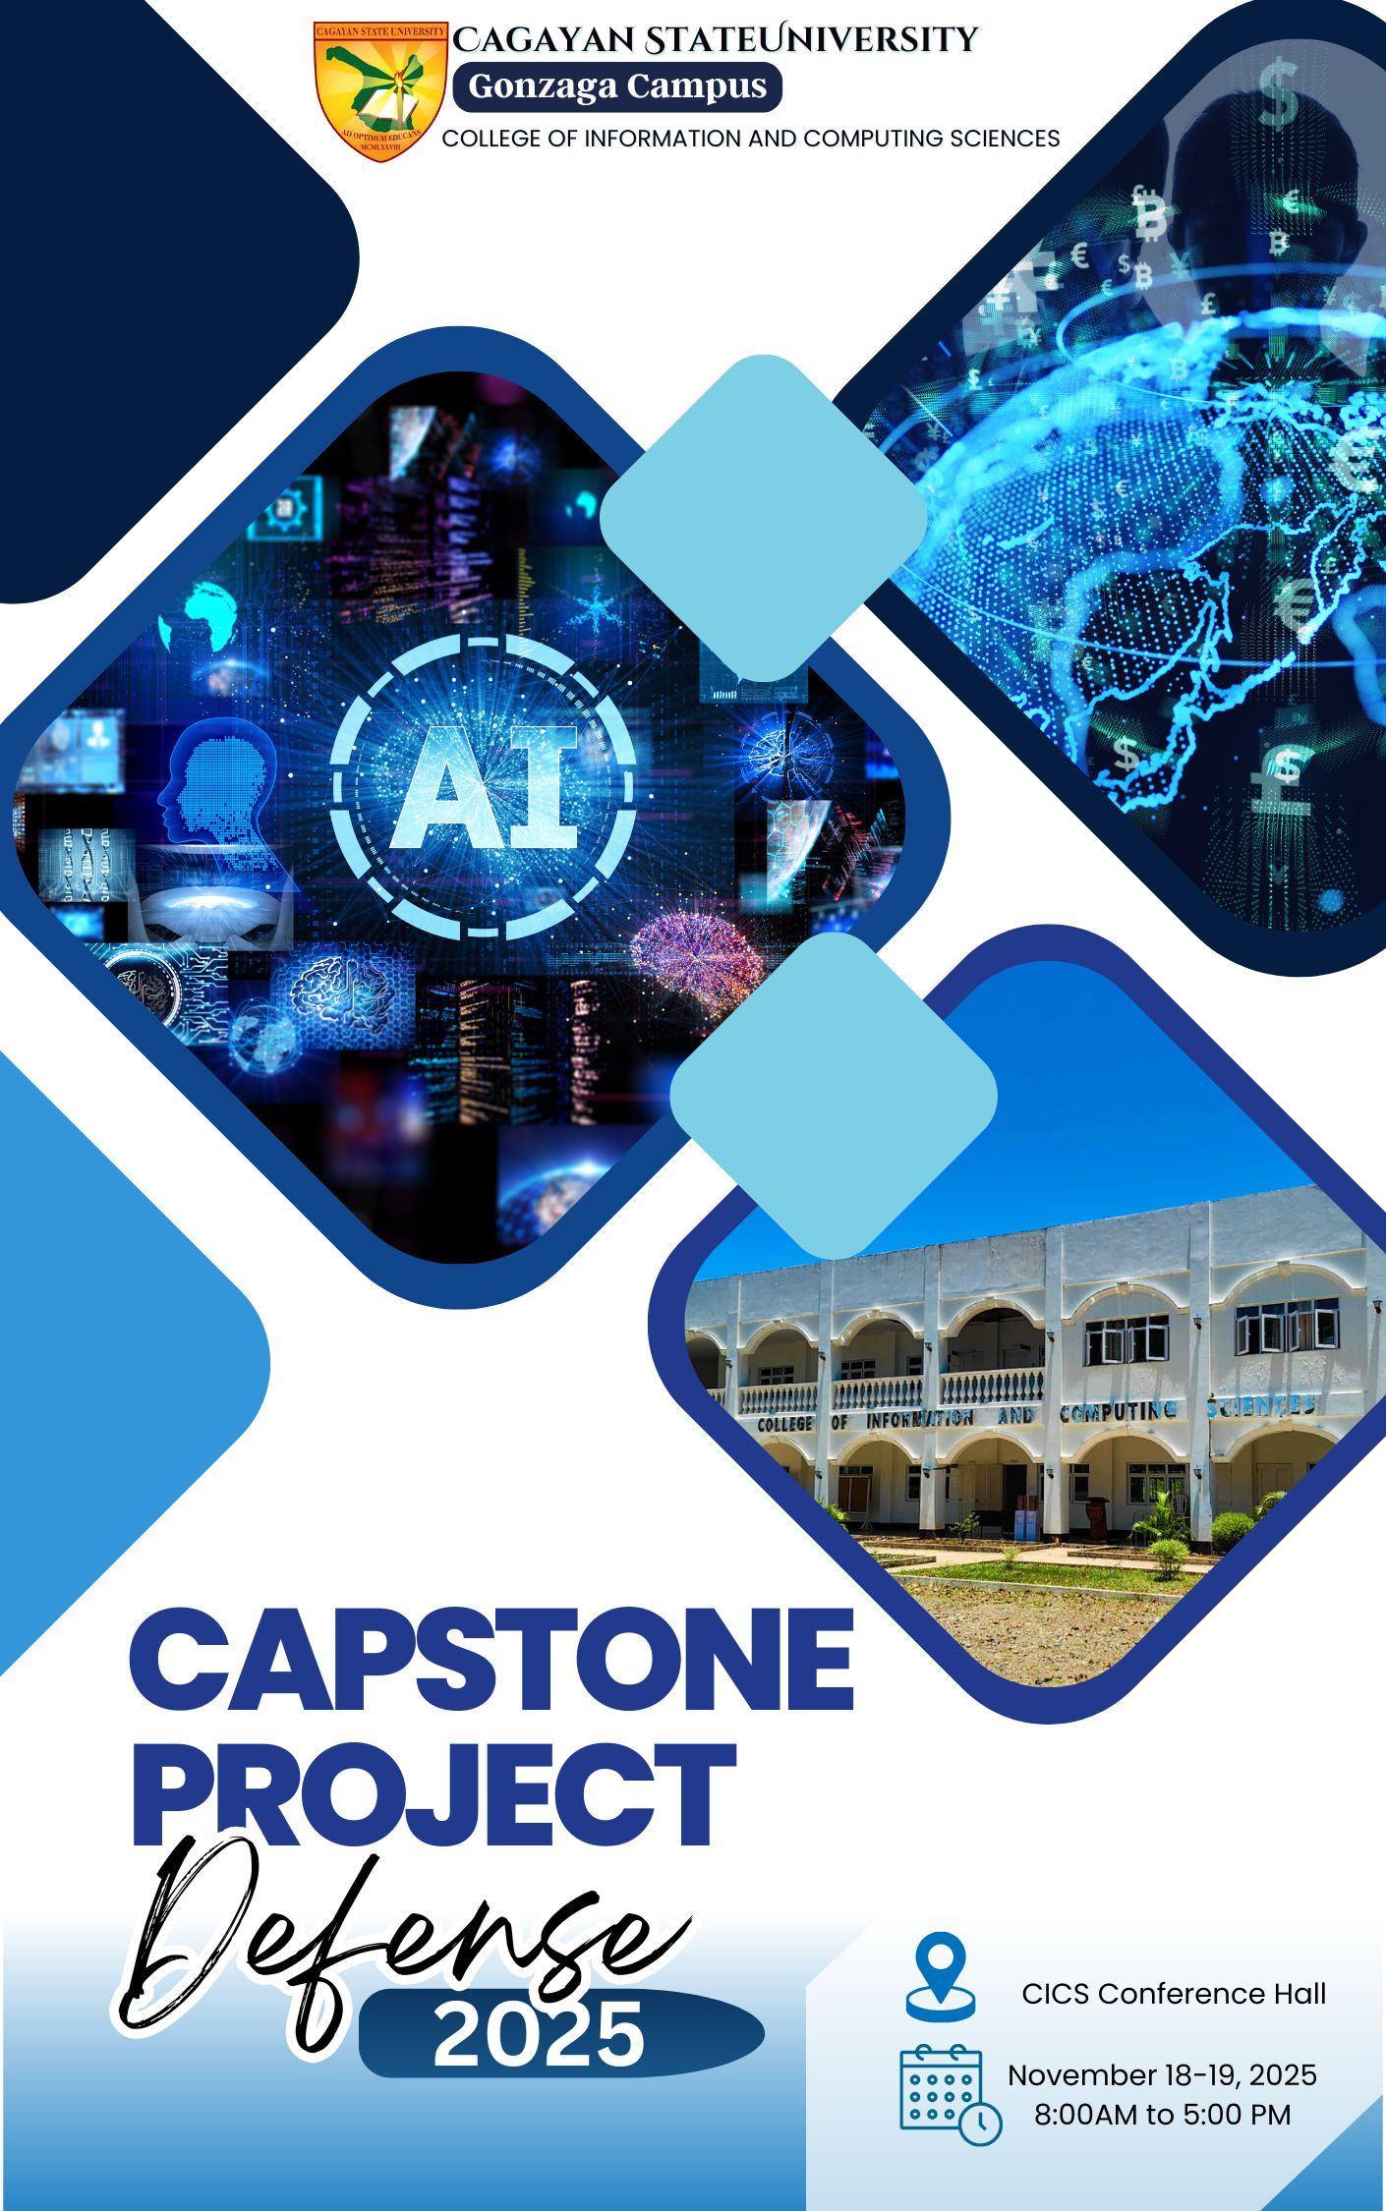

CAPSTONE PROJECT DEFENSE
November 18-19, 2025 || 8:00 am to 5:00pm

PROGRAM
PART I: OPENING PROGRAM
8:00am to 9:00am | Invocation and Nationalism |  | Audio-Visual Presentation
 | Opening Remarks |  | DR. CLYDEN B. ALIBANIA  Campus Executive Officer
 | Rationale and Mechanics of Capstone Project Presentation |  | DR. DOROTHY M. AYUYANG  College Research Coordinator
 | Presentation of Participants and Panel of Evaluators |  | IRISH MICHELLE B. CAGAOAN  College Secretary
PART II: PRESENTATION PROPER
 | Day 01: BSIT 4A
 | Day 02: BSIT 4B
PART III: CLOSING PROGRAM
 |  | Closing Remarks |  | DR. CHARLOT L. MARAMAG  4th Year Adviser

JEAN SEBASTIAN-TORRES
Master of Ceremony

Moderator: Jean Sebastian-Torres
DAY ONE (NOVEMBER 18, 2025)
BSIT 4A
**Note: 15 Minutes per presentation. (10 minutes presentation and 5 minutes Q&A)
NO. | RESEARCH TITLE | PANEL OF EVALUATORS | RESEARCHER
 | TANGQUERY: The CSU-Gonzaga Inquiry Assitance Chatbot | Chair: Verdict L. Gonzales  Members:  Charlot L. Maramag  John Eric S. Santiago  Reader/Critic: Irish Michelle B. Cagaoan  Adviser: Dorothy M. Ayuyang | Zuchini Terei C. Nuñez  Axelehne Mhae L. Palor  Jerald R. Morales  Romelyn C. Padin
 | ASSETS: Automated System for Secured Equipment Tracking Using GPS | Chair: Verdict L. Gonzales  Members:  Charlot L. Maramag  John Eric S. Santiago  Reader/Critic: Irish Michelle B. Cagaoan  Adviser: Dorothy M. Ayuyang | Aivan James M. Ayuyang  Jasper Kent L. Ines  Mark Russel S. Saribay  James Paul T. Cadang
 | PRESS FINDS: A Web-Based Platform for Accessing and Achieving Campus Publication Articles | Chair: Verdict L. Gonzales  Members:  Dorothy M. Ayuyang  Charlot L. Maramag  Reader/Critic: Irish Michelle B. Cagaoan  Adviser: Clyden Charl B. Alibania | Kriszelle Ann R. Gonzales  Carmela Marie R. Calica  Darlene Gwen C. Bautista  Ana Mae C. Ortega
 | TRACKING OF ALUMNI FOR CENTRALIZED EVENT | Chair: Verdict L. Gonzales  Members:  Elmarie Rufina A. Suetos  Jean Sebastian-Torres  Reader/Critic: Irish Michelle B. Cagaoan  Adviser: Clyden Charl B. Alibania | Philip Joshua V. Taguba  Kenji Brocks L. Tabugadir  Victor Louis R. Salviejo  Wendel B. Balgos
 | iJUDGE: Automated Pageant Scoring System | Chair: Verdict L. Gonzales  Members:  Elmarie Rufina A. Suetos  Jean Sebastian-Torres  Reader/Critic: Irish Michelle B. Cagaoan  Adviser: Charlot L. Maramag | Jay Pascua, Den Mark Pirus  Provee Mark Rita-Rita  Warre Agloanao
 | BARCODE-ENABLED ATTENDANCE ATTENDANCE MANAGEMENT SYSTEM | Chair: Clyden Charl B. Alibania  Members:  Elmarie Rufina A. Suetos  Reymark Jay T. Sosa  Reader/Critic: Irish Michelle B. Cagaoan  Adviser: Jefrey S. Quiniano | Francis Neil P. Pajamutan  Rieza Mae B. Baclig  Julie Ann A. Nolasco  Jhonna Lay D. Rumias
 | PICK-ME App: Development of OT Integrated Tricycle Booking Platform in Web and Mobile | Chair: Clyden Charl B. Alibania  Members:  Dorothy M. Ayuyang  Jean Sebastian-Torres  Reader/Critic: Irish Michelle B. Cagaoan  Adviser: Elmarie Rufina A. Suetos | Lethpa A. Carrera  Mary Grace V. Dutdut  Jasmin Arte A. Los Baños  Remy Dianne L. Ventura
 | TRACK-TVET RECORD AND ARCHIVAL CONTROL KIOSK | Chair: Clyden Charl B. Alibania  Members:  John Eric S. Santiago  Reymark Jay T. Sosa  Reader/Critic: Irish Michelle B. Cagaoan  Adviser: Jefrey S. Quiniano | Rodary P. Tabasan  Jacqueline C. Mape  Noralyn A. Saludares  Teodie Q. Quejado
 | SAGIP: Smart AI-Powered Guidance for Identifying Pest | Chair: Clyden Charl B. Alibania  Members:  Dorothy M. Ayuyang  Charlot L. Maramag  Reader/Critic: Irish Michelle B. Cagaoan  Adviser: Jefrey S. Quiniano | Tim Terrence S. Quines  Guiellie Keit R. Lorenzo  Mark Jhon A. Saludares  Rolan O. Crispo
 | BIOPORT: Smart Biometric Security System with Sequential Fallback Authentication and App-Based Access Control | Chair: Clyden Charl B. Alibania  Members:  Dorothy M. Ayuyang  John Eric S. Santiago  Reader/Critic: Irish Michelle B. Cagaoan  Adviser: Verdict L. Gonzales | Mark Joshua C. Vigilia  Christian V. Genova  Kenedy B. Igatay  Marki Reden P. Palor
 | SPORTS EQUIPMENT BORROWING SYSTEM MANAGEMENT | Chair: Clyden Charl B. Alibania  Members:  Dorothy M. Ayuyang  Jean Sebastian-Torres  Reader/Critic: Irish Michelle B. Cagaoan  Adviser: Elmarie Rufina A. Suetos | Lineda R. Agapinay  Janice B. Aguinaldo  Jelyn A. Antonio  Kim Leo Iii P. Palarca  Jacqueline V. Ponce
 | TANGKIRAN eMART: A Web-Based Platform for Promoting and Selling Saug-Saug Product | Chair: Charlot L. Maramag  Members:  Dorothy M. Ayuyang  Reymark Jay T. Sosa  Reader/Critic: Irish Michelle B. Cagaoan  Adviser: Elmarie Rufina A. Suetos | Lovelyn P. Pagela  Anganetth L. Calidut  Decelee Kate R. Tabala  Aljiah Leigh S. Gonzales

Moderator: Jean Sebastian-Torres
DAY TWO (NOVEMBER 19, 2025)
BSIT 4B
**Note: 15 Minutes per presentation. (10 minutes presentation and 5 minutes Q&A)
NO. | RESEARCH TITLE | PANEL OF EVALUATORS | RESEARCHER
 | R.E.S.P.O.N.D.E: Real-time Emergency System for Prompt, Operation Notification, Dispatch and Evaluation | Chair: Verdict L. Gonzales  Member:  Dorothy M. Ayuyang  Charlot L. Maramag  Reader/Critic: Irish Michelle B. Cagaoan  Adviser: Elmarie Rufina A. Suetos | Rosemarie R. Bigornia  Nzae B. Ramos  Princess Ame Solancho  Karen Joy Tajadao
 | PROFCHECK: Development and Implementation of an RFID-Based Faculty Class Monitoring System Using a Web-Based Technology | Chair : Clyden Charl B. Alibania  Members:  Dorothy M. Ayuyang  Charlot L. Maramag  Reader/Critic: Irish Michelle B. Cagaoan  Adviser: Verdict L. Gonzales | Dan Andrei A. Espiritu  Vincent Carl T. Cabasug  Kyle Jhon Ayun-Ayun
 | FOOD ORDERING AND RESERVATION KIOSK (FORK) | Chair: Clyden Charl B. Alibania  Members:  Dorothy M. Ayuyang  John Eric Santiago  Reader/Critic: Irish Michelle B. Cagaoan  Adviser: Jack Arlou S. Quiniano | Angelyn M. Millare  Jerick S. Fragata  Nathalie Mae T. Academia  John Rafael V. Tomas
 | SMART LIB: Digital Library Management & Space Optimization System | Chair: Clyden Charl B. Alibania  Members: John Eric Santiago  Reymark Jay Sosa  Reader/Critic: Irish Michelle B. Cagaoan  Adviser: Dorothy M. Ayuyang | Jhik Reije Palor  Janice Fernando  Mark James Solis  Francis Joshua Guira
 | ONLINE EXAMINATION REVIEW SYSTEM | Chair: Clyden Charl B. Alibania  Members:  Dorothy M. Ayuyang  John Eric Santiago  Reader/Critic: Irish Michelle B. Cagaoan  Adviser: Verdict L. Gonzales | Jendrix Gapay  Dianne Geralde  Jella Aizabelle Paay  Fate Ashley Castillo
 | INTERNSHIP MANAGEMENT SYSTEM | Chair: Clyden Charl B. Alibania  Members:  Elmarie Rufina A. Suetos  Charlot L. Maramag  Reader/Critic: Irish Michelle B. Cagaoan  Adviser: Elmarie Rufina A. Suetos | Jhonilyn Guerrero  Krizel Jane Sabio  Maricar Tabalno  Jenifer Udippa
 | MT. CAGUA SUMMITLINK: Registration and Management Portal | Chair: Clyden Charl B. Alibania  Members:  Elmarie Rufina A. Suetos  Charlot L. Maramag  Reader/Critic: Irish Michelle B. Cagaoan  Adviser: Verdict L. Gonzales | Nemuel Jabez G. Blanza  Mark Gil R. Orteza  Jayson C. Paat  Neil Joseph V. Sagucio
 | SMART ATTENDANCE MONITORING SYSTEM FOR SCHOOL EVENTS | Chair: Charlot L. Maramag  Members: Dorothy M. Ayuyang  Reymark Jay Sosa  Reader/Critic: Irish Michelle B. Cagaoan  Adviser: Elmarie Rufina A. Suetos | Cedrick Jhon Eugenio  Jake Roy Illustrisimo  Sherwin Carlo Tactac  John James Galanto
 | PAWS: Pet Appointment and Wellness System | Chair: Charlot L. Maramag  Members: John Eric Santiago  Reymark Jay Sosa  Reader/Critic: Irish Michelle B. Cagaoan  Adviser: Charlot L. Maramag | Earvin Denver V. Solario  Bhiernelyn B. Macapulay  Altheia L. Calipdan  Alden M. Abiva
 | OFF-CAMPUS STUDENT LODGING MANAGEMENT AND APPLICATION SYSTEM | Chair: Charlot L. Maramag  Members:  Elmarie Rufina A. Suetos  John Eric Santiago  Reader/Critic: Irish Michelle B. Cagaoan  Adviser: Dorothy M. Ayuyang | Keith Anjelo Garalde  Jay-Ar Aglibao  Rey Fuentes  Rheden Jara

