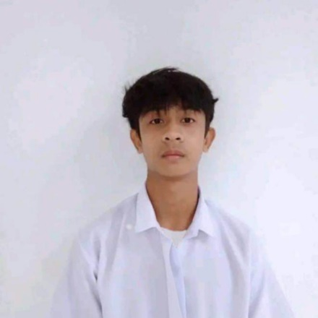**Rodary Patrimonio Tabasan**

Dungeg, Santa Teresita, Cagayan

reytabasan123@gmail.com

+63 975 660 0232

**OBJECTIVES**

To gain valuable experience and further develop my skills for personal and professional growth. In return, I am eager to contribute my efforts and dedication to be a valuable asset to your company during my on-the-job training (OJT).

**PERSONAL INFORMATION**

Date of Birth: January 8, 2004

Birthplace: Santa Teresita, Cagayan

Sex: Male

Height: 1.63 m

Weight: 49 kg

Civil Status: Single

Citizenship: Filipino

Language spoken: Ilocano, Filipino, and English.

**EDUCATION**

Tertiary: Bachelor of Science in Information Technology

Cagayan State University – Gonzaga Campus

Flourishing, Gonzaga, Cagayan

2022 – Present

Secondary: STEM

Saint Francis Academy

Villa, Santa Teresita, Cagayan

2020 – 2022

**SKILLS**

**TECHNICAL SKILLS**

* Web Development: HTML, CSS, JavaScript, TypeScript, PHP, React, Tailwind CSS, Bootstrap
* Database Management: MySQL
* Tools & Platforms: Git, VS code
* Operating System: Windows, Linux Mint
* Troubleshooting: Hardware, Software, and Network Issues
* Microsoft Office: Word, Excel, PowerPoint

**SOFT SKILLS**

* Problem-Solving
* Adaptability
* Time Management
* Self-Motivation
* Critical Thinking

**CERTIFICATION**

* Champion Static Web Design - Technolympics CSU Gonzaga 2025

**CHARACTER REFERENCE**

**Dr. Froilan Pacris Jr.**

Campus Executive Officer

Cagayan State University – Gonzaga Campus

**Dr. Clyden Charl B. Alibania**

College Dean

College of Information and Computing Sciences

I hereby certify that the above information is true and correct to the best of my knowledge and belief.

**RODARY P. TABASAN**

Applicant