**CAPSTONE PROJECT PROGRESS REPORT TEMPLATE**

1. **Basic Information**

**Project Title:** TVET RECORD AND ARCHIVAL CONTROL KIOSK

**Group Members:** Tabasan, Rodary P.

Mape, Jacqueline C.

Saludares, Noralyn A.

Quejado, Teodie Q.

**Capstone Adviser:** Jefrey S. Quiniano

**Report Period Covered:** August 18 - 22, 2025

**Date Submitted:** August 29, 2025

1. **Summary of Accomplishments**

|  |  |  |  |
| --- | --- | --- | --- |
| **Task/Activity** | **Target Date** | **Date Completed** | **Remarks** |
| Requirements Gathering (User Needs / System Specs) | July 30 | July 30 | Finished on-time |
| System design documentation | July 30 | August 3 | Done ahead of time |
| Manuscript Revision | July 20 | July 30 | Done ahead of time |

1. **Activities/Tasks in Progress**

|  |  |  |  |  |
| --- | --- | --- | --- | --- |
| **Task** | **Assigned Member(s)** | **% Completed** | **Expected Completion Date** | **Remarks** |
| System Development | Tabsan, Rodary P. | 60% | August 30 | On track |
| Manuscript | Mape, Jacqueline C. | 70% | September 15 | On track |
| System Design | Tabasan, Rodary P. | 60% | August 30 | On track |
| System Documentation | Saludares, Noralyn A.  Quejado, Teodie Q. | 50% | August 30 | On track |
| Stakeholder  Interview | Tabasan, Rodary P.  Mape, Jacqueline C.  Saludares, Noralyn A.  Quejado, Teodie Q. | 50% | August 08 | On track |

1. **Issues/Challenges Encountered**

|  |  |  |
| --- | --- | --- |
| **Issue/Challenge** | **Description** | **Proposed Solution/ Action Taken** |
| Poor internet connectivity | It caused delays in accessing online resources, uploading files, and communicating with groupmates | We worked during better internet hours and used offline tools to stay on track. |
| Learning new programming languages | It was hard to understand and apply unfamiliar coding concepts. | We learned by using online resources, watched tutorials, and practiced regularly. |

1. **Plans for the Next Period**
2. Continue developing the system
3. Continue editing manuscript

Prepared by:

Rodary P. Tabasan Jacqueline C. Mape

Noralyn A. Saludares Teodie Q. Quejado

Date Submitted: August 29, 2025

Submitted to:

**CLYDEN CHARL B. ALIBANIA, PhD**

Subject Teacher

Date Received: August 29, 2025

**Activities/Tasks in Progress - (August 18-22, 2025)**

Here is the progress of our system during August 18–22, 2025. Each member was assigned individual tasks, which were completed according to the planned schedule.

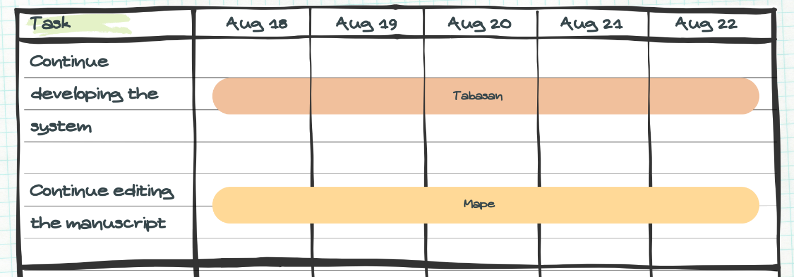

During the period of August 18–22, 2025, Rodary P. Tabasan continued the system development, with a focus on enhancing the admin dashboard.

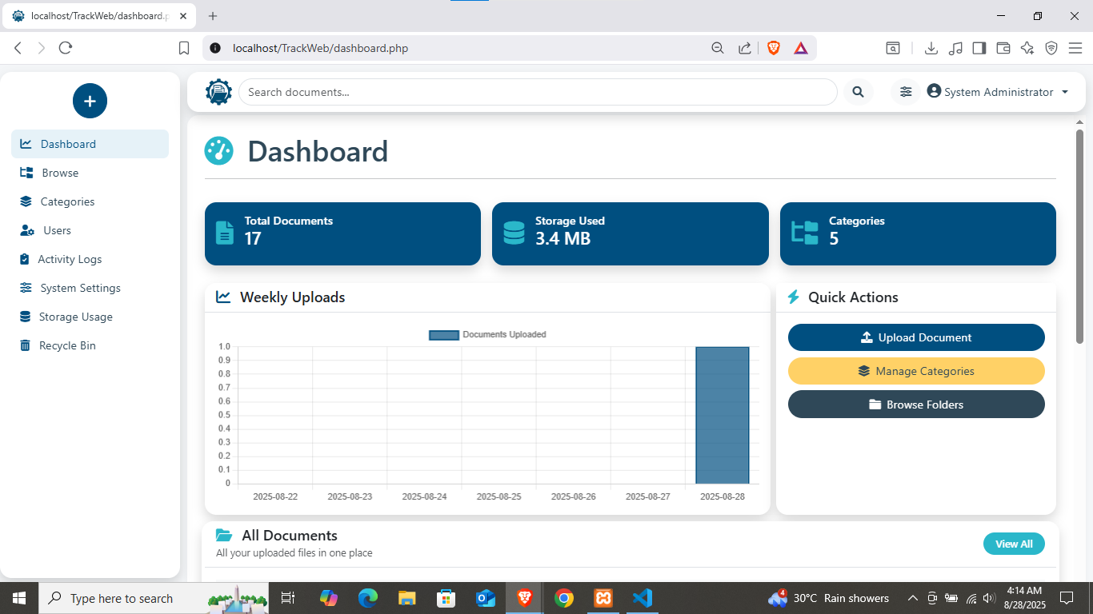

While Jacqueline C. Mape, still assigned to revise and continue editing the manuscript.

