**COS 2030**

Project Report – BRD Documentation

*Women’s Club*

Contents

1. Project overview (including vision, objectives, and context)

2. Project scope

2.1. Business requirements

3. Security, Privacy Management and Constraints

4. UML Diagrams/ Use Case Diagrams

5. System Architecture and System Design

6. Quality tests

7. Future Development

8. Timeline of the project

Project roles:

# Radko Mishev - Project Manager, Fullstack Developer, reviews code

# Petya Dimkina – Cybersecurity Analyst

# Sara Jakimovska – Back – End Developer

# Mariela Nikolova – Front – End Developer

# Magdalena Zheleva – Front–End Developer

# Lyuboslav Gigov – QA Engineer/Tester

# Bozhidara Rusenova – Business Analyst

Project overview:

Women’s Club is a modern website resource designed to offer expectant moms all-encompassing assistance and services during their pregnancy. Focusing on empowerment, well-being, and connection, our platform provides several features that aim to improve the whole pregnancy experience. On our website, future moms can share information about their experiences, they can help one another, and also learn together how to stay strong and have fun as well during this exciting new chapter of their lives.  
  
Project scope and goals:

* **Support:** To provide a welcoming and friendly atmosphere where expectant women can receive support, inspiration, and companionship.
* **Engagement:** To encourage user participation and communication by providing a range of tools, including community forums, event reservations, and networking possibilities.
* **Information:** To provide moms with accurate and current information, tools, and perspectives to assist them in making decisions regarding their pregnancy and the health of their unborn child.
* **Entertainment:** To provide joyful and engaging events and activities designed especially for expectant moms, fostering their general well-being.

Functionality and Features:

* **User Profiles and Registration:** By registering on the site, users may interact with other moms and have access to services and materials that are specifically designed for them.
* **Community Forum/Blog:** A special area where people may converse, exchange stories, and look to peers and professionals for guidance and assistance.
* **Event Booking:** This feature allows users to search and reserve events, including social gatherings, exercise courses, and pregnancy classes, which promotes networking and skill development.
* **Networking:** Resources and attributes that let people connect and develop meaningful connections and support systems.
* **Accessibility:** All users will have equal access to the platform as it is made to work with assistive technology and be available on a variety of devices.
* **Target Audience:** Expectant moms looking for community, support, and knowledge during their pregnancy are the main audience for the Women’s Club. The platform could also be useful to groups that support mother and child health, educators, and healthcare professionals.

Advantages:

* **All-inclusive Assistance:** Individuals have access to an extensive array of tools and programs designed especially to meet their demands as aspiring moms.
* **Community Engagement:** By giving users the chance to interact, exchange ideas, and gain knowledge from one another, the platform promotes a feeling of belonging and community.
* **Convenience:** Users may easily access important resources and services from the comfort of their home with features like event booking and information access.
* **Empowerment:** Women’s Club seeks to enable moms to make knowledgeable decisions and confidently manage their pregnancy experience by giving them access to information, support systems, and empowering activities. Connect and share experiences with other moms in a safe and informative environment.
* **A stronger, more supportive community:**  **Enhanced access to reliable information:** Remain calm knowing the resources shared are trustworthy and backed by experts.

Business Requirements:

**1. User Needs and Functionality:**

* **User Registration and Profiles:** Users should be able to register with basic information (name, location, due date) and create personal profiles to connect with others.
* **Community Forum:**
  + A forum or discussion board where future moms can post questions, share experiences, and offer support to each other.
  + Categorization of topics to allow easy navigation (e.g., pregnancy concerns, baby names, birthing experiences).
  + Moderation features to maintain a safe and respectful environment.
* **Event Calendar and Booking:**
  + A calendar showcasing events specifically targeted towards future moms (e.g., prenatal yoga, birthing classes, social gatherings).
  + Ability to search and filter events based on location, date, category, and other relevant criteria.
  + Seamless integration with a booking system for users to register for events.
* **Engagement Features:**
  + Icebreaker activities or prompts to facilitate conversation and connection among users.
  + Photo sharing functionality to document and share experiences.
  + Private messaging system for users to connect directly with each other.
* **Accessibility:**
  + The website should be accessible on various devices (desktop, mobile, tablet) and cater to users with disabilities.

**2. Non-Functional Requirements:**

* **Performance:** The website should load quickly and function smoothly even with high user traffic.
* **Security:** User data (personal information, messages) should be protected with robust security measures.
* **Scalability:** The platform should be able to scale to accommodate a growing user base.
* **Content Management System (CMS):** A user-friendly CMS should be implemented to allow for easy addition, editing, and management of content (event listings, forum topics, etc.)

**3. Additional Considerations:**

* **Monetization Strategy:** Explore potential revenue streams such as partnerships with event organizers, sponsored content, or premium features.
* **Content and Moderation:** Define clear policies regarding content creation and moderation to ensure a positive, inclusive, and informative environment.
* **Marketing and Outreach:** Develop a strategy to attract and engage users through online channels and local communities.

**Terms and Conditions of Business Requirements:**

1. Agreement to the Terms   
You accept these Terms and Conditions ("Terms") by accessing or using this website ("Site"). Please do not use this Site if you do not agree to all of the Terms.  
  
2. Profiles and User Registration   
a. When registering, users are required to enter complete and correct information.   
b. It is the responsibility of users to keep their passwords and account information private.   
c. Users promise to fill out their profiles with only accurate information and to update them as needed.   
  
3. Discussion Board for Community   
a. Participants pledge to participate in all forum conversations at the events responsibly and politely.   
b. Content that moderators feel objectionable or in violation of community rules may be removed at their discretion.   
c. Users are not allowed to publish any abusive, libelous, or offensive content or messages connected with our website.

4. Event Schedule and Reservation  
a. By booking events, users consent to follow the rules and regulations specified by the event organizers.  
b. Any modifications or cancellations made by event organizers are not the responsibility of the Site.  
c. When users book events, they have to give truthful information.  
  
5. Features of Engagement  
a. Users consent to refrain from abusing the private messaging feature for harassing or spamming others.  
b. It is completely forbidden to share offensive or improper information via any interaction feature.  
  
6. Accessibility

a. Users of all abilities are encouraged to use the site. They can kindly notify the administrators of any accessibility problems so they can be fixed.  
  
7. Performance

a. While the Site will try its best to guarantee seamless operation and rapid page loads, sometimes it cannot guarantee uninterrupted service.

8. Security   
a. Although the Site uses industry-standard security measures to guard user data, it is not impenetrable against hacking or unauthorized access, but there are security measures taken into account and a Security Analyst is present in our team.  
  
9. Scalability

a. In order to meet increasing user demand, the Site will make an effort to scale its infrastructure.  
  
10. CMS, or content management system  
a. The Site maintains the right to oversee and modify any content uploaded or comment posted on the platform to ensure that it complies with community rules and is accurate and acceptable.  
  
11. Strategy for Monetization  
a. To make money, the Site could show sponsored material or adverts.  
b. Users could possess premium features or services.

12. Content and Control   
a. Users consent to follow community rules and are accountable for the material they submit on the site.  
b. Content that moderators feel improper or against community norms may be edited or removed at their discretion.   
  
13. Marketing and Outreach

a. Users consent to receive notifications about updates, event promotions, and other pertinent information while using the Site.   
  
14. Liability Limitation   
a. The Site and its administrators disclaim all liability for any damages, including but not limited to direct, indirect, incidental, punitive, or consequential damages, resulting from the use of the Site or from the inability to use the Site.   
  
15. Governing Law

a. The laws of Jurisdiction shall apply to the interpretation and enforcement of these Terms and Conditions.

16. Terms Modifications:   
a. The Site retains the right, at any time and without previous notice, to alter or amend these Terms and Conditions.

b. By using the Site going forward, you agree to the updated Terms.  
  
17. Contact Details

a. Please email [womensclub@gmail.com](mailto:womensclub@gmail.com) with any questions or complaints you may have about these terms and conditions.  
  
b. You confirm that you have read, comprehended, and agree to be committed to these Terms & Conditions by using this website.

Security and Privacy Management:

Risk Categories

* User Safety:
  + Physical Harm during Events: Events might involve activities that present a risk of physical injury for pregnant women.
  + Unqualified Event Leaders: Some events (like prenatal yoga) might require specific qualifications.
  + Harassment: Forum conversations or talks during the event could expose members of the Women’s Club to abuse or harmful content.
* Data Security & Privacy:
  + Personal Information: The website collects sensitive data like names, dates, and locations. A breach could have serious consequences.
  + Medical Information: Users might divulge information mistakenly believing it's a healthcare platform.
* Reputational Damage:
  + Inaccurate/Misleading Information: Shared advice among users might not be medically proven.
  + Negative Event Experiences: Dissatisfaction with an event could harm the website's reputation.
* Operational:
  + Technology Failure: Bugs or service outages could disrupt event bookings.
  + Insufficient Resources: Lack of staff/funding could hinder platform growth and responsiveness.

Risk Mitigation Strategies:

1. Vetting and Partnership:
   * Thoroughly screen event organizers and instructors. Verify qualifications and insurance.
   * Partner with reputable organizations (hospitals, birthing centers) to co-host events.
   * Establish clear guidelines for event content and safety.
2. Content Moderation and Disclaimers:
   * Robust forum moderation by trained staff to delete harmful posts quickly.
   * Emphasize through disclaimers that the platform is for community support, not a substitute for professional medical advice.
3. Data Security:
   * Implement strong encryption and access controls on user data and informtion.
   * Have regular security audits.
   * Transparent privacy policy clearly outlines data use.
4. User Education:
   * FAQ section and guides on internet safety and responsible sharing.
   * Resources page linking to official medical websites/ resources.
5. Insurance:
   * Obtain insurance to cover liabilities (injuries during events, cybersecurity breaches).
6. Incident Response Plan:
   * Plan in place on how to react to a negative event, data breach, or harassment report. Include clear channels for users to raise concerns, write comments, or send emails when they cannot access the site, or any of the features or they cannot access their personal profiles.
7. Challenges such as budget, time management, and human resources:

* Budget: Tools, software, and maybe external security checks must be invested in to create and maintain a secure platform. A tight budget might make it impossible for the team to implement all the needed security measures.
* Time: It takes time to implement and test security measures properly. Due to time restrictions, the team may have to prioritize important security features and take care of others later.
* Human Resources: It is best to have a dedicated security specialist to monitor risks and put protections in place. Existing team members may have to take on more security responsibilities due to a small team, which might affect their core jobs.

Additional Considerations:

* Local Regulations: Understand any regulations around events targeted at pregnant women.
* Evolving Risks: Technology and social dynamics change rapidly. Stay updated on potential new risks to the platform.

UML Diagrams:

@startuml

class User {

- username: string

- email: string

- password: string

}

class PregnantUser {

- due_date: string

+ participate_in_event(): void

}

class Event {

- name: string

- date: string

- description: string

}

class Community {

- users: List<User>

- events: List<Event>

+ register_user(user: User): void

+ create_event(event: Event): void

+ user_participate_in_event(user: User, event: Event): void

}

class Website {

}

User <|-- PregnantUser

User <-- Community

Community <-- Website

Event <-- Community

@enduml

The user class represents a basic user with attributes such as username, email, and password.

**PregnantUser** class inherits from User and adds an attribute **due_date** to represent the expected due date of the pregnant user. It also has a method **participate_in_event()** to allow users to participate in events.

Event class represents an event with attributes like name, date, and description.

Community class represents the community where users can **register**, **create events**, and **participate** in events.

Actors are represented by instances of the **PregnantUser** and Website classes.

Classes from the UML diagram are implemented as classes (**User**, **PregnantUser**, **Event**, **Community, Website**). Relationships between classes are represented through method calls (**register_user**, **create_event**, **user_participate_in_event**).

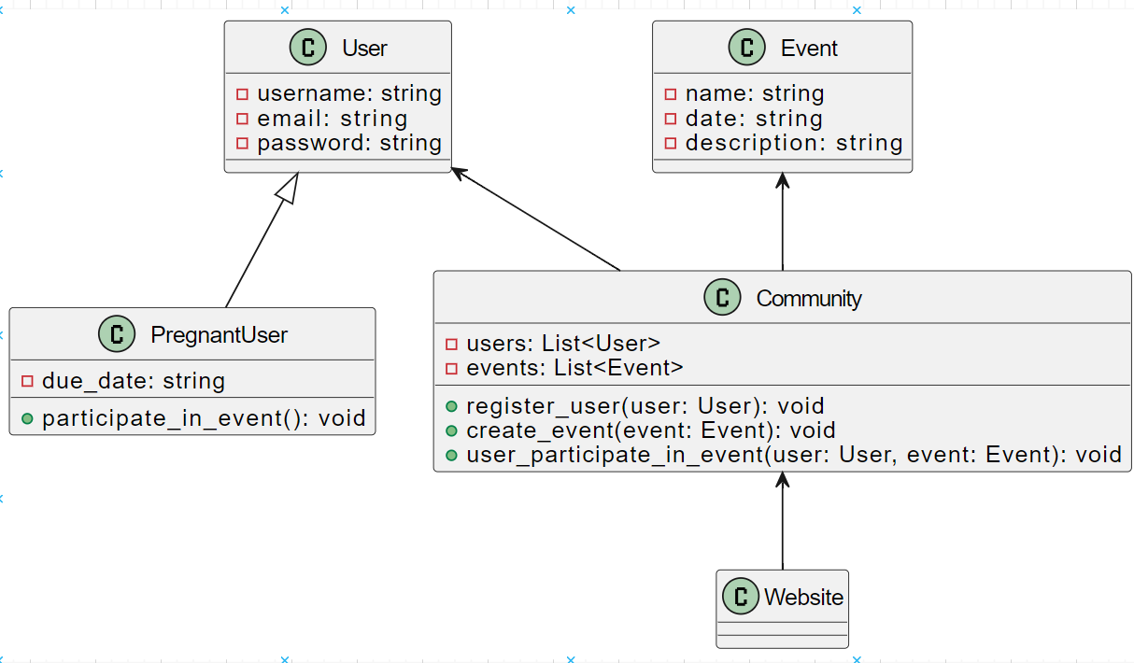

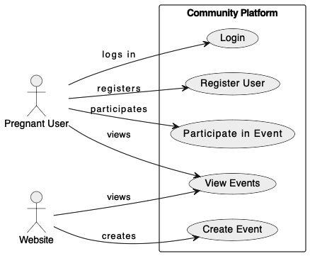

System Architecture and System Design:

High-Level Architecture:

Women's Club is designed as a three-layer architecture consisting of:

* Front-end presentation layer manages the web application's user interface (UI) and user experience (UX). Users use their web browsers to engage with this layer. This layer is developed using technologies like HTML, CSS, and Javascript (React, TypeScript, Tailwind framework).
* Back-end Business Logic Layer: This layer controls the essential features of the program. It manages data storage, website interactions, event management, and user authentication. The implementation of this layer would involve the usage of a database management system (DBMS) such as PostgreSQL to store user data, event information, and forum material, along with a server-side programming language such as Java, Cypress, and Spring Boot. Communication between the front-end and back-end layers would take place through APIs.
* Data Layer (Database): All application data is safely stored in this layer. The permanence, retrieval, and modification of data would fall under the purview of the selected DBMS.

System Design Factors:

Scalability: An expanding user base should not be a problem for the platform. Using cloud-based solutions for databases and infrastructure that can readily scale up or down in response to demand may be one way to do this.

Security: As was previously said, strong security measures are essential to safeguarding user information and privacy. It is imperative to provide features such as access restrictions, data encryption, and user authentication. To find and fix vulnerabilities, regular security audits and penetration tests should be carried out.

Performance: Even with a large volume of users, the website should load swiftly and run without a hitch. Performance may be increased by employing Content Delivery Networks (CDNs), optimizing code, and using caching techniques.

Accessibility: People with problems should be able to access and use the site.

Design patterns:

Static import - used to import code that has been exported by another component

Route-based splitting - used to dynamically load components based on the current route. Used alongside the React router

Higher Order Components - Used to pass reusable logic down as props to child components. MVC - Model View Controller pattern. Used to separate the concerns. The model is representative of the way that the entry looks in the DB. The Controller is used for business logic and communication with the DB.

We used an agile development methodology to continuously improve the Women's Club platform, ensuring we deliver features that meet user needs most effectively.

Quality Tests:

A unit test is a kind of test used in software development that confirms the accuracy of a single code unit. A function, a method, a class, or any other compact, standalone piece of code can be this unit. Ensuring that every code unit operates as expected under various scenarios is the aim of unit testing. This aids in the early detection of flaws throughout the development phase, preventing issues from arising in the finished product. Unit tests also function as code documentation, outlining the purpose and operation of the code.

For the Women's Club application to perform as intended, each component must pass unit tests. Lyuboslav implemented the well-liked framework for unit testing Java programs called JUnit. It makes it simple to develop and execute tests by offering statements to test expected results and annotations to indicate test methods. JUnit makes it possible for regular code restructuring and enhancements by ensuring that changes to the code do not affect previously implemented functionality.

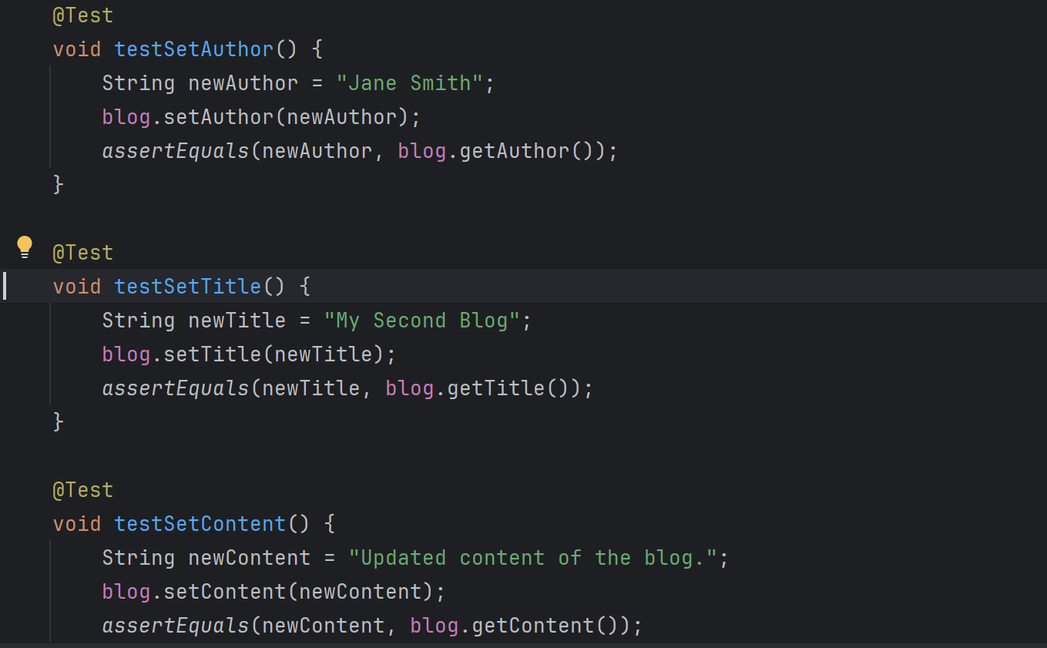

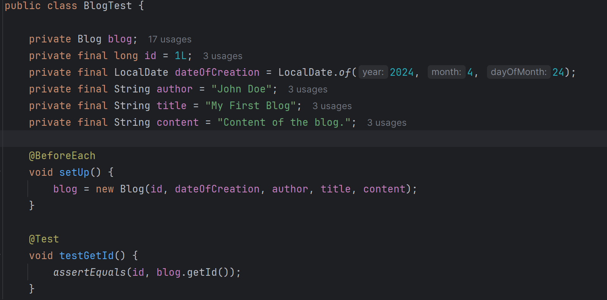

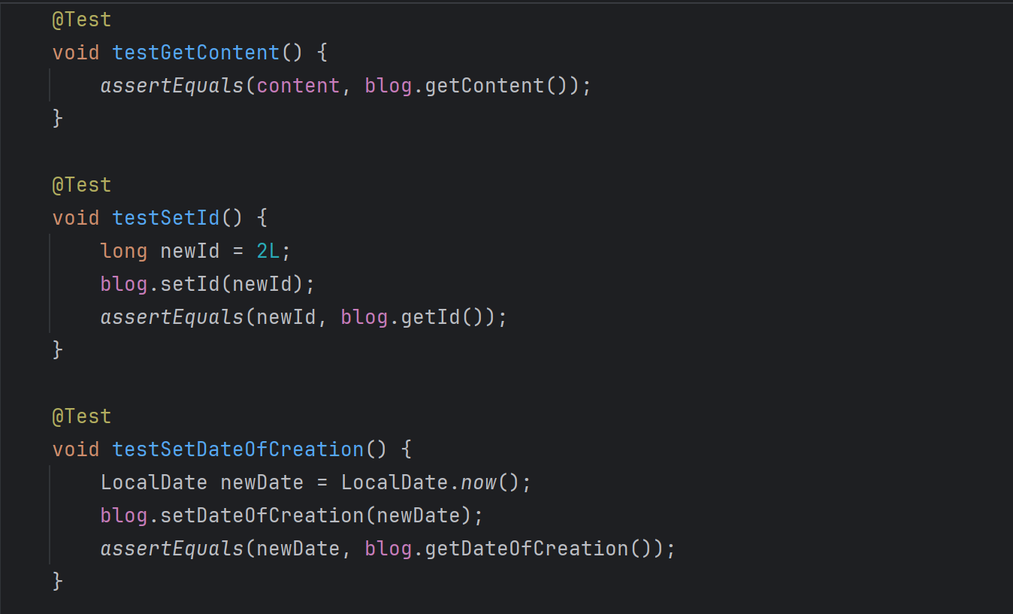

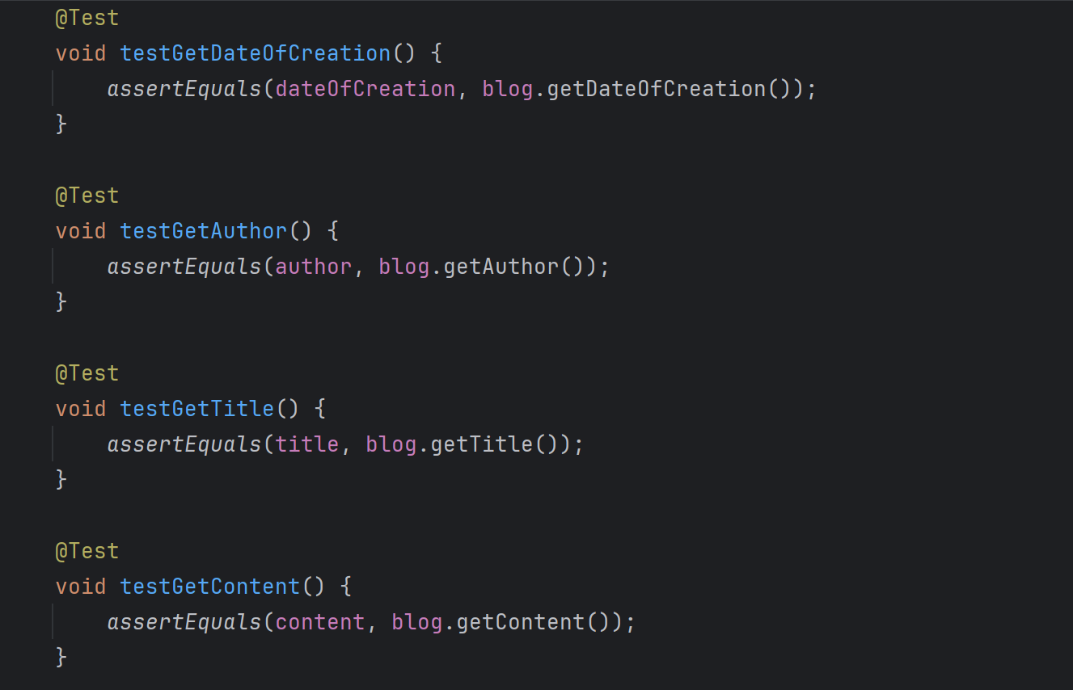

Future Development:

With a comprehensive approach to pregnancy support and empowerment, the website Women’s Club is a special and invaluable resource for expectant moms. With its intuitive design, extensive feature set, and emphasis on community and wellbeing, Women’s Club is well-positioned to grow into a dependable partner for expectant moms.

* **Updates to Our Women’s Club Platform for the Future:**

We're always striving to improve user experience on our platform for expectant mothers! Here's a breakdown of some future changes designed to foster a stronger community and enhance the pregnancy journey. Our initial focus is to offer a range of features, including connecting with other moms, finding pregnancy-related events, and sharing experiences.

* **Improved Blog Features:** We want to implement improvements to the blog/forum, making it easier to find relevant topics, connect with women in similar stages of pregnancy, and share experiences more effectively. Moreover, we also plan to widen the specter of users and implement chat into the site where women can also ask for assistance to find something on the site. In addition with this chat, they can find other buddies before meeting in person for some of our events.
* **Focus on Expert-Verified Information:** While peer support is invaluable, we want to place a greater emphasis on ensuring the information shared is accurate and reliable. We'll work with healthcare professionals to curate trustworthy resources and flag any potentially misleading content.
* **Prioritizing Mobile App:** Recognizing the widespread use of smartphones, we would consider optimizing our features for the mobile app, making it easier to connect with other moms, find events, and access resources just through your mobile phone.
* Create subforums for specific topics like baby names, workout regimens, and nutrition.
* Professional Questions and Answers: Initiate live conversations or respond to questions submitted in advance by collaborating with medical professionals, midwives, lactation consultants, and other experts in prenatal practices.
* Educational Resources: Provide a range of pregnancy-related articles, videos, and educational infographics.
* Compile a library of digital materials, such as guides to healthy recipes, checklists, and birthing plans.

Timeline of the project:

After the first week of classes in January, we started with weekly in-person meetings to turn our idea into reality. We distributed roles within our team, with members designated as project manager, cybersecurity analyst, QA Tester, web developers – full-stack, front and back-end, and business analyst. To keep ourselves organized and on track, we created a Trello board, which is a Kanban board system. This served as our central hub for managing tasks. We created lists for different stages of development (concept, development, testing, launch) and assigned tasks to specific team members. Trello's commenting feature allowed for real-time collaboration, brainstorming ideas, and providing feedback. We also made video conferences for weekly meetings and quick communication throughout the week. Following an agile development approach, we prioritized tasks for each sprint and met regularly to track progress and identify any issues. As the presentation deadline approached, we increased the frequency of meetings to ensure everything was ready for testing, final revisions, and presentation.

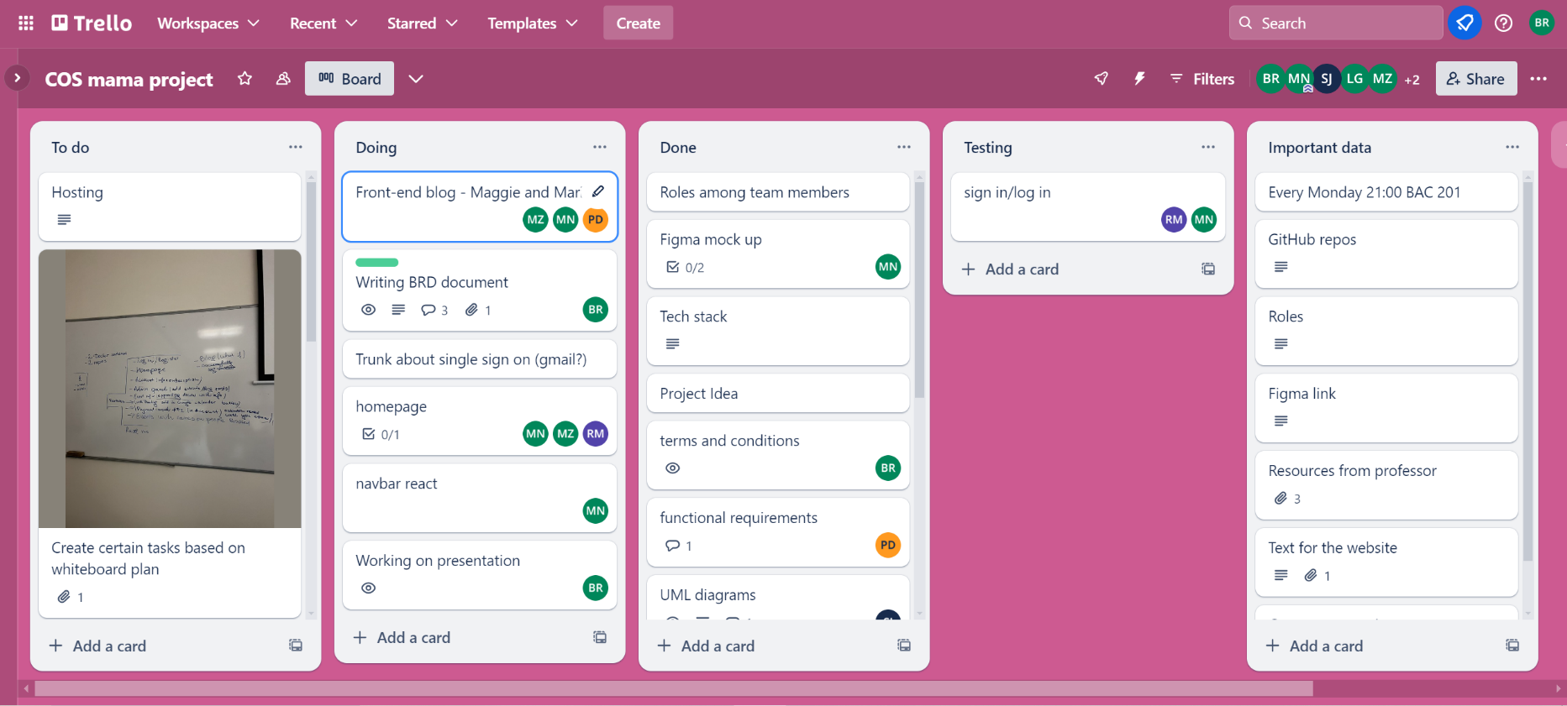

Individual contribution breakdown:

# Radko Mishev - Project Manager, Fullstack Developer:

As the Project Manager and Full Stack Developer for our web application designed for pregnant women, I held a key leadership and technical role. I took the helm in organizing tasks, meticulously planning the project timeline, and coordinating with the team to ensure that all tasks were clearly understood and executed efficiently. My responsibilities extended into the realm of full-stack development, where I architected and implemented the admin panel. This was a multifaceted task that involved writing server-side code, setting up databases, and crafting APIs, as well as creating the front-end interfaces that allow for easy management of the platform. Designing many of the web pages was another area where I dedicated my expertise. I focused on delivering an engaging user experience (UX) and an appealing user interface (UI). I aimed to construct pages that were not only visually attractive but also intuitive and easy to use, facilitating a positive experience for the women using our platform to sign up for events, meet up, and access various pregnancy training courses. My dual role was central to both driving the project forward and shaping the technical execution that would resonate well with our target users.

# Petya Dimkina – Cybersecurity Analyst:

I have identified and addressed the vulnerabilities in the system, analyzed threats, and will implement safeguards to prevent cyberattacks and data breaches in the future. I wrote a report about the safety of our system, that shows potential vulnerabilities and I gave a description of how to fix them.

# Sara Jakimovska – Back – End Developer:

# Being the Backend Developer of the team, I created the backend of our project using Java Spring Boot, structured around an MVC architecture. I focused on developing essential business logic for processing user transactions and ensuring data accuracy. Utilizing Maven, I managed project dependencies effectively. I also designed and refined RESTful APIs to enhance integration between the front and back end, particularly improving user management and content updating functionalities. I engaged in weekly Agile scrum meetings where we used to meet every week so that we guide ourselves through the development process. My aim was to increase scalability, security and performance of an application while working within agile framework towards meeting our project objectives.

# Mariela Nikolova – Front – End Developer:

I translated the design team's vision into reality by hand-coding the core user interface elements based on Figma mockups. This included the Home page, Profile page, Navigation bar, Events page, and About Us page. implemented responsive design principles to ensure the website flawlessly adapts and functions across the Web. This guarantees an optimal user experience for all expecting mothers visiting the platform.

# Magdalena Zheleva – Front–End Developer:

The Women's Club platform was shaped in large part by my UI development experience. Because of my commitment to user-centric design principles, the site has an aesthetically pleasing and user-friendly layout that makes it easy for pregnant women to explore and use its essential resources. I also implemented the Blog page, Partners page, and the page including the partner’s banner. In addition, I helped with the Homepage creation.

# Lyuboslav Gigov – QA Engineer/Tester:

In the Software Engineering team project, I played a crucial role as a QA Tester, focusing on ensuring the reliability and usability of our web application designed for pregnant women. During the project, I significantly expanded my technical skills by learning and implementing Cypress for both component and end-to-end testing. This involved rigorously testing individual components to ensure they function correctly in isolation, as well as conducting end-to-end tests to verify the entire application's workflows under various scenarios. My efforts were critical in identifying and addressing bugs early, enhancing the overall software quality and user experience. By integrating key QA testing methodologies and tools, such as test automation and usability testing, I was able to contribute significantly to the stability and effectiveness of our application. This comprehensive testing strategy not only optimized our application's performance but also significantly reduced the time to market, demonstrating the value of thorough QA practices in software development. This focus on quality helped ensure that the application could meet the specific needs of our (hypothetical) users, providing them with a reliable and user-friendly platform.

Bozhidara Rusenova – Business Analyst:   
In this project focused on creating a Women's Club, my role as a Business Analyst was crucial. I acted as the bridge between the initial concept and its practical execution. This document captured the functional and non-functional requirements for Women's Club, detailing what features the website should have and how it should operate successfully. I documented the different roles within the team, outlining the tasks and responsibilities of each team member (project manager, developers, testers, and analysts). I created a roadmap outlining the different stages of development (concept, design, development, testing, launch) with estimated timelines for each phase. I made sure that everyone in the team understood the objectives, features, and development process of the project by producing concise and clear documentation. This made it easier to collaborate and communicate throughout the project's lifespan.