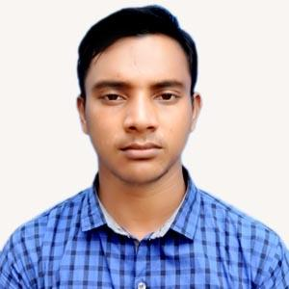
Resume Of Md. Jakir Ahammed





Contact No.: +8801772868728

Email : chem1913051brur@gmail.com
Facebook : www.facebook.com/jakir728
LinkedIn : www.linkedin.com/jakir728
GitHub : https://github.com/jakir728

Career Objectives
To develop career in dynamic and challenging environment where hard work, strick discipline, sincerity is welcomed. I have a desire to utilize my technical skill, talent, creativity, and sincerity for the better achievement of the organization.

Personal Skill And Qualities
- Hard Worker, Innovative and very responsible person.
- Able to work confidently under pressure in different situation to meet the deadline.
- Strongly believe in teamwork.
- Co-operative and Good communication skills.
- Strong analytical and problem solving skills.
- Organization &leadership competence with strong interpersonal relationship.

Educational Qualification

Exam Title | Group/ Major | Institute | Result | Passing year | Session
Bachelor of Science (B.Sc.) | Chemistry | Begum Rokeya University, Rangpur. | CGPA: 3.49 out of 4.00 | 2023 | 2019-20
HSC | Science | Itakumary Shibchandra Roy college,Rangpur. | GPA: 5.00 out of 5.00 | 2019 | 2017-18
SSC | Science | Damur Chakla High School, Rangpur. | GPA: 4.55 out of 5.00 | 2017 | 2015-16

Training & Courses Summary

Name Course | Organization Name | Department | Year | Duration
Industrial Training on Chemical Analysis and Quality control | Training institute For  Chemical Industries(TICI),  Polash, Narsingdi,  Bangladesh. (Central  Training Institute of BCIC) | Analytical Chemistry &  Environmental Science | 2024 | Four weeks  (21/09/2024 - 17/10/2024)

Language Proficiency
Language | Reading | Writing | Listening | Speaking
Bengali | Excellent | Excellent | Excellent | Excellent
English | Excellent | Good | Good | Good

Computer Skills
- Microsoft Office: MS Word, MS Excel, MS Power Point.
- Internet Browsing.
- Basic knowledge of computer hardware and software maintenance and E-mail service.
- Google Classroom
- Chem Draw

Personal Information
Father’s Name | : Md. Lutfar Rahman
Mother’s Name | : Mst. Joynob Begum
Date of Birth | : 30 Nov 2001
Gender | : Male
Marital Status | : Unmarried
Nationality | : Bangladeshi
Religion | : Islam
Permanent Address | : Durgacharan, Sundor, Pirgachha, Rangpur.
Current Location | : Durgacharan,Sundor,Pirgachha,Rangpur.
Blood Group | : O+

Reference

Mostafa Kaiyum Sharafat  Lecturer  Department of Chemistry  Begum Rokeya University, Rangpur.  Phone: +8801734785596  Email: mksharafat10@gmail.com | Dr. Md. Abdul Latif  Associate Professor  Department of Chemistry  Begum Rokeya University, Rangpur.  Phone: +8801798100131  Email: latif503@yahoo.com

Declaration of Authenticity
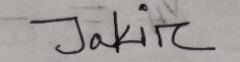
I hereby solemnly declare that the information which I have provided is true according to my knowledge and will be able to submit all needful documents in support of the aforementioned information if required.

Md. Jakir Ahammed

