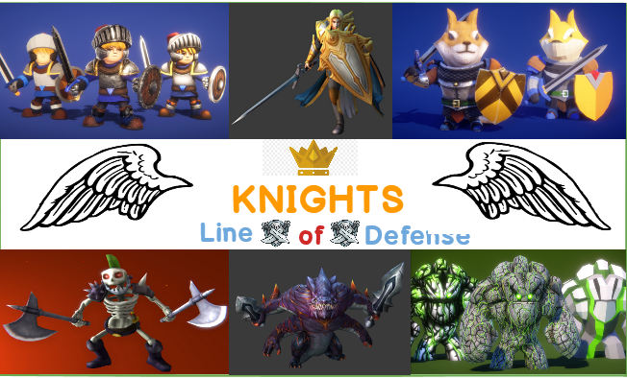

**Tiago Farinha – 180221011**

**Francisco Moura - 180221015**

Contents

Game Overview 3

Unique selling points 3

Platform Minimum Requirements 3

Competence Titles 3

Synopsis 4

Game Objectives 4

Game Rules 4

Game Structure 4

Levels 1-10 4

Gameplay 5

Game Camera 5

Player 6

Player Characters & Metrics 6

Player and Enemies States 6

Characters Lineup 7

White Knight 7

Nibbers 7

Furries 7

Kratus 7

King Sharthur 7

Golemtears 7

Characters Stats 8

White Knight 8

Nibbers 8

Furries 8

Kratus 8

King Shartur 8

Golumtears 8

Art 9

Level Design 9

Audio 9

MVP (Minimum Viable Product) 9

Improvements 9

# Game Overview

**Title: Knights Line of Defense**

**Platform: PC Standalone**

**Genre: 3D Tower Defense**

**Rating: (6+) ESRB**

**Target: Casual gamer (aging from 6 - 99)**

**Release date: To be disclosed**

**Publisher: Unity Technologies**

**Knights Line of Defense is a third-person tower defense game where the Player has multiple allies to choose from to help him protect their kingdom.**

# Unique selling points

* **It’s free;**
* **Challenging;**
* **Easy-to-learn;**

# Platform Minimum Requirements

**PC**

**OS: Windows.**

# Competence Titles

Tower Defense by Unity Technologies

# Synopsis

This is a short story about the knights of IPS and their fight against the villains from IST.

# Game Objectives

The objective of the game is to stop our enemies from reaching the final line of defense, while attacking those enemies and scoring points and resources that allows us to bring more allies.

# Game Rules

The game levels occur in an open forest-ish area. Each area contains a specific number and type of enemies. The main goal is to stop those enemies from reaching a certain point of the area. The player has to spawn his available characters in order to stop the enemies from reaching their goal.

# Game Structure

## Levels 1-10

# Gameplay



**Select Action**

## Game Camera

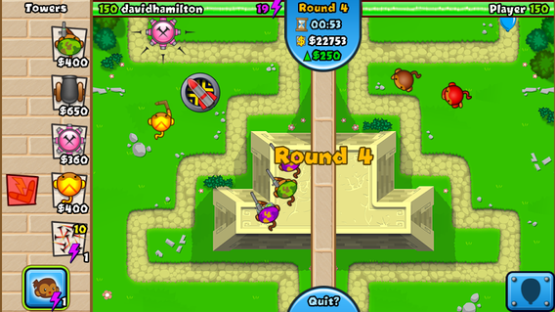

***Camera angle will be from the top but still using 3D*** Components

**Fig. 1 - Balloons Tower Defense as example**

# Player

## Player Characters & Metrics

**The player uses the character in-game. There are several “minions” to choose from.**

**Each character has different metrics that will help the player defend his tower/kingdom.**

## Player and Enemies States

**Idle: //Insert description of animation here**

**Walk (only for enemies)**

**Fight**

**Die**





# Characters Lineup

Hero

## White Knight

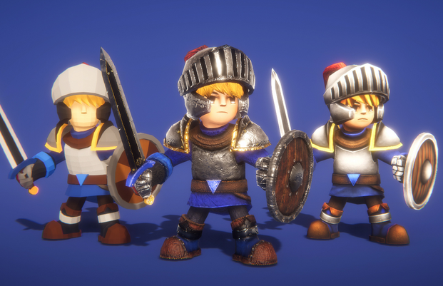

## Nibbers

Hero

Hero

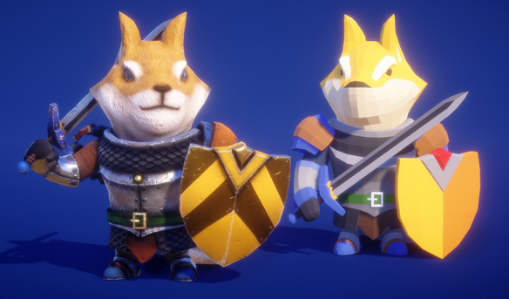

## Furries

Villain

Villain

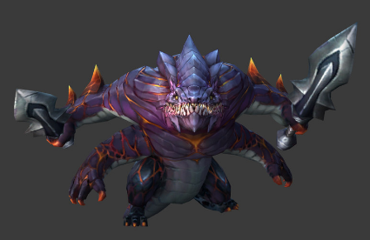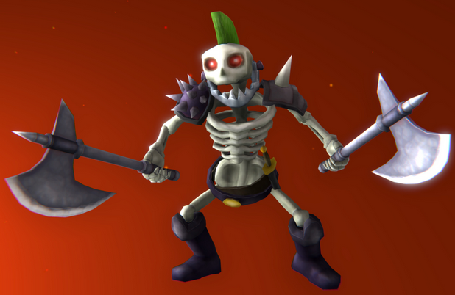

## Kratus

## King Sharthur

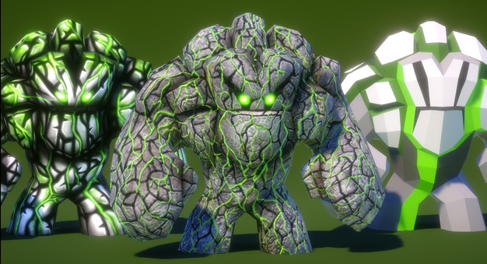

## Golemtears

Villain

# Characters Stats

## White Knight

HP: 150 | Attack Points: 40 | Time to attack: 1 | Summon Cost: 500 coins

## Nibbers

HP: 70 | Attack Points: 20 | Time to attack: 1| Summon Cost: 250

## Furries

HP: 50 | Attack Points: 10 | Time to attack: 0.5 | Summon Cost: 150

## Kratus

HP: 20 | Attack Points: 100 | Speed: 10 | Time to attack: 5 | Score Value: 40

## King Shartur

HP: 150 | Attack Points: 20 | Speed: 5 | Time to attack: 0.5 | Score Value: 300

## Golumtears

HP: 200 | Attack Points: 5 | Speed: 2 | Time to attack: 2 | Score Value: 250

# Art

**To be defined.**

# Level Design

**The levels start in a medieval scenario where several enemies appear in a certain spot (located in a somewhat far place from their goal) and they walk through the scenario to reach said goal. The player will place his heroes in attempt to stop them until there’s no enemies left.**

**These heroes are located on the right side of the screen and they are summoned by exchanging money. The money that the player currently has will be displayed in the top-center of the screen.**

# Audio

**To be defined.**

# MVP (Minimum Viable Product)

* 6 characters to choose from;
* Built for PC Platform;

# Improvements

**To be defined.**