1. Browse to <https://wires.comfed.local/wireapp> or <https://wires.comfed.local/wireapp/login>
2. Enter your username and password and click sign in

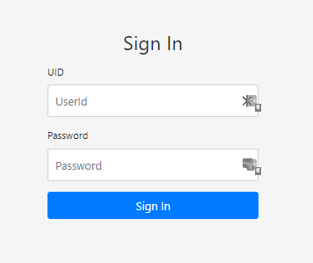

1. That will take you to the Wire Dashboard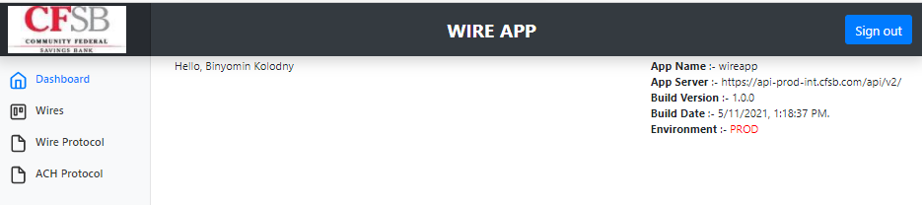
2. On the left side is the Navigation pane. Click on Wires to expand the list

