Ref: DBBL/100/048/2025/

**TO WHOM IT MAY CONCERN**

This is to certify that the following foreign remittance (as shown in Table-A) has been received in favor of ***Mr.,A/C No-,*** Dutch-Bangla Bank PLC,, during the period

***Table-A: Remittance Details:***

The aforementioned remittances were credited to the beneficiary’s account on the respective dates of receipt.

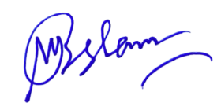

**Muhammad Aminul Islam**

Senior Assistant Vice President